Supplementary Information²⁵Mg NMR and Computational Modeling Studies of the Solvation Structures and Molecular Dynamics in Magnesium Based Liquid Electrolytes

Jian Zhi Hu,^{aǂ}* Nav Nidhi Rajput,^{bǂ} Chuan Wan^{ad+} Yuyan Shao,^{a+}
Xuchu Deng,^{ac} Nicholas R. Jaegers,ª Mary Huª, Yingwen Chenª, Yongwoo Shin,^{b} Joshua Monk,^{f} Zhong Chen^{c}, Zhaohai Qin^{d}, Karl Todd Muellerª*, Jun Liuª*, and Kristin Persson^{be}*

ª The Joint Center for Energy Storage Research (JCESR),
Pacific Northwest National Laboratory, Richland, WA 99352, USA
^{b}Lawrence Berkeley National Laboratory, Berkeley, CA 94720, USA
^{c}Department of Electronic Science, Xiamen University, Xiamen 361005, China
^{d}College of Science, China Agricultural University, Beijing 100193, China.
^{e} Department of Materials Science & Engineering, University of California, Berkeley, CA 94720-1760, USA
^{f}NASA Ames Research Center, Moffett Field, CA 94035, USA

^{ǂ} or ⁺ These authors have equal contribution to this work.
To whom correspondence should be addressed:
Jian Zhi Hu: Jianzhi.Hu@pnnl.gov; (509) 371-6544.

Karl.Mueller@pnnl.gov; (509) 371-6550

Jun Liu: Jun.Liu@pnnl.gov; (509) 375-4443
Kristin Person: kapersson@lbl.gov; (510) 486-7218

30
20
10
0
-10
PPM
0.4M
0.01M
0.005M
0.04M
0.3 ppm

Figure S1. ²⁵Mg NMR spectra of pure Mg(TFSI)₂ dissolved in DGM with different concentrations of 0.005, 0.01M, 0.04 and 0.4 M Mg(TFSI)₂, illustrating that both the peak center and the linewidth are essentially independent of the Mg(TFSI)₂ concentration over a wide range from about 0.005 to about 0.4 M. 1 M MgCl₂ in H₂O was used as the reference (i.e., 0 ppm).

Figure S2. ²⁵Mg NMR spectra of high salt concentrations of both Mg(BH₄)₂ and Mg(TFSI)₂ dissolved in DGM with different concentrations of Mg(BH₄)₂ and Mg(TFSI)₂. The linewidths, measured as the full width at the half peak height positions, are approximately: 3.5 ppm for 0.1 M Mg(BH₄)₂ + 0.1 M Mg(TFSI)₂, 4.3 ppm for 0.1 M Mg(BH₄)₂ + 0.2 M Mg(TFSI)₂, 4.5 ppm for 0.1 M Mg(BH₄)₂ + 0.3 M Mg(TFSI)₂, respectively.

Table S1. DFT-based ²⁵Mg NMR shielding calculations on the Mg atom for Structure-A showing the similarity of results using both the BLYP-D and the relatively expensive hybrid B3LYPD exchange-correlation functionals.
 | B3LYPD  δ_{calc} ppm (absolute shielding) | **B3LYPD  δ_{obs} ppm  (referenced) | BLYPD  δ_{calc} ppm (absolute shielding) | *BYLPD  δ_{obs} ppm  (referenced)
Mg(H₂O)₆ | 570.6 | 0 | 565.2 | 0
Mg(BH₄)₂ DGM | 548.6 | 22.0 | 543.6 | 21.6
Mg(BH₄)₂ DGM - 1DGM | 543.1 | 27.5 | 539.0 | 26.2
Mg(BH₄)₂ DGM - 1DGM-2 | 570.7 | -0.1 | 564.6 | 0.6
Mg(BH₄)₂ DGM -3DGM | 552.0 | 18.6 | 547.1 | 18.1
“*” δ_{obs} = 565.2 - δ_{calc} ppm
“**”δ_{obs} = 570.6 - δ_{calc} ppm
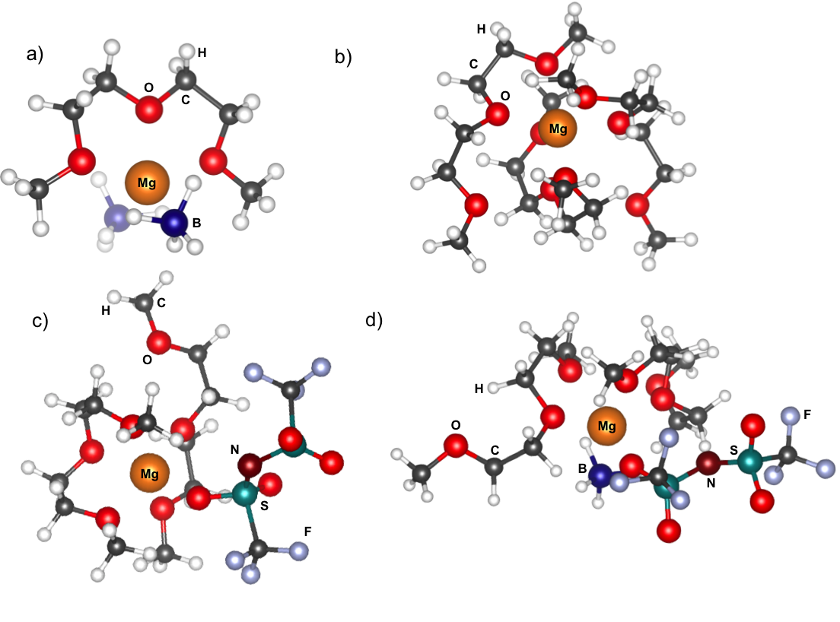
Figure S3. Representative snapshots from MD simulations of a) 0.01 M Mg(BH₄)₂/DGM b) 0.04 M Mg(TFSI)₂/DGM c) 0.4 M Mg(TFSI)₂/DGM and d) 0.01 M Mg(BH₄)₂ + 0.04 M Mg(TFSI)₂/DGM solutions.

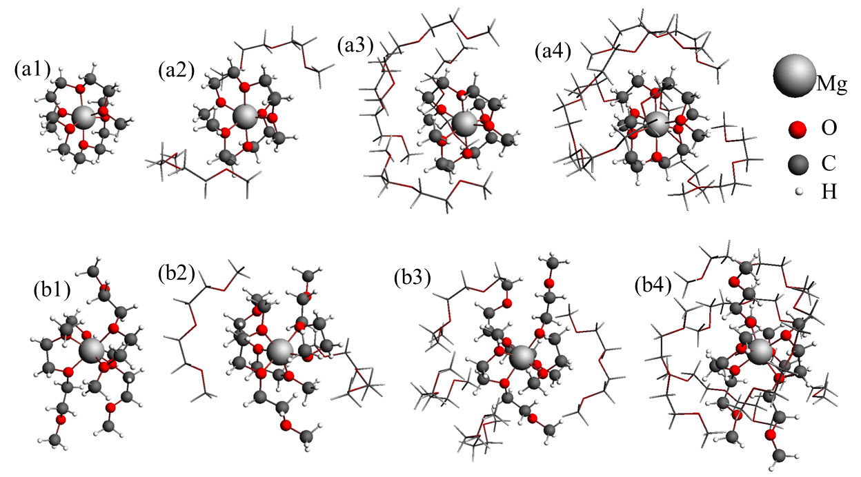
Figure S4. Geometry optimized structures of the 6-coordinated Mg²⁺ with and without 2nd solvation shells. (a1) Mg²⁺(DGM)₂, (a2) Mg²⁺(DGM)₂(DGM)₂, (a3) Mg²⁺(DGM)₂(DGM)₄, (a4) Mg²⁺(DGM)₂(DGM)₆, (b1) Mg²⁺(DGM)₃, (b2) Mg²⁺(DGM)₃(DGM)₂, (b3) Mg²⁺(DGM)₃(DGM)₄, (b4) Mg²⁺(DGM)₃(DGM)₆.

Table S2. Calculated ²⁵Mg NMR chemical shifts of the 6-coordinated Mg²⁺in DGM.
Label | Structure | ²⁵Mg Chemical shift/ppm
Figure S4a1 | Mg²⁺(DGM)₂ | -3.6
Figure S4a2 | Mg²⁺(DGM)₂(DGM)₂ | -2.2
Figure S4a3 | Mg²⁺(DGM)₂(DGM)₄ | 1.1
Figure S4a4 | Mg²⁺(DGM)₂(DGM)₆ | 3.2
Figure S4b1 | Mg²⁺(DGM)₃ | -1.7
Figure S4b2 | Mg²⁺(DGM)₃(DGM)₂ | -0.8
Figure S4b3 | Mg²⁺(DGM)₃(DGM)₄ | 1.7
Figure S4b4 | Mg²⁺(DGM)₃(DGM)₆ | 1.8

Table S3. Predicted ²⁵Mg NMR chemical shifts on model solvation structures of possible intermediates in the mixture containing both Mg(BH₄)₂ and Mg(TFSI)₂ dissolved in DGM.
First solvation shell structure | Solvation structures with 2nd solvation shells | Calculated/predicted ²⁵Mg NMR chemical shifts (ppm)
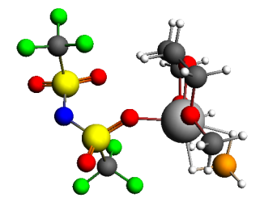 | Mg(BH₄)(TFSI)(DGM)-1 | 17.0
 | Mg(BH₄)(TFSI)(DGM)-1 + 2 DGMs | 15.4
 | Mg(BH₄)(TFSI)(DGM)-1 + 4 DGMs | 15.7
 | Mg(BH₄)(TFSI)(DGM)-1 + 6 DGMs | 17.2
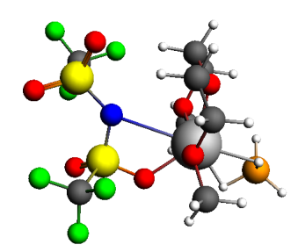 | Mg(BH₄)(TFSI)(DGM)-2 | 5.5
 | Mg(BH₄)(TFSI)(DGM)-2 + 2 DGMs | 7.4
 | Mg(BH₄)(TFSI)(DGM)-2 + 4 DGMs | 4.8
 | Mg(BH₄)(TFSI)(DGM)-2 + 6 DGMs | 3.3
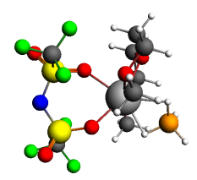 | Mg(BH₄)(TFSI)(DGM)-3 | -4.6
 | Mg(BH₄)(TFSI)(DGM)-3 + 2 DGMs | -2.8
 | Mg(BH₄)(TFSI)(DGM)-3 + 4 DGMs | -4.6
 | Mg(BH₄)(TFSI)(DGM)-3 + 6 DGMs | -2.5

Table S4: Summary of electrochemical results of electrolyte solutions prepared with two high salt Mg(BH)₄ and Mg(TFSI)₂ combinations in DGM.
Mg(BH)₄ | Mg(TFSI)₂ | Overpotential (V) | Coulombic Efficiency
0.1 | 0.1 | 0.19 | 86%
0.1 | 0.2 | 0.19 | 90%

Optimized geometries Coordinates

Reference Standard
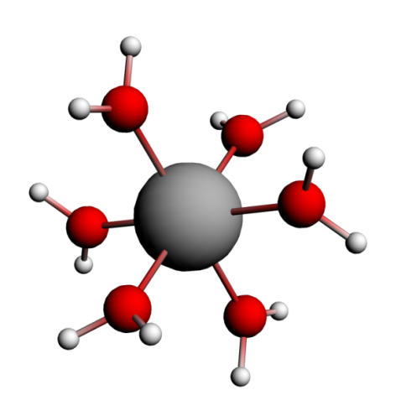
NMR Shielding ADF-GUI atom Mg(1): 565.19 ppm
Atom X Y Z (Angstrom)
1.Mg -0.601196 -0.290594 -0.013291
2.O -0.403127 1.763767 0.251771
3.O 1.461927 -0.512847 0.121515
4.O -0.824727 -2.339626 -0.290244
5.O -2.665571 -0.072523 -0.138345
6.O -0.747724 -0.562643 2.044678
7.O -0.442343 -0.012708 -2.069339
8.H -1.120238 2.425122 0.259987
9.H 0.430240 2.253351 0.384939
10.H 2.107671 -0.480298 -0.608851
11.H 1.969807 -0.679564 0.937730
12.H -1.668485 -2.813644 -0.412987
13.H -0.118827 -3.012373 -0.319958
14.H -3.305840 -0.092273 0.597344
15.H -3.180577 0.079707 -0.952947
16.H -0.885535 -1.409712 2.508488
17.H -0.726709 0.131204 2.730303
18.H -0.303141 0.837585 -2.526694
19.H -0.455677 -0.702873 -2.758784

Reference Standard – B3LYPD
NMR Shielding ADF-GUI atom Mg(1): 570.6 ppm
Atom X Y Z (Angstrom
1.Mg 0.765800 -1.373314 0.371222
2.H 3.423507 -1.025237 1.026535
3.H 1.268478 1.319728 0.031308
4.H -1.898743 -1.716813 -0.273024
5.H 0.931507 -1.828707 3.088214
6.H 1.804745 -3.912971 0.641154
7.H 0.755964 -2.454710 -2.165950
8.O 0.703924 -1.619393 -1.681791
9.H 0.604315 -0.920019 -2.342025
10.O 0.974064 -3.419106 0.611688
11.H 0.261893 -4.064536 0.716926
12.O 0.824247 -1.128960 2.429695
13.H 0.769730 -0.294894 2.915637
14.O -1.292613 -1.569867 0.465787
15.H -1.832892 -1.535894 1.266952
16.O 0.557500 0.672082 0.130623
17.H -0.274166 1.164474 0.102902
18.O 2.824003 -1.174956 0.282927
19.H 3.371503 -1.211588 -0.513247

Figure 3a: Mg(BH₄)₂DGM
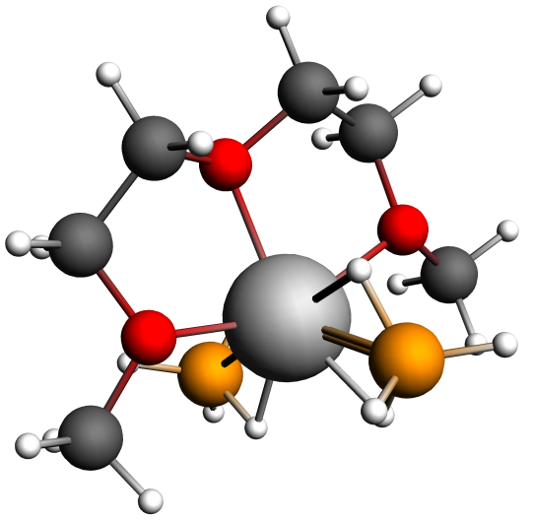
NMR Shielding ADF-GUI atom Mg(24): 543.63 ppm
Atom X Y Z (Angstrom)
1.O -0.207990 -0.337490 0.092692
2.C 1.047344 0.012610 -0.541268
3.C 2.129165 -0.365494 0.461240
4.O 1.873614 0.403698 1.657210
5.C 2.760778 0.065747 2.753197
6.C -1.402627 0.064549 -0.621849
7.C -2.560962 -0.233586 0.321373
8.O -2.308276 0.520530 1.525939
9.C -3.342631 0.374515 2.530775
10.H 1.062837 1.094110 -0.741861
11.H 1.166797 -0.554883 -1.475746
12.H 3.124951 -0.116202 0.064012
13.H 2.075216 -1.440355 0.695858
14.H 2.513504 0.754887 3.565371
15.H 3.804222 0.211603 2.439030
16.H 2.583125 -0.971862 3.068727
17.H -1.496086 -0.512995 -1.553121
18.H -1.348401 1.141510 -0.840403
19.H -2.602692 -1.307133 0.563521
20.H -3.511866 0.089538 -0.129374
21.H -4.306113 0.692711 2.107562
22.H -3.058087 1.033124 3.355438
23.H -3.379979 -0.667113 2.875384
24.Mg -0.245982 0.467392 2.105157
25.B -0.138760 2.869024 2.127923
26.H -0.142309 2.207051 1.069911
27.H -0.125707 2.090233 3.120936
28.H 0.885745 3.516982 2.173258
29.H -1.164064 3.515503 2.187824
30.B -0.474037 -1.518299 3.388456
31.H -1.523751 -1.831104 2.847545
32.H -0.180228 -2.218979 4.329237
33.H 0.434945 -1.553423 2.550660
34.H -0.587776 -0.350461 3.839753

Figure 3a: Mg(BH₄)₂DGM – B3LYPD
NMR Shielding ADF-GUI atom Mg(24): 543.63 ppm
Atom X Y Z (Angstrom
1.O -0.208029 -0.337599 0.092614
2.C 1.047840 0.010912 -0.541420
3.C 2.130385 -0.365202 0.461360
4.O 1.873605 0.404053 1.656957
5.C 2.759715 0.065220 2.753194
6.C -1.402696 0.065231 -0.621594
7.C -2.561255 -0.232432 0.321559
8.O -2.307843 0.520954 1.526491
9.C -3.341924 0.373086 2.531272
10.H 1.063251 1.092098 -0.743997
11.H 1.167329 -0.557972 -1.475043
12.H 3.126079 -0.115704 0.063945
13.H 2.077418 -1.439940 0.696752
14.H 2.512415 0.754119 3.565528
15.H 3.803293 0.210436 2.439862
16.H 2.581538 -0.972485 3.068014
17.H -1.496645 -0.512350 -1.552816
18.H -1.347829 1.142096 -0.840217
19.H -2.603537 -1.306076 0.563185
20.H -3.511835 0.091423 -0.129272
21.H -4.305467 0.691345 2.108255
22.H -3.057603 1.030728 3.356711
23.H -3.378736 -0.669144 2.874179
24.Mg -0.245924 0.467656 2.104893
25.B -0.139770 2.868942 2.127741
26.H -0.143706 2.207330 1.069558
27.H -0.126289 2.090494 3.121040
28.H 0.884476 3.517081 2.172160
29.H -1.165400 3.514849 2.187538
30.B -0.474426 -1.517605 3.388081
31.H -1.524148 -1.830047 2.847485
32.H -0.180748 -2.218322 4.328849
33.H 0.434229 -1.552793 2.550164
34.H -0.587876 -0.349841 3.839725

Table S3: Mg(BH₄)₂(DGM)₂
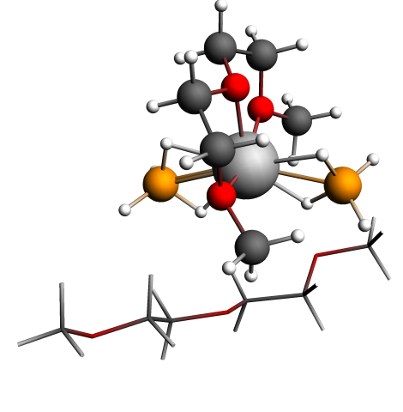
NMR Shielding ADF-GUI atom Mg(24): 538.99 ppm
Atom X Y Z (Angstrom)
1.O -0.116279 -0.235364 -0.093897
2.C 1.085621 0.515506 -0.401394
3.C 2.078689 0.151601 0.698848
4.O 1.484210 0.533082 1.962144
5.C 2.222285 0.040937 3.119963
6.C -1.290409 0.060458 -0.891901
7.C -2.438827 -0.685911 -0.215534
8.O -2.485014 -0.243107 1.158163
9.C -3.495534 -0.910796 1.963172
10.H 0.855170 1.590474 -0.381479
11.H 1.476128 0.219951 -1.386059
12.H 3.025902 0.693769 0.556834
13.H 2.264542 -0.933669 0.698549
14.H 1.674914 0.394908 3.997591
15.H 3.237070 0.461887 3.104601
16.H 2.237581 -1.055849 3.102482
17.H -1.149314 -0.300215 -1.921184
18.H -1.471249 1.144529 -0.881167
19.H -2.263483 -1.773063 -0.241057
20.H -3.389912 -0.449580 -0.716936
21.H -4.489614 -0.677225 1.556639
22.H -3.386882 -0.522178 2.980398
23.H -3.305458 -1.991691 1.966514
24.Mg -0.608716 0.190580 1.990362
25.B -1.104663 2.557707 2.056580
26.H -0.808170 2.000125 0.990746
27.H -0.993566 1.749749 3.008729
28.H -0.307331 3.446176 2.259389
29.H -2.263750 2.912956 2.006470
30.B -0.459472 -2.008230 3.056242
31.H -1.363358 -2.800395 2.872097
32.H 0.328209 -2.352755 3.912998
33.H 0.142269 -1.820071 1.994999
34.H -0.987129 -0.948756 3.464810
35.O 0.105392 1.637112 5.423753
36.C 0.365230 3.037043 5.202091
37.C 1.697109 3.136902 4.466550
38.O 2.094956 4.515149 4.442886
39.C 3.255039 4.702285 3.633714
40.C -1.270592 1.409177 5.783170
41.C -1.454624 -0.089780 6.053109
42.O -2.745401 -0.487385 5.547821
43.C -2.933628 -1.903189 5.690147
44.H 0.411187 3.573032 6.165403
45.H -0.423971 3.475236 4.574280
46.H 1.564509 2.761314 3.439060
47.H 2.463353 2.527747 4.982459
48.H 3.503493 5.769150 3.659960
49.H 3.063692 4.395025 2.588783
50.H 4.111652 4.117829 4.021392
51.H -1.925017 1.712232 4.950531
52.H -1.528262 2.015338 6.668612
53.H -1.397586 -0.316708 7.132993
54.H -0.661914 -0.649862 5.534579
55.H -2.180179 -2.455916 5.107166
56.H -3.936592 -2.132506 5.310955
57.H -2.870974 -2.203280 6.752134

Table S3: Mg(BH₄)₂(DGM)₂ – B3LYP
NMR Shielding ADF-GUI atom Mg(24): 543.1 ppm
Atom X Y Z (Angstrom)
1.O -0.151933 -0.299242 -0.097133
2.C 1.036725 0.415770 -0.443231
3.C 2.042554 0.085780 0.642280
4.O 1.482608 0.507051 1.885726
5.C 2.232110 0.087542 3.038086
6.C -1.327754 -0.022684 -0.862572
7.C -2.455911 -0.743533 -0.149880
8.O -2.469155 -0.271433 1.193779
9.C -3.478945 -0.856338 2.026685
10.H 0.826216 1.488540 -0.455986
11.H 1.407087 0.088012 -1.418330
12.H 2.984331 0.612694 0.460707
13.H 2.222168 -0.993770 0.670448
14.H 1.695757 0.464521 3.906732
15.H 3.234299 0.521770 2.997663
16.H 2.271776 -1.002584 3.073076
17.H -1.214939 -0.399978 -1.882540
18.H -1.511040 1.054759 -0.871314
19.H -2.283493 -1.824931 -0.155269
20.H -3.410519 -0.519047 -0.636122
21.H -4.465289 -0.592133 1.636963
22.H -3.338605 -0.447523 3.025910
23.H -3.344718 -1.939074 2.062571
24.Mg -0.588121 0.159353 1.970499
25.B -1.059308 2.507985 2.062467
26.H -0.784314 1.940944 1.000368
27.H -0.942767 1.706562 3.011931
28.H -0.252989 3.386104 2.250103
29.H -2.210846 2.872439 2.025197
30.B -0.428120 -2.011715 3.023348
31.H -1.330341 -2.795306 2.829764
32.H 0.369050 -2.379245 3.853685
33.H 0.154835 -1.797361 1.963695
34.H -0.944922 -0.967444 3.460323
35.O 0.117663 1.652947 5.441305
36.C 0.377204 3.035735 5.238059
37.C 1.718794 3.164733 4.546613
38.O 2.088645 4.531848 4.569205
39.C 3.227214 4.790034 3.780128
40.C -1.246129 1.416344 5.766996
41.C -1.447672 -0.076444 5.993868
42.O -2.719017 -0.437866 5.465474
43.C -2.957178 -1.830470 5.569362
44.H 0.397143 3.567230 6.197804
45.H -0.391210 3.477598 4.597784
46.H 1.621738 2.809168 3.513960
47.H 2.471281 2.553468 5.066277
48.H 3.440739 5.856314 3.850827
49.H 3.048385 4.526216 2.728874
50.H 4.099812 4.225005 4.138708
51.H -1.885315 1.736697 4.937738
52.H -1.522293 1.994919 6.657713
53.H -1.407348 -0.329323 7.061716
54.H -0.654262 -0.627387 5.480909
55.H -2.221941 -2.396407 4.988797
56.H -3.955467 -2.016819 5.172015
57.H -2.924940 -2.158538 6.616499

Table S1: Mg(BH₄)₂(DGM)₂₋₂
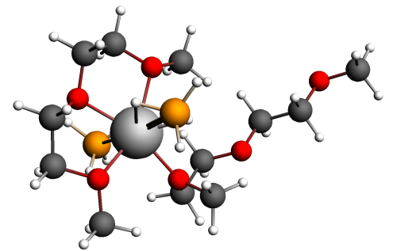
NMR Shielding ADF-GUI atom Mg(24): 564.64 ppm
Atom X Y Z (Angstrom)
1.O 0.324026 0.225345 0.606559
2.C 1.416529 1.170499 0.558188
3.C 2.155673 1.001946 1.878438
4.O 1.200725 1.318156 2.919044
5.C 1.742657 1.194754 4.248818
6.C -0.592058 0.268139 -0.507713
7.C -1.692054 -0.724699 -0.163838
8.O -2.267080 -0.318472 1.106535
9.C -3.308388 -1.227939 1.532364
10.H 1.009093 2.187953 0.463904
11.H 2.077504 0.932116 -0.288506
12.H 3.009018 1.695330 1.933486
13.H 2.489840 -0.040092 1.998405
14.H 0.918381 1.401174 4.938231
15.H 2.551196 1.926075 4.393773
16.H 2.119512 0.174096 4.410264
17.H -0.075908 -0.042698 -1.428744
18.H -0.993807 1.285971 -0.612346
19.H -1.272325 -1.735734 -0.052429
20.H -2.474521 -0.712254 -0.937662
21.H -4.081244 -1.287760 0.752238
22.H -3.730397 -0.814036 2.449730
23.H -2.877333 -2.220449 1.727614
24.Mg -0.721874 0.304587 2.498039
25.B -1.606909 2.716772 2.260918
26.H -1.088543 2.271418 1.240688
27.H -1.247826 2.037256 3.245621
28.H -1.186765 3.838445 2.476835
29.H -2.824524 2.658029 2.175671
30.B 0.404423 -2.153651 2.631779
31.H 1.263703 -2.296450 1.781285
32.H 0.442531 -3.005567 3.506678
33.H 0.596424 -1.063088 3.208602
34.H -0.717319 -2.133072 2.121127
35.O -0.696179 0.099240 6.709591
36.C 0.396808 0.453012 7.565384
37.C 0.050027 1.803303 8.189925
38.O 1.124922 2.182203 9.056356
39.C 0.855289 3.429540 9.706387
40.C -0.441472 -1.095928 5.956249
41.C -1.625135 -1.387197 5.045109
42.O -1.920315 -0.271988 4.147083
43.C -2.988033 0.595911 4.640517
44.H 1.333614 0.532740 6.987583
45.H 0.541412 -0.308097 8.351204
46.H -0.895023 1.718999 8.756249
47.H -0.092889 2.556062 7.393654
48.H 1.713633 3.651338 10.349321
49.H -0.059832 3.364658 10.322433
50.H 0.726282 4.242026 8.968912
51.H -0.302532 -1.962245 6.630063
52.H 0.467426 -0.985141 5.350169
53.H -2.527466 -1.598045 5.634995
54.H -1.367960 -2.242555 4.414176
55.H -3.886929 -0.017043 4.807231
56.H -3.162912 1.348906 3.869506
57.H -2.674494 1.069003 5.577397

Table S1: Mg(BH₄)₂(DGM)₂₋₂ – B3LYP
NMR Shielding ADF-GUI atom Mg(24): 570.7 ppm
Atom X Y Z (Angstrom)
1.O 0.370325 0.233324 0.688742
2.C 1.435118 1.180519 0.657003
3.C 2.097125 1.097594 2.014347
4.O 1.087331 1.417652 2.970654
5.C 1.527576 1.363680 4.322086
6.C -0.470226 0.191411 -0.458692
7.C -1.563662 -0.797173 -0.125792
8.O -2.193714 -0.341072 1.076049
9.C -3.274708 -1.176326 1.480354
10.H 1.026206 2.181058 0.489787
11.H 2.145304 0.917902 -0.132364
12.H 2.919028 1.816886 2.084172
13.H 2.457735 0.080056 2.193187
14.H 0.649866 1.528247 4.945985
15.H 2.270052 2.144668 4.508587
16.H 1.952817 0.380721 4.542450
17.H 0.097665 -0.151934 -1.328617
18.H -0.889917 1.183886 -0.642695
19.H -1.136837 -1.788548 0.050628
20.H -2.300924 -0.834381 -0.933521
21.H -4.012108 -1.238672 0.675471
22.H -3.720843 -0.713767 2.355634
23.H -2.902405 -2.172886 1.733662
24.Mg -0.761879 0.354652 2.505595
25.B -1.709886 2.669050 2.215855
26.H -1.134451 2.190837 1.244763
27.H -1.325326 2.095522 3.247725
28.H -1.388951 3.829481 2.342841
29.H -2.911183 2.504991 2.100054
30.B 0.416260 -2.054449 2.719605
31.H 1.267662 -2.193859 1.868072
32.H 0.480962 -2.883503 3.606467
33.H 0.578340 -0.953093 3.265261
34.H -0.704701 -2.074021 2.218617
35.O -0.751247 0.017706 6.726053
36.C 0.369425 0.346498 7.524549
37.C 0.121067 1.715458 8.124954
38.O 1.258461 2.066324 8.887644
39.C 1.117530 3.328571 9.508206
40.C -0.535908 -1.141138 5.936101
41.C -1.703254 -1.362217 5.003612
42.O -1.955461 -0.221840 4.156151
43.C -3.024506 0.607598 4.652749
44.H 1.282908 0.376507 6.917705
45.H 0.517361 -0.394624 8.320279
46.H -0.779983 1.689950 8.753139
47.H -0.049742 2.443509 7.319939
48.H 2.031928 3.520694 10.067754
49.H 0.261978 3.337814 10.196702
50.H 0.973669 4.123087 8.764071
51.H -0.432849 -2.034371 6.568658
52.H 0.376776 -1.039063 5.346796
53.H -2.612965 -1.576391 5.568625
54.H -1.458641 -2.198807 4.354000
55.H -3.932509 0.001622 4.733235
56.H -3.165969 1.412048 3.938631
57.H -2.755124 1.003416 5.631565

Figure 3b: Mg(BH₄)₂(DGM)₄
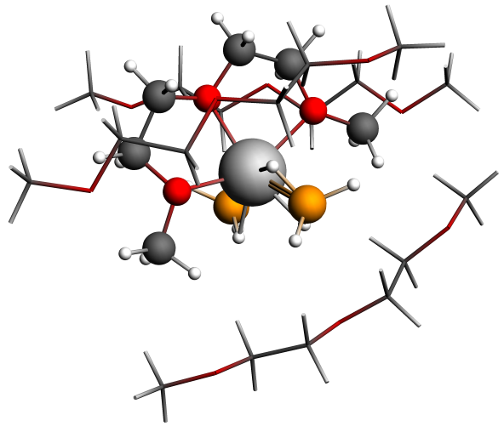
NMR Shielding ADF-GUI atom Mg(24): 547.11 ppm
Atom X Y Z (Angstrom)
1.O -0.927651 -0.475863 -0.201072
2.C 0.218965 -0.420280 -1.083808
3.C 1.443107 -0.535020 -0.187492
4.O 1.312038 0.502080 0.815747
5.C 2.428569 0.560616 1.741915
6.C -2.194607 -0.161757 -0.834125
7.C -3.231441 -0.159468 0.280543
8.O -2.736268 0.738735 1.294493
9.C -3.647364 0.906613 2.412805
10.H 0.206996 0.533138 -1.629387
11.H 0.182965 -1.262387 -1.790703
12.H 2.357397 -0.364552 -0.776873
13.H 1.486109 -1.522742 0.291825
14.H 2.247478 1.421755 2.388438
15.H 3.360998 0.703397 1.177386
16.H 2.485572 -0.363902 2.327099
17.H -2.436539 -0.932116 -1.581935
18.H -2.114217 0.826737 -1.306753
19.H -3.343271 -1.165537 0.713484
20.H -4.195588 0.210770 -0.095561
21.H -4.598821 1.301259 2.034661
22.H -3.185348 1.627056 3.091920
23.H -3.782072 -0.058063 2.920212
24.Mg -0.661774 0.486879 1.701651
25.B -0.328650 2.805643 2.105794
26.H -0.746589 2.353841 1.035958
27.H -0.230222 1.896514 2.951864
28.H 0.774214 3.274243 1.924645
29.H -1.146579 3.598466 2.519991
30.B -0.852635 -1.378480 3.061494
31.H -1.671292 -1.830960 2.275112
32.H -0.636938 -2.098387 4.005751
33.H 0.217752 -1.212007 2.449895
34.H -1.249597 -0.285493 3.484884
35.O -0.036124 1.785954 5.804296
36.C 1.142613 2.474994 5.364091
37.C 2.221839 1.407481 5.183241
38.O 3.353514 2.018289 4.539214
39.C 4.435786 1.092132 4.402578
40.C -1.239503 2.550965 5.640768
41.C -2.396045 1.564836 5.800377
42.O -3.617528 2.246404 5.456575
43.C -4.750720 1.392519 5.617157
44.H 1.457779 3.228569 6.107015
45.H 0.965380 2.976121 4.402317
46.H 1.818735 0.590348 4.561165
47.H 2.518995 0.981963 6.157885
48.H 5.234037 1.608560 3.856098
49.H 4.129025 0.189980 3.849231
50.H 4.815897 0.776233 5.391354
51.H -1.275348 3.000364 4.638459
52.H -1.300686 3.353766 6.396760
53.H -2.448546 1.189729 6.837762
54.H -2.231320 0.706196 5.128820
55.H -4.663257 0.490646 4.983998
56.H -5.635596 1.965750 5.318053
57.H -4.860203 1.067661 6.667694
58.O 1.774816 -3.609599 1.170736
59.C 2.594441 -3.228504 2.284736
60.C 3.878141 -2.640829 1.697119
61.O 4.598989 -1.991100 2.751829
62.C 5.791983 -1.370841 2.263597
63.C 0.509300 -4.187016 1.568119
64.C -0.465153 -3.904827 0.428657
65.O -1.673145 -4.643354 0.666382
66.C -2.703079 -4.245235 -0.234459
67.H 2.823257 -4.098690 2.921792
68.H 2.074235 -2.474422 2.896138
69.H 3.617725 -1.910319 0.912043
70.H 4.494623 -3.432013 1.236094
71.H 6.280169 -0.890963 3.117837
72.H 5.554655 -0.605352 1.501936
73.H 6.473196 -2.115660 1.816296
74.H 0.138056 -3.712809 2.484625
75.H 0.622900 -5.271268 1.729031
76.H -0.017729 -4.209381 -0.536901
77.H -0.680052 -2.826136 0.408839
78.H -2.943855 -3.173136 -0.109978
79.H -3.590212 -4.845830 -0.004673
80.H -2.407284 -4.419248 -1.287138
81.O -1.905724 3.248903 -1.414406
82.C -3.058279 3.501350 -0.586782
83.C -4.250078 2.797392 -1.243450
84.O -5.236951 2.516220 -0.235733
85.C -6.405336 1.921372 -0.805938
86.C -0.773791 4.081185 -1.058583
87.C 0.488921 3.274076 -1.342594
88.O 1.626433 4.129885 -1.167009
89.C 2.814320 3.377033 -0.907079
90.H -3.247716 4.584216 -0.514041
91.H -2.888640 3.101641 0.422446
92.H -3.913612 1.854372 -1.709069
93.H -4.690805 3.422744 -2.039105
94.H -7.108067 1.733822 0.013050
95.H -6.160533 0.965031 -1.306579
96.H -6.873351 2.591671 -1.547886
97.H -0.796689 4.324592 0.010033
98.H -0.791936 5.010063 -1.650695
99.H 0.466612 2.869407 -2.373630
100.H 0.530654 2.444670 -0.624907
101.H 2.698444 2.772335 0.007826
102.H 3.630227 4.096217 -0.775112
103.H 3.056872 2.706074 -1.754707

Figure 3b: Mg(BH₄)₂(DGM)₄-B3LYPD
NMR Shielding ADF-GUI atom Mg(24): 552.0 ppm
1.O -0.851089 -0.423964 -0.189667
2.C 0.274720 -0.415517 -1.067481
3.C 1.495752 -0.524689 -0.182491
4.O 1.385029 0.518639 0.786747
5.C 2.508384 0.612666 1.670141
6.C -2.112625 -0.122588 -0.794299
7.C -3.126249 -0.133826 0.328741
8.O -2.627465 0.743219 1.331341
9.C -3.533273 0.957675 2.421858
10.H 0.281621 0.515422 -1.639865
11.H 0.222947 -1.271053 -1.746596
12.H 2.402865 -0.384997 -0.778752
13.H 1.525460 -1.498947 0.311959
14.H 2.317854 1.445271 2.342103
15.H 3.413301 0.808994 1.088442
16.H 2.625688 -0.312826 2.236925
17.H -2.361149 -0.886368 -1.536951
18.H -2.054471 0.861963 -1.264314
19.H -3.227319 -1.140543 0.746669
20.H -4.092960 0.228609 -0.026416
21.H -4.459043 1.383812 2.030775
22.H -3.059442 1.662407 3.100438
23.H -3.715626 0.010804 2.935115
24.Mg -0.567140 0.519132 1.690040
25.B -0.314086 2.851357 2.026700
26.H -0.608642 2.360458 0.938769
27.H -0.108333 1.959033 2.865016
28.H 0.713725 3.470920 1.905205
29.H -1.249740 3.507182 2.417174
30.B -0.727881 -1.318262 3.060827
31.H -1.597260 -1.728381 2.313871
32.H -0.493003 -2.059134 3.976309
33.H 0.307106 -1.177826 2.398250
34.H -1.060693 -0.221072 3.515168
35.O 0.043131 1.912604 5.862067
36.C 1.211041 2.521478 5.339627
37.C 2.223831 1.409480 5.138119
38.O 3.368095 1.956231 4.500535
39.C 4.414541 1.013389 4.390993
40.C -1.161137 2.618606 5.615455
41.C -2.291643 1.625225 5.809438
42.O -3.509891 2.265867 5.455919
43.C -4.623074 1.419189 5.630798
44.H 1.606431 3.276775 6.030717
45.H 1.009645 2.999366 4.378081
46.H 1.773393 0.622983 4.519515
47.H 2.494291 0.963398 6.104127
48.H 5.215955 1.482518 3.819244
49.H 4.086240 0.100719 3.881637
50.H 4.797781 0.730994 5.380821
51.H -1.186665 2.997302 4.590475
52.H -1.273672 3.464772 6.305974
53.H -2.326509 1.282988 6.852355
54.H -2.112427 0.752609 5.170035
55.H -4.534179 0.511422 5.018647
56.H -5.509556 1.974022 5.324018
57.H -4.732805 1.114384 6.679886
58.O 1.684295 -3.620725 1.140728
59.C 2.462102 -3.314425 2.286701
60.C 3.788119 -2.761708 1.797671
61.O 4.445251 -2.162769 2.898670
62.C 5.702535 -1.625454 2.547148
63.C 0.416576 -4.190620 1.460715
64.C -0.519536 -3.879513 0.310027
65.O -1.721417 -4.601412 0.514389
66.C -2.730558 -4.224897 -0.390550
67.H 2.629045 -4.208671 2.898453
68.H 1.949712 -2.568029 2.901721
69.H 3.604877 -2.017112 1.012297
70.H 4.404261 -3.559896 1.363483
71.H 6.130934 -1.183615 3.445327
72.H 5.598433 -0.846610 1.779490
73.H 6.375570 -2.404103 2.167233
74.H 0.013609 -3.748375 2.373522
75.H 0.509896 -5.274872 1.592818
76.H -0.053252 -4.171928 -0.643042
77.H -0.716921 -2.802278 0.297553
78.H -2.976162 -3.157392 -0.289170
79.H -3.615560 -4.818253 -0.162054
80.H -2.430656 -4.415461 -1.431505
81.O -2.004759 3.236561 -1.509307
82.C -3.110485 3.398430 -0.628758
83.C -4.292101 2.660308 -1.237105
84.O -5.229424 2.385269 -0.208427
85.C -6.390577 1.749495 -0.697661
86.C -0.905724 4.092675 -1.188227
87.C 0.379500 3.366288 -1.538000
88.O 1.468925 4.257115 -1.361125
89.C 2.560668 3.673317 -0.671132
90.H -3.356793 4.459093 -0.507411
91.H -2.872224 2.983750 0.353763
92.H -3.945979 1.724221 -1.695217
93.H -4.759752 3.257805 -2.030089
94.H -7.053576 1.579186 0.149546
95.H -6.147824 0.784225 -1.165904
96.H -6.904674 2.371685 -1.440524
97.H -0.889952 4.317662 -0.121053
98.H -0.982023 5.028390 -1.752999
99.H 0.344582 3.009773 -2.576897
100.H 0.473488 2.508592 -0.868544
101.H 2.243272 3.289183 0.303792
102.H 3.307390 4.455211 -0.533078
103.H 3.007480 2.853922 -1.254029

Figure 3c: Mg(BH₄)₂(DGM)₆
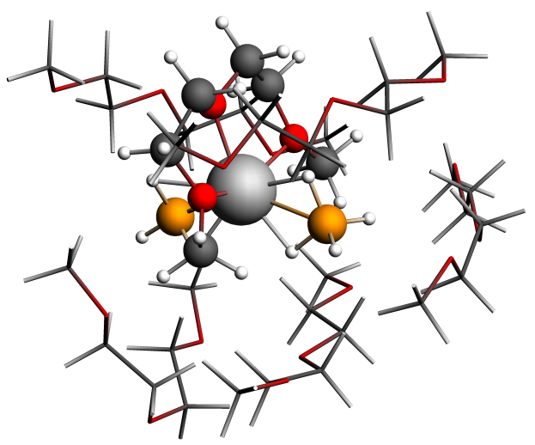
NMR Shielding ADF-GUI atom Mg(24): 551.93 ppm

Atom X Y Z (Angstrom)
1.O -1.321279 -0.593078 -0.311825
2.C -0.273498 -0.198161 -1.237264
3.C 1.038479 -0.273094 -0.464681
4.O 0.860215 0.538058 0.719070
5.C 2.073405 0.752686 1.494997
6.C -2.667025 -0.274225 -0.758286
7.C -3.603332 -0.587362 0.408554
8.O -3.051002 0.068803 1.564874
9.C -3.986853 0.517334 2.591661
10.H -0.471103 0.823751 -1.585092
11.H -0.254952 -0.893552 -2.089384
12.H 1.852986 0.139637 -1.079403
13.H 1.271803 -1.309098 -0.182213
14.H 1.782535 1.373802 2.343211
15.H 2.809786 1.291694 0.886114
16.H 2.476200 -0.204761 1.845716
17.H -2.921760 -0.892948 -1.632649
18.H -2.701286 0.792014 -1.017038
19.H -3.662960 -1.670916 0.591222
20.H -4.601510 -0.182622 0.192006
21.H -4.881321 0.922033 2.103889
22.H -3.468380 1.316128 3.127919
23.H -4.218522 -0.312690 3.267021
24.Mg -0.967487 0.058675 1.716620
25.B -1.069426 2.358934 2.278109
26.H -1.327305 1.959957 1.146509
27.H -0.941638 1.406498 3.075035
28.H -0.023342 2.956456 2.258870
29.H -2.005400 3.014812 2.664067
30.B -0.389717 -1.950988 2.685026
31.H -1.091491 -2.218443 1.716715
32.H -0.174054 -2.942402 3.331880
33.H 0.667091 -1.463275 2.298493
34.H -0.973454 -1.125598 3.400125
35.O -0.447781 1.476916 5.705708
36.C 0.836533 1.962049 5.274783
37.C 1.704340 0.726505 5.054345
38.O 3.024824 1.168307 4.683384
39.C 3.961160 0.080928 4.701804
40.C -1.456921 2.496424 5.694111
41.C -2.808607 1.795456 5.819951
42.O -3.829448 2.729879 5.429056
43.C -5.128510 2.139077 5.514323
44.H 1.285521 2.611064 6.045958
45.H 0.731659 2.538416 4.343723
46.H 1.270440 0.094327 4.260986
47.H 1.753436 0.125762 5.973851
48.H 4.952464 0.509300 4.513695
49.H 3.730678 -0.660379 3.923669
50.H 3.957089 -0.421612 5.682030
51.H -1.436946 3.036179 4.740527
52.H -1.295168 3.213157 6.517723
53.H -2.987577 1.439236 6.849592
54.H -2.821444 0.920719 5.153072
55.H -5.200022 1.241451 4.874925
56.H -5.849647 2.890316 5.173602
57.H -5.364650 1.844047 6.552599
58.O 1.974320 -3.558756 0.122885
59.C 2.829220 -3.304508 1.247885
60.C 3.908583 -2.330569 0.772057
61.O 4.548449 -1.776710 1.929471
62.C 5.473670 -0.743016 1.576503
63.C 0.811248 -4.345465 0.464882
64.C -0.279501 -3.944140 -0.524079
65.O -1.449183 -4.736550 -0.266315
66.C -2.560048 -4.273503 -1.030987
67.H 3.279212 -4.240790 1.619204
68.H 2.251801 -2.840764 2.060156
69.H 3.432215 -1.527198 0.185823
70.H 4.647722 -2.834298 0.124966
71.H 5.900619 -0.362419 2.508618
72.H 4.959911 0.082506 1.055630
73.H 6.278361 -1.132769 0.928686
74.H 0.473147 -4.109481 1.482096
75.H 1.041138 -5.420727 0.390488
76.H 0.066744 -4.099857 -1.563144
77.H -0.511970 -2.879924 -0.373379
78.H -2.800048 -3.223433 -0.781578
79.H -3.416123 -4.911956 -0.785567
80.H -2.356295 -4.338019 -2.116838
81.O -2.745343 3.169775 -1.017214
82.C -3.838889 3.141931 -0.081946
83.C -5.006420 2.460959 -0.799892
84.O -5.957659 2.014450 0.180690
85.C -7.095751 1.406730 -0.436784
86.C -1.690337 4.086885 -0.624301
87.C -0.380029 3.472535 -1.111247
88.O 0.650058 4.470574 -1.094522
89.C 1.913165 3.902795 -1.449205
90.H -4.118813 4.162472 0.219976
91.H -3.549439 2.582614 0.818336
92.H -4.634803 1.597619 -1.380421
93.H -5.488335 3.155847 -1.508792
94.H -7.770703 1.088727 0.364943
95.H -6.798064 0.527290 -1.038616
96.H -7.617776 2.119961 -1.097912
97.H -1.679438 4.211671 0.463605
98.H -1.855578 5.066932 -1.098115
99.H -0.516670 3.090710 -2.142528
100.H -0.103922 2.638779 -0.448975
101.H 2.206451 3.110081 -0.739416
102.H 2.655742 4.705804 -1.409179
103.H 1.881374 3.478235 -2.470249
104.O 1.554605 5.129262 2.801876
105.C 2.403800 4.480797 1.850756
106.C 3.591443 3.900080 2.608793
107.O 4.420617 3.199215 1.651276
108.C 5.606393 2.700391 2.274719
109.C 0.366177 5.653979 2.173506
110.C -0.747757 5.674556 3.215111
111.O -1.984146 5.924751 2.524318
112.C -3.108802 5.700816 3.386220
113.H 2.750437 5.191404 1.080366
114.H 1.849091 3.674241 1.347970
115.H 3.249098 3.203261 3.388502
116.H 4.172372 4.709696 3.084070
117.H 6.185242 2.176072 1.505772
118.H 5.359249 2.001588 3.089555
119.H 6.212300 3.525674 2.690209
120.H 0.059441 4.996798 1.353193
121.H 0.566011 6.657280 1.762021
122.H -0.576325 6.447331 3.986444
123.H -0.777662 4.687752 3.694581
124.H -3.125411 4.662962 3.755719
125.H -4.011045 5.897023 2.794334
126.H -3.087095 6.388858 4.251476
127.O -1.383297 -2.026922 7.539874
128.C 0.028070 -1.758964 7.415614
129.C 0.642717 -2.490742 6.216527
130.O 2.076168 -2.387317 6.284819
131.C 2.674572 -2.979285 5.124841
132.C -2.176062 -1.521230 6.442808
133.C -2.541580 -2.653238 5.475515
134.O -3.509193 -2.141050 4.532926
135.C -3.716896 -3.055263 3.449438
136.H 0.484936 -2.118455 8.345230
137.H 0.197843 -0.675562 7.316573
138.H 0.282999 -2.050681 5.276199
139.H 0.337124 -3.553006 6.236909
140.H 3.758759 -2.860074 5.216394
141.H 2.327594 -2.482321 4.206152
142.H 2.423297 -4.053515 5.057604
143.H -1.638947 -0.726277 5.910141
144.H -3.096522 -1.100228 6.870709
145.H -2.974783 -3.499497 6.037394
146.H -1.649966 -2.997992 4.935094
147.H -2.780056 -3.229824 2.898086
148.H -4.456870 -2.597351 2.780134
149.H -4.113563 -4.019870 3.814877

Table 2: Mg(BH₄)₂(DGM)₇
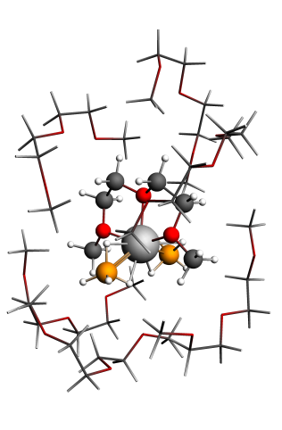
NMR Shielding ADF-GUI atom Mg(24): 550.1 ppm

Atom X Y Z (Angstrom)
1.O -0.086073 -0.895398 0.604581
2.C 1.135778 -0.834696 -0.182822
3.C 2.284830 -0.941492 0.800912
4.O 2.030571 0.057237 1.821101
5.C 3.145211 0.255087 2.731356
6.C -1.295298 -0.602237 -0.152408
7.C -2.423260 -0.542303 0.863529
8.O -2.011741 0.388701 1.893051
9.C -3.011910 0.568394 2.935881
10.H 1.180423 0.127420 -0.712606
11.H 1.162383 -1.661492 -0.897978
12.H 3.227830 -0.728230 0.285432
13.H 2.318747 -1.935943 1.270001
14.H 2.840958 1.029097 3.433988
15.H 4.018325 0.590841 2.154491
16.H 3.370007 -0.671393 3.270304
17.H -1.477119 -1.391132 -0.888234
18.H -1.187111 0.363849 -0.659945
19.H -2.594416 -1.526871 1.324823
20.H -3.341981 -0.192703 0.378047
21.H -3.924244 0.987778 2.495906
22.H -2.599765 1.279431 3.651334
23.H -3.207716 -0.391934 3.425977
24.Mg 0.020157 0.211377 2.425755
25.B 0.236541 2.607611 2.442158
26.H 0.064600 1.964481 1.403935
27.H 0.506961 1.861577 3.396279
28.H 1.187934 3.331458 2.258639
29.H -0.781474 3.201058 2.706698
30.B -0.417803 -1.503392 4.015982
31.H -1.397194 -1.884505 3.400138
32.H -0.261293 -2.104329 5.056921
33.H 0.587657 -1.648973 3.314898
34.H -0.555683 -0.304366 4.297641
35.O -0.276551 -4.590235 0.426291
36.C -0.361021 -4.423492 -4.538599
37.H -0.696673 -6.505652 -4.009019
38.H 0.899434 -5.848095 -3.519746
39.H -1.374520 -4.004408 -4.401046
40.H -0.267282 -4.787034 -5.570914
41.C -0.882325 -5.824576 0.045929
42.H -0.452850 -1.904514 -3.409733
43.H 1.330706 -1.914902 -3.184219
44.H 0.314674 -3.112344 -2.329091
45.C -0.178234 -5.618002 -3.595442
46.C 0.436511 -2.540513 -3.258303
47.H 0.775653 -6.318853 -1.249957
48.C -0.751334 -4.112509 1.696642
49.O 0.641031 -3.411243 -4.391653
50.O -0.712629 -5.304598 -2.299584
51.C -0.326183 -6.256775 -1.302813
52.H -0.720000 -7.260583 -1.551593
53.H -0.662331 -6.612759 0.791617
54.H -1.979744 -5.711170 -0.019420
55.H -0.272571 -3.152581 1.889941
56.H -0.504178 -4.825352 2.502738
57.H -1.843942 -3.966634 1.675034
58.O -4.127151 -0.035816 5.990176
59.C -3.533023 4.450031 3.516921
60.H -3.608637 4.872035 5.629066
61.H -5.091405 4.092000 4.979250
62.H -2.457593 4.240232 3.428304
63.H -3.688638 5.530509 3.336541
64.C -3.351361 0.925015 6.719139
65.H -3.444292 4.523854 0.838304
66.H -4.241884 2.930460 0.666198
67.H -2.634130 3.043966 1.450708
68.C -3.987659 4.105397 4.926114
69.C -3.606110 3.539775 1.316734
70.H -5.034762 2.275227 6.525180
71.C -3.495110 -1.324510 6.016603
72.O -4.290112 3.674919 2.571646
73.O -3.456770 2.821603 5.267075
74.C -3.930620 2.317932 6.513828
75.H -3.601048 2.977021 7.341216
76.H -3.362790 0.674966 7.798598
77.H -2.308567 0.919089 6.366445
78.H -4.138288 -2.008009 5.450563
79.H -3.399493 -1.694399 7.055547
80.H -2.497547 -1.292495 5.554369
81.O -1.959331 2.536960 -1.368887
82.C -3.530169 -2.205243 -2.722766
83.H -3.905595 -0.830733 -4.339785
84.H -4.820301 -0.479337 -2.838618
85.H -2.467926 -2.436642 -2.907591
86.H -4.142723 -2.943702 -3.274693
87.C -1.952947 2.358788 -2.787195
88.H -3.803939 -4.375273 -1.230856
89.H -3.613695 -3.479345 0.312982
90.H -2.246333 -3.582630 -0.844945
91.C -3.843116 -0.808187 -3.234961
92.C -3.339148 -3.497759 -0.746635
93.H -4.034087 1.782574 -2.723534
94.C -0.887219 3.390220 -0.938160
95.O -3.821590 -2.274906 -1.322055
96.O -2.807032 0.093548 -2.823608
97.C -3.096887 1.445752 -3.201522
98.H -3.222477 1.511415 -4.299406
99.H -2.080838 3.335112 -3.294087
100.H -0.991434 1.923228 -3.118088
101.H -0.932963 3.443232 0.151244
102.H -0.991997 4.398914 -1.378308
103.H 0.090904 2.973904 -1.234574
104.O 4.173165 2.414091 4.934415
105.C 2.866073 -2.665042 5.526673
106.H 3.149406 -1.675097 7.407226
107.H 4.624044 -1.734851 6.390564
108.H 1.815542 -2.396462 5.339565
109.H 2.897637 -3.621408 6.084569
110.C 3.330570 2.107026 6.061750
111.H 2.819987 -4.729007 3.832106
112.H 3.444503 -3.749858 2.463418
113.H 1.853364 -3.355011 3.196609
114.C 3.528440 -1.585652 6.369406
115.C 2.875169 -3.711858 3.399622
116.H 4.839218 0.690489 6.703656
117.C 3.677654 3.555766 4.219092
118.O 3.567955 -2.816485 4.276897
119.O 3.207301 -0.296938 5.844234
120.C 3.737547 0.764473 6.648067
121.H 3.332402 0.687021 7.675782
122.H 3.445032 2.890091 6.834794
123.H 2.272135 2.080401 5.763320
124.H 4.357523 3.720106 3.374057
125.H 3.666534 4.453033 4.863976
126.H 2.656931 3.382202 3.847670
127.C 4.706109 -2.943923 -1.593008
128.O 3.347907 1.766569 -0.849580
129.H 6.224958 -1.764367 -2.568381
130.H 4.557835 -1.478468 -3.164665
131.H 5.179587 -3.037832 -0.598245
132.H 5.018959 -3.806780 -2.211644
133.C 4.770360 1.788847 -0.975218
134.H 3.030147 -4.998331 -1.343498
135.H 1.696409 -3.975221 -0.711691
136.H 3.207347 -4.151643 0.229435
137.C 5.167049 -1.658465 -2.260993
138.C 2.781318 -4.075204 -0.787189
139.H 4.594435 0.778939 -2.871074
140.C 2.886272 2.702274 0.139015
141.O 3.281290 -2.919722 -1.465046
142.O 5.019360 -0.575023 -1.338538
143.C 5.202592 0.706848 -1.951565
144.H 6.265229 0.855876 -2.221978
145.H 5.111012 2.772744 -1.353515
146.H 5.246465 1.614662 0.007476
147.H 1.807216 2.581599 0.233228
148.H 3.128548 3.739541 -0.159260
149.H 3.337809 2.496488 1.121241
150.C -0.405448 4.052229 5.971516
151.O -0.008692 1.674966 6.222160
152.C 0.821490 5.964553 3.814837
153.H 2.065235 6.211590 5.537808
154.H 0.333915 6.573962 5.827839
155.H 1.274934 5.089278 3.327363
156.H 1.312458 6.884897 3.436392
157.C -0.402257 2.861921 6.922471
158.H -0.331070 6.934877 1.643705
159.H -1.885106 6.081657 1.939548
160.H -0.399680 5.132215 1.631346
161.C 1.038763 5.882828 5.327442
162.C -0.802988 6.042909 2.097825
163.H -0.766931 3.751466 4.979530
164.C 0.249672 0.581588 7.105496
165.O -0.584518 6.020766 3.514236
166.O 0.942601 4.573996 5.896622
167.H -1.076646 4.833978 6.371811
168.H -1.411234 2.724781 7.347821
169.H 0.298522 3.065310 7.753900
170.H 0.514138 -0.273669 6.478487
171.H -0.643023 0.339478 7.711180
172.H 1.083260 0.820927 7.790714

Figure 4a:MgDGM₂TFSI-6
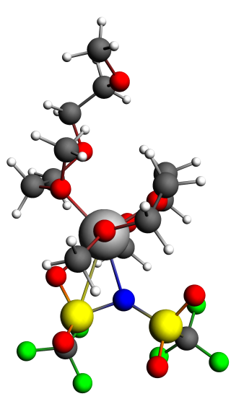
NMR Shielding ADF-GUI atom Mg(24): 564.96 ppm
Atom X Y Z (Angstrom)
1.O 1.301156 -0.196176 0.675857
2.C 2.742038 -0.147526 0.517352
3.C 3.312077 -0.175933 1.932578
5.C 3.156420 1.062696 4.021673
6.C 0.499135 -0.027075 -0.532433
7.C -0.915550 -0.404887 -0.113388
8.O -1.187854 0.251093 1.159982
9.C -2.507289 -0.081474 1.675483
10.H 3.018478 0.771183 -0.019014
11.H 3.083733 -1.022396 -0.052391
12.H 4.370572 0.119644 1.922149
13.H 3.195989 -1.168083 2.386273
14.H 2.513427 1.790394 4.522420
15.H 4.161788 1.475996 3.866001
16.H 3.205734 0.138074 4.610228
17.H 0.858078 -0.708155 -1.315158
18.H 0.563957 1.012785 -0.878627
19.H -1.006293 -1.490276 0.033668
20.H -1.640557 -0.055181 -0.859983
21.H -3.267317 0.256178 0.958584
22.H -2.615323 0.447509 2.624036
23.H -2.582231 -1.162348 1.836872
24.Mg 0.463805 0.745661 2.332201
25.N -0.013059 -0.884056 3.803780
26.S 0.519072 -2.460336 3.966787
27.S -0.185206 0.187629 5.016827
28.C -1.112340 -3.438537 3.664923
29.C -1.900954 -0.029567 5.871904
30.O -0.331029 1.438336 4.192776
31.O 0.780433 0.175331 6.095455
32.O 1.343750 -2.717266 2.792618
33.O 0.946624 -2.795084 5.310816
34.F -2.126534 1.065883 6.623201
35.F -0.877270 -4.746892 3.857752
36.F -1.542664 -3.239983 2.383981
37.F -2.072030 -3.009979 4.520012
38.F -1.869372 -1.128230 6.641990
39.F -2.879315 -0.144274 4.936012
40.C -1.776213 3.270682 0.977073
41.C -0.579851 3.679751 1.854007
42.O 0.542137 2.740498 1.744356
43.C 1.549716 3.163505 0.774883
44.H -2.288028 2.418227 1.427458
45.H -2.484527 4.116553 0.946947
46.H -0.881590 3.680993 2.908322
47.H -0.204130 4.675965 1.590288
48.H 1.787803 4.221515 0.945041
49.H 1.181565 3.010420 -0.245595
50.H 2.438280 2.562247 0.975794
51.O -1.399482 2.854683 -0.342897
52.C -1.251400 3.940326 -1.285182
53.C -0.773557 3.344329 -2.607338
54.H -0.524335 4.682069 -0.913475
55.H -2.221726 4.445266 -1.427738
56.H -1.388484 2.468161 -2.850976
57.O 0.592638 2.882415 -2.545176
58.C 1.538132 3.944113 -2.791350
59.H -0.889839 4.090713 -3.410284
60.H 1.459711 4.740018 -2.030869
61.H 1.371633 4.385385 -3.787049
62.H 2.537828 3.498356 -2.750731

Figure 4b:MgDGM₂TFSI-3
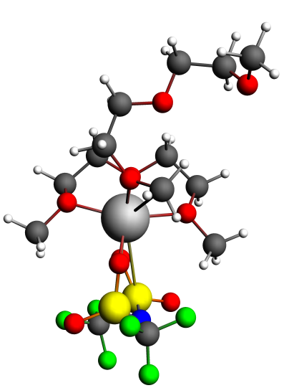
NMR Shielding ADF-GUI atom Mg(24): 570.50 ppm
Atom X Y Z (Angstrom)
1.O -0.067472 -0.127589 0.216407
2.C 1.071581 0.229093 -0.618004
3.C 2.225262 0.416260 0.361790
4.O 1.773362 1.331374 1.399639
5.C 2.799870 1.582995 2.404592
6.C -1.296570 -0.522407 -0.435173
7.C -2.329737 -0.628003 0.680923
8.O -2.312031 0.637428 1.407480
9.C -3.243480 0.632672 2.536493
10.H 0.854516 1.160986 -1.158988
11.H 1.297455 -0.587159 -1.317201
12.H 3.095115 0.848633 -0.153092
13.H 2.502102 -0.539723 0.829489
14.H 2.358210 2.256144 3.142476
15.H 3.665133 2.059004 1.925811
16.H 3.090265 0.641586 2.887441
17.H -1.168254 -1.493474 -0.932887
18.H -1.588338 0.235019 -1.174612
19.H -2.067177 -1.437845 1.376557
20.H -3.331891 -0.800627 0.264610
21.H -4.267225 0.516789 2.159552
22.H -3.124317 1.592102 3.044730
23.H -2.988868 -0.186395 3.221016
24.Mg -0.312548 1.265363 1.771470
25.N 0.562538 1.048298 5.194898
26.S -0.514404 2.186923 4.845450
27.S 0.573313 -0.363620 4.442593
28.C 0.434815 3.678021 5.574601
29.C -0.561850 -1.493320 5.492369
30.O 1.891757 -0.961245 4.474224
31.O -0.142169 -0.323671 3.128885
32.O -0.543889 2.502136 3.374962
33.O -1.809107 2.119901 5.496707
34.F -0.553173 -2.737028 4.968246
35.F -0.308942 4.782184 5.362904
36.F 1.623615 3.817829 4.935820
37.F 0.638058 3.502592 6.884572
38.F -1.826547 -1.005246 5.462118
39.F -0.118038 -1.524781 6.755965
40.C -1.084795 3.018807 -1.849517
41.C -1.506033 3.331699 -0.402251
42.O -0.505169 2.958856 0.584778
43.C 0.423467 4.055817 0.901893
44.H -1.244983 1.952811 -2.092204
45.H -1.733953 3.607161 -2.522669
46.H -2.415377 2.770245 -0.158174
47.H -1.706770 4.404846 -0.291748
48.H -0.162169 4.930075 1.214226
49.H 1.037697 4.280408 0.025418
50.H 1.037749 3.712863 1.734985
51.O 0.289614 3.344085 -2.025126
52.C 0.709918 3.353004 -3.402862
53.C 2.241807 3.365031 -3.443624
54.H 0.282422 4.231501 -3.912465
55.H 0.353557 2.444715 -3.922448
56.H 2.619625 2.456295 -2.956452
57.O 2.845824 4.455561 -2.749081
58.C 2.659512 5.720902 -3.409794
59.H 2.552470 3.352217 -4.505253
60.H 1.600333 6.026884 -3.411504
61.H 3.024548 5.676261 -4.450519
62.H 3.245304 6.455373 -2.847929

Figure 4c:MgDGM₂TFSI5
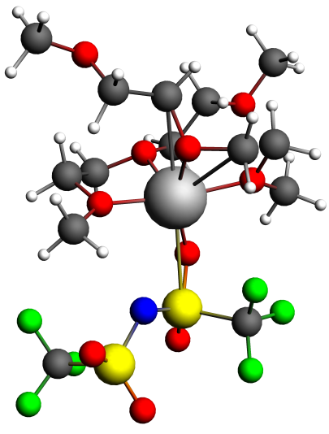
NMR Shielding ADF-GUI atom Mg(24): 565.48 ppm
Atom X Y Z (Angstrom)
1.O -1.184914 -1.350315 0.261954
2.C 0.122129 -1.855812 -0.175413
3.C 0.837889 -2.343021 1.076050
4.O 0.794148 -1.249132 2.037590
5.C 1.829313 -1.300354 3.068687
6.C -2.044523 -0.881056 -0.832316
7.C -3.493157 -1.167908 -0.430773
8.O -4.319926 -0.370076 -1.268785
9.C -5.718566 -0.664473 -1.089319
10.H 0.673144 -1.035585 -0.654266
11.H -0.029983 -2.679812 -0.883056
12.H 1.882841 -2.577320 0.834305
13.H 0.336000 -3.222027 1.506673
14.H 1.731997 -0.391727 3.664127
15.H 2.812000 -1.308960 2.589546
16.H 1.690378 -2.197147 3.686563
17.H -1.778916 -1.417897 -1.749158
18.H -1.880407 0.192710 -0.981897
19.H -3.643448 -0.903258 0.632878
20.H -3.718761 -2.241791 -0.546539
21.H -5.930772 -1.718132 -1.330272
22.H -6.269099 -0.009925 -1.770714
23.H -6.029627 -0.463544 -0.048430
24.Mg -0.812329 0.005608 1.810085
25.O -1.711780 -0.832157 3.555041
26.C -2.267898 -2.174193 3.264534
27.C -1.302709 -3.239489 3.792648
28.O -1.481517 -4.391241 2.967470
29.C -0.779259 -5.539064 3.486989
30.C -2.676253 0.120611 4.104010
31.C -3.542425 0.674107 2.978367
32.O -2.621829 1.055508 1.925489
33.C -3.211493 1.952860 0.928069
34.H -2.373799 -2.286287 2.179526
35.H -3.254558 -2.254904 3.733432
36.H -1.514276 -3.472398 4.849919
37.H -0.270383 -2.864128 3.726737
38.H -0.971052 -6.365000 2.796214
39.H -1.148492 -5.799774 4.491328
40.H 0.305157 -5.343070 3.541871
41.H -2.073574 0.918703 4.550772
42.H -3.282731 -0.364372 4.878244
43.H -4.102464 1.553862 3.324272
44.H -4.247546 -0.077308 2.590790
45.H -4.004515 1.426627 0.383456
46.H -2.404218 2.231857 0.252301
47.H -3.599672 2.841900 1.438622
48.N 1.851526 1.606224 1.909651
49.S 3.396508 2.060546 2.323146
50.S 0.968580 2.374650 0.844602
51.C 4.420263 1.153587 0.967106
52.C 0.034323 3.721317 1.842867
53.O -0.167889 1.413837 0.567361
54.O 1.533827 3.033872 -0.311291
55.O 3.669635 3.474395 2.150357
56.O 3.693224 1.348102 3.555172
57.F -0.926735 4.284772 1.071750
58.F 5.727358 1.390267 1.168222
59.F 4.063823 1.566482 -0.265038
60.F 4.199880 -0.195831 1.047083
61.F 0.874732 4.657761 2.284960
62.F -0.581172 3.120852 2.915878

Figure 4d:MgDGM₂TFSI4
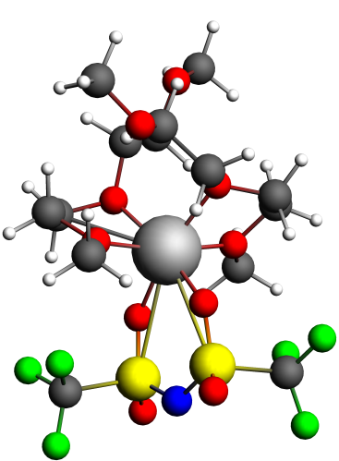
NMR Shielding ADF-GUI atom Mg(24): 571.55 ppm
Atom X Y Z (Angstrom)
1.O -1.355800 -1.532931 0.043156
2.C -0.078683 -2.043499 -0.449524
3.C 0.682207 -2.554959 0.763479
4.O 0.670031 -1.491851 1.751189
5.C 1.635126 -1.676687 2.823684
6.C -2.257856 -1.080762 -1.022316
7.C -3.686674 -1.415333 -0.591428
8.O -4.559492 -0.638597 -1.405225
9.C -5.943513 -0.950043 -1.157058
10.H 0.465044 -1.228656 -0.944378
11.H -0.261730 -2.861241 -1.158326
12.H 1.717794 -2.788459 0.479264
13.H 0.202648 -3.447742 1.192287
14.H 1.491342 -0.848806 3.519698
15.H 2.648854 -1.654681 2.404760
16.H 1.451971 -2.635971 3.326787
17.H -2.000281 -1.597917 -1.953211
18.H -2.135109 -0.001241 -1.166103
19.H -3.819557 -1.163666 0.474683
20.H -3.882982 -2.494907 -0.710820
21.H -6.151071 -2.010882 -1.370016
22.H -6.535846 -0.315913 -1.822631
23.H -6.209164 -0.736004 -0.106299
24.Mg -0.924849 -0.147300 1.627692
25.O -2.059783 -1.068793 3.165641
26.C -2.629145 -2.403423 2.944029
27.C -1.682801 -3.425940 3.574088
28.O -2.102838 -4.706409 3.117424
29.C -1.398607 -5.775757 3.777400
30.C -2.969290 -0.055668 3.694110
31.C -3.722964 0.614708 2.547124
32.O -2.736009 0.934866 1.535450
33.C -3.235244 1.843348 0.506444
34.H -2.714996 -2.581371 1.866689
35.H -3.623127 -2.457994 3.402783
36.H -1.724214 -3.355367 4.675511
37.H -0.646279 -3.211201 3.259309
38.H -1.790160 -6.711979 3.369543
39.H -1.569985 -5.742623 4.865857
40.H -0.313958 -5.710385 3.582076
41.H -2.324789 0.669409 4.199808
42.H -3.662939 -0.507357 4.413126
43.H -4.203226 1.537741 2.902924
44.H -4.489240 -0.046159 2.113104
45.H -4.023632 1.345850 -0.072461
46.H -2.385127 2.079703 -0.135306
47.H -3.609524 2.756267 0.984930
48.N 1.173471 2.821999 1.603836
49.S 0.712041 2.313948 3.042155
50.S 0.839889 2.203729 0.177294
51.C -0.647035 3.584793 3.481313
52.C 2.469695 1.304444 -0.259879
53.O 0.625000 3.209429 -0.836107
54.O -0.129948 1.062320 0.191298
55.O -0.056715 1.030333 3.041353
56.O 1.748397 2.437642 4.039676
57.F 2.278981 0.595483 -1.401252
58.F -1.223885 3.222379 4.652821
59.F -1.599205 3.566673 2.507060
60.F -0.135103 4.814252 3.583819
61.F 2.781865 0.433614 0.739627
62.F 3.468488 2.175264 -0.424409

Figure 5:MgDGM₄TFSI
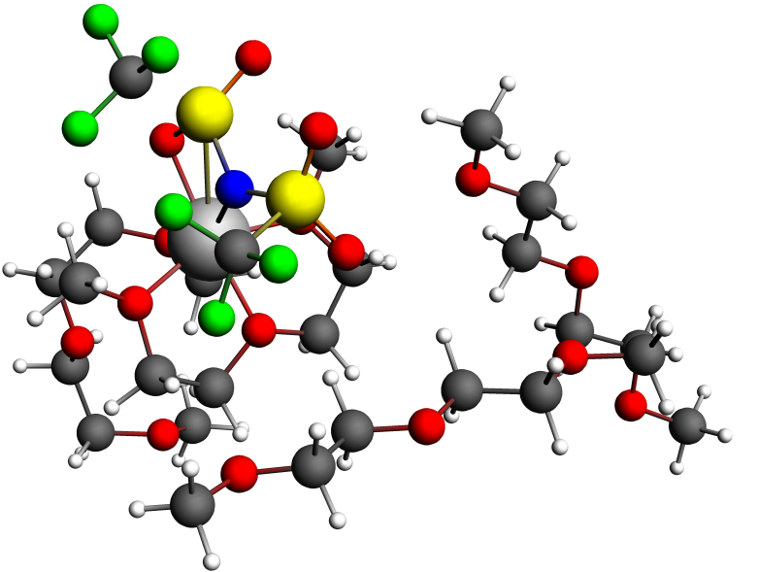
NMR Shielding ADF-GUI atom Mg(24): 563.97 ppm
Atom X Y Z (Angstrom)
1.O -0.110749 0.235455 2.572533
2.C 0.231148 0.562746 3.946820
3.C -0.736876 -0.224678 4.820074
4.O -2.075791 -0.030176 4.253868
5.C -3.138001 -0.566252 5.105353
6.C 0.584347 1.002473 1.538594
7.C 0.160268 0.372966 0.220127
8.O -1.286416 0.144008 0.267310
9.C -1.759492 -0.555712 -0.914970
10.H 0.133689 1.647759 4.088083
11.H 1.263323 0.254271 4.151658
12.H -0.722121 0.149539 5.850717
13.H -0.506471 -1.293528 4.829729
14.H -4.078667 -0.359500 4.588769
15.H -3.103656 -0.060813 6.077911
16.H -2.997848 -1.642215 5.245602
17.H 1.667888 0.883209 1.660338
18.H 0.295791 2.059012 1.613616
19.H 0.666736 -0.587031 0.078745
20.H 0.380744 1.055795 -0.611049
21.H -1.474544 0.014329 -1.809678
22.H -2.846672 -0.609993 -0.832990
23.H -1.331168 -1.563906 -0.951132
24.Mg -2.117207 -0.061335 2.159194
25.N -2.269094 -2.305405 2.015531
26.S -1.357187 -3.622372 2.466601
27.S -3.894114 -2.261757 2.037500
28.C -0.545431 -4.045208 0.773834
29.C -4.604100 -3.162772 0.480809
30.O -4.090604 -0.797525 1.758554
31.O -4.578245 -2.858155 3.165194
32.O -0.261170 -3.131437 3.290233
33.O -2.152773 -4.774898 2.843731
34.F -5.927471 -2.916030 0.427745
35.F 0.189861 -5.164314 0.905049
36.F 0.267737 -3.019260 0.381088
37.F -1.499000 -4.227593 -0.174635
38.F -4.375629 -4.480804 0.595112
39.F -4.012261 -2.690665 -0.646974
40.C -2.981371 2.687100 -0.172158
41.C -3.721937 2.477621 1.164846
42.O -2.879110 1.879276 2.202222
43.C -2.192974 2.867543 3.032479
44.H -2.872707 1.731637 -0.688251
45.H -3.600019 3.351318 -0.801099
46.H -4.559151 1.785717 1.012593
47.H -4.113576 3.422086 1.563079
48.H -2.892564 3.676784 3.278296
49.H -1.320452 3.262755 2.502813
50.H -1.907268 2.350500 3.949939
51.O -1.651857 3.199780 -0.023647
52.C -1.578163 4.630282 0.155393
53.C -0.102825 4.997074 0.299307
54.H -2.141795 4.942064 1.050971
55.H -2.008961 5.141664 -0.722232
56.H 0.466492 4.518978 -0.508096
57.O 0.465940 4.520606 1.538068
58.C 0.264050 5.441727 2.627348
59.H 0.015740 6.090091 0.217412
60.H -0.809207 5.596083 2.834227
61.H 0.727650 6.415703 2.402740
62.H 0.744857 5.003177 3.508840
63.O 3.226170 -2.404695 3.848519
64.C 2.682022 -1.965613 5.098907
65.C 3.325238 -2.776857 6.221424
66.O 2.754062 -2.294247 7.443012
67.C 3.276875 -2.971125 8.599147
68.C 2.735324 -1.613450 2.764065
69.C 3.258030 -2.210984 1.462356
70.O 2.824424 -1.341617 0.398693
71.C 3.202595 -1.857397 -0.890297
72.H 1.587595 -2.108019 5.111253
73.H 2.902284 -0.892021 5.256395
74.H 4.420057 -2.635287 6.215172
75.H 3.112262 -3.851815 6.086288
76.H 2.744854 -2.558525 9.461843
77.H 4.361568 -2.794903 8.698796
78.H 3.096774 -4.058050 8.530264
79.H 3.094022 -0.569556 2.862477
80.H 1.634583 -1.611442 2.754579
81.H 2.848063 -3.224703 1.320765
82.H 4.358686 -2.275785 1.481613
83.H 4.298117 -1.953626 -0.968730
84.H 2.845275 -1.143259 -1.641338
85.H 2.741277 -2.844179 -1.065279
86.O 0.844735 -0.824878 9.447651
87.C 1.764247 0.281243 9.427417
88.C 2.550431 0.270786 10.737037
89.O 3.491952 1.346532 10.666765
90.C 4.301376 1.420429 11.851844
91.C 0.112157 -0.924577 8.224458
92.C -0.491205 -2.325705 8.152561
93.O -1.227981 -2.421287 6.917236
94.C -1.752771 -3.746581 6.717799
95.H 1.218843 1.236359 9.324919
96.H 2.457303 0.170819 8.576717
97.H 3.072930 -0.696341 10.853687
98.H 1.868886 0.399473 11.597196
99.H 4.992570 2.259503 11.716207
100.H 4.874902 0.487249 11.994897
101.H 3.676696 1.595395 12.745601
102.H 0.790587 -0.788007 7.367219
103.H -0.682730 -0.153950 8.186871
104.H -1.157812 -2.508275 9.012685
105.H 0.325035 -3.064745 8.165052
106.H -0.937714 -4.488486 6.692122
107.H -2.274076 -3.752516 5.753464
108.H -2.458987 -4.013628 7.522072

Figure 5:MgDGM₆TFSI
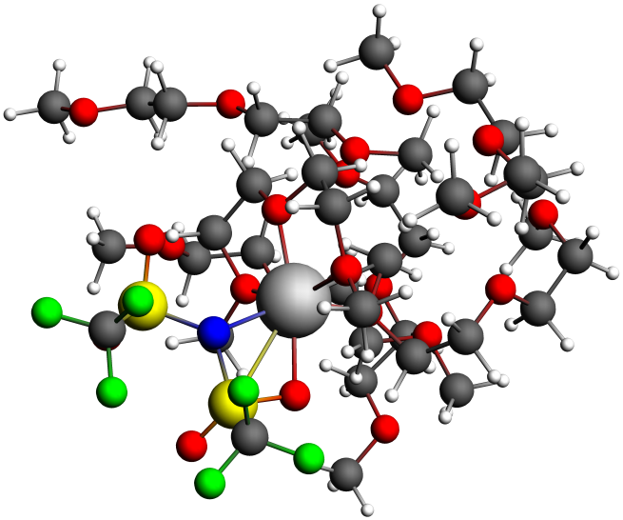
NMR Shielding ADF-GUI atom Mg(24): 564.00 ppm
Atom X Y Z (Angstrom)
1.O -0.211694 -1.992782 2.418302
2.C -0.863578 -2.638840 3.546725
3.C -1.665861 -3.794419 2.952616
4.O -2.350735 -3.275191 1.767320
5.C -3.326532 -4.224794 1.225622
6.C 0.593584 -0.812227 2.711303
7.C 1.241930 -0.426239 1.392915
8.O 0.183093 -0.416245 0.374655
9.C 0.684342 -0.015657 -0.934013
10.H -1.497633 -1.911167 4.069716
11.H -0.099262 -3.027253 4.234245
12.H -2.418028 -4.161893 3.660634
13.H -1.003431 -4.612567 2.643164
14.H -3.772514 -3.735469 0.354372
15.H -4.082780 -4.421195 1.993636
16.H -2.807206 -5.142914 0.919821
17.H 1.366841 -1.069109 3.448341
18.H -0.042757 -0.018989 3.118091
19.H 1.992886 -1.169862 1.088403
20.H 1.678683 0.577376 1.457554
21.H 1.024949 1.023794 -0.878792
22.H -0.149508 -0.121097 -1.632845
23.H 1.504288 -0.681177 -1.233147
24.Mg -1.237720 -1.926585 0.634839
25.N -0.103986 -3.511819 -0.523546
26.S 0.508276 -4.943039 0.073117
27.S -1.071305 -3.362033 -1.823630
28.C 1.897847 -5.386594 -1.182648
29.C 0.075009 -2.748673 -3.305043
30.O -1.835772 -2.130654 -1.423110
31.O -1.799298 -4.507985 -2.326195
32.O 1.174516 -4.584056 1.316588
33.O -0.451179 -6.034077 0.021330
34.F -0.412677 -1.574687 -3.777808
35.F 2.427155 -6.578471 -0.848548
36.F 2.861419 -4.435100 -1.164477
37.F 1.363007 -5.456099 -2.431007
38.F 0.064731 -3.668338 -4.279140
39.F 1.343171 -2.555861 -2.868881
40.C -2.575568 1.661826 -0.178454
41.C -3.313358 0.324972 -0.072001
42.O -2.748278 -0.567323 0.933404
43.C -2.978762 -0.142152 2.319232
44.H -1.498487 1.482845 -0.275685
45.H -2.937110 2.180322 -1.086255
46.H -3.238845 -0.213938 -1.021919
47.H -4.370460 0.473963 0.180956
48.H -3.939444 0.374403 2.378283
49.H -2.173576 0.519762 2.650863
50.H -3.014936 -1.049828 2.920189
51.O -2.726431 2.503844 0.973454
52.C -4.025484 3.124919 1.074227
53.C -4.016096 4.076583 2.272101
54.H -4.813403 2.365118 1.199614
55.H -4.231438 3.694880 0.150114
56.H -3.074360 4.639634 2.274985
57.O -4.092193 3.407968 3.541959
58.C -5.438359 3.008218 3.873228
59.H -4.854402 4.787797 2.168552
60.H -5.793574 2.195757 3.221455
61.H -6.123837 3.870042 3.801703
62.H -5.413523 2.650671 4.907509
63.O 0.362587 2.956628 2.992233
64.C -0.854100 3.094699 3.755968
65.C -0.678404 2.477468 5.129368
66.O -0.651025 1.043772 5.019619
67.C -0.460651 0.421691 6.296867
68.C 0.333815 3.791755 1.820086
69.C 1.710443 3.847754 1.183419
70.O 1.998185 2.608810 0.505755
71.C 3.314273 2.620267 -0.076485
72.H -1.698731 2.633393 3.226314
73.H -1.088271 4.166144 3.893196
74.H -1.529742 2.784151 5.763608
75.H 0.256096 2.839039 5.592972
76.H -0.476598 -0.660872 6.135907
77.H -1.276679 0.689572 6.989971
78.H 0.501736 0.725907 6.742928
79.H 0.054714 4.822453 2.109218
80.H -0.418895 3.424709 1.103732
81.H 2.473912 4.036261 1.958045
82.H 1.735418 4.678945 0.456006
83.H 3.408630 3.430954 -0.818864
84.H 3.456929 1.652752 -0.571833
85.H 4.085803 2.754424 0.700283
86.O -3.429803 -3.710650 7.457301
87.C -2.817621 -2.839702 6.502079
88.C -3.498414 -1.477343 6.608754
89.O -3.145227 -0.729407 5.431102
90.C -3.739443 0.577441 5.457696
91.C -2.900173 -5.049767 7.375102
92.C -3.843393 -5.970336 8.148187
93.O -3.428138 -7.315771 7.890109
94.C -4.183586 -8.261466 8.667829
95.H -2.967415 -3.241265 5.486504
96.H -1.731192 -2.754543 6.688049
97.H -3.162474 -0.939771 7.512548
98.H -4.590152 -1.598906 6.664849
99.H -3.399170 1.121729 4.574813
100.H -3.423597 1.129171 6.359529
101.H -4.838328 0.496663 5.455203
102.H -1.883386 -5.085926 7.800494
103.H -2.865360 -5.369359 6.324217
104.H -4.881649 -5.810449 7.800540
105.H -3.806284 -5.750645 9.230032
106.H -4.048439 -8.076558 9.747425
107.H -3.807187 -9.258155 8.414370
108.H -5.259915 -8.197527 8.427110
109.O -8.904647 -1.452746 5.064902
110.C -8.575726 -0.421048 6.006008
111.C -8.194849 -1.063677 7.328323
112.O -6.923695 -1.721265 7.196907
113.C -6.586092 -2.449432 8.391826
114.C -9.245325 -0.921607 3.774250
115.C -9.430374 -2.118527 2.843894
116.O -9.550223 -1.616294 1.503803
117.C -9.809481 -2.677407 0.568373
118.H -9.442703 0.245801 6.162545
119.H -7.734328 0.185663 5.621829
120.H -8.970558 -1.794053 7.619199
121.H -8.140235 -0.284445 8.111100
122.H -5.609909 -2.915256 8.222890
123.H -6.530305 -1.771010 9.261751
124.H -8.431588 -0.279176 3.396298
125.H -10.169253 -0.320972 3.831733
126.H -10.332388 -2.688633 3.124778
127.H -9.884580 -2.220547 -0.424502
128.H -10.754864 -3.191061 0.811820
129.H -7.343019 -3.226074 8.598950
130.H -8.556068 -2.788816 2.927417
131.H -8.989184 -3.417211 0.577801
132.O -5.767982 -3.198161 3.430400
133.C -5.868348 -3.751482 4.761579
134.C -5.601932 -5.241972 4.713620
135.O -4.233278 -5.478409 4.330089
136.C -3.909276 -6.884023 4.374078
137.C -5.896720 -1.763205 3.463867
138.C -6.127748 -1.295731 2.028833
139.O -6.281428 0.143188 2.049485
140.C -7.028212 0.626512 0.913377
141.H -6.872837 -3.558885 5.171542
142.H -5.142513 -3.269312 5.429712
143.H -6.279398 -5.737233 3.995776
144.H -5.787761 -5.663854 5.717937
145.H -2.875058 -6.985026 4.025202
146.H -3.986526 -7.269511 5.404038
147.H -4.986667 -1.313656 3.889047
148.H -6.750309 -1.477969 4.091689
149.H -7.039337 -1.762947 1.632481
150.H -7.109147 1.713813 1.028816
151.H -8.027765 0.170160 0.889596
152.H -4.577291 -7.457454 3.710198
153.H -5.275133 -1.573115 1.385431
154.H -6.505501 0.397341 -0.032408

Figure 5:MgDGM₈TFSI
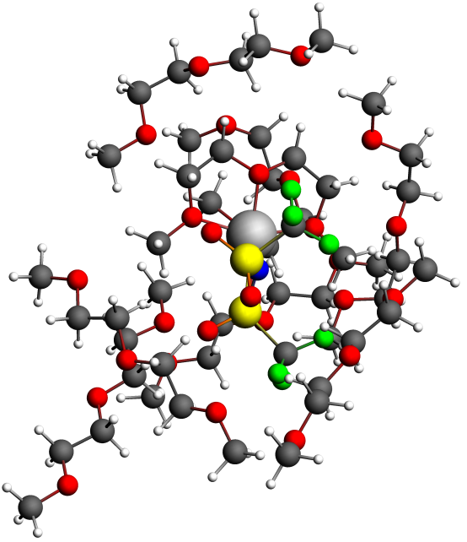
NMR Shielding ADF-GUI atom Mg(24): 563.62 ppm
Atom X Y Z (Angstrom)
1.O 0.178333 -1.732501 -0.277911
2.C 1.294814 -1.386921 0.591327
3.C 1.034531 -2.106533 1.904226
4.O -0.343476 -1.816682 2.300854
5.C -0.653406 -2.355565 3.628353
6.C 0.119304 -1.011461 -1.549473
7.C -1.094231 -1.579204 -2.261504
8.O -2.214878 -1.508950 -1.325480
9.C -3.435810 -2.055452 -1.909663
10.H 1.343381 -0.302318 0.726741
11.H 2.235614 -1.730241 0.150362
12.H 1.719115 -1.722386 2.670193
13.H 1.138217 -3.194393 1.802763
14.H -1.702972 -2.130039 3.827077
15.H -0.011273 -1.870781 4.371875
16.H -0.476227 -3.434458 3.631512
17.H 1.036943 -1.189498 -2.123585
18.H 0.000027 0.064273 -1.353369
19.H -0.936019 -2.631517 -2.534129
20.H -1.328058 -0.970374 -3.140695
21.H -3.636202 -1.524965 -2.847235
22.H -4.230188 -1.851856 -1.195500
23.H -3.327672 -3.134805 -2.070203
24.Mg -1.666183 -1.606084 0.680165
25.N -2.412385 -3.724955 0.878828
26.S -1.703917 -5.217516 1.075083
27.S -3.678175 -3.250465 1.772791
28.C -1.136545 -5.485245 -0.747680
29.C -5.362670 -3.857200 1.024679
30.O -3.650951 -1.782458 1.479661
31.O -3.729035 -3.717044 3.144106
32.O -0.460362 -5.099558 1.826409
33.O -2.679609 -6.252610 1.375308
34.F -6.318568 -2.992908 1.452324
35.F -0.607206 -6.721367 -0.844598
36.F -0.189579 -4.562837 -1.084312
37.F -2.177674 -5.366158 -1.603549
38.F -5.633545 -5.091047 1.476838
39.F -5.328367 -3.851185 -0.324580
40.C -2.420429 1.748448 -1.042558
41.C -2.746544 1.239399 0.364575
42.O -1.671287 0.419056 0.935878
43.C -0.646499 1.203629 1.621805
44.H -2.386586 0.913209 -1.743639
45.H -3.230308 2.425384 -1.353279
46.H -3.630996 0.603736 0.316628
47.H -2.942510 2.051234 1.073074
48.H -1.143329 1.932175 2.275743
49.H -0.018201 1.716267 0.890684
50.H -0.063631 0.512603 2.225400
51.O -1.141173 2.402158 -1.136937
52.C -1.143134 3.745961 -0.624252
53.C 0.281041 4.289664 -0.711934
54.H -1.493907 3.764126 0.422196
55.H -1.827948 4.375822 -1.216842
56.H 0.675309 4.107977 -1.719409
57.O 1.188977 3.627652 0.195264
58.C 1.086992 4.109452 1.545455
59.H 0.272191 5.376098 -0.518215
60.H 0.057348 4.027101 1.930762
61.H 1.408563 5.162352 1.609297
62.H 1.740837 3.475289 2.154555
63.O 3.938311 0.287085 0.305156
64.C 3.807966 1.550504 0.993345
65.C 3.680493 1.301448 2.485790
66.O 2.348751 0.823439 2.775057
67.C 2.166679 0.570178 4.175969
68.C 3.621442 0.411323 -1.089791
69.C 4.039879 -0.883665 -1.793680
70.O 3.241738 -1.006058 -2.982996
71.C 3.647419 -2.127053 -3.790369
72.H 2.922923 2.094807 0.630036
73.H 4.701007 2.170311 0.801273
74.H 3.860588 2.246543 3.028646
75.H 4.428215 0.560919 2.818449
76.H 1.134161 0.224063 4.308588
77.H 2.324205 1.487103 4.769599
78.H 2.864682 -0.206518 4.533651
79.H 4.143532 1.274759 -1.533462
80.H 2.536377 0.572125 -1.217563
81.H 3.872165 -1.749766 -1.128257
82.H 5.111697 -0.863538 -2.051684
83.H 4.694691 -2.015512 -4.116252
84.H 2.989525 -2.143838 -4.666440
85.H 3.545023 -3.072489 -3.229652
86.O -4.709419 -2.582579 7.382738
87.C -4.511526 -2.341018 5.982324
88.C -3.510798 -1.195289 5.844331
89.O -3.508113 -0.794387 4.458371
90.C -2.705314 0.370928 4.241248
91.C -5.584408 -3.715484 7.578457
92.C -5.680493 -3.991083 9.075755
93.O -6.572147 -5.100506 9.236632
94.C -6.742623 -5.445762 10.618794
95.H -5.465963 -2.057570 5.502584
96.H -4.138550 -3.249367 5.491184
97.H -2.500935 -1.521588 6.144050
98.H -3.818645 -0.350311 6.481602
99.H -2.781121 0.603366 3.174972
100.H -1.647520 0.177062 4.496232
101.H -3.079836 1.219375 4.834506
102.H -5.176959 -4.594789 7.059583
103.H -6.586257 -3.489828 7.172449
104.H -6.063756 -3.101827 9.609400
105.H -4.681200 -4.233446 9.482564
106.H -5.778638 -5.734532 11.075420
107.H -7.434992 -6.294134 10.654854
108.H -7.165598 -4.598256 11.188038
109.O -5.291091 -8.205930 -0.932053
110.C -5.896701 -8.454539 0.352949
111.C -5.935353 -9.967603 0.561505
112.O -6.799764 -10.223916 1.677235
113.C -6.836626 -11.618526 2.011530
114.C -5.200216 -6.803701 -1.196182
115.C -4.741439 -6.627406 -2.641619
116.O -4.667575 -5.212187 -2.913857
117.C -4.193261 -4.967379 -4.242701
118.H -6.927750 -8.057744 0.361337
119.H -5.326615 -7.964266 1.158074
120.H -4.920985 -10.356213 0.762293
121.H -6.323105 -10.460769 -0.348235
122.H -7.516270 -11.727069 2.864247
123.H -7.210142 -12.218102 1.161949
124.H -4.484091 -6.332193 -0.506495
125.H -6.183904 -6.320058 -1.060207
126.H -5.457215 -7.109336 -3.329158
127.H -4.161078 -3.879770 -4.381458
128.H -4.867377 -5.412500 -4.995324
129.H -5.831760 -11.982650 2.290530
130.H -3.752023 -7.094131 -2.786100
131.H -3.180736 -5.388284 -4.384327
132.O -5.409810 2.851415 1.413621
133.C -5.018480 2.972825 2.790590
134.C -5.702383 1.851409 3.570152
135.O -5.395942 2.044399 4.955957
136.C -6.106719 1.099278 5.777362
137.C -4.920142 3.938103 0.613731
138.C -5.593134 3.849953 -0.759350
139.O -4.743595 4.528976 -1.708256
140.C -5.466933 4.951664 -2.877899
141.H -5.329156 3.950829 3.194893
142.H -3.919270 2.894606 2.888584
143.H -5.344194 0.862203 3.234187
144.H -6.792727 1.905827 3.402225
145.H -5.789514 1.270033 6.811649
146.H -7.196062 1.256321 5.694102
147.H -3.825477 3.870515 0.489561
148.H -5.144775 4.902619 1.099178
149.H -6.587049 4.324490 -0.728695
150.H -4.743577 5.436880 -3.542798
151.H -6.260712 5.667499 -2.606980
152.H -5.865030 0.068170 5.478119
153.H -5.710141 2.790877 -1.039505
154.H -5.925515 4.093064 -3.398127
155.O -3.617080 0.762976 -3.925958
156.C -4.854295 1.412735 -3.572658
157.C -5.738405 0.509534 -2.728826
158.O -5.243210 0.459500 -1.382778
159.C -6.169882 -0.188122 -0.492226
160.C -2.817117 1.654670 -4.732359
161.C -1.570124 0.956166 -5.245431
162.O -0.585583 0.874584 -4.202972
163.C 0.630429 0.274144 -4.678092
164.H -5.402217 1.676075 -4.495889
165.H -4.642393 2.342139 -3.020030
166.H -5.785473 -0.506345 -3.159361
167.H -6.760372 0.929628 -2.732828
168.H -5.715083 -0.184777 0.503078
169.H -7.126758 0.358438 -0.462842
170.H -2.530210 2.539796 -4.138902
171.H -3.411683 1.991070 -5.600814
172.H -1.164462 1.537596 -6.093116
173.H 1.350657 0.283726 -3.855445
174.H 1.041424 0.838119 -5.532876
175.H -6.359456 -1.227862 -0.808166
176.H -1.826679 -0.054149 -5.615422
177.H 0.454434 -0.769547 -4.999905
178.O -3.280527 -5.622595 5.908747
179.C -1.975787 -5.062540 5.714878
180.C -1.664713 -4.186355 6.930463
181.O -0.660380 -3.222504 6.537423
182.C -0.263600 -2.412994 7.655312
183.H -3.303051 -7.529833 5.033174
184.H -5.622344 -6.760614 5.754211
185.H -1.973078 -4.442664 4.805607
186.H -1.220393 -5.858012 5.594909
187.H -1.287980 -4.795241 7.769938
188.H 0.488321 -1.702223 7.291181
189.H 0.175970 -3.033094 8.455328
190.H -2.577229 -3.665535 7.260157

191.H -1.126349 -1.861097 8.068055
192.C -3.669767 -6.509180 4.836235
193.C -5.195223 -6.489215 4.771587
194.O -5.604545 -7.423785 3.768702
195.C -7.035974 -7.478234 3.658188
196.H -3.257501 -6.164190 3.878559
197.H -5.539436 -5.469928 4.517128
198.H -7.269251 -8.257833 2.927947
199.H -7.492563 -7.731632 4.631554
200.H -7.437552 -6.503216 3.324475

Figure S4a1: Mg²⁺(DGM)₂
NMR Shielding ADF-GUI atom Mg(24): 568.79 ppm

Atom X Y Z (Angstrom)
1.O -1.404840 0.607696 2.682633
2.C -0.297449 0.131867 1.856939
3.C 0.946572 0.257631 2.724050
4.O 0.948522 1.616240 3.256741
5.C 2.168353 1.937144 3.986984
6.C -2.702015 0.672361 2.015074
7.C -3.673988 1.210821 3.054955
8.O -3.056572 2.395010 3.648413
9.C -3.944089 3.068341 4.593460
10.H -0.225154 0.761260 0.958579
11.H -0.469261 -0.911832 1.565422
12.H 1.849062 0.093206 2.120404
13.H 0.927560 -0.457825 3.559290
14.H 3.034850 1.821633 3.324927
15.H 2.267776 1.282241 4.863004
16.H 2.079298 2.982312 4.297277
17.H -3.004627 -0.328410 1.682379
18.H -2.623303 1.343788 1.148592
19.H -4.625918 1.485873 2.581435
20.H -3.858551 0.471346 3.847382
21.H -3.384662 3.916081 4.994890
22.H -4.224313 2.377496 5.400715
23.H -4.843426 3.412785 4.068797
24.Mg -0.957006 2.317412 3.825003
25.H -1.888797 5.488581 3.218847
26.H -2.132042 4.178620 1.030332
27.H -0.864011 2.933391 0.736580
28.H -0.465049 4.669179 0.557122
29.H 0.876765 3.431518 6.346483
30.H -0.400754 4.391609 7.166486
31.H -1.982494 2.506757 7.081933
32.H -0.436954 1.863015 7.728110
33.C -0.817507 5.249420 3.148450
34.H -0.870927 -0.390432 6.825948
35.H -1.375967 -0.499274 5.101226
36.H -2.485552 0.213001 6.324075
37.O -0.658463 3.944181 2.515688
38.C -0.206533 3.589487 6.443422
39.C -0.924782 2.311914 6.852632
40.C -1.436978 0.089770 6.018915
41.H 0.910026 5.027311 4.456610
42.O -0.849966 1.393297 5.718371
43.O -0.751958 3.949371 5.137389
44.C -1.063416 3.939650 1.115887
45.C -0.180401 5.146948 4.526592
46.H -0.419678 6.027826 5.135300
47.H -0.308216 6.016991 2.550658

Figure S4a2: Mg²⁺(DGM)₂(DGM)₂
NMR Shielding ADF-GUI atom Mg(24): 567.36 ppm
Atom X Y Z (Angstrom)
1.O -0.977867 0.847065 3.096961
2.C 0.149779 0.497164 2.247656
3.C 1.277694 0.119899 3.197939
4.O 1.414797 1.212265 4.145683
5.C 2.558463 1.039277 5.045728
6.C -2.161069 1.365858 2.405877
7.C -3.150175 1.749133 3.491089
8.O -2.395071 2.533946 4.474644
9.C -3.232384 3.363382 5.334192
10.H 0.423127 1.368431 1.633531
11.H -0.114942 -0.345863 1.595976
12.H 2.217502 -0.008894 2.643671
13.H 1.043427 -0.808681 3.740541
14.H 2.661908 1.959153 5.621430
15.H 3.462998 0.891849 4.443721
16.H 2.388316 0.182458 5.707814
17.H -2.575231 0.589361 1.749835
18.H -1.868223 2.240666 1.810401
19.H -3.574926 0.874052 3.996115
20.H -3.958860 2.360504 3.078774
21.H -3.714191 4.131975 4.721314
22.H -2.559622 3.810389 6.071250
23.H -3.994483 2.743037 5.818040
24.Mg -0.416459 2.023201 4.766388
25.H -7.323317 1.331874 4.005613
26.H -7.717990 1.764114 5.698439
27.C -5.060153 4.897864 1.686039
28.H -6.699144 -0.286779 6.476587
29.H -4.996902 -0.592160 6.007703
30.H -6.303834 -0.730882 4.784984
31.O -3.672894 4.508385 1.831388
32.C -6.707673 3.309611 4.611337
33.C -6.949024 1.840077 4.910488
34.H -5.223504 5.388772 3.789715
35.C -3.005739 4.560712 0.559308
36.O -5.730278 1.209264 5.359332
37.O -5.921044 3.447408 3.414547
38.C -5.778434 4.820514 3.020675
39.H -6.771911 5.286940 2.906914
40.H -5.116251 5.933948 1.311457
41.H -5.557871 4.233733 0.959636
42.H -1.963361 4.266383 0.723676
43.H -3.030185 5.578839 0.137753
44.H -3.471782 3.868966 -0.162128
45.C 0.817700 4.188611 6.409607
46.H 0.746836 4.829510 7.298181
47.H 0.969259 5.729185 4.899171
48.H -0.718133 5.321558 5.366193
49.H -0.208598 3.737728 2.109010
50.H 0.228878 5.399595 2.599017
51.H -1.401624 4.733242 3.006463
52.H 0.189934 2.654165 8.618645
53.H 1.291266 1.740659 7.528290
54.H -1.773563 1.402496 7.811658
55.H -0.514979 0.205467 8.279040
56.C 0.289193 4.917089 5.184809
57.H -1.631017 -1.345804 6.674465
58.H -1.719444 -0.808986 4.960177
59.H -2.789400 -0.054771 6.190616
60.O 0.217414 3.942138 4.102825
61.C 0.271548 2.124621 7.660207
62.C -0.767882 1.017122 7.585040
63.C -1.799320 -0.494286 6.002908
64.H 1.850334 3.850767 6.265861
65.H -7.686162 3.799918 4.473115
66.H -6.197208 3.795201 5.461875
67.C -5.954360 -0.175973 5.671732
68.C 3.325022 5.050188 3.560982
69.O 2.952193 0.421319 8.238595
70.O 4.091788 3.029137 7.306928
71.C 5.096346 3.671926 6.495527
72.H 5.851944 4.146676 7.145102
73.H 5.312201 5.275558 5.113070
74.H 3.926950 5.478428 6.226091
75.H 2.611411 4.545215 2.902553
76.H 4.241277 5.299504 3.002194
77.H 2.883472 5.993662 3.930594
78.H 5.419529 2.611776 8.864058
79.H 5.297185 1.342521 7.610270
80.H 3.004587 2.083735 9.515741
81.H 4.229312 0.821585 9.844454
82.C 4.485362 4.745857 5.615732
83.H 2.767921 -1.025477 9.750752
84.H 1.621440 -1.127848 8.377456
85.H 1.410856 0.135211 9.642777
86.O 3.610508 4.148185 4.639159
87.C 4.721686 2.080646 8.194383
88.C 3.694025 1.359974 9.044510
89.C 2.145614 -0.443099 9.053329
90.H 5.603463 2.921198 5.865895
91.C -0.335438 4.501859 2.881679
92.O -0.763718 0.507005 6.215153
93.O -0.063809 3.032599 6.567410

Figure S4a3: Mg²⁺(DGM)₂(DGM)₄
NMR Shielding ADF-GUI atom Mg(24): 564.06 ppm
Atom X Y Z (Angstrom)
1.O -2.549354 0.700740 3.233611
2.C -1.701093 -0.071933 2.335398
3.C -0.529709 -0.530733 3.199730
4.O 0.055035 0.625334 3.868761
5.C 1.280830 1.123122 3.206652
6.C -3.671437 1.393786 2.599760
7.C -4.341383 2.202164 3.695726
8.O -3.290025 2.988471 4.335507
9.C -3.803041 3.830180 5.415232
10.H -1.362021 0.565362 1.509871
11.H -2.264005 -0.930848 1.943723
12.H 0.224701 -1.043435 2.591693
13.H -0.883524 -1.206830 3.987381
14.H 1.538286 2.071211 3.681509
15.H 1.093119 1.294731 2.142123
16.H 2.071228 0.375654 3.350987
17.H -4.369365 0.658204 2.178335
18.H -3.275486 2.034849 1.800105
19.H -4.814401 1.560243 4.450265
20.H -5.097320 2.880449 3.287582
21.H -4.616142 4.444210 5.021363
22.H -2.966386 4.458997 5.728687
23.H -4.166861 3.200394 6.234767
24.Mg -1.424994 2.035544 4.434103
25.H -7.822363 1.315947 5.288312
26.H -8.167298 1.761738 6.988252
27.C -6.621395 5.223275 2.661924
28.H -6.560131 0.148682 7.786884
29.H -4.885115 0.275069 7.157906
30.H -6.202407 -0.338709 6.100754
31.O -5.199746 5.295808 2.886058
32.C -7.708932 3.429282 5.723146
33.C -7.519563 1.975693 6.120410
34.H -6.969525 5.752984 4.726930
35.C -4.465268 5.388602 1.660266
36.O -6.142259 1.731076 6.467835
37.O -7.079561 3.678769 4.454389
38.C -7.330260 5.014489 3.989028
39.H -8.413836 5.170408 3.847146
40.H -6.976435 6.159938 2.199232
41.H -6.855933 4.386776 1.979703
42.H -3.409346 5.530043 1.905199
43.H -4.806463 6.245200 1.054960
44.H -4.585352 4.469518 1.057483
45.O 2.067385 4.928522 7.548304
46.O 0.849443 7.386260 6.316338
47.C 0.527369 8.195232 5.175655
48.H 1.101840 9.138237 5.209515
49.H -1.127686 9.336867 4.429511
50.H -1.280451 8.875251 6.153047
51.H -3.595076 6.723806 4.280377
52.H -3.271552 8.441770 3.886419
53.H -3.545263 7.955354 5.589302
54.H 2.863094 7.933608 6.265538
55.H 2.466099 6.406891 5.421458
56.H 2.218557 6.809725 8.458393
57.H 3.703132 6.221240 7.648037
58.C -0.956075 8.524973 5.159120
59.H 3.592785 4.123131 8.751328
60.H 2.079045 3.175676 8.613559
61.H 2.124785 4.653207 9.633452
62.O -1.704326 7.358979 4.768775
63.C -3.107613 7.640620 4.627556
64.C 2.239217 7.022932 6.308947
65.C 2.602060 6.269067 7.577001
66.C 2.493083 4.186579 8.705057
67.H 0.797718 7.663597 4.247410
68.C 3.640949 4.039962 4.554160
69.O 0.252333 0.850414 -0.241482
70.O 2.141755 2.989482 0.696957
71.C 2.582348 4.322835 0.995374
72.H 3.156769 4.723534 0.141738
73.H 4.080529 5.251797 2.224840
74.H 4.211490 3.472022 2.113076
75.H 3.029025 4.004030 5.461287
76.H 4.335724 4.895167 4.623341
77.H 4.235385 3.115508 4.461037
78.H 2.203682 3.361623 -1.356677
79.H 0.577037 3.454739 -0.627222
80.H 2.263439 0.892665 -0.818700
81.H 1.091028 1.409742 -2.070602
82.C 3.500839 4.311180 2.206559
83.H -0.097295 -0.635444 -1.687711
84.H -0.740979 -0.937214 -0.046166
85.H 1.017966 -1.103663 -0.366936
86.O 2.752668 4.190926 3.431911
87.C 1.531009 2.909729 -0.605718
88.C 1.332152 1.456833 -0.994886
89.C 0.106490 -0.532265 -0.609477
90.H 1.725115 4.995848 1.159546
91.C -0.919952 3.537667 1.738401
92.O -1.820622 1.173830 6.347256
93.O -0.506526 3.319548 5.717186
94.C -0.099995 4.632166 5.191644
95.H -0.443332 5.433289 5.849158
96.H -0.200976 5.513054 3.224140
97.H -1.791555 5.033968 3.865083
98.H -0.682796 2.567218 1.301163
99.H -0.307153 4.309648 1.274657
100.H -1.973037 3.801780 1.593696
101.H -1.710372 3.737933 7.369521
102.H 0.046982 3.617149 7.711846
103.H -1.369393 1.515542 8.371335
104.H 0.039816 1.191557 7.300687
105.C -0.732328 4.761099 3.812119
106.H -2.597073 -0.406153 7.480852
107.H -1.161189 -0.817048 6.480772
108.H -2.756215 -0.528840 5.695670
109.O -0.615496 3.461001 3.156930
110.C -0.782436 3.200000 7.130782
111.C -0.931003 1.703261 7.381380
112.C -2.096549 -0.239851 6.517956
113.H 0.988690 4.636678 5.135636
114.C -2.423798 3.061552 -1.362679
115.O 1.341436 7.614218 0.298940
116.O -1.396701 6.535234 0.817959
117.C -1.386912 6.556826 -0.631771
118.H -1.795793 7.518334 -0.985644
119.H -2.425386 5.597944 -2.246450
120.H -3.246384 5.448298 -0.663510
121.H -1.836092 2.157178 -1.166009
122.H -2.672853 3.120387 -2.435427
123.H -3.368388 3.026925 -0.787296
124.H -1.251217 7.773638 2.425798
125.H -1.103767 8.606982 0.843155
126.H 1.002701 6.795404 2.180031
127.H 1.006243 8.579872 2.122997
128.C -2.264062 5.436902 -1.166131
129.H 3.026421 8.733687 0.857587
130.H 3.186178 7.679317 -0.586285
131.H 3.186720 6.958324 1.058639
132.O -1.618014 4.170001 -0.952166
133.C -0.821447 7.710042 1.418178
134.C 0.698663 7.668814 1.573376
135.C 2.765786 7.754871 0.421100
136.H -0.360398 6.456035 -1.008947
137.C -5.945325 0.378300 6.900889
138.H -8.791920 3.631742 5.652396
139.H -7.281976 4.091745 6.496280

Figure S4a4: Mg²⁺(DGM)₂(DGM)₆
NMR Shielding ADF-GUI atom Mg(24): 561.98 ppm
Atom X Y Z (Angstrom)
1.O -2.475646 1.130487 2.685288
2.C -1.239746 0.585747 2.105675
3.C -0.278901 0.365655 3.265673
4.O -0.361578 1.555217 4.119546
5.C 0.701744 1.632571 5.092071
6.C -3.489208 1.560056 1.742953
7.C -4.622367 2.120627 2.594223
8.O -4.036939 3.131347 3.455623
9.C -4.974886 3.608195 4.482865
10.H -0.845248 1.312492 1.384464
11.H -1.455223 -0.363556 1.606256
12.H 0.739334 0.269885 2.885021
13.H -0.554680 -0.515190 3.855652
14.H 0.524528 2.533496 5.684653
15.H 1.658208 1.705306 4.569001
16.H 0.690524 0.733493 5.723291
17.H -3.837297 0.708188 1.142429
18.H -3.067683 2.328439 1.077633
19.H -5.065963 1.325386 3.212575
20.H -5.406972 2.576341 1.976540
21.H -5.932586 3.852131 4.018314
22.H -4.512493 4.493265 4.923047
23.H -5.112390 2.825248 5.234271
24.Mg -2.075020 2.642165 4.096822
25.H -7.049401 1.633552 6.386489
26.H -8.157539 2.210716 7.671089
27.C -8.391403 3.389047 2.039825
28.H -6.286276 3.179871 8.869902
29.H -5.258665 4.354889 7.978042
30.H -5.164130 2.611395 7.592614
31.O -7.340412 4.370941 2.090763
32.C -8.743216 2.778574 5.682588
33.C -7.671586 2.485973 6.718127
34.H -9.430979 4.313497 3.685069
35.C -6.798620 4.643396 0.796090
36.O -6.851903 3.650315 6.906024
37.O -8.153048 2.811502 4.371867
38.C -9.075570 3.310418 3.392284
39.H -9.951145 2.641627 3.308422
40.H -9.141398 3.674319 1.282014
41.H -7.972545 2.404402 1.762246
42.H -6.000774 5.378566 0.930609
43.H -7.567648 5.048135 0.117015
44.H -6.373456 3.733146 0.337109
45.O 0.910071 3.844878 7.914975
46.O -0.034706 6.702091 7.498052
47.C 0.082899 8.106509 7.178156
48.H 0.120850 8.683807 8.118704
49.H -1.194435 9.676263 6.480403
50.H -2.034085 8.111293 6.718865
51.H -1.776251 8.529757 3.130481
52.H -1.992040 9.923889 4.246524
53.H -2.949172 8.420746 4.482952
54.H 1.264873 6.969571 9.108038
55.H 1.997334 6.223354 7.658208
56.H -0.173399 4.881392 9.377202
57.H 1.585801 4.733294 9.679134
58.C -1.105084 8.582198 6.354824
59.H 1.866116 2.508986 9.222022
60.H 1.084884 1.810777 7.767600
61.H 0.082794 2.357228 9.152495
62.O -0.908296 8.275590 4.965258
63.C -1.974956 8.823483 4.164786
64.C 1.086581 6.259679 8.280212
65.C 0.822107 4.897416 8.898790
66.C 0.988896 2.563889 8.555894
67.H 1.015897 8.294191 6.620816
68.C 1.997744 4.448413 4.137838
69.O 0.987677 -1.361569 1.165033
70.O 2.815241 0.964795 1.844142
71.C 3.346782 2.245989 1.468076
72.H 4.384681 2.128958 1.107711
73.H 3.973926 4.064703 2.419083
74.H 3.827489 2.670451 3.531398
75.H 0.953521 4.727633 4.297095
76.H 2.604165 5.354709 3.968376
77.H 2.382367 3.934961 5.034973
78.H 4.034780 -0.112676 0.535938
79.H 2.429418 0.330640 -0.118555
80.H 2.748135 -1.547544 2.277677
81.H 2.835933 -2.143300 0.587293
82.C 3.360466 3.179763 2.668236
83.H 0.787586 -3.449618 1.308332
84.H -0.647904 -2.460905 1.739035
85.H 0.734277 -2.549679 2.867411
86.O 2.024930 3.585384 2.993212
87.C 2.964596 -0.005757 0.785746
88.C 2.426874 -1.352876 1.240771
89.C 0.442931 -2.527399 1.806396
90.H 2.745707 2.686791 0.653980
91.C -0.950603 4.308280 1.611587
92.O -2.757370 1.661165 5.894764
93.O -1.897565 4.074291 5.491536
94.C -1.678590 5.462888 5.073692
95.H -2.416777 6.108430 5.557610
96.H -1.362317 6.351379 3.121369
97.H -2.929356 5.507321 3.290261
98.H -0.373552 3.403494 1.405280
99.H -0.344465 5.192628 1.391980
100.H -1.867915 4.351211 1.009464
101.H -3.352713 4.210453 6.972381
102.H -1.671465 4.369986 7.549629
103.H -2.797575 2.048848 7.963175
104.H -1.174782 2.043028 7.192755
105.C -1.864444 5.486619 3.559489
106.H -3.173691 -0.198739 6.764146
107.H -1.497569 -0.012067 6.142077
108.H -2.841345 -0.186298 4.990353
109.O -1.274718 4.255120 3.031414
110.C -2.332232 3.846002 6.853223
111.C -2.222667 2.343405 7.074341
112.C -2.554358 0.222661 5.960485
113.H -0.672384 5.750885 5.379369
114.C -3.887274 4.618427 -0.913370
115.O 1.303002 6.750290 0.530188
116.O -1.451426 7.499407 1.018966
117.C -2.676791 7.869900 0.376752
118.H -3.192904 8.658435 0.955922
119.H -4.594426 6.978607 -0.013444
120.H -3.645118 6.140665 1.253433
121.H -3.406035 3.994884 -1.673786
122.H -4.890677 4.915949 -1.264008
123.H -4.008100 4.038784 0.021061
124.H -0.603647 9.395058 1.304339
125.H -0.280714 8.631928 -0.287256
126.H 0.777764 7.556916 2.392671
127.H 1.682184 8.655648 1.306799
128.C -3.578992 6.648617 0.274136
129.H 3.365954 7.043949 0.781955
130.H 2.826241 5.430249 0.210453
131.H 2.604619 5.884501 1.926556
132.O -3.048722 5.753615 -0.708435
133.C -0.386589 8.440447 0.792404
134.C 0.909768 7.865845 1.338948
135.C 2.599049 6.257524 0.891184
136.H -2.480160 8.254844 -0.636844
137.C -5.839529 3.433513 7.893144
138.H -9.518941 1.993812 5.729265
139.H -9.215533 3.749060 5.912458
140.C -3.818078 3.635987 10.697403
141.O -3.327486 4.500321 9.661235
142.O -3.903475 6.451866 7.448511
143.C -5.097825 7.227847 7.238378
144.H -5.817318 7.069453 8.059834
145.H -6.665626 7.421512 5.804434
146.H -6.068694 5.746913 5.980389
147.H -4.751096 7.154353 2.809802
148.H -6.294090 7.743697 3.505808
149.H -5.981818 5.984648 3.395945
150.H -3.381118 7.782069 8.981565
151.H -2.188620 6.524481 8.554093
152.H -4.889618 5.877109 9.869887
153.H -3.413352 6.245661 10.809859
154.C -5.760660 6.802730 5.937398
155.H -3.470735 3.968180 11.689573
156.H -3.427770 2.632607 10.493166
157.H -4.920548 3.607527 10.697013
158.O -4.848250 7.017345 4.842936
159.C -5.515375 6.965046 3.570898
160.C -3.255650 6.721329 8.709070
161.C -3.785062 5.853262 9.846108
162.H -4.834681 8.298809 7.202770
163.C -4.070540 -1.769118 3.162652
164.O -2.723531 -2.114606 3.508120
165.O -0.406831 -2.501659 5.314527
166.C 0.890049 -3.048849 5.621488
167.H 0.808423 -3.737646 6.480706
168.H 2.780810 -2.410951 6.380707
169.H 1.446526 -1.273109 6.734766
170.H 3.491278 0.190799 4.043550
171.H 4.224318 -0.936600 5.246027
172.H 3.142626 0.381033 5.796905
173.H -1.342296 -4.348626 5.604445
174.H -0.904119 -3.967214 3.912207
175.H -3.039287 -2.474194 5.545480
176.H -3.362278 -3.860532 4.462095
177.C 1.872018 -1.942756 5.962648
178.H -4.667612 -2.670201 2.945380
179.H -4.022080 -1.139065 2.270087
180.H -4.562908 -1.209176 3.978287
181.O 2.195396 -1.197179 4.782686
182.C 3.332187 -0.343587 4.984836
183.C -1.288146 -3.539952 4.853860
184.C -2.690687 -3.002607 4.640230
185.H 1.273387 -3.617808 4.757584

Figure S4b1: Mg²⁺(DGM)₃
NMR Shielding ADF-GUI atom Mg(24): 566.87 ppm
Atom X Y Z (Angstrom)
1.O -3.804120 1.714903 1.110706
2.C -2.937935 1.226140 0.024207
3.C -1.992879 0.160844 0.596736
4.O -0.748169 0.294719 -0.082162
5.C 0.135779 -0.818041 0.182133
6.C -5.136342 2.111989 0.673711
7.C -5.927884 2.451142 1.927963
8.O -5.110456 3.363868 2.717762
9.C -5.837710 3.973844 3.824195
10.H -2.353717 2.065931 -0.368543
11.H -3.573630 0.819044 -0.769197
12.H -2.414180 -0.848045 0.451047
13.H -1.874366 0.319978 1.684321
14.H -0.327696 -1.765344 -0.132588
15.H 0.380561 -0.875358 1.256678
16.H 1.045682 -0.641482 -0.397871
17.H -5.614127 1.282581 0.137124
18.H -5.057102 2.980531 0.006145
19.H -6.873034 2.940993 1.656257
20.H -6.140461 1.554021 2.525852
21.H -5.146317 4.669826 4.300919
22.H -6.164146 3.195837 4.528059
23.H -6.708846 4.513844 3.433745
24.Mg -3.035466 3.153835 2.489146
25.H -4.116365 6.607425 4.761389
26.H -2.608764 9.660579 6.137149
27.H -3.150602 8.302766 7.180533
28.H -4.201640 8.882467 5.843919
29.H -1.997482 4.062811 6.178063
30.H -3.643348 3.450067 5.842931
31.H -2.090057 1.487468 5.943435
32.H -0.975924 2.300173 4.803065
33.C -3.099402 6.545451 5.190124
34.H -3.429826 -0.101365 4.867269
35.H -4.206869 0.364797 3.316163
36.H -4.595261 1.268608 4.823441
37.O -2.484214 7.823063 5.245204
38.C -2.624915 3.543375 5.443537
39.C -2.022870 2.186013 5.100435
40.C -3.814983 0.731291 4.267246
41.H -2.257273 6.077885 3.259135
42.O -2.713499 1.631984 3.930486
43.O -2.682029 4.307616 4.196798
44.C -3.157767 8.715490 6.159197
45.C -2.207293 5.696622 4.280320
46.H -1.174544 5.695735 4.653422
47.H -3.167603 6.097810 6.199600
48.C -4.049217 5.483348 0.515060
49.H -2.994955 7.389590 0.448492
50.H -4.257948 8.683315 3.586337
51.H -4.945375 9.130315 1.984133
52.H -3.164315 9.053462 2.223124
53.H -1.829292 4.185407 -0.563862
54.H -1.490384 5.833590 0.055661
55.H -0.307517 4.983192 2.004941
56.H 0.299720 4.049573 0.595193
57.C -3.963502 6.975677 0.785533
58.H 0.605127 1.828602 1.456393
59.H -0.410672 1.361720 2.853826
60.H 0.691481 2.776371 2.994595
61.O -4.149531 7.193223 2.182053
62.C -1.703246 4.795993 0.341272
63.C -0.578695 4.266673 1.216800
64.C 0.044762 2.197817 2.321414
65.H -4.950361 5.076454 0.978509
66.O -1.050821 3.037439 1.847217
67.O -2.937326 4.732297 1.119527
68.C -4.129820 8.606136 2.505183
69.H -4.056801 5.286603 -0.565954
70.H -4.755700 7.470717 0.193975

Figure S4b2: Mg²⁺(DGM)₃(DGM)₂
NMR Shielding ADF-GUI atom Mg(24): 565.94 ppm
Atom X Y Z (Angstrom)
1.O -3.837678 1.083078 1.422522
2.C -2.936112 0.465399 0.448115
3.C -1.922198 -0.378512 1.228282
4.O -0.723332 -0.432463 0.461887
5.C 0.281051 -1.233588 1.118980
6.C -5.145676 1.451215 0.889257
7.C -6.016833 1.837434 2.075790
8.O -5.218378 2.691164 2.947849
9.C -6.017891 3.378289 3.946098
10.H -2.414281 1.247487 -0.115347
11.H -3.532027 -0.146334 -0.239149
12.H -2.320854 -1.394039 1.404431
13.H -1.737977 0.086612 2.209424
14.H -0.072453 -2.269634 1.248945
15.H 0.533106 -0.806985 2.104379
16.H 1.162680 -1.228538 0.471710
17.H -5.585201 0.589751 0.370723
18.H -5.040259 2.283671 0.185572
19.H -6.888851 2.395639 1.707732
20.H -6.336192 0.957474 2.652968
21.H -5.330621 4.009622 4.512233
22.H -6.503685 2.642454 4.602493
23.H -6.763646 3.998569 3.438068
24.Mg -3.155867 2.742705 2.606398
25.H -4.030104 6.493631 4.639553
26.H -2.237289 9.504822 5.660027
27.H -2.859015 8.294464 6.831662
28.H -3.888654 8.826617 5.460838
29.H -2.067731 3.976900 6.189857
30.H -3.616531 3.113867 5.965189
31.H -1.756891 1.415251 6.051916
32.H -0.875579 2.306872 4.783697
33.C -3.000606 6.363718 5.015865
34.H -3.157063 -0.299594 5.246278
35.H -4.066810 -0.000892 3.724666
36.H -4.382871 1.016175 5.169374
37.O -2.271670 7.587696 4.941045
38.C -2.642066 3.336527 5.511220
39.C -1.866328 2.070611 5.178944
40.C -3.619326 0.461325 4.607033
41.H -2.360078 5.638149 3.087223
42.O -2.585218 1.361092 4.114093
43.O -2.896881 4.035429 4.247430
44.C -2.853671 8.608736 5.775315
45.C -2.262145 5.354710 4.135991
46.H -1.206867 5.260986 4.412131
47.H -3.048051 6.007786 6.062275
48.C -4.664851 4.914913 0.775568
49.H -3.769430 6.772685 0.047632
50.H -3.765555 8.542916 3.183056
51.H -5.129368 8.738924 2.017653
52.H -3.433808 8.719796 1.433939
53.H -2.640157 3.462498 -0.609004
54.H -2.328743 5.205664 -0.349825
55.H -0.713178 4.766737 1.436196
56.H -0.300373 3.663806 0.083913
57.C -4.527319 6.424464 0.773455
58.H 0.529121 1.813533 1.343134
59.H -0.258785 1.436068 2.904279
60.H 0.553027 3.019298 2.699665
61.O -4.180860 6.866820 2.090871
62.C -2.385337 4.226168 0.140473
63.C -1.064715 3.921805 0.830073
64.C -0.014201 2.228413 2.199826
65.H -5.401789 4.618870 1.517740
66.O -1.282071 2.783258 1.711509
67.O -3.413279 4.232540 1.167254
68.C -4.129826 8.303436 2.180620
69.H -4.972015 4.547991 -0.209613
70.H -5.506489 6.830093 0.468825
71.C -0.406851 -1.093796 4.949282
72.C 0.636938 6.672547 3.090465
73.O 0.380392 0.051981 4.603245
74.O 1.450432 2.819106 5.095535
75.C 2.381677 3.881520 4.795438
76.H 3.120341 3.957887 5.611869
77.H 2.461495 6.004168 4.689136
78.H 0.997533 5.392381 5.509958
79.H 0.128474 6.660356 2.119817
80.H 1.553146 7.278729 3.012016
81.H -0.032396 7.115812 3.844018
82.H 2.949011 1.689274 6.011982
83.H 2.648320 1.298093 4.294617
84.H 0.621882 0.788918 6.548248
85.H 1.851984 -0.396075 6.016293
86.C 1.682927 5.223156 4.660413
87.H 0.233068 -1.954474 5.201731
88.H -1.021641 -1.337157 4.077050
89.H -1.059735 -0.880697 5.814299
90.O 0.964018 5.304332 3.413307
91.C 2.162458 1.573846 5.246448
92.C 1.234019 0.457650 5.690152
93.H 2.923049 3.654507 3.861114
94.C -7.383005 6.566156 3.313068
95.C -4.579391 2.105496 -2.536449
96.O -7.350529 5.864789 2.058794
97.O -7.722676 3.928977 -0.124119
98.C -7.796610 3.673463 -1.542914
99.H -8.820985 3.360055 -1.809154
100.H -7.097412 2.272387 -2.991560
101.H -6.957594 1.688339 -1.308242
102.H -3.575503 2.541091 -2.485993
103.H -4.849369 1.933292 -3.589770
104.H -4.586182 1.137519 -2.005868
105.H -9.679936 4.664811 -0.041395
106.H -8.412308 5.891084 -0.340294
107.H -8.794143 4.366947 2.307019
108.H -9.436389 5.990114 1.926256
109.C -6.840835 2.571536 -1.961680
110.H -8.095081 7.405703 3.273999
111.H -6.367046 6.937472 3.480704
112.H -7.677142 5.897228 4.141307
113.O -5.478117 3.041084 -1.920486
114.C -8.654694 4.975559 0.225246
115.C -8.617951 5.282099 1.712218
116.H -7.561256 4.594130 -2.103000

Figure S4b3: Mg²⁺(DGM)₃(DGM)₄
NMR Shielding ADF-GUI atom Mg(24): 563.54 ppm
Atom X Y Z (Angstrom)
1.O -1.764384 0.545564 1.257353
2.C -0.431937 0.255827 0.733263
3.C 0.348846 -0.456812 1.837397
4.O 1.746511 -0.263606 1.584476
5.C 2.548839 -0.858816 2.620404
6.C -2.858187 0.364906 0.300368
7.C -4.153031 0.407273 1.092458
8.O -4.059914 1.504786 2.062107
9.C -5.336518 1.815932 2.678779
10.H 0.064032 1.199172 0.476983
11.H -0.523332 -0.371403 -0.152673
12.H 0.096826 -1.530361 1.834491
13.H 0.081180 -0.029043 2.815564
14.H 2.366101 -1.945256 2.681392
15.H 2.326091 -0.399146 3.597992
16.H 3.596075 -0.681251 2.356653
17.H -2.760978 -0.606995 -0.185341
18.H -2.812399 1.157812 -0.453407
19.H -5.000861 0.578396 0.422636
20.H -4.302941 -0.526705 1.644640
21.H -5.163457 2.669051 3.338242
22.H -5.686238 0.945545 3.255678
23.H -6.058978 2.075177 1.897127
24.Mg -2.146928 2.161609 2.497415
25.H -4.698459 5.082178 4.599824
26.H -4.498450 8.700989 4.937636
27.H -4.521317 7.585966 6.344387
28.H -5.647135 7.320858 4.970257
29.H -2.859228 3.322376 6.202037
30.H -3.883781 2.092799 5.406575
31.H -1.800832 0.973093 6.256916
32.H -0.794671 2.190896 5.427989
33.C -3.726742 5.498085 4.914033
34.H -2.186250 -0.979731 4.996767
35.H -2.417935 -0.810543 3.219074
36.H -3.607863 -0.085328 4.349028
37.O -3.632826 6.881677 4.572911
38.C -2.920895 2.618531 5.365061
39.C -1.744897 1.651685 5.395917
40.C -2.548113 -0.330256 4.190955
41.H -2.580137 5.115448 3.129239
42.O -1.741074 0.880132 4.154309
43.O -2.882293 3.332419 4.087020
44.C -4.636792 7.662048 5.250806
45.C -2.601576 4.771275 4.166776
46.H -1.625253 4.914570 4.641284
47.H -3.637316 5.372527 6.008517
48.C -3.440730 3.956176 0.198029
49.H -2.841491 5.827903 -0.780551
50.H -3.636956 7.935858 2.124304
51.H -4.847097 7.616567 0.833022
52.H -3.163574 8.057372 0.391394
53.H -0.694040 3.200919 -0.275212
54.H -1.026871 4.948315 -0.035225
55.H -0.158909 4.919000 2.242282
56.H 1.039403 4.054926 1.224790
57.C -3.577916 5.452927 -0.045312
58.H 1.824740 2.328706 2.685366
59.H 0.685206 1.725518 3.925146
60.H 1.138800 3.457999 3.931138
61.O -3.413313 6.133317 1.202451
62.C -0.978325 3.970176 0.457179
63.C 0.010831 4.037241 1.612089
64.C 0.954752 2.578889 3.305721
65.H -4.298511 3.594255 0.762796
66.O -0.180871 2.845224 2.423214
67.O -2.268035 3.622836 1.024439
68.C -3.788408 7.519086 1.123844
69.H -3.374583 3.421655 -0.755208
70.H -4.586517 5.606784 -0.458889
71.C 0.508702 -0.912676 5.891585
72.C -0.020158 6.942947 4.257394
73.O 1.053091 0.408927 5.813121
74.O 1.069257 3.327552 6.545139
75.C 1.728483 4.611641 6.557148
76.H 2.081969 4.828338 7.580343
77.H 1.268472 6.684707 6.418851
78.H -0.169814 5.653342 6.668634
79.H -0.136075 6.867060 3.170994
80.H 0.633257 7.796987 4.496555
81.H -1.011385 7.101977 4.711389
82.H 2.358414 2.582877 8.009373
83.H 2.839551 2.228609 6.324937
84.H 0.327901 1.069972 7.661516
85.H 1.936015 0.285805 7.701567
86.C 0.793403 5.730589 6.132839
87.H 1.205700 -1.600179 6.398204
88.H 0.337078 -1.250569 4.864996
89.H -0.446703 -0.915223 6.446084
90.O 0.576681 5.709126 4.708918
91.C 1.977802 2.309268 7.009913
92.C 1.285935 0.962875 7.121261
93.H 2.605779 4.592139 5.887834
94.C -6.382019 5.681451 2.615070
95.C -4.120154 3.865846 -3.382217
96.O -6.293782 4.888802 1.427999
97.O -6.778085 2.498395 -0.276226
98.C -6.660076 1.847471 -1.563845
99.H -6.703534 0.769814 -1.373500
100.H -5.323727 1.579133 -3.220908
101.H -4.491082 1.807062 -1.673310
102.H -4.131797 4.948308 -3.548184
103.H -4.196088 3.341796 -4.349054
104.H -3.168990 3.567039 -2.909915
105.H -8.482511 3.602557 -0.758670
106.H -6.929062 4.445909 -1.040528
107.H -7.960925 3.659947 1.746286
108.H -8.299687 5.228900 0.954860
109.C -5.346763 2.149609 -2.273981
110.H -7.095343 6.513945 2.484134
111.H -5.382010 6.079386 2.803550
112.H -6.719600 5.074506 3.476101
113.O -5.238148 3.558436 -2.539695
114.C -7.465222 3.766974 -0.362894
115.C -7.579117 4.394009 1.012946
116.H -7.508256 2.133631 -2.205250
117.C -2.074268 -3.502406 -0.623536
118.O -0.859187 -2.736743 -0.493664
119.C -3.796244 -3.123130 2.652748
120.C 2.115691 0.088770 -1.824216
121.O -3.179688 -2.729859 1.420486
122.C 0.050221 -2.987245 -1.588865
123.H 0.357132 -4.046582 -1.569096
124.H 2.090819 -2.540640 -2.078937
125.H 1.621243 -2.066770 -0.415178
126.H 1.806955 1.064758 -2.214941
127.H 2.957365 -0.290937 -2.426914
128.H 2.429476 0.184581 -0.773262
129.H -1.868038 -4.448607 -1.150961
130.H -2.816550 -2.927664 -1.198924
131.H -1.842238 -4.338642 1.355862
132.H -3.434323 -4.625320 0.587089
133.C 1.282393 -2.106729 -1.464731
134.H -4.589976 -3.869426 2.479999
135.H -4.240716 -2.225775 3.096158
136.H -3.056932 -3.551456 3.351016
137.O 0.975925 -0.782358 -1.934914
138.C -2.633392 -3.878651 0.739153
139.H -0.445466 -2.787049 -2.553753
140.O -4.183666 -1.150688 -2.070914
141.C -6.987768 -1.549321 1.081992
142.C -0.984758 1.719440 -2.665032
143.O -6.490572 -1.232771 -0.221949
144.C -3.514079 -0.924272 -3.324879
145.H -3.371776 -1.889262 -3.843530
146.H -1.538227 -0.439376 -4.003921
147.H -1.628047 -0.825441 -2.267163
148.H -1.163569 2.794508 -2.547147
149.H -0.364262 1.551571 -3.560383
150.H -0.442089 1.324638 -1.793582
151.H -5.112542 -2.875305 -2.795311
152.H -6.135288 -1.408722 -2.791178
153.H -5.068901 -2.758863 -0.244464
154.H -6.649253 -3.164032 -1.002059
155.C -2.143718 -0.309065 -3.090713
156.H -7.770627 -2.324762 1.033223
157.H -7.413096 -0.627450 1.492835
158.H -6.173997 -1.907760 1.736496
159.O -2.268812 1.097966 -2.801105
160.C -5.362875 -1.960135 -2.229329
161.C -5.894020 -2.369548 -0.864824
162.H -4.121772 -0.270888 -3.972937

Figure S4b4: Mg²⁺(DGM)₃(DGM)₆
NMR Shielding ADF-GUI atom Mg(24): 563.38 ppm
Atom X Y Z (Angstrom)
1.O -1.716467 0.525107 1.255042
2.C -0.384364 0.294016 0.702443
3.C 0.412565 -0.484366 1.746267
4.O 1.795640 -0.448182 1.363358
5.C 2.623732 -1.088198 2.348810
6.C -2.826232 -0.028886 0.469282
7.C -4.066891 0.019383 1.342415
8.O -4.064197 1.300368 2.051162
9.C -5.328271 1.573295 2.715559
10.H 0.081001 1.266288 0.509683
11.H -0.463254 -0.271175 -0.228227
12.H 0.050642 -1.524842 1.787814
13.H 0.281963 -0.011906 2.731371
14.H 2.343273 -2.149114 2.465469
15.H 2.530519 -0.581796 3.324063
16.H 3.657288 -1.022738 1.994105
17.H -2.597812 -1.061836 0.198871
18.H -2.961055 0.573213 -0.431736
19.H -4.966415 -0.055619 0.723716
20.H -4.066868 -0.787651 2.084342
21.H -5.253978 2.579628 3.124333
22.H -5.483501 0.848485 3.529051
23.H -6.152346 1.498630 1.999846
24.Mg -2.207975 2.137298 2.452415
25.H -4.575443 5.503544 4.047699
26.H -3.844911 8.750087 5.498683
27.H -4.587052 7.406084 6.429255
28.H -5.155813 7.766247 4.765497
29.H -2.993604 3.278197 6.175566
30.H -3.870925 1.962881 5.348111
31.H -1.670328 1.077890 6.242265
32.H -0.799287 2.349327 5.351427
33.C -3.725366 5.542738 4.744752
34.H -2.051078 -0.886292 5.112596
35.H -2.188226 -0.872869 3.320637
36.H -3.478894 -0.134501 4.318320
37.O -3.253355 6.886008 4.892533
38.C -2.965716 2.581820 5.329259
39.C -1.701149 1.731177 5.360088
40.C -2.398327 -0.322549 4.238948
41.H -2.376383 5.042199 3.147546
42.O -1.663309 0.923242 4.143772
43.O -2.995279 3.312783 4.064521
44.C -4.274113 7.746037 5.427716
45.C -2.574854 4.717783 4.169109
46.H -1.665008 4.781045 4.778918
47.H -4.045310 5.144337 5.726896
48.C -3.669191 4.039512 0.354049
49.H -3.079793 6.053903 -0.242058
50.H -4.344993 7.782172 2.670282
51.H -5.450648 7.466133 1.279944
52.H -3.773999 8.044448 0.997281
53.H -0.905698 3.329252 -0.263204
54.H -1.302936 5.054440 0.051832
55.H -0.360422 5.005477 2.257941
56.H 0.826924 4.214135 1.162704
57.C -3.883151 5.540617 0.310178
58.H 1.743432 2.451296 2.538036
59.H 0.684674 1.773622 3.817845
60.H 1.101544 3.513970 3.853394
61.O -3.947379 6.060840 1.648089
62.C -1.197991 4.066379 0.494327
63.C -0.170878 4.148282 1.605350
64.C 0.897592 2.652490 3.208769
65.H -4.490802 3.544785 0.873138
66.O -0.285063 2.919093 2.398675
67.O -2.461244 3.650398 1.099777
68.C -4.411609 7.417219 1.640935
69.H -3.602747 3.658540 -0.669534
70.H -4.831295 5.698648 -0.218607
71.C 0.695888 -1.117412 5.541073
72.C 0.230671 6.730972 4.470583
73.O 1.095248 0.255804 5.622733
74.O 1.060782 3.050884 6.687755
75.C 1.656182 4.346001 6.907005
76.H 1.850692 4.482767 7.985586
77.H 1.154054 6.412749 6.804523
78.H -0.274327 5.338965 6.839505
79.H 0.288616 6.662654 3.381442
80.H 0.868309 7.560650 4.819146
81.H -0.810363 6.923289 4.769966
82.H 2.342893 2.172965 8.084263
83.H 2.868125 2.044674 6.379901
84.H 0.396371 0.641838 7.555540
85.H 2.032032 -0.077512 7.461357
86.C 0.743421 5.460267 6.426671
87.H 1.505357 -1.785005 5.881235
88.H 0.461824 -1.325169 4.493596
89.H -0.195416 -1.310417 6.164010
90.O 0.706332 5.476316 4.991281
91.C 1.990755 2.014654 7.049133
92.C 1.343655 0.643441 6.986088
93.H 2.617720 4.413247 6.369946
94.C -6.911534 5.310462 2.551476
95.C -2.585990 4.950395 -3.873183
96.O -6.952490 5.390787 1.124964
97.O -6.099303 4.053931 -1.467677
98.C -6.053886 4.268884 -2.881806
99.H -6.806764 3.632672 -3.385321
100.H -4.762350 3.995355 -4.545907
101.H -4.436058 2.856903 -3.205883
102.H -1.867706 5.634950 -3.411066
103.H -2.943115 5.380759 -4.823546
104.H -2.085655 3.990915 -4.086425
105.H -8.091324 3.462546 -1.360883
106.H -7.817546 5.234471 -1.275681
107.H -6.833358 3.309408 0.885647
108.H -8.478120 3.990691 0.893710
109.C -4.691606 3.900160 -3.449061
110.H -7.909571 5.094344 2.969539
111.H -6.555577 6.277504 2.918925
112.H -6.222793 4.516803 2.883505
113.O -3.666612 4.788140 -2.944320
114.C -7.432271 4.249985 -0.958472
115.C -7.439536 4.165037 0.557176
116.H -6.285050 5.323467 -3.113244
117.C 0.831038 5.008977 -2.121197
118.O 0.698871 5.942093 -1.039215
119.C 2.791356 2.490843 -0.249239
120.C -1.253774 8.309024 1.976369
121.O 1.632770 3.125892 -0.817644
122.C -0.243904 6.983854 -1.338656
123.H 0.072324 7.525447 -2.247738
124.H -0.876767 8.859074 -0.522713
125.H 0.693583 8.281132 0.116991
126.H -1.825270 7.790677 2.750599
127.H -1.838890 9.164251 1.598833
128.H -0.306581 8.688225 2.395675
129.H 1.034718 5.547782 -3.063891
130.H -0.102374 4.433912 -2.249169
131.H 2.860418 4.676375 -1.508590
132.H 2.275104 3.539732 -2.762161
133.C -0.321628 7.966347 -0.181335
134.H 3.396175 2.000670 -1.029781
135.H 2.435444 1.730730 0.452304
136.H 3.420756 3.231355 0.271917
137.O -1.007107 7.360752 0.926125
138.C 1.996175 4.075046 -1.836640
139.H -1.245675 6.556538 -1.523054
140.O -4.137792 -1.820776 -1.643307
141.C -6.648737 -2.245216 1.730038
142.C -1.917237 1.737157 -2.492746
143.O -6.291993 -2.040435 0.358051
144.C -3.792509 -1.438620 -2.987425
145.H -3.509596 -2.337277 -3.564936
146.H -2.160433 -0.465388 -3.988994
147.H -1.840509 -0.835604 -2.278110
148.H -2.320872 2.718354 -2.225969
149.H -1.357618 1.812841 -3.440397
150.H -1.223816 1.389918 -1.710822
151.H -4.820275 -3.735934 -2.125910
152.H -6.062967 -2.451258 -2.172414
153.H -4.650557 -3.321783 0.411468
154.H -6.177308 -4.055074 -0.186056
155.C -2.609273 -0.483897 -2.980651
156.H -7.275484 -3.146391 1.845591
157.H -7.210818 -1.359616 2.046377
158.H -5.746212 -2.361212 2.354073
159.O -3.036852 0.849098 -2.625144
160.C -5.175800 -2.816121 -1.627187
161.C -5.555261 -3.141416 -0.190672
162.H -4.660932 -0.970881 -3.482167
163.C -9.288644 1.348939 3.222556
164.O -8.507648 0.818325 2.140963
165.C -6.707014 2.623735 5.555951
166.C -6.311927 0.845454 -1.476202
167.O -7.511606 2.498147 4.385093
168.C -9.176346 0.984853 0.877152
169.H -10.138777 0.442454 0.879423
170.H -8.882206 0.560321 -1.192343
171.H -8.102804 -0.628187 -0.106371
172.H -5.423331 1.479542 -1.464312
173.H -6.886456 1.048151 -2.398325
174.H -6.015511 -0.211120 -1.452045
175.H -10.170968 0.709826 3.404088
176.H -9.642538 2.364998 2.976376
177.H -7.904292 0.455864 4.626433
178.H -9.110402 1.563269 5.355668
179.C -8.314349 0.441282 -0.249928
180.H -7.321818 2.816433 6.451555
181.H -6.026711 3.466794 5.390161
182.H -6.113246 1.706249 5.731195
183.O -7.089283 1.184114 -0.316149
184.C -8.446701 1.409378 4.486862
185.H -9.382646 2.055646 0.712634
186.C -1.827365 -3.919790 -0.061293
187.O -0.722507 -3.015565 -0.232719
188.C -3.290646 -3.328566 3.306293
189.C 1.647757 0.018071 -2.100802
190.O -2.799034 -3.004426 1.999722
191.C -0.127947 -3.186288 -1.537808
192.H 0.222678 -4.227909 -1.640158
193.H 1.719116 -2.642273 -2.494995
194.H 1.616572 -2.178070 -0.764187
195.H 1.200905 1.002317 -2.273701
196.H 2.374435 -0.212551 -2.898479
197.H 2.160827 0.022796 -1.129198
198.H -1.566844 -4.907988 -0.480875
199.H -2.709191 -3.533056 -0.594152
200.H -1.214393 -4.374444 1.962038
201.H -2.810581 -5.022256 1.476448
202.C 1.051758 -2.245052 -1.710025
203.H -3.962299 -4.202529 3.271331
204.H -3.853854 -2.461826 3.666647
205.H -2.463442 -3.547051 4.003357
206.O 0.578224 -0.942040 -2.092405
207.C -2.141209 -4.145911 1.408345
208.H -0.875921 -2.995114 -2.326515

Table S3: Mg(BH4)(TFSI)(DGM)-1
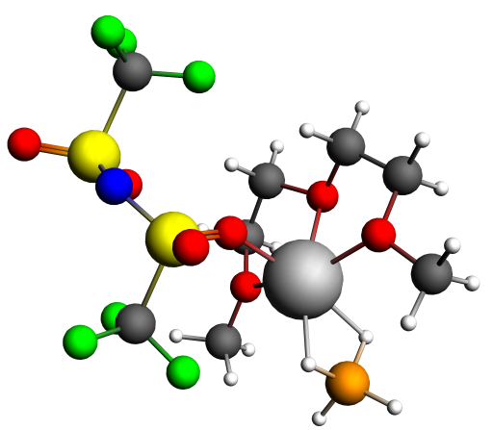
NMR Shielding ADF-GUI atom Mg(24): 548.20 ppm
Atom X Y Z (Angstrom)
1.O -0.643278 1.359463 -0.835967
2.C 0.805845 1.279481 -0.944007
3.C 1.199333 -0.053113 -0.322388
4.O 0.626593 -0.089283 1.007085
5.C 0.857467 -1.346236 1.700834
6.C -1.192352 2.663412 -1.205497
7.C -2.666548 2.643851 -0.820639
8.O -2.762616 2.139807 0.534771
9.C -4.110936 2.152210 1.068875
10.H 1.251096 2.118415 -0.394411
11.H 1.107063 1.316008 -2.000263
12.H 2.294746 -0.135330 -0.261564
13.H 0.797374 -0.894352 -0.909019
14.H 0.276999 -1.300661 2.624007
15.H 1.931261 -1.454284 1.904977
16.H 0.492838 -2.181446 1.086954
17.H -1.083610 2.817684 -2.287962
18.H -0.664364 3.442104 -0.649420
19.H -3.249231 1.982729 -1.481319
20.H -3.060771 3.668668 -0.863741
21.H -4.438978 3.192030 1.195865
22.H -4.067933 1.626818 2.025211
23.H -4.783864 1.613050 0.386630
24.Mg -1.176712 0.992336 1.213341
25.F -1.918752 2.379379 4.222917
26.F -2.490791 4.198139 3.121616
27.F -1.390416 4.366370 5.023271
28.F 1.578563 4.569781 -0.230529
29.F 2.431194 6.405634 0.646040
30.B -2.401738 -0.717277 2.275557
31.H -3.572281 -0.477327 2.469281
32.H -2.020291 -1.780828 2.706778
33.H -2.181599 -0.700419 1.042268
34.H -1.721942 0.171889 2.851946
35.N 0.480286 5.055197 2.593827
36.S 0.141221 3.555848 2.955993
37.S -0.150494 5.922786 1.370880
38.C -1.528178 3.640032 3.898431
39.C 1.310476 5.868931 0.128902
40.O -0.240575 7.314252 1.769984
41.O -1.249808 5.291736 0.637690
42.O -0.205074 2.676777 1.794015
43.O 1.093340 3.017534 3.907889
44.F 0.972187 6.547598 -0.996240

Table S3: Mg(BH4)(TFSI)(DGM)-1 + 2 DGMs
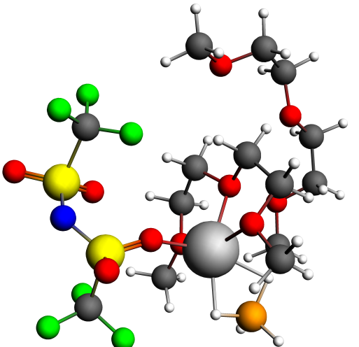

NMR Shielding ADF-GUI atom Mg(24): 549.84 ppm
Atom X Y Z (Angstrom)
1.O -0.683677 1.386980 -0.957533
2.C 0.694666 1.123884 -1.321554
3.C 1.087919 -0.121247 -0.542887
4.O 0.818309 0.150259 0.857723
5.C 1.099222 -0.984746 1.720819
6.C -1.201902 2.669857 -1.433955
7.C -2.635120 2.786102 -0.922739
8.O -2.683314 2.229768 0.423127
9.C -3.946182 2.432350 1.092393
10.H 1.316547 1.982944 -1.032925
11.H 0.756835 0.952086 -2.400907
12.H 2.157030 -0.343738 -0.677074
13.H 0.486562 -0.986522 -0.865136
14.H 0.896569 -0.654685 2.742269
15.H 2.154380 -1.271456 1.611758
16.H 0.432138 -1.819418 1.468894
17.H -1.172973 2.683992 -2.527354
18.H -0.574902 3.465161 -1.018380
19.H -3.324786 2.217109 -1.556086
20.H -2.912711 3.847838 -0.882728
21.H -4.085743 3.501867 1.295725
22.H -3.901901 1.856905 2.020149
23.H -4.762634 2.049585 0.462713
24.Mg -1.080614 1.120055 1.076887
25.F -1.920359 2.406217 4.428416
26.F -2.547972 4.216440 3.339020
27.F -1.400090 4.401005 5.211446
28.F 1.554239 4.276995 0.003268
29.F 2.392721 6.202796 0.668007
30.B -2.248758 -0.686802 2.029061
31.H -3.441447 -0.477223 1.961070
32.H -1.938255 -1.714967 2.585710
33.H -1.780408 -0.723426 0.871279
34.H -1.716771 0.248780 2.675646
35.N 0.330597 5.129260 2.689394
36.S 0.081879 3.618557 3.101141
37.S -0.224563 5.848441 1.341652
38.C -1.557213 3.670060 4.090498
39.C 1.285449 5.610423 0.181328
40.O -0.284260 7.280762 1.566052
41.O -1.311054 5.163717 0.641570
42.O -0.248905 2.702632 1.974680
43.O 1.078404 3.154694 4.047371
44.F 1.008185 6.139170 -1.044035
45.O -3.358216 0.116845 -2.695912
46.O -0.775213 0.617677 -4.252808
47.C -0.238987 1.344526 -5.365775
48.H -0.018817 0.656382 -6.203421
49.H 1.544373 2.456898 -5.836348
50.H 1.739667 1.273151 -4.506684
51.H 1.636092 4.394015 -2.730078
52.H 2.525579 4.155027 -4.274840
53.H 2.604021 2.906237 -2.988029
54.H -1.624660 -0.939950 -5.346533
55.H -2.685265 0.483749 -5.102632
56.H -1.718163 -1.180803 -2.731706
57.H -3.131469 -1.690375 -3.708335
58.C 1.054369 2.023712 -4.944808
59.H -4.536052 -1.335745 -1.737665
60.H -4.529869 0.310835 -1.028774
61.H -3.118480 -0.756389 -0.793869
62.O 0.764758 3.045638 -3.987050
63.C 1.954102 3.657637 -3.472248
64.C -1.926830 -0.159703 -4.623850
65.C -2.528779 -0.818292 -3.390528
66.C -3.908802 -0.458915 -1.498395
67.H -0.966152 2.097586 -5.716387

Table S3: Mg(BH4)(TFSI)(DGM)-1 + 4 DGMs
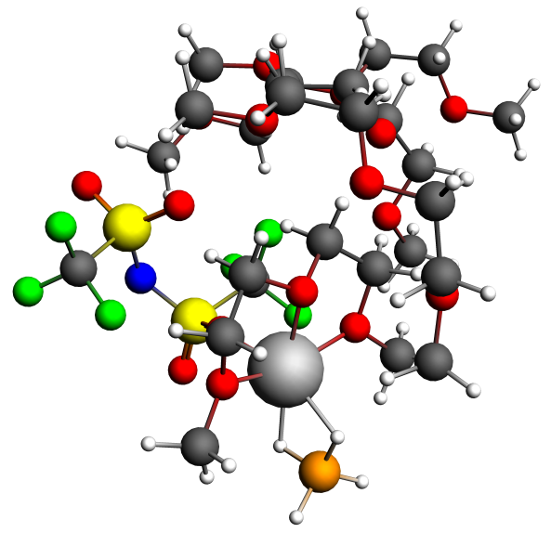
NMR Shielding ADF-GUI atom Mg(24): 549.45 ppm
Atom X Y Z (Angstrom)
1.O -2.460735 1.884852 0.561538
2.C -1.667398 1.711528 -0.641906
3.C -1.732446 0.226716 -0.968938
4.O -1.432402 -0.504660 0.247724
5.C -1.425846 -1.941488 0.074190
6.C -2.411985 3.240679 1.118471
7.C -3.218182 3.211658 2.407491
8.O -2.872789 1.976931 3.122069
9.C -3.581733 1.839864 4.373421
10.H -0.639044 2.029000 -0.438641
11.H -2.097011 2.314803 -1.449697
12.H -0.991639 -0.024372 -1.742874
13.H -2.738726 -0.062711 -1.311959
14.H -1.332865 -2.376095 1.071830
15.H -0.581561 -2.226577 -0.569579
16.H -2.375277 -2.269130 -0.374373
17.H -2.853035 3.936305 0.399539
18.H -1.364133 3.497039 1.301087
19.H -4.293343 3.191153 2.195056
20.H -2.951268 4.071012 3.029266
21.H -3.290451 2.654829 5.045738
22.H -3.313738 0.862549 4.781670
23.H -4.666179 1.872426 4.187037
24.Mg -1.987374 0.470561 2.034018
25.F -0.667918 2.485603 4.993549
26.F -0.031878 3.899612 3.417858
27.F 1.332912 3.392385 5.071147
28.F 1.417880 0.410102 -0.113125
29.F 3.610124 0.591754 -0.011646
30.B -3.014736 -1.403668 3.071806
31.H -3.669973 -1.249020 4.079437
32.H -2.922562 -2.553377 2.700237
33.H -3.542382 -0.740366 2.152990
34.H -1.851616 -0.989700 3.299521
35.N 2.329664 2.011168 2.462957
36.S 1.053089 1.436997 3.229312
37.S 2.289830 2.736667 1.017893
38.C 0.377512 2.915332 4.242010
39.C 2.465023 1.273911 -0.215318
40.O 3.516899 3.495462 0.841081
41.O 1.010404 3.347383 0.644115
42.O -0.095261 1.114682 2.340258
43.O 1.444292 0.449644 4.215291
44.F 2.470880 1.774917 -1.484217
45.O -5.590686 2.329218 0.372047
46.O -4.210330 3.698099 -1.952088
47.C -3.823170 4.981812 -2.454600
48.H -4.470889 5.274325 -3.302156
49.H -2.143372 5.861114 -3.471125
50.H -2.280210 4.085429 -3.665586
51.H 0.460707 4.469112 -1.352494
52.H 0.190448 5.475799 -2.817368
53.H -0.024899 3.696542 -2.897777
54.H -6.199482 3.769784 -2.574730
55.H -5.886903 4.454321 -0.947252
56.H -5.375215 1.506881 -1.538699
57.H -7.020249 2.088376 -1.131449
58.C -2.386544 4.918115 -2.945371
59.H -6.606878 0.574248 0.928879
60.H -5.278186 1.131342 2.001289
61.H -4.889825 0.354980 0.444947
62.O -1.507949 4.730046 -1.834250
63.C -0.142349 4.586157 -2.254171
64.C -5.613869 3.643636 -1.645332
65.C -5.940292 2.298827 -1.013388
66.C -5.598319 1.023198 0.960895
67.H -3.921862 5.746821 -1.663535
68.C 3.410678 5.466043 3.772796
69.O -2.363000 9.020843 6.976126
70.O -0.049191 8.372921 5.318573
71.C 1.337135 8.273350 4.958435
72.H 1.551562 8.930201 4.097188
73.H 0.962040 6.493272 3.780036
74.H 1.499608 6.163689 5.454776
75.H 4.426775 5.538438 3.372511
76.H 2.752301 5.045915 2.997796
77.H 3.399786 4.797881 4.648080
78.H -0.057687 10.433648 4.986403
79.H 0.100090 9.933066 6.699991
80.H -2.380273 9.483313 4.939100
81.H -2.160163 10.879305 6.042968
82.C 1.638629 6.824718 4.582549
83.H -4.150984 10.088999 7.246911
84.H -4.065472 8.432805 7.938286
85.H -4.263956 8.657741 6.168161
86.O 3.002148 6.794481 4.133461
87.C -0.391020 9.694188 5.739390
88.C -1.899922 9.816683 5.876928
89.C -3.788843 9.057810 7.082386
90.H 1.978120 8.584980 5.801601
91.C 1.649469 6.936680 1.080662
92.O -2.190790 5.264345 4.922896
93.O -2.576893 6.296092 2.128887
94.C -2.074188 6.822687 0.888864
95.H -2.686314 6.366893 0.101185
96.H -0.440948 6.722919 -0.492664
97.H -0.444165 5.406697 0.707342
98.H 2.276580 7.441637 1.821541
99.H 1.895996 7.291201 0.062968
100.H 1.833953 5.853345 1.126750
101.H -2.450533 8.111583 3.150616
102.H -1.049085 7.040406 3.369194
103.H -3.863762 6.419873 4.429557
104.H -2.566235 7.263162 5.347489
105.C -0.618664 6.484187 0.572907
106.H -2.173299 5.709158 6.968338
107.H -2.011731 3.981788 6.502368
108.H -3.609816 4.794055 6.401839
109.O 0.279162 7.239226 1.400461
110.C -2.138075 7.057844 3.278128
111.C -2.769079 6.531865 4.552247
112.C -2.518216 4.925042 6.273858
113.H -2.209695 7.919526 0.862413

Table S3: Mg(BH4)(TFSI)(DGM)-1 + 6 DGMs
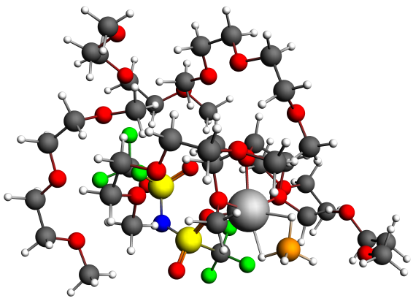
NMR Shielding ADF-GUI atom Mg(24): 547.99 ppm
Atom X Y Z (Angstrom)
1.O -1.926966 1.641757 2.053659
2.C -0.643276 1.965791 1.441727
3.C 0.334586 0.978726 2.043681
4.O 0.147318 1.013303 3.493522
5.C 1.049431 0.110523 4.187393
6.C -3.066972 2.404553 1.571186
7.C -4.229846 1.922929 2.420400
8.O -3.814162 1.995171 3.811474
9.C -4.855171 1.491862 4.705221
10.H -0.385947 3.001782 1.694848
11.H -0.715457 1.845305 0.357202
12.H 1.368620 1.248372 1.815508
13.H 0.143034 -0.041229 1.692037
14.H 0.775924 0.148883 5.243720
15.H 2.076909 0.438610 4.008865
16.H 0.913825 -0.909322 3.804340
17.H -3.225106 2.191090 0.507275
18.H -2.872005 3.474572 1.715035
19.H -4.473821 0.874512 2.183578
20.H -5.118961 2.549226 2.277598
21.H -5.734332 2.132719 4.628103
22.H -4.440343 1.501305 5.711597
23.H -5.097444 0.459751 4.426139
24.Mg -1.779368 1.558909 4.108845
25.F -3.222460 3.521169 6.598783
26.F -3.747503 5.148749 5.209873
27.F -2.843999 5.620300 7.158724
28.F 0.829066 5.026825 2.426128
29.F 1.287630 7.168621 2.685650
30.B -2.098589 -0.263301 5.590690
31.H -3.125771 -0.500520 6.178840
32.H -1.181783 -1.008187 5.844769
33.H -2.328408 -0.320947 4.370740
34.H -1.748716 0.897278 5.914409
35.N -0.854617 6.026189 4.702554
36.S -1.106437 4.611850 5.359633
37.S -1.285557 6.477743 3.201077
38.C -2.849907 4.742135 6.133814
39.C 0.363301 6.290910 2.258296
40.O -1.592426 7.895424 3.199048
41.O -2.185275 5.557162 2.507734
42.O -1.273156 3.490628 4.394614
43.O -0.203469 4.377395 6.468353
44.F 0.124177 6.506617 0.944157
45.O -2.412436 -0.832679 0.394225
46.O -1.068492 0.731456 -1.673658
47.C -1.527082 1.582507 -2.735622
48.H -1.084582 1.266825 -3.698394
49.H -1.434438 3.647009 -3.304899
50.H -0.034657 3.106176 -2.342248
51.H -2.084000 5.128485 -0.097347
52.H -2.273031 5.410343 -1.856107
53.H -0.648418 5.234183 -1.163521
54.H -0.918982 -1.143552 -2.586145
55.H -2.577083 -0.630738 -2.142579
56.H -0.397936 -1.205378 -0.056850
57.H -1.558834 -2.429024 -0.655223
58.C -1.130653 3.020220 -2.446233
59.H -2.560632 -2.566253 1.562478
60.H -3.189418 -1.040607 2.272265
61.H -1.437562 -1.316560 2.189513
62.O -1.777246 3.454878 -1.248289
63.C -1.685869 4.891802 -1.086819
64.C -1.521426 -0.620902 -1.821175
65.C -1.404873 -1.344674 -0.489454
66.C -2.391634 -1.479430 1.668075
67.H -2.625342 1.508111 -2.815121
68.C 2.578646 3.325815 4.238951
69.O 1.621277 -2.036535 1.473589
70.O 3.691449 0.039467 2.020615
71.C 4.314481 1.288616 1.680858
72.H 5.379992 1.129449 1.429837
73.H 4.776185 3.158974 2.663110
74.H 4.616031 1.756094 3.769720
75.H 1.496367 3.350982 4.380328
76.H 2.959705 4.344424 4.111785
77.H 3.047997 2.847423 5.115999
78.H 4.703380 -1.068938 0.567561
79.H 3.099767 -0.440081 0.073374
80.H 3.477069 -2.502929 2.314456
81.H 3.271554 -2.962364 0.594601
82.C 4.201681 2.236953 2.863813
83.H 1.195712 -4.077671 1.241035
84.H -0.067212 -3.054581 2.004921
85.H 1.392382 -3.522128 2.936089
86.O 2.820805 2.539483 3.057066
87.C 3.671634 -0.871581 0.915426
88.C 3.043651 -2.186219 1.348804
89.C 1.007851 -3.243871 1.940118
90.H 3.813379 1.727912 0.800775
91.C 2.844938 6.122400 6.303326
92.O 2.416653 4.941745 -0.002231
93.O 4.199782 5.781955 2.329884
94.C 4.580455 6.914456 3.128183
95.H 5.633630 7.182407 2.919457
96.H 4.964799 7.340328 5.203783
97.H 4.913137 5.594953 4.807653
98.H 1.764314 6.072007 6.459790
99.H 3.302121 6.839407 7.008455
100.H 3.284178 5.124135 6.477571
101.H 5.426007 6.214642 0.697869
102.H 3.793171 6.951683 0.642170
103.H 4.121476 3.928073 0.665478
104.H 4.314010 4.834230 -0.865039
105.C 4.438082 6.573939 4.603149
106.H 2.163846 3.102015 -0.993735
107.H 0.715432 3.838473 -0.246002
108.H 1.957466 3.072739 0.794148
109.O 3.054893 6.536853 4.947654
110.C 4.356394 6.045499 0.928522
111.C 3.841508 4.851356 0.135625
112.C 1.785201 3.659210 -0.117930
113.H 3.941084 7.779550 2.882080
114.C -4.511296 6.961777 0.247666
115.O 0.774870 5.972078 -3.211441
116.O -0.813968 7.830418 -1.536928
117.C -1.757909 8.882441 -1.300700
118.H -1.224860 9.789792 -0.959954
119.H -3.294735 9.340093 0.132522
120.H -2.189587 8.030720 0.634411
121.H -5.171322 6.233399 -0.236334
122.H -5.122979 7.763499 0.701238
123.H -3.930108 6.470040 1.041505
124.H 0.648953 9.166579 -2.179805
125.H -0.271841 8.356064 -3.484632
126.H 1.613827 6.893140 -1.537623
127.H 2.120187 7.567240 -3.124446
128.C -2.736693 8.452685 -0.223003
129.H 2.582998 5.455086 -4.135235
130.H 1.389867 4.137931 -3.870735
131.H 2.338529 4.784002 -2.488557
132.O -3.649183 7.487038 -0.767386
133.C 0.180861 8.211086 -2.486392
134.C 1.267833 7.153039 -2.551874
135.C 1.836094 5.038440 -3.434755
136.H -2.299984 9.126949 -2.232138
137.C -6.309886 -1.150150 6.318687
138.H -9.663006 1.874909 6.214320
139.H -8.122038 2.270701 7.040581
140.H -8.390614 -0.119453 5.144010
141.H -8.771610 -0.230863 6.891961
142.C -7.713964 4.460945 3.725138
143.H -6.814948 -1.809668 7.046512
144.H -5.232280 -1.132142 6.510567
145.H -6.494623 -1.540356 5.301383
146.O -6.286486 4.367751 3.757917
147.C -8.562566 1.783869 6.152644
148.C -8.172863 0.314340 6.137801
149.H -7.791836 4.268304 5.871160
150.C -5.673812 5.091930 2.684507
151.O -6.779144 0.197523 6.436215
152.O -8.087466 2.416718 4.955397
153.C -8.288630 3.835197 4.984939
154.H -9.369191 4.065840 5.042488
155.H -8.023884 5.521852 3.686069
156.H -8.111908 3.951154 2.828164
157.H -4.592258 4.994119 2.800177
158.H -5.949487 6.159126 2.723074
159.H -5.983581 4.686682 1.704923

Table S3: Mg(BH4)(TFSI)(DGM)-2
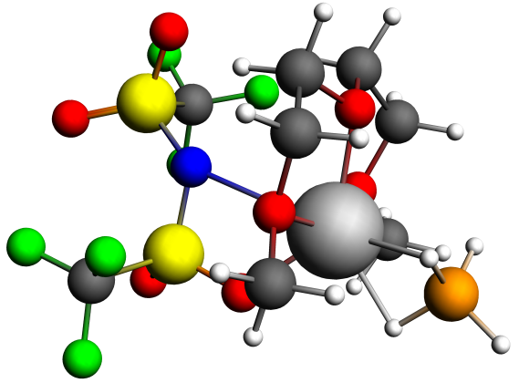
NMR Shielding ADF-GUI atom Mg(24): 559.66 ppm
Atom X Y Z (Angstrom)
1.O 0.316577 -0.044188 0.289386
2.C 1.745253 0.160373 0.476698
3.C 2.092098 -0.560577 1.770551
4.O 1.210700 -0.029309 2.791215
5.C 1.379626 -0.665010 4.083983
6.C -0.257220 0.685558 -0.831728
7.C -1.766705 0.614093 -0.652690
8.O -2.063062 1.097785 0.685190
9.C -3.487786 1.112737 0.968508
10.H 1.945825 1.237107 0.544553
11.H 2.298057 -0.277606 -0.366457
12.H 3.138251 -0.367896 2.049658
13.H 1.919659 -1.643913 1.676661
14.H 0.676611 -0.172931 4.760731
15.H 2.409127 -0.512478 4.433742
16.H 1.142269 -1.734583 4.005783
17.H 0.036329 0.202230 -1.774788
18.H 0.105195 1.717807 -0.810554
19.H -2.128906 -0.421539 -0.738060
20.H -2.263792 1.256153 -1.392738
21.H -3.990184 1.769658 0.245799
22.H -3.596875 1.509515 1.981075
23.H -3.883674 0.089635 0.919098
24.Mg -0.773528 0.226053 2.103532
25.F 0.502687 3.287519 5.672223
26.F 1.645700 4.523020 4.249688
27.F 1.940735 2.343691 4.296553
28.F -1.793287 5.177554 0.684731
29.F -1.390307 3.652909 -0.848047
30.B -1.878304 -1.731778 2.502143
31.H -2.325327 -1.542998 1.374901
32.H -2.382398 -2.671057 3.063184
33.H -0.651546 -1.892873 2.422094
34.H -2.108092 -0.711995 3.196699
35.N 0.291449 2.964803 1.713099
36.S -0.398354 3.148380 3.149020
37.S 0.755351 4.204612 0.748377
38.C 1.028898 3.341363 4.424694
39.C -0.860017 4.713478 -0.167377
40.O 1.564979 3.599154 -0.306822
41.O 1.187785 5.409571 1.435229
42.O -1.263561 4.286385 3.393457
43.O -0.935820 1.787625 3.463413
44.F -0.550969 5.678971 -1.064259

Table S2: Mg(BH4)(TFSI)(DGM)-2 + 2 DGMs
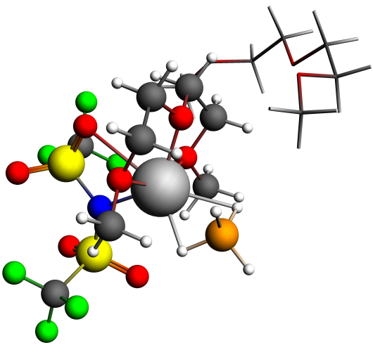
NMR Shielding ADF-GUI atom Mg(24): 557.80 ppm

Atom X Y Z (Angstrom)
1.O 1.286289 1.244150 -1.118534
2.C 2.719326 1.400587 -1.028635
3.C 3.146954 0.582752 0.182029
4.O 2.361161 1.041460 1.312840
5.C 2.642434 0.270357 2.512636
6.C 0.622590 2.085546 -2.111474
7.C -0.860946 1.853361 -1.916363
8.O -1.153439 2.119343 -0.507154
9.C -2.551458 1.886106 -0.197110
10.H 2.964624 2.462453 -0.897144
11.H 3.196441 1.009281 -1.939857
12.H 4.216067 0.733991 0.392632
13.H 2.937407 -0.485761 0.021811
14.H 2.046246 0.710940 3.312457
15.H 3.712837 0.348238 2.748952
16.H 2.345771 -0.774855 2.353537
17.H 0.914455 1.764808 -3.118171
18.H 0.897875 3.131407 -1.923065
19.H -1.121141 0.813417 -2.140825
20.H -1.435945 2.531134 -2.554682
21.H -3.168808 2.585608 -0.776172
22.H -2.675369 2.059311 0.874039
23.H -2.812997 0.846638 -0.438095
24.Mg 0.294827 1.263029 0.756025
25.F -0.885964 2.725069 6.017950
26.F 0.944405 3.478560 5.050251
27.F 0.403298 1.349985 4.875490
28.F -0.970924 6.480083 1.553204
29.F -1.883644 4.705749 0.626725
30.B -0.296557 -0.954738 1.000361
31.H -0.951674 -0.479340 0.068418
32.H -0.806895 -1.967371 1.411523
33.H 0.859892 -1.126305 0.627178
34.H -0.296862 -0.141896 1.958222
35.N -0.037228 2.924870 2.132292
36.S -1.133784 2.997562 3.365433
37.S 0.695661 4.297930 1.577082
38.C -0.087806 2.618648 4.931342
39.C -0.733509 5.399070 0.793376
40.O 1.458795 3.835748 0.414722
41.O 1.310455 5.142025 2.583694
42.O -1.656848 4.337862 3.581877
43.O -2.005849 1.840816 3.225777
44.F -0.311349 5.816594 -0.433200
45.C -1.181068 -0.764726 -4.654452
46.O -2.359892 4.187634 -3.717659
47.O -2.232923 1.406973 -4.706041
48.C -1.618503 0.403536 -5.526813
49.H -2.341725 0.041527 -6.281240
50.H -1.010391 -1.652492 -5.291648
51.H -1.986899 -1.003637 -3.937025
52.H 1.269445 -1.050439 -2.461514
53.H 0.497221 -2.389664 -3.384633
54.H -0.442594 -1.442633 -2.175335
55.H -3.368594 2.238749 -6.250176
56.H -1.786075 3.026358 -5.953378
57.H -4.077857 3.010686 -3.914076
58.H -3.876359 4.293065 -5.150264
59.H -3.573908 5.812536 -3.170724
60.H -2.155430 5.452450 -2.125537
61.H -3.612715 4.411973 -2.049348
62.O 0.023209 -0.422718 -3.957597
63.C 0.347421 -1.389444 -2.942017
64.C -2.653293 2.547324 -5.464783
65.C -3.339260 3.542046 -4.541749
66.C -2.965786 5.012690 -2.713159
67.H -0.744233 0.821357 -6.057335

Table S3: Mg(BH4)(TFSI)(DGM)-2 + 4 DGMs
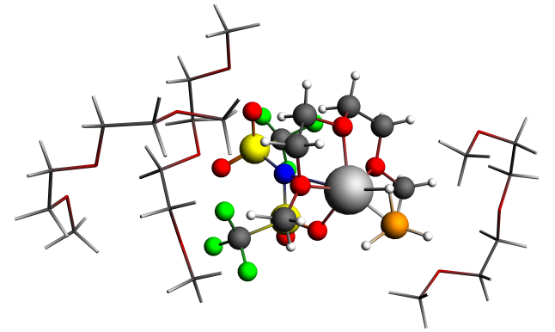

NMR Shielding ADF-GUI atom Mg(24): 560.38 ppm
Atom X Y Z (Angstrom)
1.O 0.418662 1.083719 2.526549
2.C 1.016221 2.404545 2.331488
3.C 0.262056 3.363206 3.230887
4.O -1.148708 3.181556 2.933358
5.C -1.987138 4.226272 3.489365
6.C 0.844575 0.120837 1.522462
7.C -0.041465 -1.104962 1.679177
8.O -1.411680 -0.633365 1.747030
9.C -2.378056 -1.720326 1.799787
10.H 0.901664 2.685566 1.279657
11.H 2.081328 2.378379 2.592513
12.H 0.557274 4.390372 2.996904
13.H 0.428001 3.136070 4.296673
14.H -3.017359 3.946915 3.262525
15.H -1.729772 5.175683 3.008939
16.H -1.853531 4.265494 4.579975
17.H 1.898251 -0.147266 1.690438
18.H 0.729683 0.572038 0.531694
19.H 0.187109 -1.676700 2.587989
20.H 0.076636 -1.755745 0.799682
21.H -2.312893 -2.296771 0.865703
22.H -3.364192 -1.270198 1.905493
23.H -2.178206 -2.357968 2.667283
24.Mg -1.724083 1.186166 2.745992
25.F -4.216927 4.445743 1.023006
26.F -3.705243 4.559402 -1.113136
27.F -2.126047 4.764827 0.402596
28.F -1.976205 0.289778 -2.768470
29.F -0.193862 -0.366145 -1.652587
30.B -2.674923 0.812190 4.787097
31.H -3.050216 0.126242 3.821673
32.H -2.997735 0.235634 5.797641
33.H -1.430540 0.897124 4.755586
34.H -3.154149 1.931783 4.681872
35.N -1.427244 1.985439 -0.125138
36.S -3.009469 2.208637 0.069453
37.S -0.641793 2.304506 -1.514040
38.C -3.272304 4.140687 0.090336
39.C -0.713080 0.624569 -2.438716
40.O 0.775545 2.434553 -1.179512
41.O -1.288210 3.266711 -2.395746
42.O -3.930782 1.698838 -0.930205
43.O -3.252062 1.803119 1.485586
44.F 0.033322 0.707248 -3.567963
45.C 2.647050 5.848832 0.948418
46.H 1.055890 6.196959 -0.458796
47.H 1.038758 4.576170 0.271679
48.H 2.767605 6.863776 1.361785
49.H 3.339407 5.722830 0.095527
50.C -1.049716 7.795262 2.490518
51.H 5.043014 5.086794 1.809224
52.H 4.405532 4.365419 3.323071
53.H 4.248877 6.133327 3.036554
54.O -2.340271 7.325627 2.053769
55.C 1.208974 5.637797 0.480305
56.C 4.236701 5.136867 2.562418
57.H -0.344647 7.766240 0.452361
58.C -3.332010 7.503562 3.062676
59.O 2.960070 4.875124 1.968326
60.O 0.243203 6.037428 1.462624
61.C 0.000662 7.460630 1.451708
62.H 0.910709 8.018753 1.705505
63.H -1.065929 8.884411 2.640082
64.H -0.782426 7.318821 3.451534
65.H -4.275582 7.115929 2.663170
66.H -3.452109 8.570974 3.327717
67.H -3.069352 6.945997 3.981458
68.C -5.462004 -3.104098 4.088625
69.H -4.851829 -5.179689 4.197033
70.H -4.370013 -4.335710 2.690878
71.H -5.321121 -2.777006 5.134073
72.H -6.496937 -3.479979 3.975502
73.C -0.885677 -4.466285 4.754179
74.H -6.932217 -0.909293 3.722496
75.H -5.611640 -0.036310 2.871133
76.H -5.409047 -0.475918 4.591701
77.O -0.286280 -3.219267 4.378613
78.C -4.476178 -4.224623 3.785044
79.C -5.837206 -0.794422 3.628039
80.H -1.993047 -4.735807 2.905835
81.C -0.820713 -2.074094 5.090469
82.O -5.230331 -2.019026 3.185291
83.O -3.211164 -3.904232 4.382677
84.C -2.170312 -4.804540 3.995255
85.H -2.453855 -5.850010 4.232128
86.H -0.146884 -5.247548 4.524065
87.H -1.091485 -4.482427 5.838840
88.H -0.207294 -1.214401 4.803863
89.H -0.741733 -2.231196 6.179246
90.H -1.866486 -1.878350 4.830995
91.C 2.181665 9.021230 4.638697
92.H 2.418774 11.142732 4.338403
93.H 2.998737 10.134980 2.973460
94.H 1.254863 9.037222 5.240002
95.H 3.045449 9.056015 5.329098
96.C -0.489043 11.414003 1.466381
97.H 2.566371 6.492688 5.421835
98.H 1.915731 5.824493 3.879776
99.H 0.846372 6.757809 4.980359
100.O -0.454526 10.388214 0.471202
101.C 2.202373 10.242892 3.731746
102.C 1.870762 6.661826 4.579507
103.H 1.670016 11.400680 1.442930
104.C -1.758905 10.096420 -0.050537
105.O 2.233283 7.834120 3.838151
106.O 0.924408 10.363047 3.100205
107.C 0.852869 11.462034 2.183353
108.H 0.945311 12.419475 2.729676
109.H -0.694231 12.395430 0.998414
110.H -1.285813 11.210755 2.206028
111.H -1.627420 9.343454 -0.834192
112.H -2.225889 10.999507 -0.482376
113.H -2.411505 9.680334 0.735238

Table S3: Mg(BH4)(TFSI)(DGM)-2 + 6 DGMs
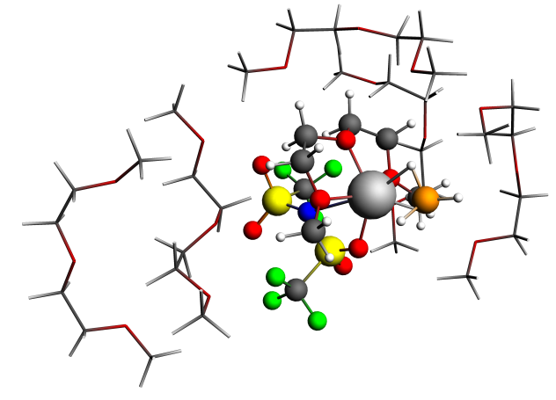
NMR Shielding ADF-GUI atom Mg(24): 561.87 ppm
Atom X Y Z (Angstrom)
1.O -0.839366 1.710146 3.736717
2.C 0.301877 2.596839 3.584349
3.C 0.083783 3.774475 4.523488
4.O -1.281574 4.229840 4.321602
5.C -1.575196 5.481820 4.999865
6.C -0.891283 0.677905 2.702708
7.C -2.273223 0.047284 2.742186
8.O -3.244053 1.120559 2.866941
9.C -4.612276 0.709907 2.581040
10.H 0.354356 2.932548 2.544139
11.H 1.224686 2.059035 3.837577
12.H 0.782500 4.582717 4.268732
13.H 0.203902 3.482631 5.578935
14.H -2.631099 5.688181 4.811471
15.H -0.944199 6.274374 4.579780
16.H -1.411479 5.361898 6.080552
17.H -0.118907 -0.062122 2.919174
18.H -0.695374 1.155733 1.738223
19.H -2.378504 -0.635864 3.589761
20.H -2.465574 -0.489850 1.807890
21.H -4.695592 0.456766 1.519278
22.H -5.237379 1.567628 2.831668
23.H -4.890003 -0.151216 3.195210
24.Mg -2.672326 2.659059 4.121464
25.F -4.556181 6.613715 2.083771
26.F -3.374434 6.571935 0.230324
27.F -2.355736 6.540331 2.182250
28.F -3.254643 2.386684 -1.610168
29.F -2.223656 0.999510 -0.240296
30.B -3.621801 2.344144 6.161648
31.H -4.390193 2.122212 5.213230
32.H -4.119569 1.946788 7.187584
33.H -2.562772 1.722255 5.962576
34.H -3.371546 3.549097 6.199777
35.N -2.068613 3.612959 1.313555
36.S -3.542518 4.185912 1.531787
37.S -1.293222 3.554269 -0.114005
38.C -3.439128 6.111508 1.495005
39.C -2.068989 2.062994 -1.064535
40.O 0.059687 3.085955 0.177612
41.O -1.496952 4.711273 -0.977407
42.O -4.578619 3.844570 0.567914
43.O -3.841066 3.945147 2.970243
44.F -1.211519 1.709566 -2.062233
45.C 1.923937 5.577754 1.154865
46.H -0.069290 6.327897 0.910253
47.H 0.069476 5.031643 2.112176
48.H 2.504400 6.492258 0.955120
49.H 1.790240 5.012993 0.217665
50.C 0.856068 9.169054 3.525330
51.H 4.006027 3.995309 0.713714
52.H 4.471150 3.913468 2.443011
53.H 4.526162 5.485926 1.570936
54.O -0.422742 9.295634 4.181341
55.C 0.555658 5.930042 1.725921
56.C 3.984444 4.531241 1.679704
57.H -0.124758 8.491323 1.730268
58.C -0.353939 10.227270 5.256863
59.O 2.639628 4.757751 2.110145
60.O 0.617799 6.865572 2.815820
61.C 0.748774 8.225930 2.347098
62.H 1.659546 8.345228 1.746216
63.H 1.190482 10.147937 3.148587
64.H 1.607339 8.791364 4.241828
65.H -1.350155 10.282211 5.710713
66.H -0.060325 11.233125 4.896904
67.H 0.379631 9.908268 6.021354
68.C -8.338427 -0.785962 2.940788
69.H -8.439171 -2.942192 3.040708
70.H -7.314916 -2.300355 1.804164
71.H -8.428651 -0.505659 4.005565
72.H -9.353904 -0.823171 2.502389
73.C -4.694912 -3.531467 4.576030
74.H -9.006512 1.668459 2.140472
75.H -7.299827 2.168086 1.891911
76.H -7.884730 1.773428 3.540859
77.O -3.727414 -2.475803 4.653491
78.C -7.687869 -2.157415 2.832324
79.C -7.962975 1.517316 2.470638
80.H -5.243508 -3.171877 2.506649
81.C -4.143190 -1.382602 5.511459
82.O -7.536465 0.170081 2.235822
83.O -6.610213 -2.255346 3.773461
84.C -5.738201 -3.356244 3.472106
85.H -6.320830 -4.297804 3.405581
86.H -4.135739 -4.451858 4.348946
87.H -5.201450 -3.662211 5.548321
88.H -3.350824 -0.632625 5.482024
89.H -4.266463 -1.744058 6.546658
90.H -5.087004 -0.944479 5.168157
91.C 4.858059 9.203868 2.307482
92.H 5.206874 10.848630 0.952045
93.H 4.282659 9.485718 0.242443
94.H 4.767335 9.770375 3.251520
95.H 5.918308 8.915880 2.174489
96.C 1.295695 12.070429 0.889925
97.H 5.071288 6.959485 3.809108
98.H 3.334834 6.547187 3.542667
99.H 3.782860 8.050346 4.421393
100.O 0.331187 11.015445 0.875191
101.C 4.421121 10.095387 1.153360
102.C 4.061909 7.361749 3.605185
103.H 2.512443 10.899753 -0.456837
104.C -0.884974 11.385840 1.534497
105.O 4.024561 8.040870 2.342125
106.O 3.195144 10.739870 1.513876
107.C 2.643599 11.520747 0.447028
108.H 3.319554 12.361482 0.199811
109.H 0.986464 12.885565 0.208045
110.H 1.394621 12.490245 1.908508
111.H -1.553956 10.521912 1.482224
112.H -1.355597 12.256249 1.042381
113.H -0.697614 11.625490 2.595577
114.C -2.981934 -3.101291 1.103958
115.C -4.602915 -2.286602 -0.498726
116.C -6.133635 1.063388 -0.907146
117.H -3.328722 -4.116601 0.837919
118.C -0.448279 -2.766537 -1.597345
119.O -5.122971 0.044466 -0.836217
120.O -3.983678 -2.126360 0.795693
121.H -2.849228 -3.042560 2.192409
122.H -0.858220 -3.442154 0.961090
123.H -1.367642 -1.775058 0.570012
124.H -0.536514 -3.047309 -2.652047
125.H 0.428742 -3.273505 -1.154147
126.H -0.305455 -1.674683 -1.515508
127.C -5.703314 -1.249408 -0.645051
128.H -5.046596 -3.297778 -0.568315
129.H -3.859799 -2.175636 -1.299552
130.H -6.343197 -1.242140 0.253453
131.H -6.329145 -1.520829 -1.518579
132.C -1.629605 -2.839361 0.446302
133.H -6.762497 0.925829 -1.806442
134.H -5.618945 2.025842 -0.952662
135.H -6.777533 1.028486 -0.014654
136.O -1.659307 -3.173236 -0.946838
137.C 1.578580 -1.975896 1.933370
138.C 0.002053 -2.654381 3.594746
139.C -0.983062 -0.930840 6.717559
140.H 0.700472 -1.762929 1.305468
141.C 2.919669 1.436305 1.395615
142.O -0.710433 -1.153079 5.330389
143.O 1.221992 -1.949957 3.321196
144.H 1.968291 -2.973806 1.656417
145.H 3.095420 -1.112040 0.671317
146.H 3.428805 -0.964333 2.428436
147.H 2.343805 2.364835 1.419481
148.H 3.390092 1.314717 0.402883
149.H 3.716560 1.476025 2.160216
150.C -0.352794 -2.510249 5.066099
151.H 0.113445 -3.728400 3.352796
152.H -0.816950 -2.247322 2.982276
153.H 0.510579 -2.811146 5.688597
154.H -1.209105 -3.173945 5.286902
155.C 2.636027 -0.915349 1.659504
156.H -1.778809 -1.607317 7.076213
157.H -1.324450 0.104931 6.813125
158.H -0.075195 -1.093042 7.326335
159.O 2.006690 0.368265 1.662999

Table S3: Mg(BH4)(TFSI)(DGM)-3
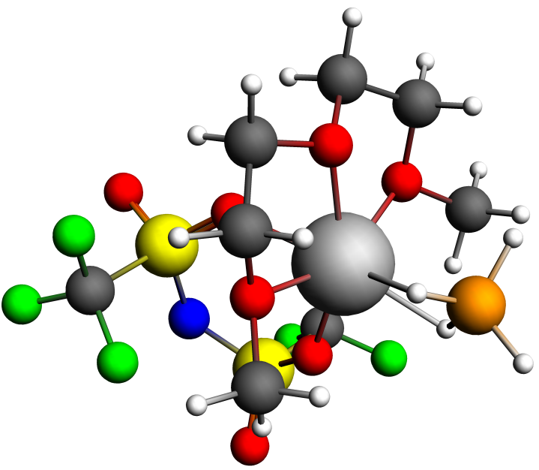
NMR Shielding ADF-GUI atom Mg(24): 569.76 ppm
Atom X Y Z (Angstrom)
1.O -0.429487 0.264915 -0.253581
2.C 0.761106 0.645144 -0.984271
3.C 1.927073 0.376876 -0.040225
4.O 1.691765 1.126883 1.178947
5.C 2.667548 0.826779 2.213155
6.C -1.692745 0.596722 -0.879117
7.C -2.757061 0.242444 0.150554
8.O -2.462057 0.983532 1.364222
9.C -3.363557 0.616704 2.447408
10.H 0.704175 1.707380 -1.253293
11.H 0.859971 0.027639 -1.889085
12.H 2.870745 0.709237 -0.496937
13.H 1.977775 -0.694030 0.206786
14.H 2.403795 1.449146 3.071787
15.H 3.671749 1.084838 1.851253
16.H 2.601297 -0.235893 2.481808
17.H -1.832681 -0.004260 -1.789673
18.H -1.710221 1.668012 -1.122693
19.H -2.721538 -0.832582 0.381978
20.H -3.755063 0.523318 -0.217910
21.H -4.390151 0.886672 2.163632
22.H -3.050964 1.186038 3.323334
23.H -3.267621 -0.456834 2.650420
24.Mg -0.365099 1.037565 1.769954
25.F -2.627262 3.160363 4.844854
26.F -2.918830 3.721740 2.732805
27.F -2.583354 5.281716 4.252904
28.F 2.506819 3.813250 1.634307
29.F 2.319500 5.658018 0.456704
30.B -0.445823 -1.129932 2.826929
31.H -1.402658 -1.573974 2.209653
32.H -0.055004 -1.855640 3.713767
33.H 0.480811 -0.929620 2.034209
34.H -0.781789 -0.056443 3.369121
35.N -0.165608 4.862358 2.321625
36.S -0.365284 3.891070 3.578349
37.S -0.023869 4.363402 0.806314
38.C -2.253234 4.033459 3.875848
39.C 1.884588 4.389182 0.577848
40.O -0.522015 5.350072 -0.130238
41.O -0.405869 2.952386 0.573936
42.O -0.191978 2.436745 3.304028
43.O 0.267168 4.416476 4.768544
44.F 2.213084 3.701473 -0.552910

Table S3: Mg(BH4)(TFSI)(DGM)-3 + 2 DGMs
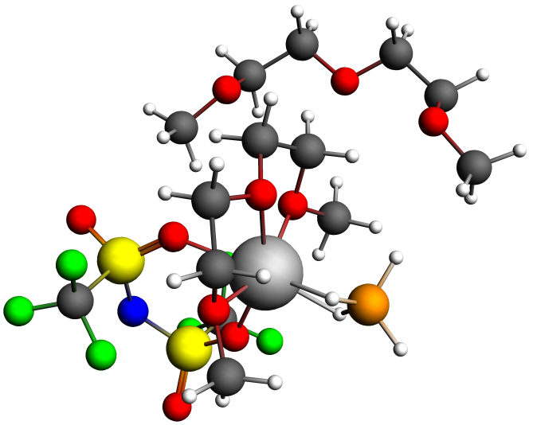
NMR Shielding ADF-GUI atom Mg(24): 568.02 ppm
Atom X Y Z (Angstrom)
1.O 1.753789 -0.187764 2.869543
2.C 2.981691 0.344612 2.331050
3.C 3.357554 1.510342 3.238513
4.O 2.235264 2.428947 3.266225
5.C 2.418433 3.499506 4.230850
6.C 1.085114 -1.206664 2.073174
7.C -0.234619 -1.463972 2.773263
8.O -0.938704 -0.181401 2.846551
9.C -2.213558 -0.315349 3.540332
10.H 2.819851 0.681058 1.298958
11.H 3.771907 -0.420773 2.359319
12.H 4.245177 2.030975 2.849940
13.H 3.545534 1.149277 4.260816
14.H 1.530530 4.132099 4.159989
15.H 3.317007 4.074775 3.969834
16.H 2.497472 3.074551 5.240427
17.H 1.692988 -2.122582 2.055256
18.H 0.933725 -0.830654 1.053391
19.H -0.070917 -1.826599 3.794809
20.H -0.847558 -2.171137 2.207899
21.H -2.813883 -1.076546 3.030026
22.H -2.693673 0.664066 3.495319
23.H -2.027424 -0.591815 4.583152
24.Mg 0.359122 1.378326 3.375591
25.F -3.691227 3.235084 3.157930
26.F -3.054863 2.017883 1.433108
27.F -3.878808 4.037640 1.115349
28.F 1.938023 4.552642 1.359718
29.F 1.968392 4.639655 -0.835278
30.B 0.191536 0.916601 5.745606
31.H -0.054275 -0.278797 5.760818
32.H 0.204269 1.433937 6.842129
33.H 1.301868 1.083927 5.222121
34.H -0.687027 1.494013 5.078642
35.N -0.818239 3.824540 0.584353
36.S -1.358179 4.013492 2.081398
37.S 0.291430 2.757227 0.146114
38.C -3.119618 3.282626 1.931559
39.C 1.900436 3.812347 0.226309
40.O 0.149508 2.400599 -1.253009
41.O 0.526861 1.658224 1.103887
42.O -0.731148 3.140522 3.109322
43.O -1.541525 5.408252 2.423968
44.F 2.984955 2.986221 0.208183
45.C -2.839313 -2.435554 -0.223610
46.H -3.785451 -4.301574 0.304426
47.H -1.996434 -4.320345 0.405944
48.H -3.602428 -1.727795 0.147648
49.H -3.070205 -2.671712 -1.279442
50.C -3.019711 -4.095426 4.294660
51.H -1.755185 -0.569166 -1.765599
52.H -0.455643 -0.182242 -0.594573
53.H -2.157949 0.141783 -0.164334
54.O -1.831035 -3.406115 4.687013
55.C -2.897870 -3.712402 0.600268
56.C -1.480471 -0.545004 -0.696877
57.H -1.946447 -5.052804 2.680776
58.C -1.924285 -2.884076 6.020471
59.O -1.532236 -1.861024 -0.120926
60.O -2.979077 -3.371899 1.992088
61.C -2.903583 -4.525224 2.840443
62.H -3.729290 -5.223051 2.607035
63.H -3.169726 -4.994698 4.922298
64.H -3.900922 -3.438646 4.415769
65.H -1.023503 -2.288097 6.199107
66.H -1.997752 -3.700583 6.760417
67.H -2.808180 -2.230346 6.123666

Table S3: Mg(BH4)(TFSI)(DGM)-3 + 4 DGMs
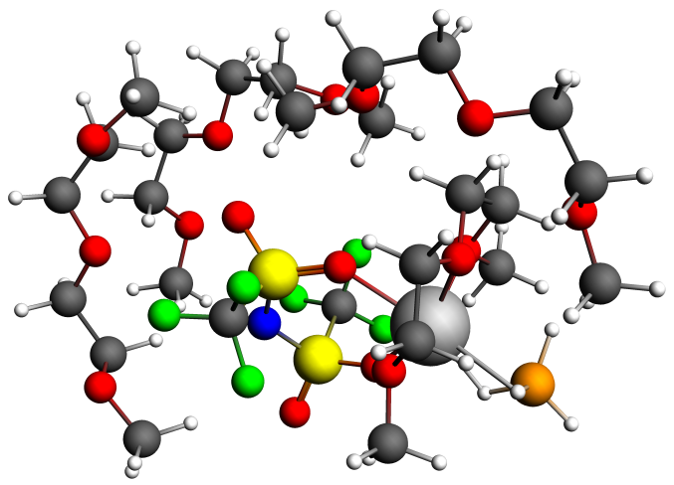
NMR Shielding ADF-GUI atom Mg(24): 569.77 ppm
1.O 3.563435 -0.363763 3.205171
2.C 4.830835 0.032577 2.629305
3.C 5.527000 0.839848 3.716406
4.O 4.622835 1.902400 4.137257
5.C 5.143138 2.659115 5.259167
6.C 2.655031 -1.060463 2.313224
7.C 1.385996 -1.264650 3.123212
8.O 0.955267 0.040843 3.613396
9.C -0.168753 -0.064163 4.525737
10.H 4.648593 0.637793 1.732852
11.H 5.408567 -0.860155 2.365930
12.H 6.454437 1.288412 3.330546
13.H 5.739281 0.205298 4.588650
14.H 4.399235 3.426929 5.487684
15.H 6.094121 3.128478 4.971208
16.H 5.272182 1.992253 6.121967
17.H 3.096380 -2.020575 2.027312
18.H 2.477991 -0.447075 1.425436
19.H 1.581195 -1.912218 3.989425
20.H 0.591741 -1.690950 2.494098
21.H -1.029100 -0.492083 3.992691
22.H -0.399953 0.949921 4.857507
23.H 0.116020 -0.684440 5.385956
24.Mg 2.618175 1.202027 4.236690
25.F -1.411315 3.257934 4.543303
26.F -0.681217 2.496001 2.604213
27.F -1.415714 4.568692 2.771943
28.F 4.568757 4.474342 2.740389
29.F 4.227590 5.193529 0.690870
30.B 2.897850 0.084710 6.406694
31.H 2.331534 -0.803547 5.780801
32.H 2.779586 -0.059743 7.603987
33.H 4.072461 0.136893 6.065781
34.H 2.346431 1.182352 6.156554
35.N 1.637504 4.456489 2.389413
36.S 1.019520 4.165165 3.832550
37.S 2.416063 3.367537 1.505323
38.C -0.749529 3.587250 3.401979
39.C 4.181002 4.123921 1.487118
40.O 2.001875 3.374860 0.117115
41.O 2.579651 2.042201 2.143065
42.O 1.589565 2.998643 4.561563
43.O 0.870162 5.399062 4.578667
44.F 5.049972 3.175148 1.020117
45.C -0.316817 1.504043 -1.620833
46.H -0.861659 2.849048 -3.200135
47.H -2.265430 2.121877 -2.351755
48.H 0.605652 2.009275 -1.299376
49.H -0.061490 0.758924 -2.400328
50.C -1.762326 6.016590 -1.029468
51.H 0.512226 -0.651782 -0.287264
52.H -0.544991 -0.303724 1.123455
53.H 0.771652 0.824781 0.697626
54.O -2.640031 5.979215 0.102686
55.C -1.255414 2.546740 -2.209404
56.C 0.007531 0.145569 0.291529
57.H -3.055796 4.584174 -2.023153
58.C -2.303246 7.008131 1.038089
59.O -0.943126 0.854637 -0.506603
60.O -1.295079 3.677424 -1.337396
61.C -1.977457 4.796195 -1.911865
62.H -1.559164 5.011128 -2.914517
63.H -1.959852 6.931125 -1.624332
64.H -0.711339 6.031666 -0.702275
65.H -2.996713 6.920824 1.881077
66.H -2.406251 8.011202 0.580989
67.H -1.267663 6.891352 1.399913
68.C 1.472165 7.881995 1.056262
69.H 0.247515 8.224427 -0.678696
70.H 1.970076 8.676136 -0.895134
71.H 0.999696 6.967166 1.453378
72.H 0.970599 8.761424 1.506697
73.C 1.348517 5.106249 -2.845179
74.H 2.644325 8.608438 3.338375
75.H 4.167657 7.743656 2.940458
76.H 2.637620 6.825606 3.162444
77.O 2.715458 4.697314 -3.009343
78.C 1.289730 7.926012 -0.453704
79.C 3.083275 7.758007 2.783159
80.H 2.025131 7.165270 -2.961930
81.C 2.813027 3.283080 -3.172410
82.O 2.868167 7.897819 1.373702
83.O 1.545052 6.627644 -0.995267
84.C 1.290684 6.560243 -2.400769
85.H 0.279130 6.954559 -2.616971
86.H 0.812469 4.999335 -3.809825
87.H 0.843444 4.486560 -2.088957
88.H 3.875869 3.042980 -3.292603
89.H 2.261166 2.940545 -4.070359
90.H 2.415086 2.757825 -2.291124
91.C 5.838569 -3.770399 2.881232
92.H 6.285212 -4.613863 0.946115
93.H 4.535302 -4.475498 1.308538
94.H 6.748421 -3.147633 2.974243
95.H 6.046171 -4.753259 3.345667
96.C 4.933293 -1.382133 -1.190461
97.H 5.216386 -3.588742 5.509510
98.H 4.174639 -2.138812 5.225114
99.H 5.926799 -2.070364 4.873567
100.O 3.756349 -0.769277 -0.654375
101.C 5.513027 -3.971415 1.408648
102.C 5.029485 -2.715341 4.860205
103.H 4.122916 -3.320905 -0.701128
104.C 3.576989 0.568722 -1.140774
105.O 4.732068 -3.130463 3.516671
106.O 5.476552 -2.691694 0.761754
107.C 5.083041 -2.781780 -0.613414
108.H 5.846389 -3.333578 -1.193271
109.H 4.858109 -1.455587 -2.292007
110.H 5.826941 -0.779459 -0.944886
111.H 2.667708 0.963344 -0.682238
112.H 3.470466 0.579582 -2.239010
113.H 4.428470 1.212161 -0.861994

Table S3. Mg(BH4)(TFSI)(DGM)-3 + 6 DGMs
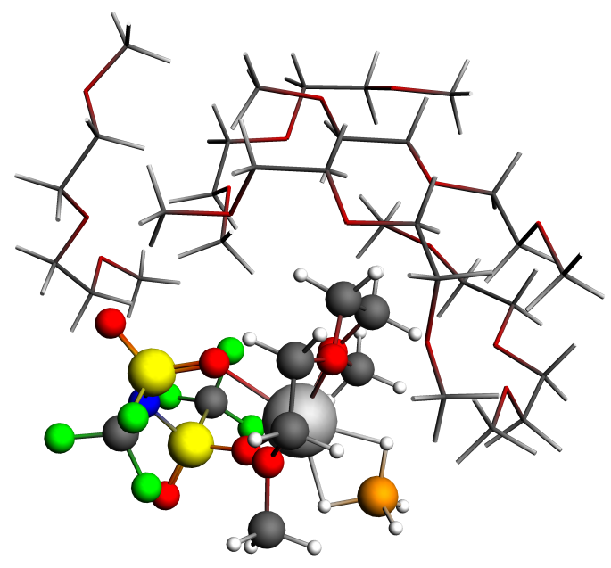
NMR Shielding ADF-GUI atom Mg(24): 567.73 ppm
1.O 1.952442 1.824690 -2.292106
2.C 1.340961 2.689803 -3.282873
3.C 2.515218 3.333745 -4.000396
4.O 3.407068 3.911807 -3.000470
5.C 4.620626 4.441827 -3.589402
6.C 1.030537 1.075258 -1.448845
7.C 1.896951 0.409037 -0.398770
8.O 2.699329 1.468602 0.240507
9.C 3.655771 0.927719 1.191025
10.H 0.705349 3.427160 -2.779453
11.H 0.743320 2.094850 -3.979998
12.H 2.170336 4.130006 -4.676734
13.H 3.077833 2.576816 -4.567147
14.H 5.218960 4.845974 -2.771210
15.H 4.357783 5.235738 -4.303284
16.H 5.179574 3.632271 -4.075777
17.H 0.509690 0.317705 -2.042462
18.H 0.298740 1.765216 -1.017900
19.H 2.582960 -0.314456 -0.856009
20.H 1.285994 -0.093572 0.355904
21.H 3.111131 0.493714 2.037044
22.H 4.275112 1.763866 1.521247
23.H 4.271526 0.162156 0.708581
24.Mg 3.458712 2.812396 -1.176863
25.F 4.897335 3.625663 3.196319
26.F 2.717128 3.523590 2.895900
27.F 3.614939 5.270957 3.900222
28.F 3.478605 6.544232 -1.737957
29.F 1.860642 7.963775 -1.286035
30.B 5.594718 1.734488 -1.777028
31.H 4.498868 1.166097 -1.687969
32.H 6.368893 1.169006 -1.028520
33.H 5.940316 1.703551 -2.947067
34.H 5.510984 2.919054 -1.435006
35.N 2.573505 5.924386 1.062476
36.S 4.011148 5.218901 1.232578
37.S 1.551216 5.550677 -0.113580
38.C 3.790200 4.357078 2.921624
39.C 2.140369 6.670275 -1.555924
40.O 0.225111 6.052279 0.202178
41.O 1.665049 4.181410 -0.646778
42.O 4.274977 4.085193 0.315933
43.O 5.073540 6.180794 1.442318
44.F 1.503139 6.316223 -2.702238
45.C 2.952076 -2.347865 2.464543
46.H 4.358590 -3.727460 1.627511
47.H 2.732810 -3.809070 0.880412
48.H 3.673881 -1.566629 2.763152
49.H 2.833558 -3.049653 3.312819
50.C 5.018057 -1.929209 -1.908319
51.H 0.998220 -1.700863 4.121394
52.H 0.164690 -0.638895 2.954014
53.H 1.798417 -0.204550 3.552360
54.O 3.840750 -1.613990 -2.662816
55.C 3.503271 -3.120660 1.273386
56.C 1.136326 -1.034554 3.253183
57.H 4.022840 -3.711824 -1.212754
58.C 4.135340 -0.842409 -3.840017
59.O 1.688587 -1.759926 2.142133
60.O 3.931076 -2.220275 0.248581
61.C 4.646890 -2.900410 -0.796828
62.H 5.569786 -3.346110 -0.381054
63.H 5.761476 -2.427781 -2.560567
64.H 5.471849 -1.010754 -1.501104
65.H 3.170565 -0.565715 -4.273739
66.H 4.712715 -1.451515 -4.562026
67.H 4.704601 0.061353 -3.587263
68.C -3.573504 4.883400 1.812788
69.H -2.226249 6.371505 1.014269
70.H -3.220388 6.932039 2.401494
71.H -2.965304 3.972701 1.688328
72.H -4.195977 5.025293 0.908324
73.C 0.476103 6.176713 3.956728
74.H -5.720421 3.376443 2.067406
75.H -5.774783 3.521473 3.856341
76.H -4.405472 2.671923 3.059715
77.O 0.061158 5.662954 5.233710
78.C -2.650508 6.079009 1.991190
79.C -5.113030 3.514431 2.982728
80.H -1.246732 7.493843 3.886294
81.C 1.090512 4.891985 5.855943
82.O -4.420622 4.762174 2.967855
83.O -1.600041 5.696369 2.881275
84.C -0.723005 6.770602 3.236126
85.H -0.364668 7.288529 2.331349
86.H 1.254400 6.949479 4.087705
87.H 0.896836 5.368217 3.338831
88.H 0.693628 4.544240 6.816533
89.H 1.999134 5.495238 6.030678
90.H 1.363163 4.021498 5.233720
91.C -0.869913 2.627397 3.824125
92.H -1.686802 2.163318 5.769719
93.H -2.809036 1.899084 4.399248
94.H 0.187379 2.351564 3.997634
95.H -1.001642 3.695445 4.049456
96.C -1.797013 -1.897918 5.123064
97.H -0.276149 4.046596 1.706916
98.H -0.743563 2.784361 0.531164
99.H 0.670880 2.520175 1.592421
100.O -1.873701 -2.300401 3.750482
101.C -1.760717 1.797904 4.729782
102.C -0.334830 2.965569 1.529219
103.H -3.282174 -0.365720 4.778730
104.C -1.305212 -3.595344 3.545116
105.O -1.235189 2.349770 2.463373
106.O -1.350908 0.418152 4.662294
107.C -2.294385 -0.467381 5.264221
108.H -2.413846 -0.238542 6.340967
109.H -2.419194 -2.564308 5.750072
110.H -0.752603 -1.960122 5.480101
111.H -1.422468 -3.831371 2.483050
112.H -1.819622 -4.359761 4.155279
113.H -0.230161 -3.598111 3.800916
114.C -1.857267 -0.291139 0.887948
115.H -0.679906 -1.978895 1.416270
116.H -2.178593 -2.393877 0.535859
117.H -1.087905 0.461895 0.658477
118.H -2.070897 -0.229488 1.965809
119.C 1.061979 -2.949494 -1.933675
120.H -3.888866 1.148516 1.655247
121.H -4.599837 1.312512 0.014751
122.H -3.010927 2.060749 0.401210
123.O 0.345164 -3.210945 -3.154667
124.C -1.336759 -1.680782 0.588256
125.C -3.666195 1.193645 0.577317
126.H -0.604161 -3.795305 -0.849349
127.C 1.225840 -3.162938 -4.284681
128.O -3.057281 -0.021933 0.132793
129.O -0.581684 -1.711252 -0.639794
130.C 0.116537 -2.962675 -0.749628
131.H 0.712549 -3.116964 0.165643
132.H 1.828652 -3.733555 -1.786991
133.H 1.592310 -1.989328 -1.988682
134.H 0.629382 -3.430899 -5.164702
135.H 2.056004 -3.882893 -4.170281
136.H 1.652460 -2.156872 -4.415488
137.C -0.113508 -0.329417 -5.693959
138.H -1.842772 -1.061426 -4.669666
139.H -0.395962 -0.980942 -3.644045
140.H -0.623234 0.330896 -6.418536
141.H 0.003235 -1.329606 -6.147040
142.C -2.751018 2.158348 -2.521580
143.H 2.148330 -0.559776 -7.070655
144.H 2.952065 0.789334 -6.205015
145.H 1.516060 1.111416 -7.237283
146.O -1.757171 2.880197 -1.773173
147.C -0.950286 -0.452027 -4.433022
148.C 1.985914 0.395613 -6.539403
149.H -1.765561 0.295846 -2.011036
150.C -2.214214 4.196764 -1.441142
151.O 1.182274 0.208389 -5.373422
152.O -1.353011 0.855262 -3.999577
153.C -2.251841 0.769398 -2.874394
154.H -3.122178 0.145732 -3.147920
155.H -3.666836 2.065134 -1.915285
156.H -2.997259 2.711074 -3.446700
157.H -1.442914 4.668688 -0.828522
158.H -3.156985 4.150341 -0.869545
159.H -2.384728 4.796428 -2.353041

