Supporting Information for

Low-temperature (<200°C) degradation of electronic nicotine delivery system liquids generates toxic aldehydes

Nicholas R. Jaegers, Wenda Hu, Thomas J. Weber, and Jian Zhi Hu*
Pacific Northwest National Laboratory, Richland, WA 99354, USA

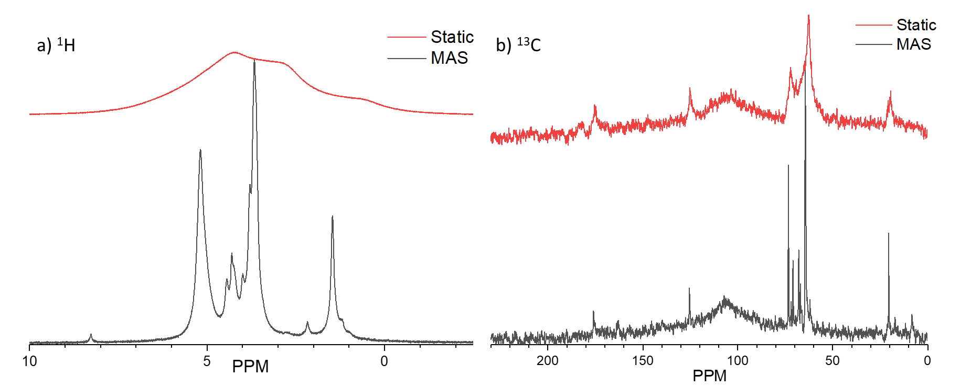
Figure S1. Room temperature ¹H MAS NMR (a) and ¹³C MAS NMR (b) of 20 μl of glycerol and 75 psig O₂ reacted over 50.1 mg dehydrated ZrO₂ at 175°C.

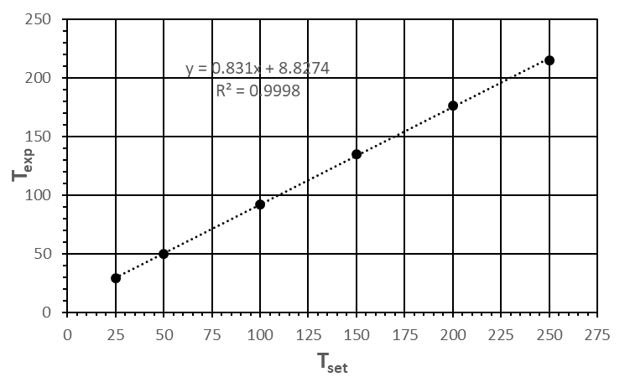
Figure S2. Heating set temperature vs experimental temperature as determined by a 250 μl ethylene glycol thermometer. Temperature expressed in degrees centigrade.

$$P_{s}(Pa(K))=e^{\left[C1+\frac{C2}{T}+C3*ln\left(T\right)+C4*T^{C5}\right]}$$

Table S1. Antoine equation constants for the vapor pressure of propylene glycol.
Chemical | C1 | C2 | C3 | C4 | C5 | T_{min} (K) | T_{max} (K)
Propylene Glycol | 212.8 | -15420 | -28.109 | 2.16*10⁻⁵ | 2 | 213.15 | 626

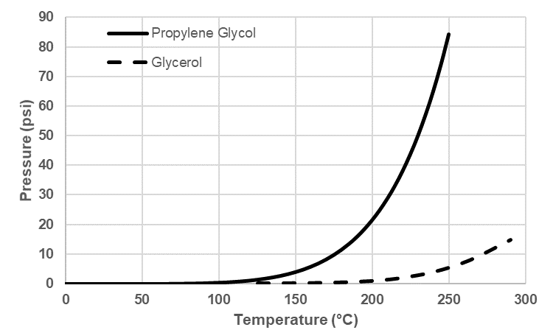
Figure S3. Vapor pressures of propylene glycol and glycerol as a function of temperature.

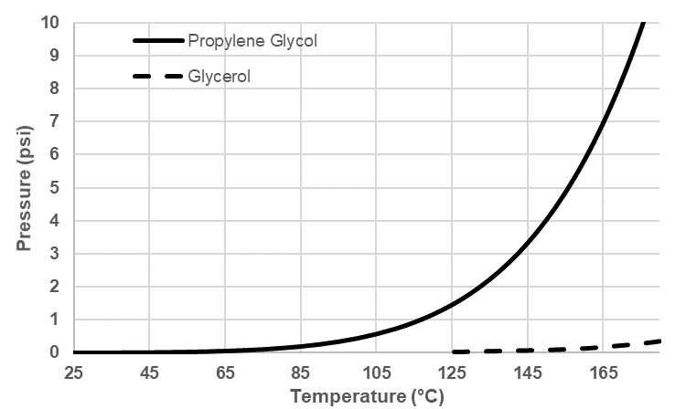
Figure S4. Vapor pressures of propylene glycol and glycerol as a function of temperature.

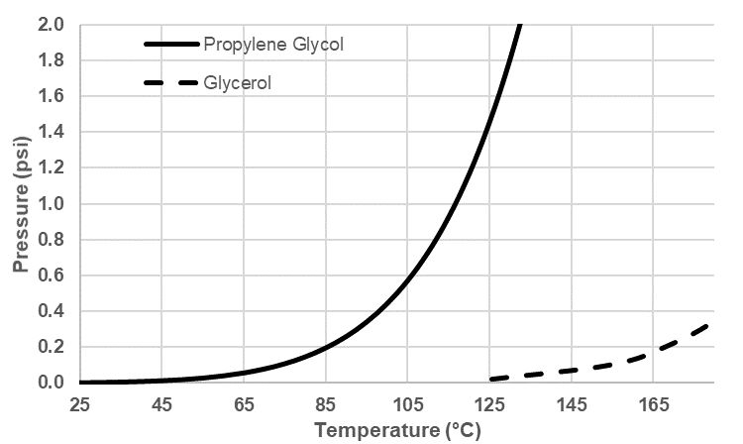
Figure S5. Vapor pressures of propylene glycol and glycerol as a function of temperature.

Table S2. Approximate system pressure at elevated temperatures used in this study.
Temperature °C | Vapor Pressure Glycerol (psi) | Vapor Pressure Propylene Glycol (psi) | Gas Pressure (psi) | Total Pressure (psi)
25 | ~0 | ~0 | 75 | 75
133 | ~0.05 | ~1.8 | 102 | 104
175 | ~0.3 | ~9 | 113 | 122
217 | ~2 | ~30 | 123 | 155

Table S3. Predicted ¹H and ¹³C chemical shifts of relevant compounds.
Structure | Chemical | Δ ¹H_{calc} | Δ ¹³C_{calc}
 | Acetaldehyde | CH: 9.79  CH₃: 2.20 | CH: 199.9  CH₃: 30.7
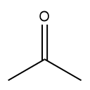 | Acetone | CH₃: 2.13 | C: 206.4  CH₃: 30.6
 | Acrolein | OCH: 9.68  CH: 6.27  CH₂: 6.28 | OC: 194.5  CC: 138.5  CH₂: 137.6
 | Acrylic Acid | C¹OH: 12.05  C²H: 6.29  C³H₂: 5.99, 6.64 | C¹OH: 172  C²H: 127.5  C³H₂: 134.1
 | Butyraldehyde | OCH: 9.72  C²H₂: 2.38  C³H₂: 1.65  CH₃: 0.98 | OC: 202.2  C²: 45.7  C³: 15.5  CH₃: 13.6
 | CO
 | CO₂ |  | 124.2
 | 2,3-Dihydroxypropanal | C¹H: 9.72  C²H: 4.46  C²OH: 6.18  C³H₂: 4.13, 3.88  C⁴OH: 4.94 | C¹: 200.8  C²: 92.1  C³: 59.2
 | 1,3-Dihydroxypropan-2-one | OH: 4.91  CH: 4.69 | C^{1,3}: 66.4  C²: 201.3
 | (1,3-dioxolan-4-yl)methanol | O₂CH₂: 5.4, 5.5  OCH₂: 3.36, 3.61  OCH: 3.5  OHCH₂: 3.51, 3.57  COH: 3.94 | O₂CH₂: 95.2  OCH₂: 68.2  OCH: 78.1  OHCH₂: 61.0
 | (2-methyl-1,3-dioxolan-4-yl)methanol | CH₃: 1.39  O₂CH: 3.18  OCH₂: 3.62, 3.87  OCH: 3.92  OHCH₂: 3.51, 3.57  COH: 3.94 | CH₃: 20.6  O₂CH₂: 105.3  OCH₂: 66.7  OCH: 78.0  OHCH₂: 61.3
 | 1,3-dioxan-5-ol | O₂CH₂: 4.87, 4.89  OCH₂: 3.83, 4.08  CH: 3.78  CHOH: 5.77 | O₂CH₂: 94.3  OCH₂: 71.6  CH: 63.5
 | 2-methyl-1,3-dioxan-5-ol | CH₃: 1.32  O₂CH: 4.5  OCH₂: 3.83, 4.08  CH: 3.78  CHOH: 5.77 | CH₃: 20.6  O₂CH: 106.9  OCH₂: 71.4  CH: 63.8
 | Formaldehyde | 9.6
 | Formic Acid | OH: 12.6  CH: 8.05 | 165.7
 | Glycerol | C¹OH: 3.94  C^{1,3}: 3.5  C²: 3.06  C²OH: 5.77 | C^{1,3}: 63.5  C²: 74.2
 | Propane-1,1,2,3-tetraol | OH: 4.2, 4.2, 5.8, 3.9  CH: 5.6, 3.6  CH₂: 3.6, 3.5 | CH: 92.9  CH: 83  CH₂: 60.1
 | Glycidol | OCH₂: 2.36, 2.61  CH: 2.54  CH₂: 3.51, 3.57  OH: 4.94 | OC¹H₂: 43.9  C²H: 54.5  C³H₂: 63.1
 | Glyoxal | 9.69 | 190
 | 3-hydroxypropanal | OC¹H: 9.72  C²H₂: 2.59  C³H₂: 3.86  OH: 6.34 | OC¹H: 202  C²H₂: 45.4  C³H₂: 54.8
 | 1-(hydroxymethoxy)propan-2-ol | OH: 4.12  OH: 5.37  CH₂: 5.61  CH: 3.9  CH₂: 3.63, 3.38  CH₃: 1.11 | CH₂: 89.5  CH: 67.7  CH₂: 76.4  CH₃: 19.8
 | 1-(1-hydroxyethoxy)propan-2-ol | OH: 4.52  OH: 5.37  CH: 5.5  CH: 3.9  CH₂: 3.63, 3.38  CH₃: 1.39  CH₃: 1.11 | CH: 106.8  CH: 68  CH₂: 73.9  CH₃: 17.9  CH₃: 19.8
 | 2-(hydroxymethoxy)propan-1-ol | OH: 4.12  OH: 4.94  CH₂: 5.61  CH: 3.4  CH₂: 3.57, 3.51  CH₃: 1.32 | CH₂: 86.7  CH: 76  CH: 67.3  CH₃: 17.3
 | 2-(1-hydroxyethoxy)propan-1-ol | OH: 4.5  OH: 4.9  CH: 5.5  CH: 3.4  CH₃: 1.32, 13.9  CH₂: 3.57, 3.51 | CH: 104  CH: 73.5  CH₂: 67.6  CH₃: 18.2, 17.6
 | 3-(hydroxymethoxy)propane-1,2-diol | HOC¹: 3.94  C¹H₂: 3.53, 3.59  C²OH: 5.77  C²H: 3.8  C³H₂: 3.38, 3.68  C⁴H: 5.61  C⁴OH: 4.12 | C¹H₂: 63.8  C²H: 70.7  C³H₂: 70.2  C⁴H: 89.5
 | 2-hydroxypropanal | OH: 5.48  CH: 9.72  CH: 4.56  CH₃: 1.26 | CH: 200.8  CH: 85.7  CH₃: 15.8
 | 1-hydroxypropan-2-one | OH: 4.91  CH₂: 4.69  CH₃: 2.24 | C: 203.1  CH₂: 73.9  CH₃: 25.6
 | H₂O | 4.8
 | Methylglyoxal | CO: 9.69  CH₃: 2.17 | C¹O: 190.0  C²O: 196.5  CH₃: 25.2
 | Prop-1-en-2-ol | OH: 16.77  CH₃: 1.99  H: 5.1  H: 5.04 | C: 171.5  CH₂: 70.6  CH₃: 27.2
 | Prop-1-en-1-ol | OH: 12.58  CH₃: 2.05  H: 4.85  H: 5.76 | CH: 168.6  CH: 103.4  CH₃: 12.2
 | Prop-1-en-1,2-diol | OH: 16.77  OH: 12.58  CH₃: 1.99  H: 4.85 | C: 150.1  CH: 133.3  CH₃: 20.1
 | 2-Propenol | C¹H₂: 5.31, 5.43  C²H: 6.07  C³H₂: 4.18  OH: 5.05 | CH₂: 114.9  CH: 137.5  CH₂OH: 63.3
 | Propionaldehyde | CO: 9.72  CH₂: 2.44  CH₃: 1.04 | CO: 202.2  CH₂: 37.3  CH₃: 6.5
 | Propylene Glycol | C¹OH: 4.94  C¹H₂: 3.56  C²H: 3.7  C²OH: 5.37  CH₃: 1.11 | C¹OH: 67.8  C²OH: 68.5  C³H₃: 19.5
 | Propylene Oxide | CH₂: 2.61, 2.36  CH: 2.96  CH₃: 1.32 | CH₂: 47.5  CH: 49.8  CH₃: 19.1
 | Valeraldehyde | C¹O: 9.72  C²H₂: 2.38  C³H₂: 1.58  C⁴H₂: 1.38  CH₃: 0.93 | C¹O: 202.2  C²H₂: 43.2  C³H₂: 24.3  C⁴H₂: 22.2  CH₃: 13.8

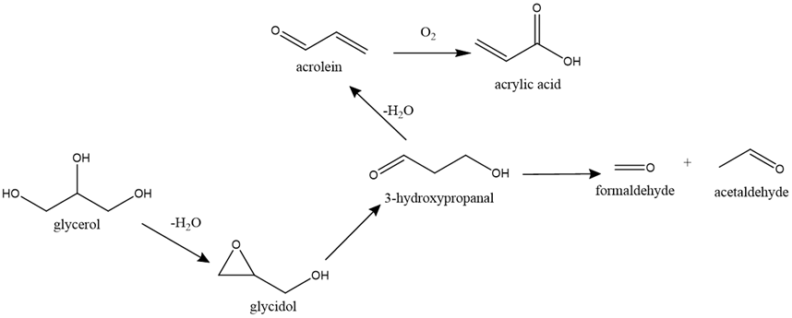
Figure S6. Commonly proposed scheme for the oxidative degradation of glycerol.

Figure S7. Radical formation mechanism for glycerol.

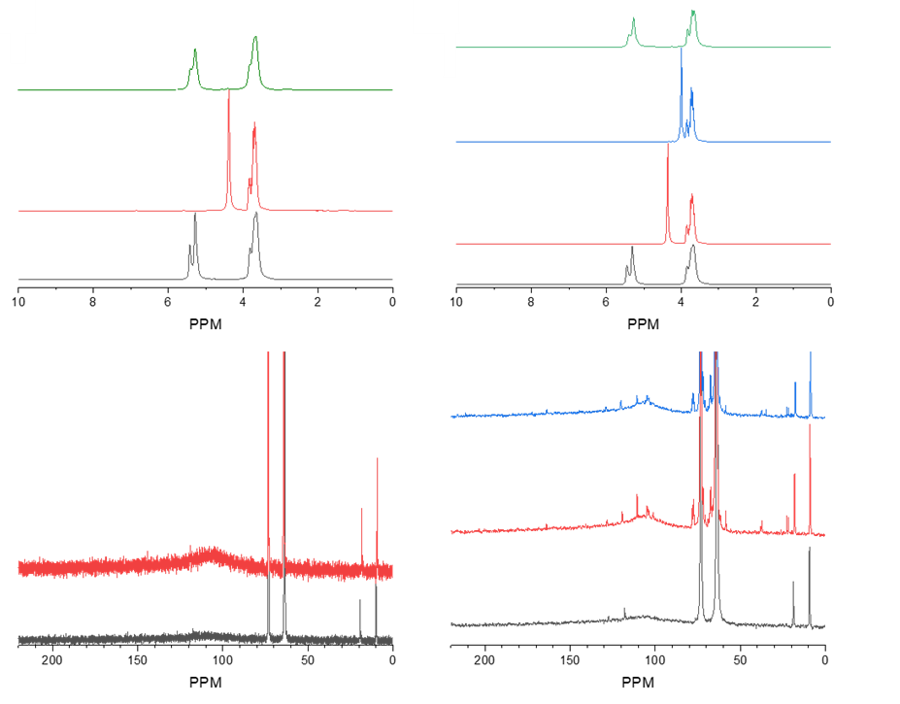
Figure S8. ¹H (top) and ¹³C (bottom) MAS NMR spectra of 100 μl glycerol in O₂ heated to various temperatures prior to cooling to monitor the thermal degradation processes taking place. The sepctra represent different pressures of 1(left) and 15 (right) psig.

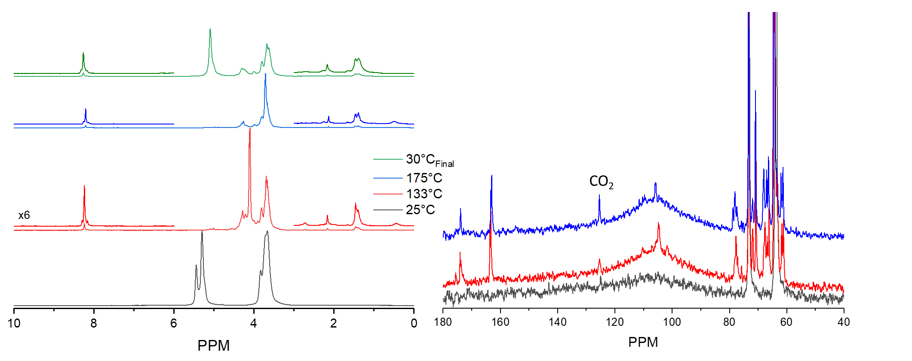
Figure S9. ¹H (left) and ¹³C (right) MAS NMR spectra of 20 ul glycerol in 75 psig O₂.

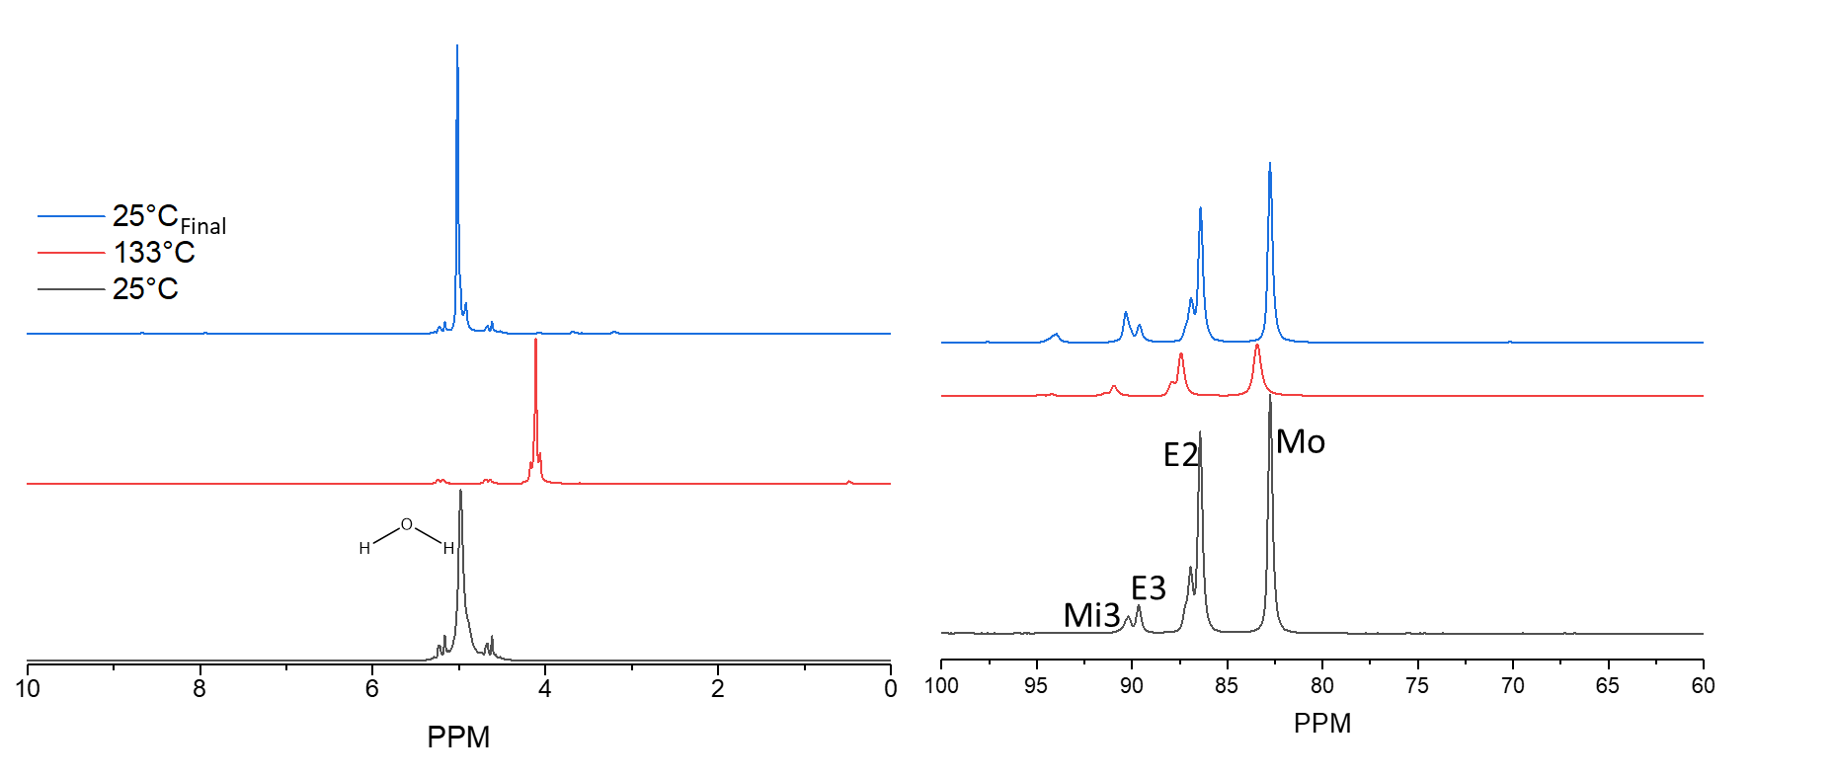
Figure S10. ¹H (left) and ¹³C (right) MAS NMR spectra of 20 μL 20% formaldehyde (balance water) in N₂.

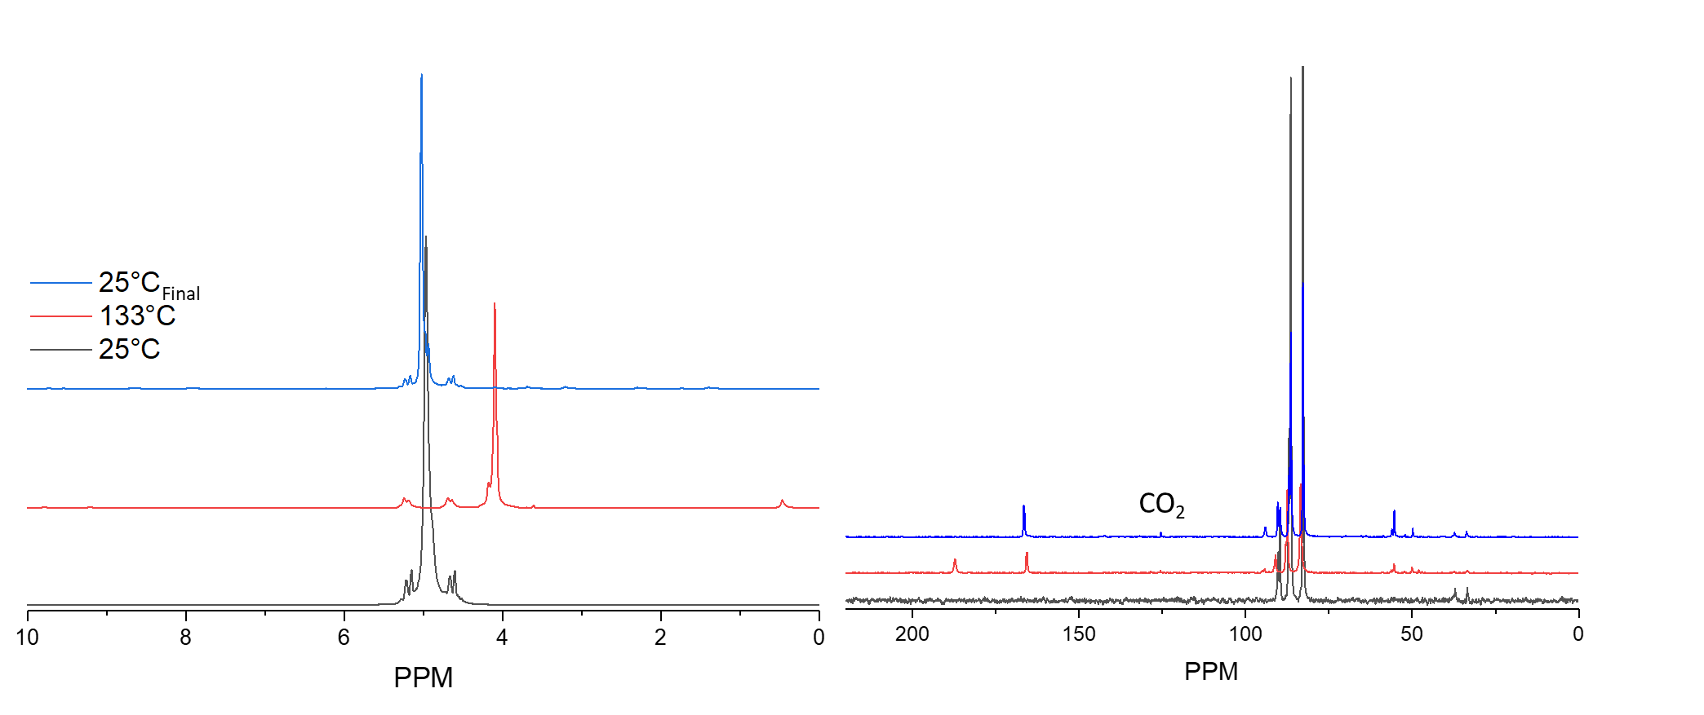
Figure S11. ¹H (left) and ¹³C (right) MAS NMR spectra of 20 μL 20% formaldehyde (balance water) in 75 psig O₂.

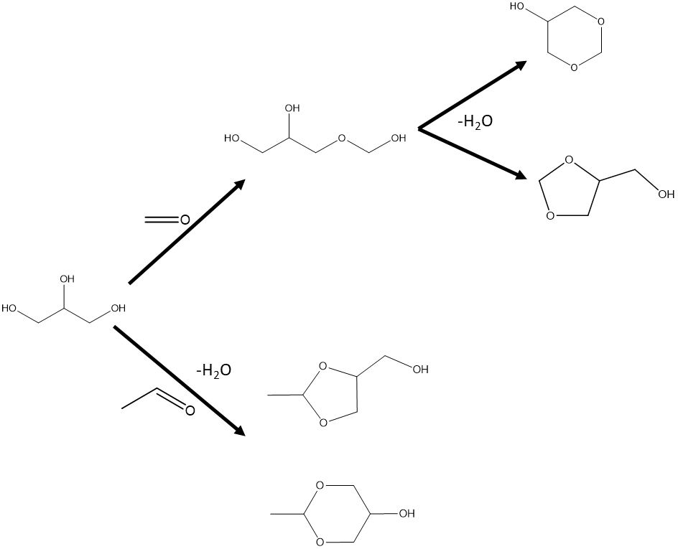
Figure S12. Scheme for acetal formation from water (top) and glycerol with formaldehyde or acetaldehyde (bottom).

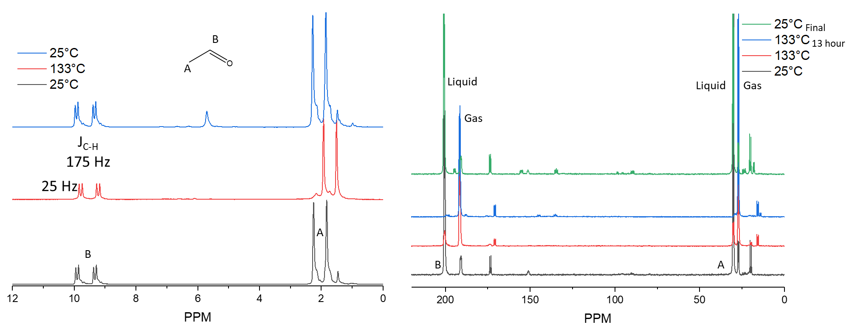
Figure S13. ¹H (left) and ¹³C (right) MAS NMR spectra of 20 μL ¹³C-acetaldehyde in N₂.

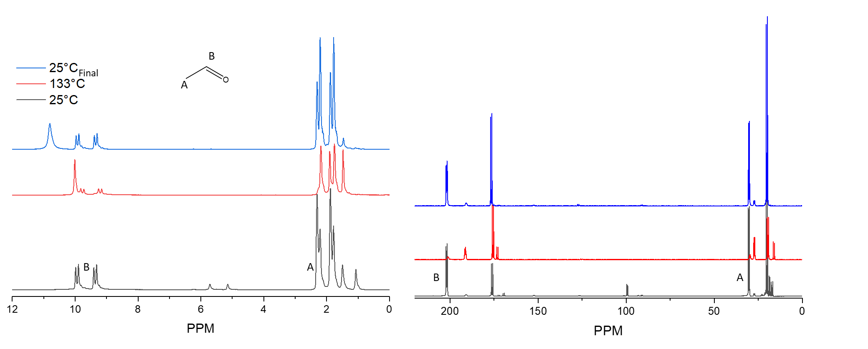
Figure S14. ¹H (left) and ¹³C (right) MAS NMR spectra of 20 μL ¹³C-acetaldehyde in 76 psig O₂.

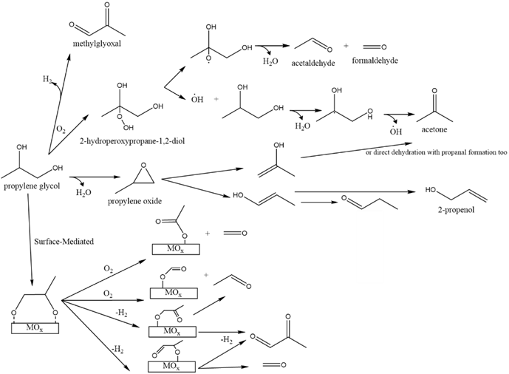
Figure S15. Proposed decomposition pathways for propylene glycol.

Figure S16. Pathway for propylene glycol radical formation.

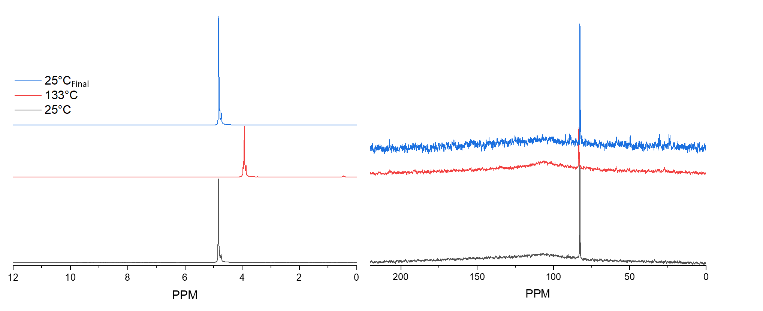
Figure S17. ¹H (left) and ¹³C (right) MAS NMR spectra of 20 μL 0.5% acrolein in H₂O and N₂.

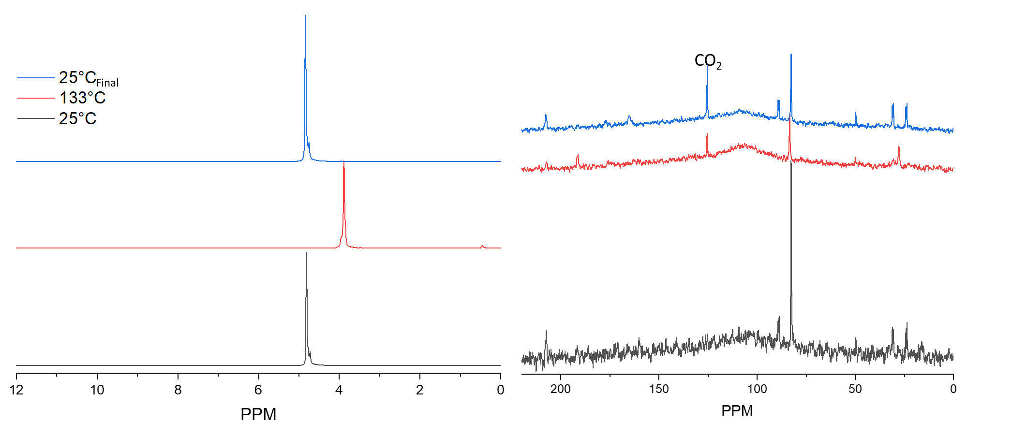
Figure S18. ¹H (left) and ¹³C (right) MAS NMR spectra of 20 μL 0.5% acrolein in H₂O and 75 psig O₂. CO₂ is the only peak in common with the mixed propylene glycol and glycerol experiment.

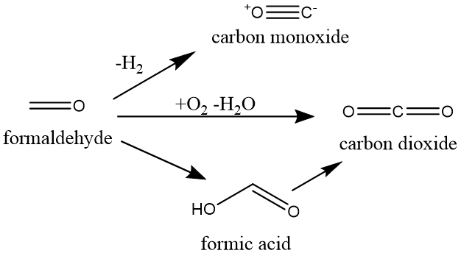
Figure S19. Decomposition pathway for formaldehyde.

Figure S20. Time sequence of in situ ¹³C MAS NMR of 20 μl glycerol (black), 20 μl propylene glycol (red), and a mixture 20 μl/20 μl (blue) in 75 psig O₂.

Figure S21. ¹³C NMR spectrum of 18.7 mg Cr₂O₃ with 75 μL of propylene glycol, 75 μL of glycerol in the absence of O₂ after thermal treatment at 175°C for 30 hours and 220°C for 10 hours.

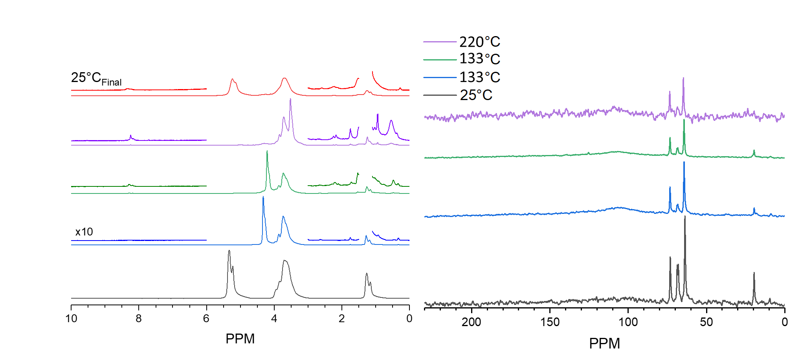
Figure S22. ¹H (left) and ¹³C (right) MAS NMR spectra 86 mg Cr₂O₃ with 20 μL propylene glycol, 20 ul glycerol, and 75 psig O₂.

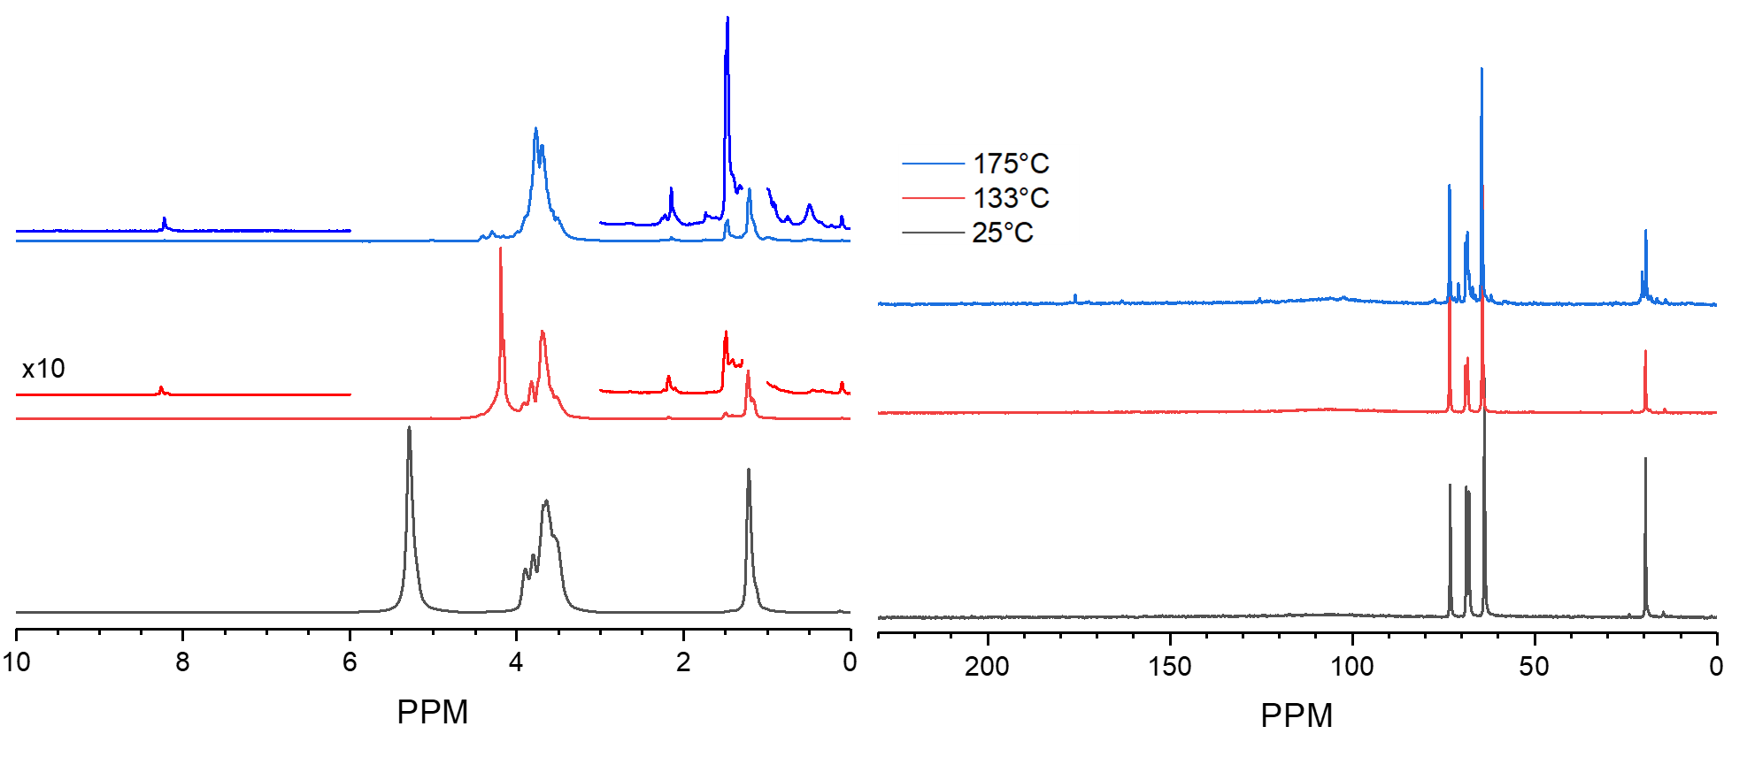
Figure S23. ¹H (left) and ¹³C (right) MAS NMR spectra of 51.3 mg ZrO₂ with 20 μL propylene glycol, 20 μl glycerol and 76 psig O₂.

