Supporting Information for
Mechanistic Insights into Adsorptive and Catalytic Reactions from Controllable Distributions of Metal Cations (Pd, Pt, Ni, Cr, Cu) as [M-OH]⁺¹/1Al or M⁺²/2Al in Zeolites
Nicholas R. Jaegers^{1,2&}*, Miroslaw A. Derewinski²*, Eric D. Walter², Iskra Z. Koleva³, Daria Boglaienko², Dhruba J. Deka², Garam Lee², Trent Graham², Libor Kovarik², Yong Wang^{2,5}, Janos Szanyi², Hristiyan A. Aleksandrov^{3,4}* and Konstantin Khivantsev^{2&}*
¹Dept. of Chemical & Biological Engineering, University of New Mexico, Albuquerque, USA
²Pacific Northwest National Laboratory, Richland, WA 99352 USA
³Faculty of Chemistry and Pharmacy, Sofia University “St. Kliment Ohridski”, 1164 Sofia, Bulgaria
⁴Center of Excellence “Universities for Science, Informatics and Technologies in eSociety” (UNITe) 1164 Sofia, Bulgaria
⁵Voiland School of Chemical Engineering and Bioengineering Institution, Washington State University, Pullman, Washington 99164, United States
& These authors contributed equally
*Corresponding authors: Konstantin.Khivantsev@pnnl.gov, Derewinski@gmail.com, NJaegers@berkeley.edu, HAA@chem.uni-sofia.bg

Experimental Methods
NH₄-BEA with Si/Al ∼ 13 was supplied by Zeolyst (prepared via hydrothermal synthesis route in the presence of NaOH). To transform it into H-form, it was calcined at 550 °C in air.
H-BEA with Si/Al ratio ∼15 was synthesized in the presence of hydrofluoric acid. The samples were synthesized by hydrothermal synthesis at 140°C in PTFE-lined autoclaves at rotation at 100 rpm. The gel composition was as follows SiO₂ * x Al₂O₃ * (0.54 + 2x) TEAOH * (0.54 + 2x) HF * (7 + 2x) H₂O. The absence of alkali cations requires only a calcination step, decomposing the organic cation (TEA⁺) to convert it into Brønsted acidic H-Form at 550 °C.
Palladium tetramine nitrate (10% solution in water, Sigma-aldrich) was used to load 1 wt% Pd in H-BEA. More specifically, desired amount of palladium precursor solution was mixed with a minimal amount of water (the total volume approximately equivalent to the pore volume of zeolite), then added drop-wise with a micropipette to NH₄-BEA powder while stirring. For H-BEA (F) (pH of palladium precursor solution was adjusted to ~10 with ammonia solution prior to IWI). The resulting powders were calcined in air flow at 600 °C for 3 hours.
Platinum tetramine hydroxide was used to load 0.75 wt% Pt in both H-BEA materials. More specifically, desired amount of platinum precursor was dissolved in minimal amount of water (the total volume approximately equivalent to the pore volume of zeolite), then added dropwise with a micropipette to zeolite powder while stirring. The resulting powder was calcined at 390 °C in air flow for 3 hours.
Copper nitrate hydrate (99.995% Sigma-aldrich) was used to load 1 wt% copper in BEA catalysts. More specifically, desired amount of copper precursor solution was mixed with a minimal amount of water (the total volume approximately equivalent to the pore volume of zeolite), then added drop wise with a micropipette to H-BEA powder while stirring. The resulting powder was dried at 80 ⁰C in the air flow and subsequently calcined at 600 ⁰C for 3 hours.
CrCl₂ (99.9+%, Strem chemicals) was stored in the MBraun nitrogen glovebox. Its loading in zeolite was conducted in the glovebox in the absence of air. The desired amount of chromium precursor was dissolved in de-aerated DI water and added to the H-forms of BEA zeolites in the glovebox while stirring. The samples were dried under vacuum in the glovebox overnight, then loaded in the glove box in the quartz plug-flow reactor that allows exclusion of moisture and air and treated in the flow of dry nitrogen at 375 °C for 3 hours. The Cr-OH/H-BEA (F) sample was treated in the flow of 2.5 wt% H₂O/N₂ steam at 150 L/g*hr for 10 min prior to the experiment at 200 ⁰C, followed by 15 min treatment in dry N₂ at 200 ⁰C.
Standard NOx adsorption tests were conducted in a plug-flow reactor system with powder samples (120 mg, 60–80 mesh) loaded in a quartz tube, using a synthetic gas mixture that contained 100 or 200 ppm NO, 100 or 0 ppm ethylene, 200 ppm or 0 ppm CO, 3% H₂O, 14% O₂ balanced with N₂ at a flow rate of 300 sscm. All the gas lines were heated to over 100 °C. Concentrations of reactants and products were measured by an online MKS MultiGas 2030 FTIR gas analyzer with a gas cell maintained at 191 °C. Two four-way valves were used for gas switching be-tween the reactor and the bypass. Prior to storage testing at 100 °C, the sample was pretreated in air flow for 1 h at 550 °C and cooled to the target temperature in the same feed. The gas mixture was then switched from the reactor to the bypass, and desired concentration of NOx was added to the mixture. Upon stabilization, the gas mixture was switched back from bypass to the reactor for storage testing for 10 min. The sample was then heated to desired temperature at a rate of 10 °C/min to record the desorption profiles of gases in the effluent.
Ethylene reaction measurements were performed in a typical plug-flow quartz reactor. Samples were loaded into the reactor in the glove box and purged with dry (Restek O₂/H₂O traps) He before reaction. Ethylene (OxArc, 99.995% purity) was delivered into the system through a separate oxygen trap. Approximately ~30 mg of catalyst powder was loaded into the quartz reactor for each run. The ethylene flow rate was ~10 sccm/min in the undiluted stream to achieve a residence time of ~0.2 s. Initial activity was measured after 3 minutes of reaction for all samples. An Agilent 7890 Gas Chromatograph equipped with an FID was used to analyze the system effluent. An Agilent HP-PLOT/Q column (30m, 0.53, 40 μm film) was used for separation. Hydrocarbons response factors were calibrated with hydrocarbon mixtures. Turnover frequencies with respect to butene formation were calculated by the total moles of all butenes produced divided by the moles of metal loaded into the zeolite sample per min.
Methane oxidation to methanol was conducted on 200 mgs of 1wt% Cu/BEA and H-BEA catalysts. Catalysts were first treated at 600 °C in dry air flow for 15 minutes at 100 cc/min, after which the sample was cooled to 150 °C. At 150 °C the flow was switched to pure methane at 20 cc/min. After 20 minutes, the flow was switched to water-saturated nitrogen flow at 200 °C for 30 minutes at 30 ml/min to extract methanol and dimethyl ether. Total methanol amount was calculated on the basis of C1.
HAADF-STEM analysis was performed with an FEI Titan 80-300 microscope operated at 300 kV. The instrument is equipped with a CEOS GmbH double-hexapole aberration corrector for the probe-forming lens which allows for imaging with 0.1 nm resolution in scanning transmission electron microscopy mode (STEM). The images were acquired with a high angle annular dark field (HAADF) detector with inner collection angle set to 52 mrad.
Helium Ion Microscopy images were obtained using 35 keV He ions with 0.1 pA beam current at normal incidence. Secondary electrons were detected using an Everhart–Thornley detector. For HIM imaging, a very thin layer of carbon (<1 nm) was coated using a carbon sputter deposition system as the samples were completely insulating. The instrument resolution was 0.35 nm.
The BET surface areas were obtained by N₂-physisorption at −196 °C in a Micromeritics ASAP 2020 unit. The Tarazona NL-DFT method for N₂ in cylindrical pores without smoothing, provided by Micromeritics was applied to assess the micropore volume.
The static transmission IR experiments were conducted in a home-built cell housed in the sample compartment of a Bruker Vertex 80 spectrometer, equipped with an MCT detector and operated at 4 cm⁻¹ resolution. The powder sample was pressed onto a tungsten mesh which, in turn, was mounted onto a copper heating assembly attached to a ceramic feedthrough. The sample could be resistively heated, and the sample temperature was monitored by a thermocouple spot welded onto the top center of the W grid. Prior to spectrum collection, a background with the activated (annealed at 250 ⁰C) sample in the IR beam was collected. Each spectrum reported is obtained by averaging 256 scans.
Solid-state NMR measurements: The ²⁷Al 3QMAS spectra were acquired at 14.1 T with a Bruker 3.2 mm MAS probe via a z-filter, ²⁷Al 3QMAS pulse sequence at a 20 kHz spinning rate. The P1, P2, and P3 pulse durations were optimized, and the same set of pulse durations was applied to both samples with a delay (D4) of 20 µs between the second and third pulses. Proton decoupling (spinel64) was applied from the onset of P1 through the end of the acquisition time. The acquisition time was 0.0057 s, with spectral widths of 147058.8 Hz for F2 and 20 kHz for F1. A recycle delay of 0.2250 s was used between scans, and at least 1400 transients were collected with 512 increments. The data acquisition used the STATES-TPPI method with the data collected at a temperature of 298 K. The data is shown after applying a 100 Hz exponential line broadening, and the f2 dimension was referenced to the 1 m Al(H₂O)₆³⁺ solution. This solution was prepared by dissolving aluminum nitrate nonahydrate (Al(NO₃)₃·9H₂O, ≥98%, Sigma Aldrich) in deionized H₂O. The f1 dimension is shown in kHz and was referenced uniformly in both samples to the position of the HBEA-F peak at (58, 0). The apparent peak maxima are annotated and the f1 and f2 projections are summations. (C) Single pulse, direct excitation ²⁷Al NMR spectra were recorded also at 14.1 T using 4096 transients with the 3.2 mm probe. The acquisition time was 0.0049 s, with a relaxation delay of 0.5 s between transients, and a spinning rate of 20 kHz. The π/20 pulse width, a duration of 0.625 µs, was determined using an excitation length nutation experiment on a 1 m Al(H₂O)₆³⁺ solution. Chemical shifts were referenced to the 1 m Al(H₂O)₆³⁺ solution, which was set at δ = 0 ppm. The temperature during the experiment was maintained at 298 K, and data processing included zero-filling from 6187 to 1048576 complex points and applying a 5 Hz Lorentzian line broadening. The position defined by the maxima of the tetrahedral resonance is annotated.
X-ray absorption spectroscopy (XAS): Cu K-edge x-ray absorption near edge spectroscopy (XANES) and extended x-ray absorption fine structure (EXAFS) data were collected using a laboratory-based easyXAFS300 spectrometer in transmission mode (easyXAFS, WA; Seidler, et al. 2014). Cu K-edge spectra were collected using a Si(553) spherically-bent crystal analyzer and Mo anode x-ray tube operating at 35 kV voltage and 25 mA current. All the spectra were collected using the same power settings, including background scans. In all cases the silicon drift detector deadtime was kept below 30%. The energy calibration of the instrument was done using a copper foil standard (Exafs materials, CA). All the spectra were deadtime corrected. A theta-to-energy correction was applied to all the datasets, using theta-to-energy nonlinear shift of the copper standard foil.
Solid samples were pressed into pellets (13 mm diameter) in amount of 120 mg of zeolite without a filler and/or binder. Each pellet was wrapped in a polyamide tape to maintain its integrity.
XAS data processing was performed using the Athena program (version 0.9.26) (Ravel and Newville 2005).
Seidler, G.T., Mortensen, D.R., Remesnik, A.J., Pacold, J.I., Ball, N.A., Barry, N., Styczinski, M. and Hoidn, O.R., 2014. A laboratory-based hard x-ray monochromator for high-resolution x-ray emission spectroscopy and x-ray absorption near edge structure measurements. Review of scientific instruments, 85(11), p.113906.
Ravel, B. and Newville, M., 2005. ATHENA, ARTEMIS, HEPHAESTUS: data analysis for X-ray absorption spectroscopy using IFEFFIT. Journal of synchrotron radiation, 12(4), pp.537-541.

Computational details and models
Our periodic density functional theory calculations (DFT) were performed using VASP package¹ with PBE functional² and D2 Grimme's dispersion correction (PBE+D2).³ We sampled the Brillouin zone using the Gamma point only while the valence wave functions were expanded on a plane-wave basis as the cutoff energy was 600 eV. Projector augmented wave (PAW) pseudopotentials were used.^{4,5} The BEA structure consisting of 64 T atoms was optimized and has the following parameters: a = 12.688 Å, b = 12.688 Å, c = 26.3977 Å, α = β = γ = 90°. One or two Si centers in the unit cell located in one six-member ring were replaced with Al, as the negative charge around Al was compensated by M²⁺, MOH⁺ (M = Pd, Pt, Ni, Cr, Cu), or H⁺ cations, depending on the modeled species.
All atoms in the modeled systems were allowed to relax until the force on each atom became less than 0.05 eV/Å during the geometry optimization. The C-O vibrational frequencies of the adsorbed CO molecules in the modeled Pd(II)(CO)₂/2Al, Pd(II)(OH)(CO)/1Al, Ni(II) (CO)/2Al, Ni(II)(OH)(CO)/1Al complexes were calculated numerically for all degrees of freedom of the ligand molecules. These complexes were also optimized with Heyd-Scuseria-Ernzerhof (HSE06) hybrid functional.^{6,7} The frequencies were shifted by the difference of the calculated harmonic frequency of the free CO molecule obtained with the same computational approach and the experimentally measured (anharmonic) frequency of CO in the gas phase, 2143 cm⁻¹.⁸
ν(C-O)^{calc} = ν(CO-complex)^{calc} – ν(CO-gas)^{calc} + 2143
Thus, the calculated frequencies were corrected by +14 and -92 cm⁻¹, respectively, for the PBE+D2 and HSE06 functionals.

References
(1). G. Kresse and J. Hafner, Ab initio molecular dynamics for liquid metals, Phys. Rev. B, 1993, 47, 558–561. https://doi.org/10.1103/PhysRevB.47.558.

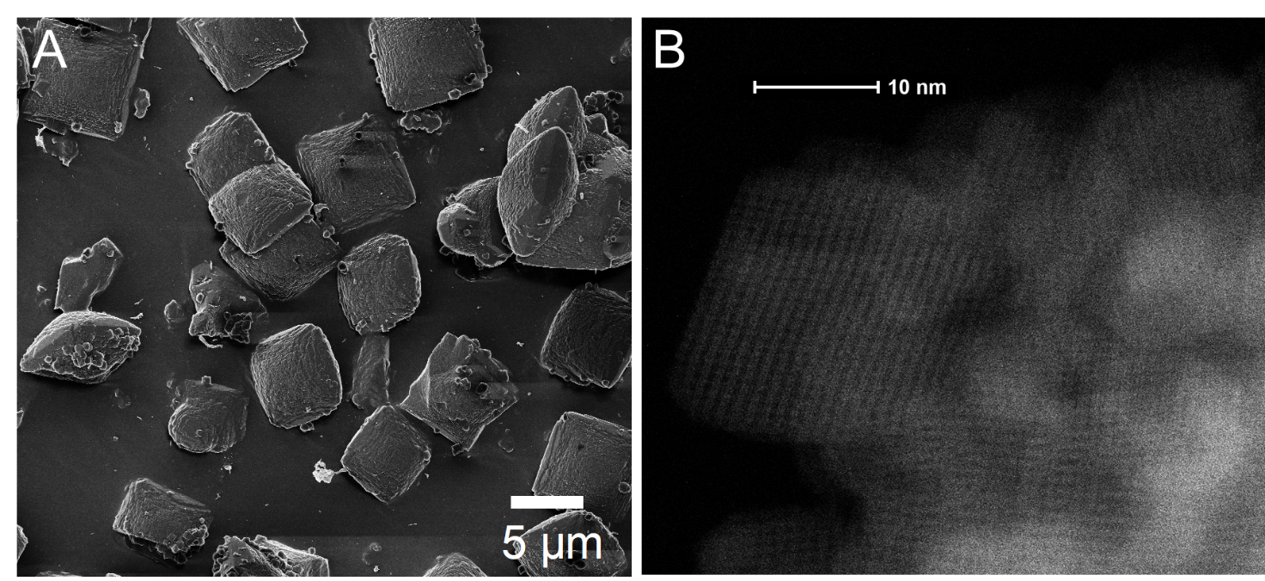Figure S1. A. Helium ion microscopy (HIM) images of H-BEA (Si/Al ~ 15) crystals synthesized in the presence of HF. micrometer-sized crystals of H-BEA are present. B. HAADF-STEM images of H-BEA (Si/Al~13) crystals synthesized via conventional route in the presence of hydroxide. Nanosized crystals of H-BEA are present. The HAADF-STEM image illustrates crystalline nature of this material and straight ~0.7 nm channels present throughout the crystals
Table S1. Specific surface area and pore volume determined by N₂-physisorption. The Tarazona NL-DFT model was used to determine the micropore volume. Roquerol BET isotherm was used to measure the specific surface area.
Sample | BET  (m²/g) | Micropore volume  (cm³/g)
H-BEA (F) | 690 | 0.31
H-BEA (OH) | 672 | 0.23
1 wt% Pd/BEA (F) | 677 | 0.27
1 wt% Pd/BEA (OH) | 659 | 0.20
0.4 wt% Ni/BEA (F) | 685 | 0.29
0.4 wt% Ni/BEA (OH) | 674 | 0.21
0.75 wt% Pt/BEA (F) | 652 | 0.25
0.75 wt% Pt/BEA (OH) | 650 | 0.18
0.3 wt% Cr/BEA (F) | 694 | 0.30
0.3 wt% Cr/BEA (OH) | 667 | 0.21

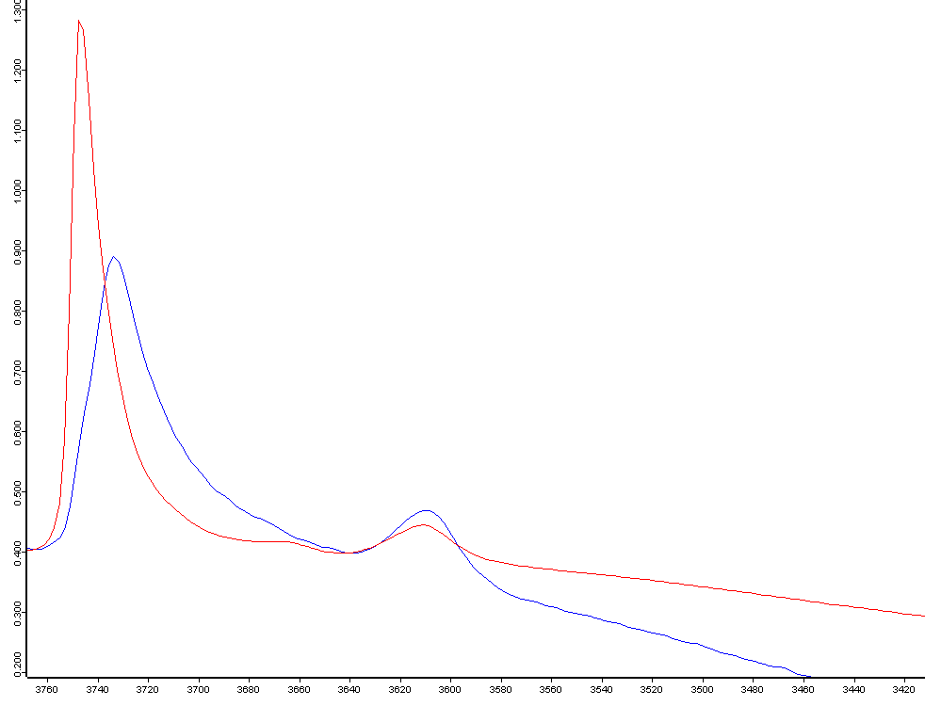
Figure S2. Comparison of FTIR spectra in the OH-stretching region for H-BEA (OH) with Si/Al ~ 13 (red spectrum) and H-BEA (F) with Si/Al ~ 15 (blue spectrum). The two bands at ~3,740-3,720 cm⁻¹ belong to terminal silanol Si-OH groups. The band at 3,610 cm⁻¹ corresponds to OH groups of Bronsted Si-OH-Al sites and has the identical position for both samples.
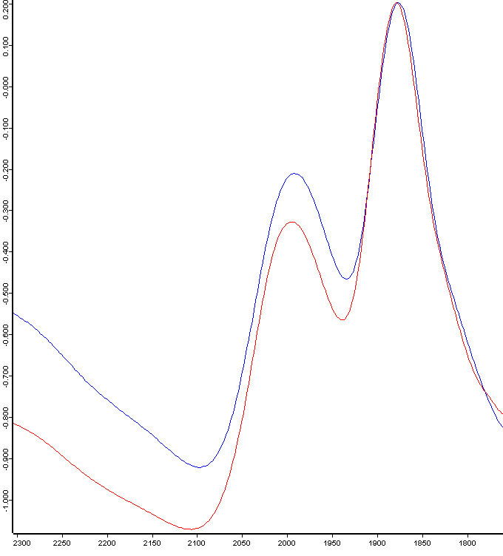
Figure S3. Figure S2. Comparison of FTIR spectra in the2,100 – 1,750 cm⁻¹ region for H-BEA (OH) with Si/Al ~ 13 (red spectrum) and H-BEA (F) with Si/Al ~ 15 (blue spectrum). The samples do not show appreciable differences, consistent with both being H-BEA.

Fig. S4. Echo Detected Field Swept EPR spectra of dehydrated 1 wt% Cu/BEA at 5 K. Cu/H-BEA(F) (Red), Cu/H-BEA (OH) (Blue). Arrows indicate field positions at which HYSCORE spectra were collected.
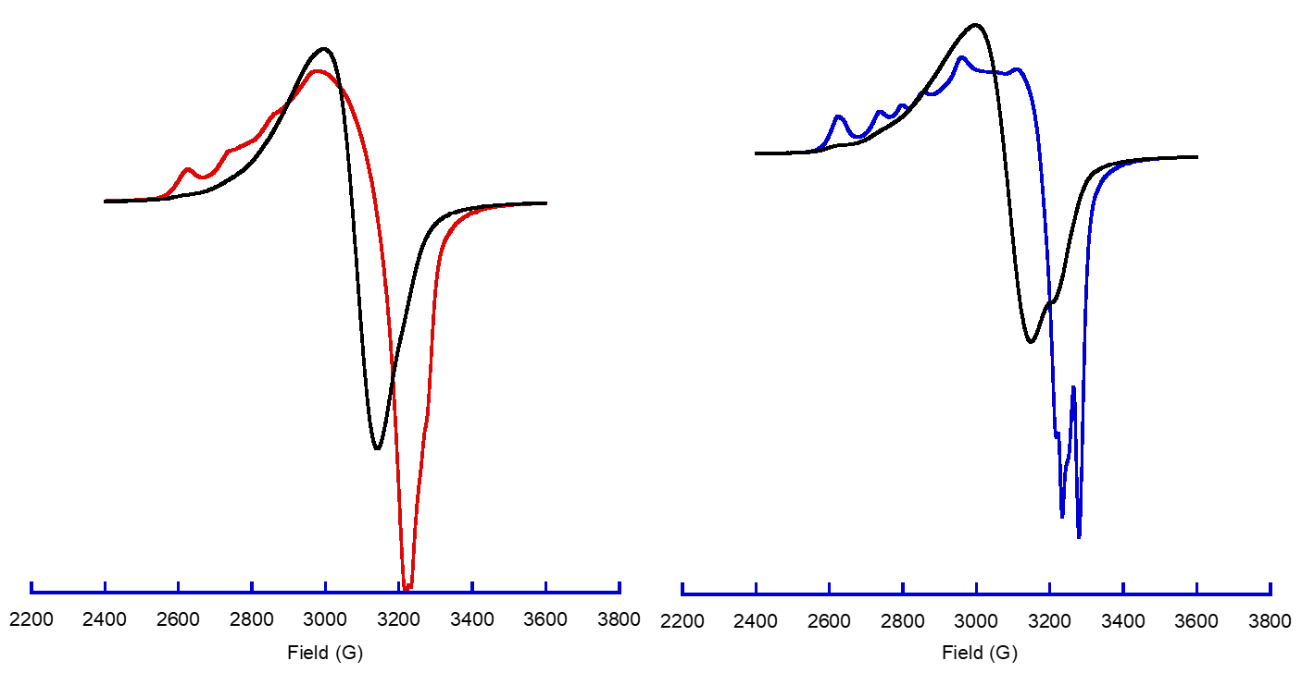
Fig. S5. Continuous Wave-EPR spectra of 1 wt% Cu/H-BEA at 293 K, comparing as received with after dehydration at 393 K under vacuum. Cu/H-BEA (F) (left) as received (Black), dehydrated (Red). Cu/H-BEA (OH) (right), as received (Black), dehydrated (Blue).

Table S2. Cu K-edge EXAFS fit parameters for 1 wt% Cu/H-BEA (F) (S1) and 1 wt% Cu/H-BEA (OH) (S2).
Sample | Path | CN | R (Å) | σ² (Å²) | ΔE₀ (eV) | R-factor
S1 | Cu-O | 4.0 (7) | 1.95 (2) | 0.007 (4) | -3.5 ± 1.7 | 0.003
S2 | Cu-O | 3.6 (3) | 1.95 (3) | 0.004 (2) | -3.5^{f} | 0.001
CN is the coordination number; f is the fixed parameter. R is the atomic distance (Å); σ² is the EXAFS Debye-Waller factor (Å²); ΔE₀ is the shift in energy (eV); R-factor is the closeness of fit. Fitting the first shell only with k-range from 1.7 to 7.2 Å⁻¹ to eliminate contribution of noise in higher k; Fourier transform fitting range from 1.1 to 2.5 Å. The amplitude reduction factor S₀² = 0.9 (ref: Deka et al., 2012). Number in parenthesis is one SD error on the last significant figure. E₀ set at 8989 eV.

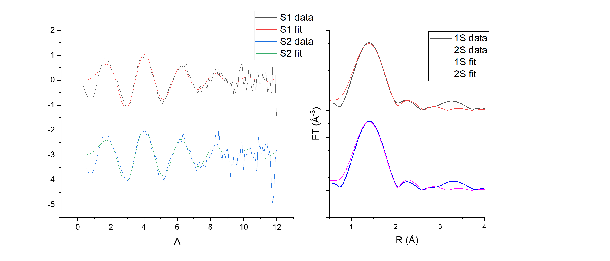
Fig. S6. EXAFS fitting data (see Table S2) for 1 wt% Cu/H-BEA (F) (S1) and 1 wt% Cu/H-BEA (OH) (S2).

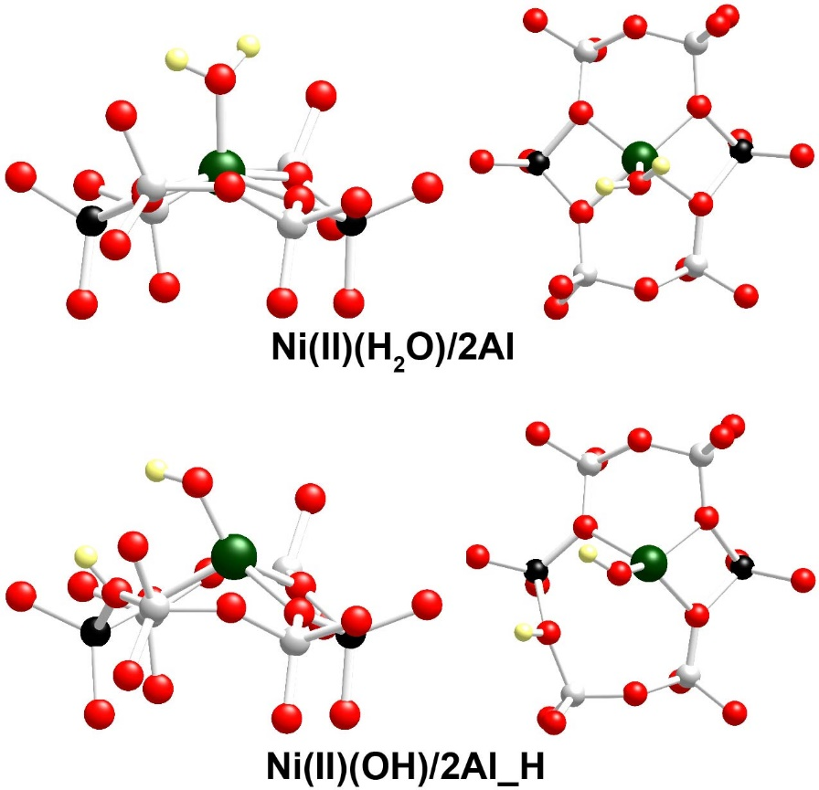
Figure S7. Side (left column) and top (right column) views of the local structure of Ni(II)(H₂O)/2Al and Ni(II)(OH)/2Al_H complexes located in BEA zeolite. Color coding: Si – gray, O – red, Al – black, H – yellow, and Ni – green.

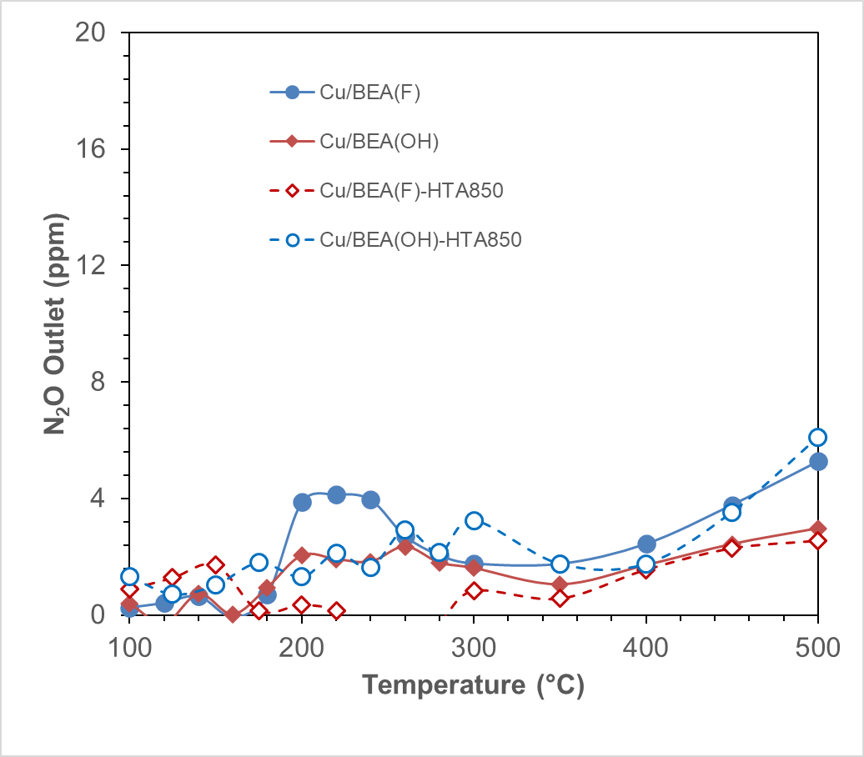
Fig. S8. N₂O formation during SCR on catalysts from Fig. 5. Conditions: 365 ppm NO, 365 ppm NH₃, 10% O₂, 3% H₂O, 150000/h SV, 100mg catalyst. Hydrothermal aging conditions (severe hydrothermal aging): 850 ⁰C, 3hours, 10% H₂O/Air at 150000/h SV. In all cases N₂O concentration is below 5 ppm, and selectivity to N₂ is ~99%.

Table S3. Total amount of methanol produced during low-temperature methane oxidation on H-BEA and 1 wt% Cu/BEA samples.
Sample | Total amount of CH₃OH, µmol/g
H-BEA (F) | 0.0
H-BEA (OH) | 0.1
1 wt% Cu/BEA (F) | 4.2
1 wt% Cu/BEA (OH) | 0.9

