Supporting Information
Effect of Promoters (CeO_{x}, ZrO_{x}, and SiO_{x}) on Activity and Selectivity in the presence of H₂O for Selective Catalytic Reduction (SCR) of NO with NH₃ by Supported V₂O₅-WO₃/TiO₂ Catalysts
Dinh Nhat Dang Nguyen^{a,1,#}, Bar Mosevitzky Lis^{a,b,1,#}, Mingyu Guo^{a,e,f,1,#}, Wenda Hu^{c,d,1,#}, Nicholas R. Jaegers^{c,d,1}, Qingling Liu^{e}, Caixia Liu^{e}, Yong Wang^{c,d,*}, Jian Zhi Hu^{c,d,*}, Israel E. Wachs^{a,*}
ª Operando Molecular Spectroscopy & Catalysis Laboratory, Department of Chemical and Biomolecular Engineering, Lehigh University, Bethlehem, PA 18015, USA
^{b} Department of Chemical Sciences and Bernal Institute, University of Limerick, Limerick, V94 T9PX, Ireland
^{c} Institute for Integrated Catalysis and Earth and Biological Science Directorate, Pacific Northwest National Laboratory, Richland, WA 99354, USA
^{d} Voiland School of Chemical Engineering and Bioengineering, Washington State University, Pullman, WA 99163
^{e} Tianjin Key Laboratory of Indoor Air Environmental Quality Control, School of Environmental Science and Engineering, Tianjin University, Tianjin 300350, China
^{f} Laboratory of Environmental Protection in Water Transport Engineering, Tianjin Research Institute of Water Transport Engineering, Tanggu, Tianjin, 300456, China

*Corresponding authors:
Y.W.: email, yong.wang@pnnl.gov; tel, 509-371-6273
J.Z.H.: email, jianzhi.hu@pnnl.gov; tel, 509-371-6544; fax, 509-371-6546
I.E.W.: email, iew0@lehigh.edu; tel, 610-758-4274

To achieve Ce, Si, and Zr surface coverages of less than a single monolayer (80% monolayer), surface atomic densities were calculated according to the following formulation:
$$\text{Ce surface atomic density}\text{ = }\frac{{\text{W}}_{\text{Ce}{\text{O}}_{\text{2}}}\text{×}{\text{N}}_{\text{A}}}{{\text{M}}_{\text{Ce}{\text{O}}_{\text{2}}}\text{×}{\text{S}}_{\text{BET}}\text{×}{\text{10}}^{\text{18}}} \text{（}\text{Equation S1}\text{）}$$
Where: Ce surface atomic density, cations nm⁻²; ${\text{W}}_{\text{C}e{\text{O}}_{\text{2}}}$ is the loading weight content of CeO₂; N_{A} is Avogadro's number, 6.023×10²³ mol⁻¹; ${\text{M}}_{\text{Ce}{\text{O}}_{\text{2}}}$ is the molecular weight of CeO₂, g·mol⁻¹; S_{BET} is the BET surface area of the support, m²·g⁻¹.

Figure S1. In situ Raman spectra of dehydrated unpromoted and promoted supported 1% V₂O₅/PO_{x}/TiO₂ catalysts at 400 ºC for the 100-1200 cm⁻¹ spectral region.

The effect of promoter impregnation on the oligomerization of surface VO_{x} sites was investigated in previous studies [28,29]. The NO conversions, using NO/NH₃/O₂-TPSR, of the unpromoted and promoted 1%V₂O₅/TiO₂ catalysts were shown to achieve a maximum at ~400 ºC [28,29] before decreasing at higher temperatures due to NH₃ over-oxidation [27]. Figure S2 compares the locations and behaviors of the V=O bands under dehydrated, water vapor-free and water vapor-containing SCR conditions for all catalysts.

Figure S2. In situ IR spectra of the (a) unpromoted 1% V₂O₅/TiO₂; (b) CeO_{x}-promoted 1% V₂O₅/7.9% CeO₂/TiO₂; (c) SiO_{x}-promoted 1% V₂O₅/5.0% SiO₂/TiO₂ and (d) ZrO_{x}-promoted 1% V₂O₅/3.2% ZrO₂/TiO₂ catalysts for the 1800-2200 cm⁻¹ spectral region under dehydrated (10% O₂/Ar), water vapor-free SCR reaction (10% O₂/1000 ppm NO/1000 ppm NH₃/Ar), and water vapor-containing SCR reaction (10% O₂/1000 ppm NO/1000 ppm NH₃/5% H₂O/Ar) conditions at 400 ºC.

For all examined catalysts under the dehydrated condition of 400 ºC (Fig. S2), the location of the overtone V=O IR band remains the same at ~2038 cm⁻¹, indicating a dehydrated catalytic surface regardless of absence or presence of promoters. Under the examined SCR conditions, depending on the types of promoter present on the surface of the 1% V₂O₅/TiO₂ catalysts, the physical interaction of NH₃ (the reactant of the SCR reaction) and H₂O (the product of SCR reaction and the added component in the reactant mixture) via hydrogen bonding with the double-bonded V=O results in different responses of the observed IR V=O bands. The V=O band of the unpromoted 1% V₂O₅/TiO₂ catalyst (Fig. S2a) negligibly redshifts (2 cm⁻¹) under the water vapor-free SCR condition and appreciably (10 cm⁻¹) under the water vapor-containing SCR condition with respect to the dehydrated catalyst. The same behavior of the V=O band occurs for the CeO_{x}-promoted catalyst (Fig. S2b), with the redshift being slightly less pronounced under the water vapor-free SCR reaction (6 cm⁻¹) than under the water vapor-containing SCR condition (8 cm⁻¹). The SiO_{x} promoter modifies the surface VO_{x} sites, making the surface hydrophobic towards interactions with H-containing NH₃ and H₂O molecules. This results in the same location of the Raman V=O bands (Fig. S2c) for all dehydrated and SCR reaction conditions. Finally, the V=O bands of the ZrO_{x}-promoted catalyst (Fig. S2d) behave similarly to those of unpromoted and CeO_{x}-promoted catalysts, redshifting mildly (3 cm⁻¹) under the dehydrated SCR condition and more noticeably (10 cm⁻¹) under the hydrated SCR condition. Despite the similar surface VO_{x} sites being present on the 1% V₂O₅/TiO₂ catalysts, the influence of different promoters results in various characteristic responses to the hydrogen bonding from NH₃ and water vapor in the gas phase.
Considering the broad IR bands of these surface vanadia species and the differences in band locations appearing insignificant, the integrity of surface VO_{x} sites remains unchanged under dehydrated, dehydrated SCR, and hydrated SCR conditions at 400 ºC. These observations remain consistent for both unpromoted and promoted supported 1% V₂O₅/TiO₂ catalysts, as illustrated in Figure S2. Specifically, there are minuscule changes in V=O band positions when comparing all catalysts under the initial dehydrated state and dehydrated SCR condition. Under the hydrated SCR condition, the CeO_{x}- and ZrO_{x}-promoted catalysts exhibit essentially the same V=O wavenumber (~1030 cm⁻¹) compared to the unpromoted catalyst. The shifts of V=O bands observed within the overtone region are mostly indicative of the hydrogen-bonding effects, not real structural changes.

The corresponding in situ Raman spectra of the interaction of NH₃ and H₂O with the surface VO_{x} sites at various reaction temperatures provides insights into the potential changes of surface structures due to variations in environmental conditions. The Raman spectra of the dehydrated unpromoted and promoted catalysts exhibit Raman vibrations of terminal V=O bonds at 1028-1030 cm⁻¹ (Fig. S3-S6). At lower temperatures (200-300 ºC) under the water vapor-free SCR reaction conditions, the surface V=O bands redshift to lower wavenumbers and become broadened. This arises from the interaction of the hydrogen bonding between H₂O/NH₃ molecules and the terminal V=O bonds of the surface VO_{x} sites. The redshifts of the V=O vibrations are not present at higher temperatures (400-500 ºC) because of the low surface concentration of water vapor and NH₃ on the catalyst surface at these high reaction temperatures. However, under the water vapor-containing SCR reaction conditions, at 400 ºC, the terminal V=O vibrations demonstrate redshifts of 7, 3, and 3 wavenumber for unpromoted, CeO_{x}-promoted, and ZrO_{x}-promoted catalysts. This suggests increased perturbation by gas phase H₂O molecules on SCR active sites. These H₂O molecules compete with NH₃ and prevent them from interacting with the SCR active sites on vanadia supported catalysts. In summary, the modification of surface VO_{x} sites by water and NH₃ is only an effect that manifests itself at temperatures that are much lower than the typical SCR reaction temperatures of ~400 ºC [74]. Thus, almost similar surface VO_{x} sites are present in all the catalysts as probed by Raman spectroscopy both under dehydrated and SCR reaction conditions of 400 ºC.
Figure S3. In situ Raman spectra of the dehydrated unpromoted 1% V₂O₅/TiO₂ catalyst for the spectral region 800-1200 cm⁻¹ before SCR, under (a) water vapor-free SCR reaction, and (b) water vapor-containing SCR reaction.

Figure S4. In situ Raman spectra of dehydrated CeO_{x}-promoted 1% V₂O₅/7.92% CeO₂/TiO₂ catalyst for the spectral region 800-1200 cm⁻¹ before SCR, under (a) water vapor-free SCR reaction, and (b) water vapor-containing SCR reaction. Small hydrogen bonding so fast catalyst

Figure S5. In situ Raman spectra of dehydrated SiO_{x}-promoted 1% V₂O₅/4.56% SiO₂/TiO₂ catalyst for the spectral region 800-1200 cm⁻¹ before SCR, under (a) water vapor-free SCR reaction, and (b) water vapor-containing SCR reaction.

Figure S6. In situ Raman spectra of dehydrated ZrO_{x}-promoted 1% V₂O₅/3.2% ZrO₂/TiO₂ catalyst for the spectral region 800-1200 cm⁻¹ before SCR, under (a) water vapor-free SCR reaction, and (b) water vapor-containing SCR reaction.
Table S1. Summary of in situ solid-state ⁵¹V MAS NMR chemical shifts (ppm) with respect to surface vanadia concentration for each hydrated unpromoted and promoted 1% V₂O₅/TiO₂ catalyst. Fractions are obtained from deconvolution of ⁵¹V MAS NMR spectra. 5-15% quantitative errors reflect the combined effects of spectral noise/model variance, imperfect central-transition selectivity, and the absence of T₁ corrections [75,76].
Structures | 1% V₂O₅/TiO₂ | 1% V₂O₅/  7.9% CeO₂/TiO₂ | 1% V₂O₅/  5.0% SiO₂/TiO₂ | 1% V₂O₅/  3.2% ZrO₂/TiO₂
Monomer | 21% | 7% | 46% | 33%
Dimer | 41% | 54% | 25% | 42%
Oligomer &  Bulk like VO_{x} | 38% | 39% | 29% | 25%

Regarding the hydrated NMR protocol, the hydrated catalyst samples were exposed to ambient air for several months prior to loading into the 1.6 mm pencil-type ZrO₂ NMR rotors with no additional treatment. The in situ ⁵¹V MAS NMR spectra of the hydrated unpromoted and promoted 1% V₂O₅/TiO₂ catalysts are summarized in Table S1 and Figure S7. Generally, moisture enhances the signal-to-noise ratio and improves spectral resolution by reducing line broadening effects associated with quadrupolar interactions, resulting in sharper peaks. All hydrated ⁵¹V MAS NMR spectra have shown no contribution of bulk-like V₂O₅ clusters as a result of the hydration of surface vanadia species on the support [49]. Nevertheless, the typical NMR band of crystalline V₂O₅ nanoparticles (-614 ppm) could be eclipsed by those of oligomeric vanadia species. Therefore, the presence of a trace amount of V₂O₅ nanoparticles cannot be completely discounted. Compared to the dehydrated NMR results, the hydrated NMR spectra suggest the vanadia species are generally more oligomerized under hydrated conditions. However, the presence of the silica promoter behaves differently and favors more monomeric vanadia surface species. When compared with the hydrated supported unpromoted 1% V₂O₅/TiO₂ catalyst, the NMR spectra of the hydrated 1% V₂O₅/7.9% CeO₂/TiO₂ and 1% V₂O₅/3.2% ZrO₂/TiO₂ catalysts show a modest tendency to favor oligomerized vanadia species. In contrast, the NMR spectrum of the hydrated 1% V₂O₅/5.0% SiO₂/TiO₂ catalyst exhibits a decrease in the concentration of oligomeric vanadia sites and favors the formation of monomeric vanadia species. These results suggest the reorganization of surface vanadia structures under hydrated conditions driven by the interaction of the vanadium oxide species with the different metal oxide ligands. The CeO_{x}- and ZrO_{x}-promoted catalysts aid the assembly of surface vanadia sites, under the effects of water molecules, towards more oligomerized species. In contrast, the SiO_{x}-promoted catalyst inhibits this interaction with moisture, resulting in catalysts possessing fewer oligomerized vanadia species.
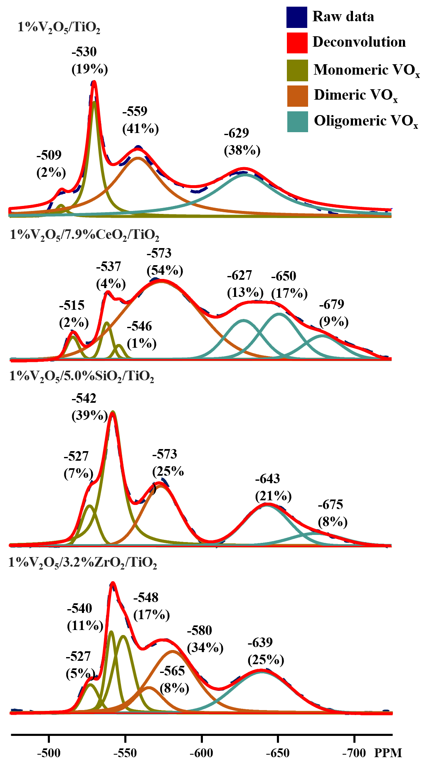
Figure S7. In situ solid-state ⁵¹V MAS NMR spectra of hydrated unpromoted and promoted titania-supported vanadia catalysts and the spectral deconvolution.

⁵¹V MAS NMR spectra are shown below with the spinning sideband manifolds for (top) Dehydrated V-Ce-Ti and (bottom) Hydrated V-Zr-Ti samples, recorded at 14.1 T and a spinning rate of 34 kHz. Despite the low vanadium content (~1 wt%) and signal-to-noise limitations, the spectra qualitatively illustrate the sideband distribution resulting from combined chemical shift anisotropy (CSA) and quadrupolar interactions. The low S/N arises from the combination of a small quantity of samples and low V-loading and the rolling baseline becomes an issue for showing the full spectrum. Due to the presence of a rolling baseline, sideband overlap, and limited spectral resolution, reliable quantitative fitting of CSA and quadrupolar parameters was not feasible for the current experiments. These examples are provided for completeness to address the reviewer’s suggestion, while the main spectral analysis in this study focuses on the centerband regions where features can be more reliably interpreted.

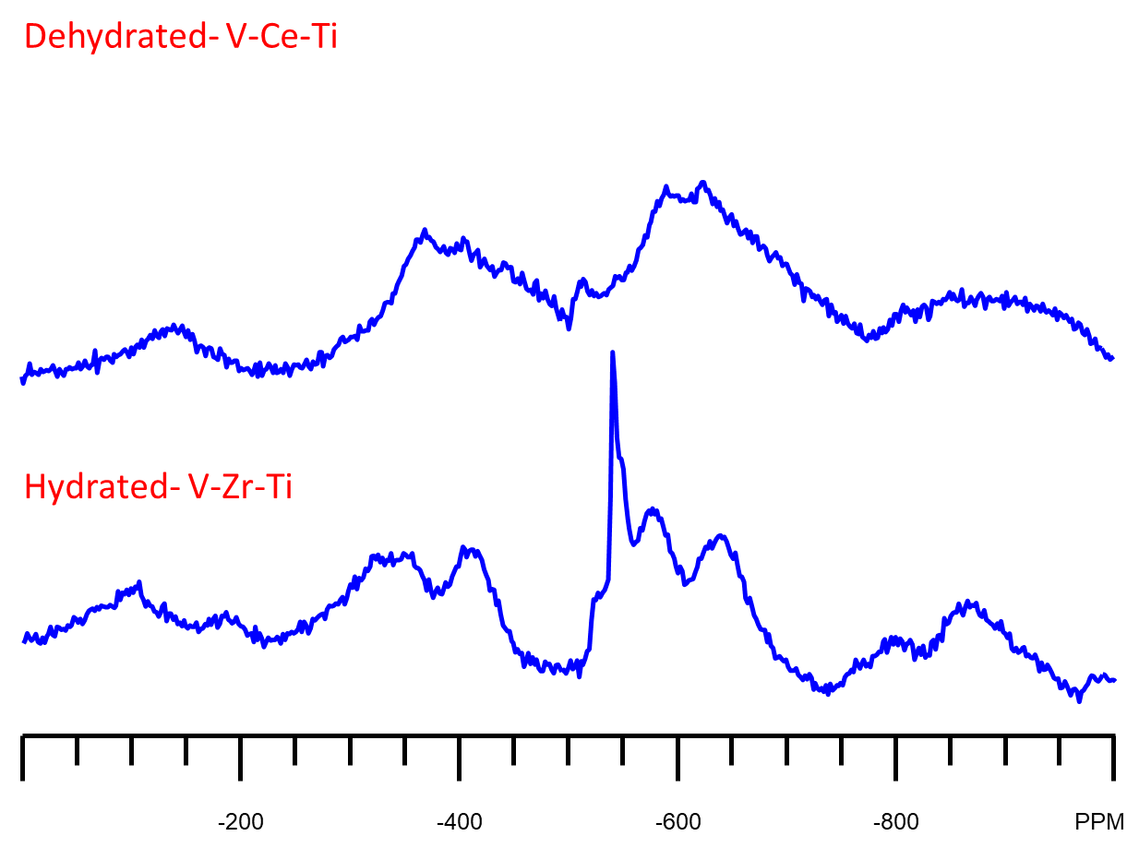

Figure S8. ⁵¹V MAS NMR spectra with entire spinning sideband manifolds for (top) Dehydrated 1% V₂O₅/7.9% CeO₂/TiO₂ and (bottom) Hydrated 1% V₂O₅/3.2% ZrO₂/TiO₂ samples recorded at 14.1 T and a spinning rate of 34 kHz.

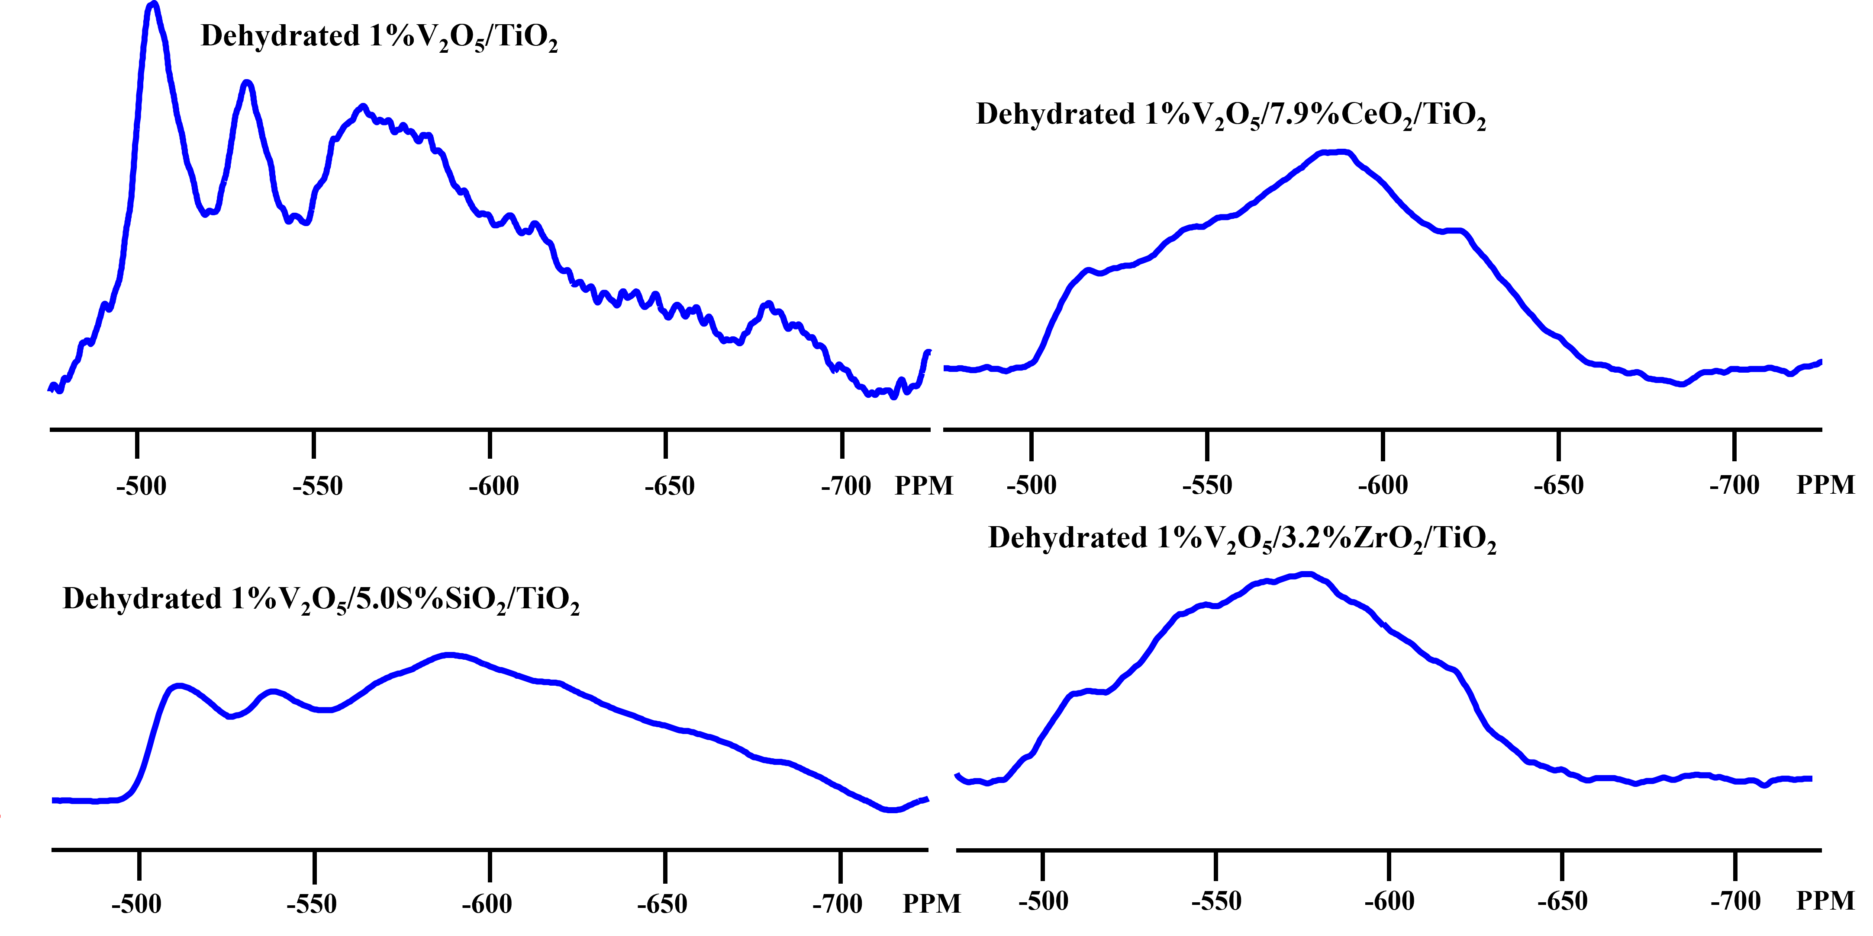

Figure S9. In situ solid-state ⁵¹V MAS NMR spectra of dehydrated unpromoted and promoted titania-supported vanadia catalysts with raw data.

Figure S10. In situ IR spectra of (a) unpromoted 1% V₂O₅/TiO₂; (b) CeO_{x}-promoted 1% V₂O₅/7.92% CeO₂/TiO₂; (c) SiO_{x}-promoted 1% V₂O₅/5.0% SiO₂/TiO₂ and (d) ZrO_{x}-promoted 1% V₂O₅/3.2% ZrO₂/TiO₂ catalysts for the spectral region 1100-1500 cm⁻¹ under dehydrated condition (10% O₂/Ar) and water vapor-free SCR reaction (10% O₂/1000 ppm NO/1000 ppm NH₃/Ar).
Figure S11. In situ IR spectra of (a) unpromoted 1% V₂O₅/TiO₂; (b) CeO_{x}-promoted 1% V₂O₅/7.92% CeO₂/TiO₂; (c) SiO_{x}-promoted 1% V₂O₅/5.0% SiO₂/TiO₂ and (d) ZrO_{x}-promoted 1% V₂O₅/3.2% ZrO₂/TiO₂ catalysts for the spectral region 1100-1500 cm⁻¹ under dehydrated condition (10% O₂/Ar) and water vapor-containing SCR reaction (10% O₂/1000 ppm NO/1000 ppm NH₃/5% H₂O/Ar).

Table S2. Number of surface acid sites on unpromoted and promoted supported 1%V₂O₅/TiO₂ catalysts with respect to temperature under the water vapor-free SCR reaction conditions. The relative IR sensitivity of surface NH₄* species on Brønsted acid sites to surface NH₃* species on Lewis acid sites was close to unity [16], suggesting direct comparison between the population of these two adsorbed ammonia species can be conducted using their IR characteristic peaks.

Samples | Temperature  (ºC) | Brønsted acid sites (a.u.) | Lewis acid sites (a.u.) | Total acid sites (a.u.) | B/L
V₂O₅/TiO₂ | 120 | 1.7 | 5.9 | 7.6 | 0.29
V₂O₅/TiO₂ | 200 | 0.2 | 5.1 | 5.4 | 0.05
V₂O₅/TiO₂ | 250 | - | 4.7 | 4.7 | -
V₂O₅/TiO₂ | 300 | - | 3.3 | 3.3 | -
V₂O₅/TiO₂ | 350 | - | 2.0 | 2.0 | -
V₂O₅/TiO₂ | 400 | - | 0.3 | 0.3 | -
V₂O₅/TiO₂ | 450 | - | - | - | -
V₂O₅/TiO₂ | 500 | - | - | - | -
V₂O₅/CeO₂/TiO₂ | 120 | 1.7 | 4.8 | 6.5 | 0.34
V₂O₅/CeO₂/TiO₂ | 200 | - | 3.6 | 3.6 | -
V₂O₅/CeO₂/TiO₂ | 250 | - | 2.8 | 2.8 | -
V₂O₅/CeO₂/TiO₂ | 300 | - | 1.8 | 1.8 | -
V₂O₅/CeO₂/TiO₂ | 350 | - | 0.6 | 0.6 | -
V₂O₅/CeO₂/TiO₂ | 400 | - | 0.3 | 0.3 | -
V₂O₅/CeO₂/TiO₂ | 450 | - | - | - | -
V₂O₅/CeO₂/TiO₂ | 500 | - | - | - | -
V₂O₅/SiO₂/TiO₂ | 120 | 4.1 | - | 4.1 | -
V₂O₅/SiO₂/TiO₂ | 200 | 1.8 | - | 1.8 | -
V₂O₅/SiO₂/TiO₂ | 250 | 0.9 | - | 0.9 | -
V₂O₅/SiO₂/TiO₂ | 300 | 0.7 | - | 0.7 | -
V₂O₅/SiO₂/TiO₂ | 350 | 0.3 | - | 0.3 | -
V₂O₅/SiO₂/TiO₂ | 400 | - | - | - | -
V₂O₅/SiO₂/TiO₂ | 450 | - | - | - | -
V₂O₅/SiO₂/TiO₂ | 500 | - | - | - | -
V₂O₅/ZrO₂/TiO₂ | 120 | 1.9 | 4.5 | 6.4 | 0.42
V₂O₅/ZrO₂/TiO₂ | 200 | 0.4 | 4.1 | 4.5 | 0.10
V₂O₅/ZrO₂/TiO₂ | 250 | - | 3.5 | 3.5 | -
V₂O₅/ZrO₂/TiO₂ | 300 | - | 2.8 | 2.8 | -
V₂O₅/ZrO₂/TiO₂ | 350 | - | 1.6 | 1.6 | -
V₂O₅/ZrO₂/TiO₂ | 400 | - | 0.3 | 0.3 | -
V₂O₅/ZrO₂/TiO₂ | 450 | - | - | - | -
V₂O₅/ZrO₂/TiO₂ | 500 | - | - | - | -

Table S3. Number of surface acid sites on unpromoted and promoted supported 1%V₂O₅/TiO₂ catalysts with respect to temperature under the water vapor-containing SCR reaction conditions. The relative IR sensitivity of surface NH₄* species on Brønsted acid sites to surface NH₃* species on Lewis acid sites was close to unity [16], suggesting direct comparison between the population of these two adsorbed ammonia species can be conducted using their IR characteristic peaks.

Samples | Temperature  (ºC) | Brønsted acid sites (a.u.) | Lewis acid sites (a.u.) | Total acid sites (a.u.) | B/L
V₂O₅/TiO₂ | 120 | 1.4 | 1.7 | 3.1 | 0.86
V₂O₅/TiO₂ | 200 | 1.4 | 2.2 | 3.5 | 0.63
V₂O₅/TiO₂ | 250 | 1.7 | 1.8 | 3.5 | 0.93
V₂O₅/TiO₂ | 300 | 0.9 | 1.0 | 1.9 | 0.85
V₂O₅/TiO₂ | 350 | 0.2 | 0.8 | 1.0 | 0.22
V₂O₅/TiO₂ | 400 | 0.05 | 0.5 | 0.6 | 0.09
V₂O₅/TiO₂ | 450 | - | - | - | -
V₂O₅/TiO₂ | 500 | - | - | - | -
V₂O₅/CeO₂/TiO₂ | 120 | 0.9 | 2.1 | 3.0 | 0.45
V₂O₅/CeO₂/TiO₂ | 200 | 2.1 | 1.5 | 3.6 | 1.40
V₂O₅/CeO₂/TiO₂ | 250 | 1.6 | 1.1 | 2.7 | 1.45
V₂O₅/CeO₂/TiO₂ | 300 | 0.3 | 1.1 | 1.4 | 0.24
V₂O₅/CeO₂/TiO₂ | 350 | - | 0.8 | 0.8 | -
V₂O₅/CeO₂/TiO₂ | 400 | - | 0.2 | 0.2 | -
V₂O₅/CeO₂/TiO₂ | 450 | - | - | - | -
V₂O₅/CeO₂/TiO₂ | 500 | - | - | - | -
V₂O₅/SiO₂/TiO₂ | 120 | 4.0 | - | 4.0 | -
V₂O₅/SiO₂/TiO₂ | 200 | 2.7 | - | 2.7 | -
V₂O₅/SiO₂/TiO₂ | 250 | 1.6 | - | 1.6 | -
V₂O₅/SiO₂/TiO₂ | 300 | 1.0 | - | 1.0 | -
V₂O₅/SiO₂/TiO₂ | 350 | 0.3 | - | 0.3 | -
V₂O₅/SiO₂/TiO₂ | 400 | 0.2 | - | 0.2 | -
V₂O₅/SiO₂/TiO₂ | 450 | - | - | - | -
V₂O₅/SiO₂/TiO₂ | 500 | - | - | - | -
V₂O₅/ZrO₂/TiO₂ | 120 | 1.3 | 2.3 | 3.6 | 0.59
V₂O₅/ZrO₂/TiO₂ | 200 | 0.7 | 2.9 | 3.6 | 0.25
V₂O₅/ZrO₂/TiO₂ | 250 | 1.1 | 2.7 | 3.8 | 0.41
V₂O₅/ZrO₂/TiO₂ | 300 | 0.9 | 2.1 | 3.0 | 0.41
V₂O₅/ZrO₂/TiO₂ | 350 | 0.3 | 1.2 | 1.5 | 0.25
V₂O₅/ZrO₂/TiO₂ | 400 | - | 0.4 | 0.4 | -
V₂O₅/ZrO₂/TiO₂ | 450 | - | - | - | -
V₂O₅/ZrO₂/TiO₂ | 500 | - | - | - | -

Figure S12. Comparison of steady state kinetic data of unpromoted and promoted catalysts for N₂O formation. Reaction gas compositions include 10% O₂/1000 ppm NO/1000 ppm NH₃/N₂ for water vapor-free SCR reaction and 10% O₂/1000 ppm NO/1000 ppm NH₃/5% H₂O/N₂ for water vapor-containing SCR reaction. The dashed lines and straight lines were constructed to aid the visualization of the data and are not measured data points.

Figure S13. Steady state kinetic data of 1%V₂O₅/TiO₂, 7.9%CeO₂/TiO₂, 5.0%SiO₂/TiO₂, and 3.2%ZrO₂/TiO₂ catalysts for (a) NO conversion and (b,c) N₂O formation. Reaction gas compositions include 10% O₂/1000 ppm NO/1000 ppm NH₃/N₂ for water vapor-free SCR reaction conditions and 10% O₂/1000 ppm NO/1000 ppm NH₃/5% H₂O/N₂ for water vapor-containing SCR reaction conditions. The straight lines (water vapor-free) and dashed lines (water vapor-containing) were constructed to aid the visualization of the data and were not measured data points.

