Supporting Information
Versatile and Robust Nickel Single Atom Catalysts
Brandon Burnsideª, Jesse Larenceª, Ryan Alcalaª, Stephen Porterª, Andrew DeLaRivaª, Karl Kharasª, Christopher Riley^{a,1}, Angelica Benavidezª, Nicholas Jaegersª, Geunho Han^{b}, Justin Notestein^{b}, Siddhant Singh^{c}, Robert W.J. Scott^{c}, Lulu Chen^{d}, Juan Li ^{d}, Sen Lin^{d}, Hua Guo^{e}, Shan Jiang^{f}, Wei-Ling Huang^{f}, Jeffrey T. Miller^{f} and Abhaya K. Datye^{a,*}
ªDepartment of Chemical & Biological Engineering, University of New Mexico, Albuquerque, NM 87131, USA
^{b}Department of Chemical and Biological Engineering, Northwestern University, Evanston, IL 60208, USA
^{c}Department of Chemistry, University of Saskatchewan, Saskatoon, Saskatchewan S7N 5C9, Canada
^{d}State Key Laboratory of Chemistry for NBC Hazards Protection, College of Chemistry, Fuzhou University, Fuzhou 350116, China
^{e}Department of Chemistry and Chemical Biology, Center for Computational Chemistry, University of New Mexico, Albuquerque, NM 87131, USA
^{f}Davidson School of Chemical Engineering, Purdue University, W. Lafayette, IN, 47907 USA
¹present address: Sandia National Laboratories, Albuquerque, NM 87185, USA
*datye@unm.edu

Contents
Methods
TOF Calculation
Figures S1-S22
Tables S1-S9

Methods
Experimental details at the Canadian Light Source (CLS)
XAS analysis was performed at the HXMA beamline (energy range 5–30 keV; resolution 1 × 10^{–4} ΔE/E) at the Canadian Light Source (CLS). To select the energy for the Zr K and Ni K edges, a Si(111) double-crystal monochromator with a rhodium-coated 100-nm-long Kirkpatrick–Baez mirror was used. All the data were collected in fluorescence mode using a 32-element Ge detector. The powdered samples were packed in a sample holder having a dimension of around 0.001 x 0.5 x 0.1 cm. Data processing and EXAFS fitting was carried out using the Demeter software package (1). For EXAFS fitting, the amplitude reduction factor was obtained from fitting the Zr and Ni foils and fixed at 0.68 and 0.7, respectively, during the fitting. For Ce-edge EXAFS fitting, the amplitude reduction factor was fixed at 0.8. The EXAFS spectra were fitted between k values 3 to 8 and R values of 1–3 Å, except for the Zr foil.
Total X-ray Scattering Analysis- X-ray total scattering data was collected at the Brockhouse Diffraction Sector-Wiggler High Energy Beamline (energy range, 20–94 keV; beam size, 2–10 mm × ∼100 μm (W × H); energy resolution, 1 × 10^{–3} Δd/d; monochromator crystal Si(111); flux, 5 × 10⁹–2 × 10¹³) at the CLS. To collect the scattering data, a large 2D area detector was placed approximately 155 mm away from the sample. The sample itself was packed inside the Kapton capillary of 0.2 mm thickness. A total of 256 scans were taken and averaged with a total exposure time of less than 5 min for each sample. Data for the pure Ni standard was also taken to calibrate the instrumental parameters. To remove the background from air scattering and the quartz capillary, the scattering data of an empty Kapton capillary of the same dimensions was collected and subtracted from the data of the samples. The azimuthal integration of 2D scattering patterns was carried out using the GSAS-II (2) software package. PDFgetX3 (3) was used for background subtraction and the calculation of PDF data. The PDFs were calculated with a Q_{max} of 23.5 Å^{–1} to give the best balance between the statistical noise and real space resolution. The model making and its fitting with the experimental data were carried out using the PDFgui software package (4). The fitting of Ni data was carried out with Ni fcc model to obtain the values of Qdamp and delta-1. ¹⁻⁴
TOF Calculation for Ce_{0.9}Ni_{0.1}O_{2-x}
$$TOF=\frac{\frac{moles {CO}_{2} converted}{Second}}{moles of {Ni}_{surface}}$$
Turnover frequency for Ce_{0.9}Ni_{0.1}O_{2-x} during CO₂ hydrogenation was calculated as follows
$$moles of \frac{{Ni}_{surface}}{g_{cat}}=\frac{Ceria atoms on \left(111\right)surface}{m^{2}}*\frac{0.14 Ni atom}{Ce atom}*\frac{mole}{6.023*{10}^{23}atoms}*\frac{m^{2}}{g}$$
For a Ceria (111) surface, the surface Ce atoms per m² are 7.9*10¹⁸
BET surface area after 500 °C treatment in 10% H₂ for Ce_{0.9}Ni_{0.1}O_{2-x} = 105 m²/gram
XPS shows a surface concentration of 0.14 Ni atom per Ce atom
We therefore estimate Ni_{surface}/gcat to be 1.1x10⁻⁴ moles of surface Ni atoms/gcat
$$Dispersion=\frac{moles {Ni}_{Surface}}{moles {Ni}_{bulk}}$$
Moles of Ni_{surface} = 0.00011 per g of catalyst
Moles of Ni_{bulk} = 0.000579 per g of catalyst (3.4 wt% (g/100 g cat)/MW Ni 58.70 g/g mol)
Dispersion of Ni in the SAC = 0.00011/0.000579 = 18.98%
Moles CO₂ converted per second at 260 °C
= (3 ml CO₂/min) x (18% conversion)/(100)/(29,165 ml/mole at Albuquerque atmospheric pressure)
= 1.85x10⁻⁵/min
TOF at 260 C = 1.85x10-5 moles/min)/(1.1x10⁻⁴ moles of surface Ni/g cat)/(0.3 g catalyst)/(60 s/min)
TOF at 260 C = 8.4x10⁻² (s⁻¹)

Turnover frequency for Ni/SiO₂
$$TOF ({Ni}/{SiO_{2}})=\frac{\frac{moles {CO}_{2} converted}{Second}}{0.03g (mass of catalyst)*0.03 (Ni wt loading)*58.69\frac{g*Ni}{mol}*dispersion}$$
Turnover frequency for Ni/SiO₂ during CO₂ hydrogenation was calculated as follows
$$Dispersion=\frac{moles {Ni}_{Surface}}{moles {Ni}_{bulk}}=\frac{1}{\overline{d}}$$
Dispersion was taken to be the inverse of the average particle size as seen in TEM as 3.2 nm.
Moles of Ni surface/g cat = 0.03/58.69*0.3125 = 4.792x10⁻⁶ moles/g cat=1.597x10⁻⁴ moles/g cat
Moles CO₂ converted per second at 280 °C
= (3 ml CO₂/min) x (6% conversion)/(100)/(29,165 ml/mole at Albuquerque atmospheric pressure) = 6.17 x10⁻⁶ mol/min
TOF at 280 °C = (6.17x10⁻⁶ mol/min)/(1.597x10⁻⁴ mol/gcat)/60s/min/(0.03 g cat) = 2.14 x10⁻²(s⁻¹)

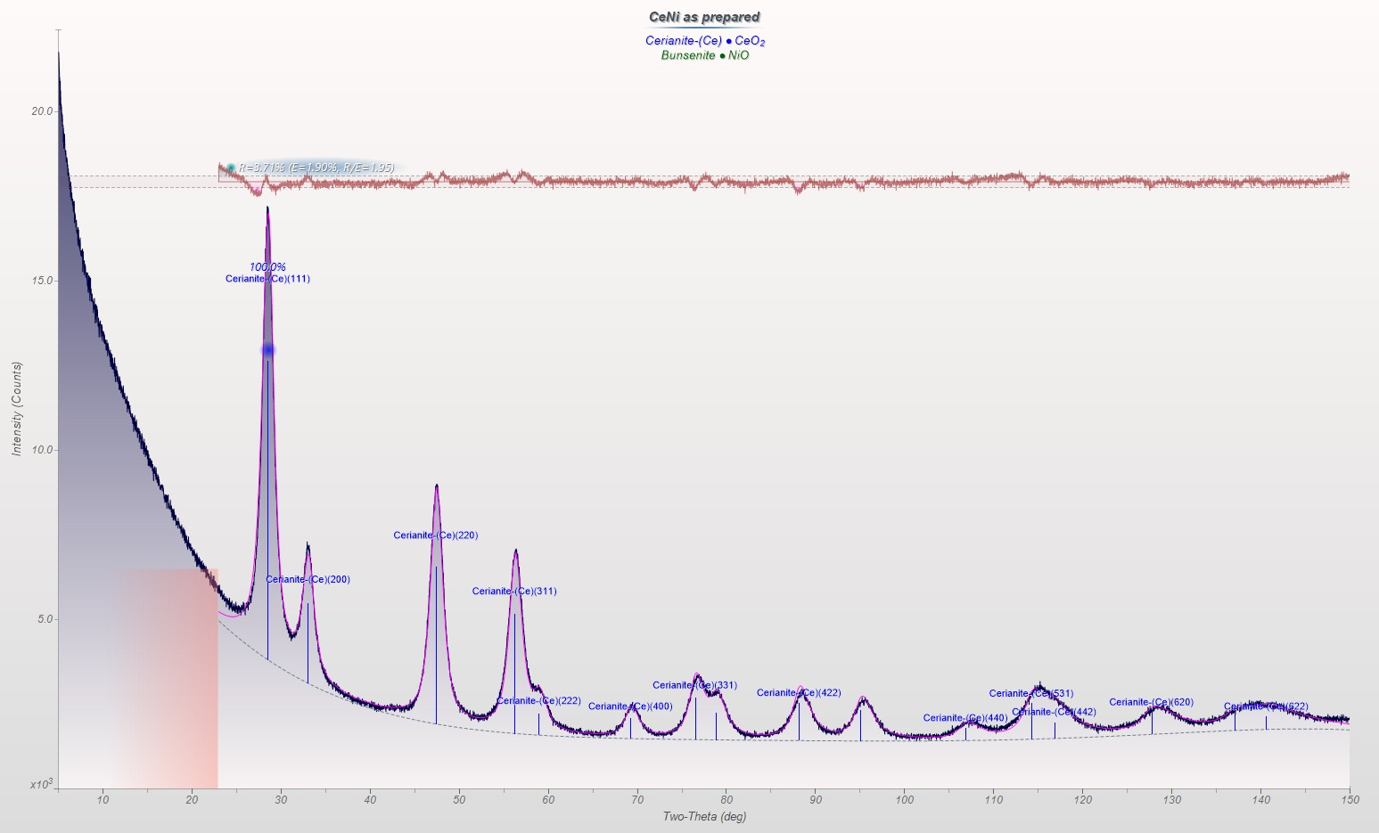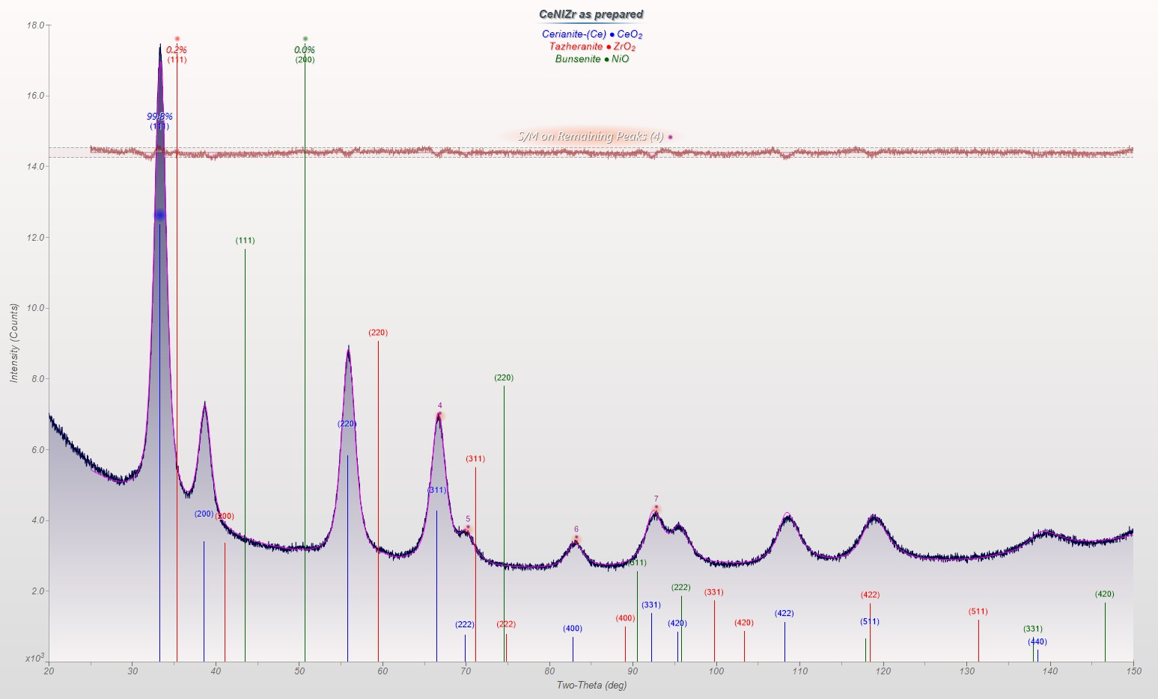Figure S1:(a) Jade fit of the XRD powder pattern of as-prepared Ce_{0.9}Ni_{0.1}O_{2-x.} This measurement was obtained with Cu Kα radiation. The only phase visible is cerium oxide, there are no peaks corresponding to any Ni containing phases, Ni metal or NiO.
(b) JADE software fit for the Ce_{0.9}Ni_{0.05}Zr_{0.05}O_{2-x}. This measurement was obtained with Co Kα radiation. No phases corresponding to Ni or Zr are evident in this powder pattern.
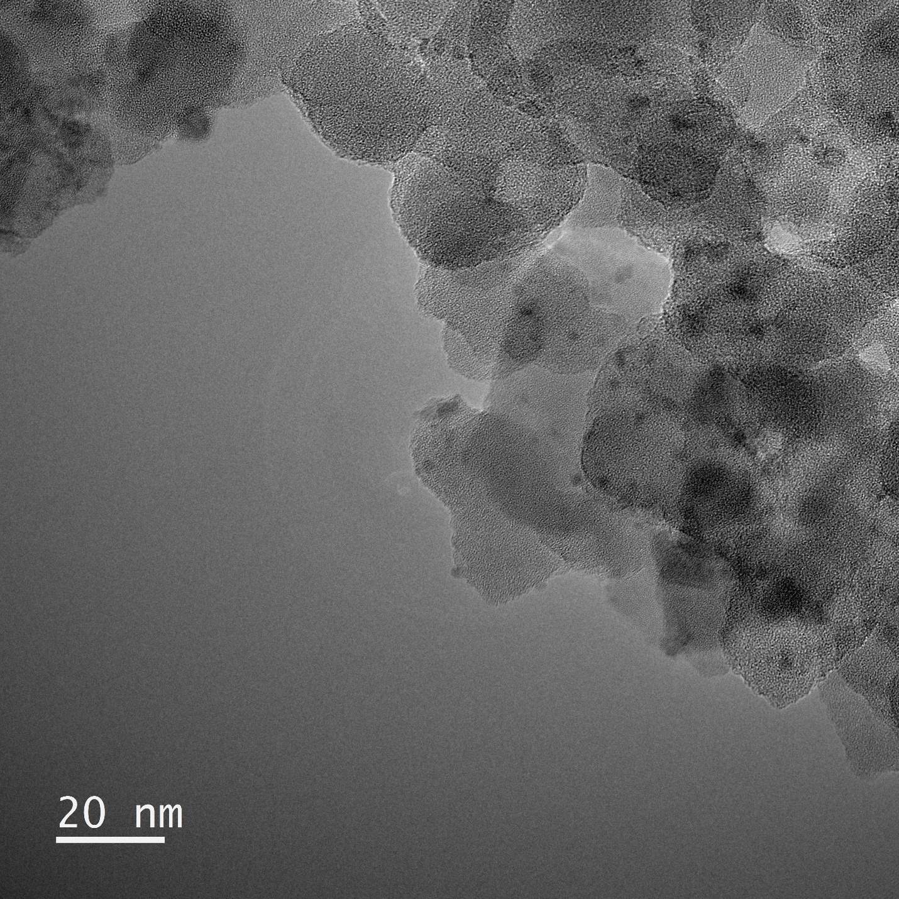
Figure S2: HRTEM image of the as prepared Ni/SiO₂ calcined at 500°C. By counting particles (22), we obtain an average particle diameter of 3.2 nm.
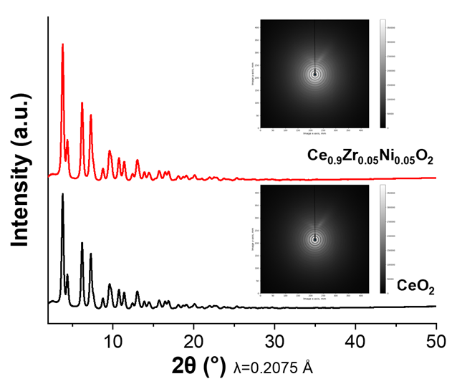
Figure S3: High-energy synchrotron powder XRD of Ce_{0.9}Ni_{0.05}Zr_{0.05}O_{2-x} along with the CeO₂ standard. Insets represent the 2D scattering patterns of the respective samples.

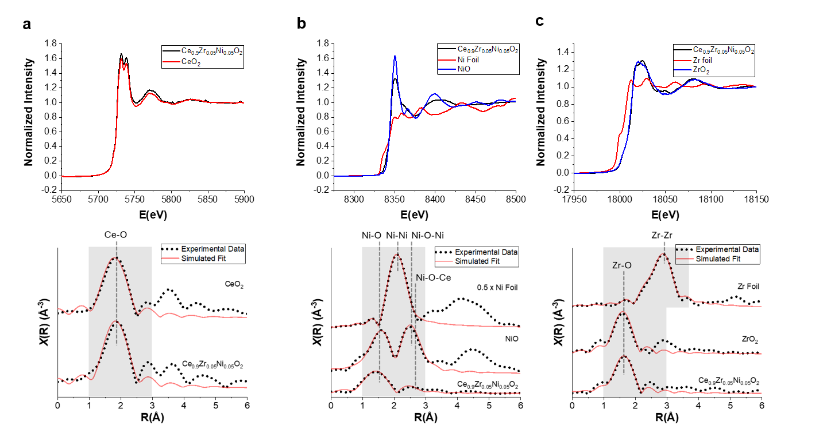
Figure S4: (a) Ce L₃; (b) Ni K, and (c) Zr K edge XANES spectra of Ce_{0.9}Ni_{0.05}Zr_{0.05}O_{2-x} along with some common standards and the respective Fourier Transforms of the EXAFS showing experimental data and the fits.

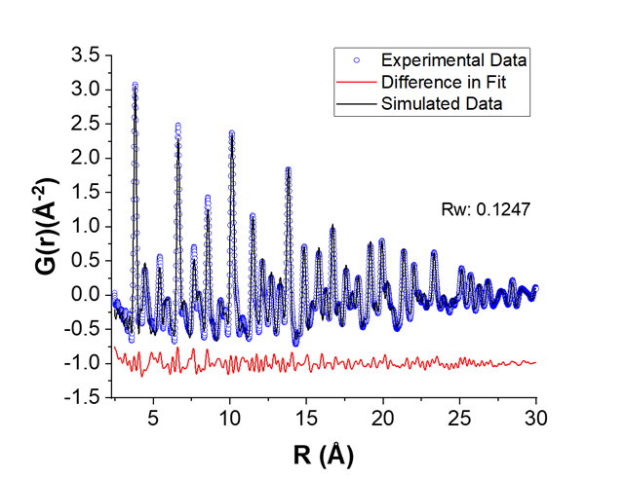

Figure S5: PDF data for the Ce_{0.9}Ni_{0.05}Zr_{0.05}O_{2-x} (blue dots), its best-simulated fit with the model (black), and the difference between the fit and experimental data (red).

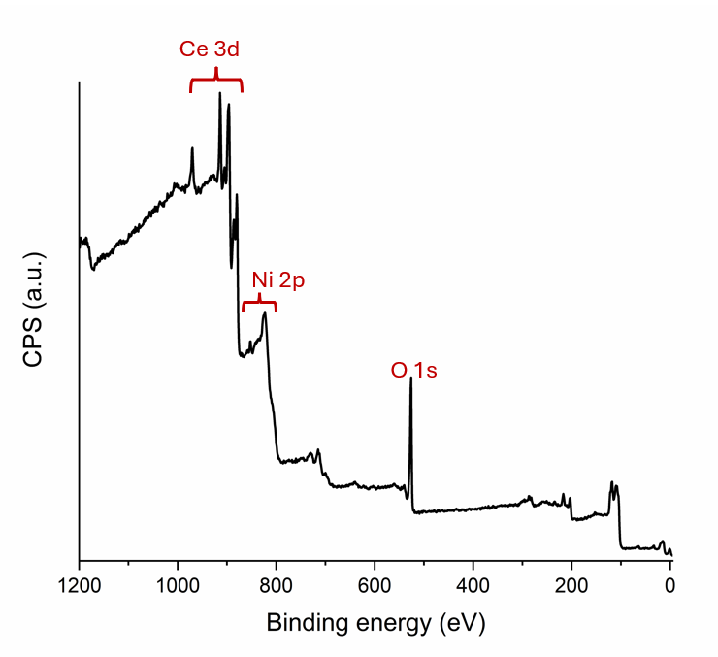
Sample | Ce 3d (at%) | Ni 2p (at%) | O 1s (at%)
Ce_{0.9}N_{i0.1}O_{2-x} | 27.76 | 3.89 | 68.35

Figure S6: XPS survey scan of the as-prepared Ce_{0.9}N_{i0.1}O_{2-x} sample (calcined 500 °C) and air-exposed.
Figure S7: XPS spectra of Ni for the as prepared Ce_{0.9}N_{0.1}O_{2-x} (calcined 500 °C in air). the main Ni²⁺ 2P^{3/2} is seen around 854.8 eV. With the corresponding satellite peak appearing around 860.8 eV.

Sample | Ce³⁺ (%) | Ce⁴⁺ (%)
Ce_{0.9}Ni_{0.1}O_{2-x} | 17 | 83
Figure S8: XPS spectrum of Ce for the air-exposed Ni SAC as prepared (calcined 500 °C in air).
O1s lattice | O1s hydroxyls/defects | O1s adventitious carbon
529.36 eV | 531.1 eV | 534.27 eV
65.9% | 31.3% | 2.8

Figure S9: XPS spectra of the O 1s region for the air-exposed Ni SAC sample, with the O1s associated with lattice oxygen (red), a second feature that is associated with hydroxyls (green) or defects associated with O vacancies, and a small feature that is assigned to oxygen associated with adventitious carbon (blue). The basis for these assignments is explained in the manuscript.

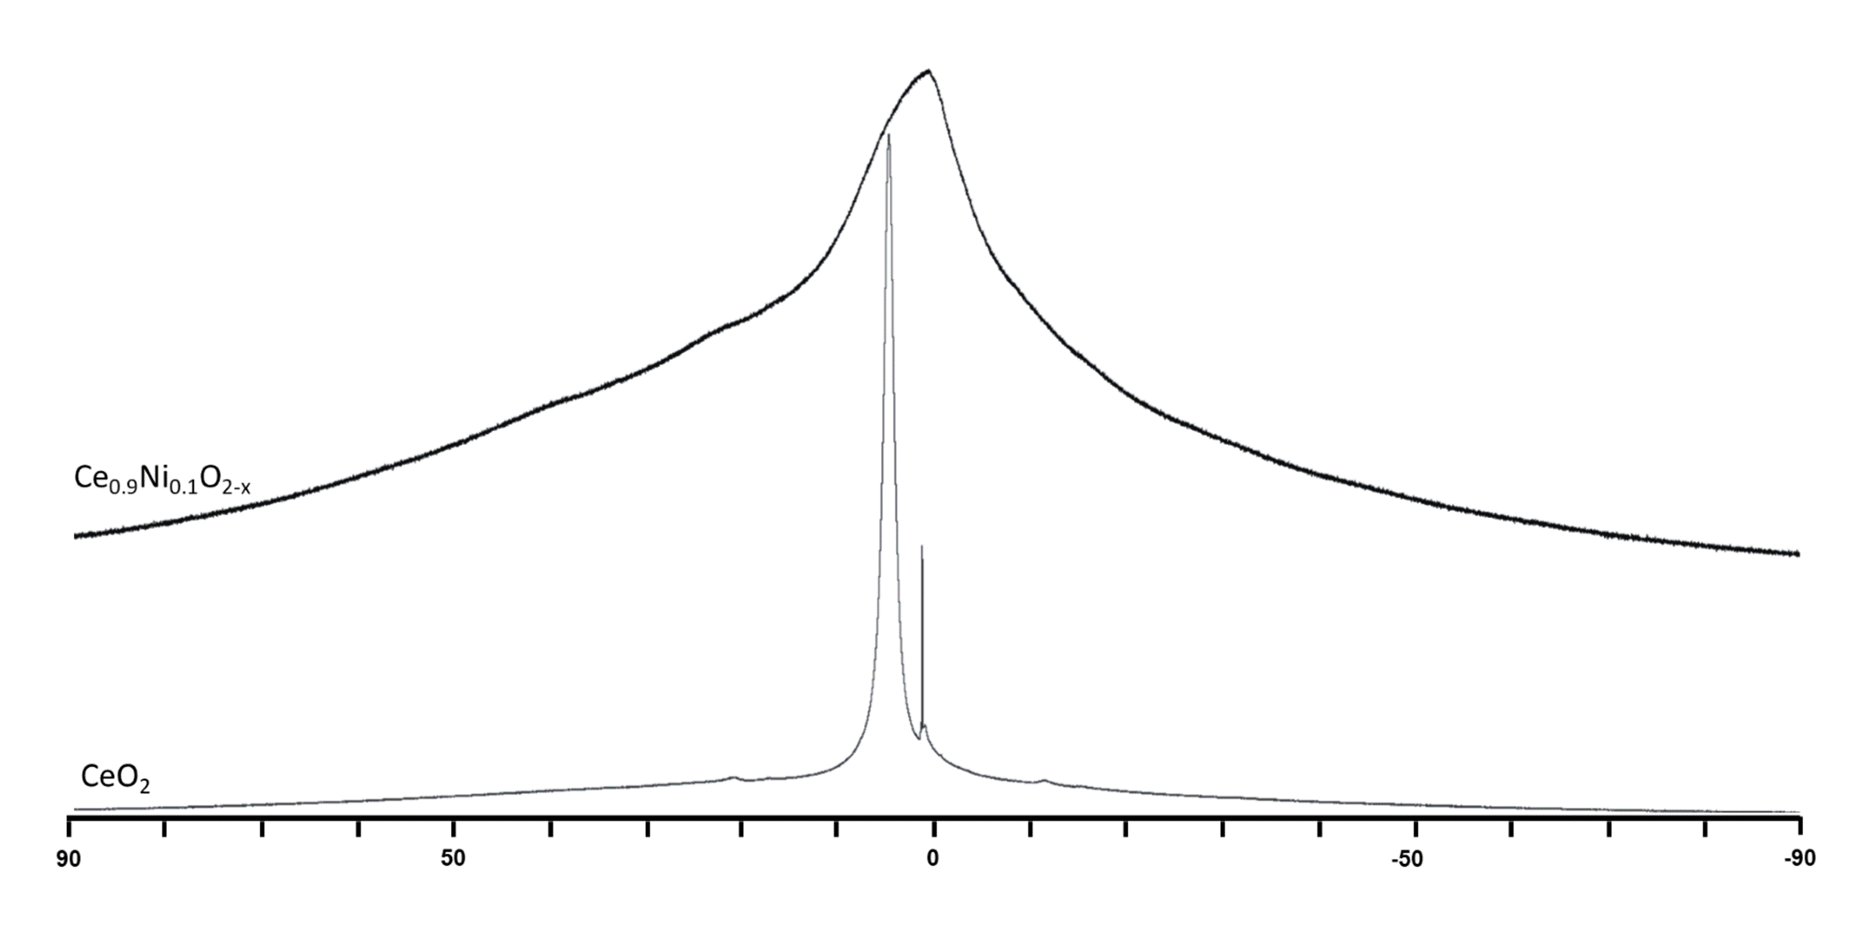

Figure S10: ¹H MAS NMR of Ce_{0.9}Ni_{0.1}O_{2-x} (top) and CeO₂ (bottom) (scaled to sample weight) after treatment in dynamic vacuum at 423 K and transfer to the MAS NMR rotor. Samples were rotated at the magic angle with respect to the magnetic field at 8 kHz. Collection of ¹H MAS NMR spectra of dehydrated CeO₂ was hindered by incomplete removal of physisorbed water, a likely consequence of unavoidably exposure to ambient air during rotor packing. The resulting spectrum is dominated by a sharp resonance at 4.8 ppm, consistent with molecularly adsorbed H₂O. Literature studies of well-dehydrated ceria report surface hydroxyl resonances at 0.7–1.2 ppm and a weak water signal near 5–6 ppm,^{24,25} but these features were not observed here due to the overwhelming intensity of physisorbed water and its H-bonding and exchange interactions with surface hydroxyl groups. A minor narrow signal at ~1.5 ppm is attributed to rotor hardware (Vespel) proton resonances, which commonly appear in this region. No clear evidence of intrinsic CeO₂ hydroxyls could be resolved under the present sample-handling constraints. The ¹H MAS NMR spectrum of Ce_{0.9}Ni_{0.1}O_{2-x} differs markedly from that of CeO₂ and is dominated by a very broad underlying resonance spanning the full spectral width, which is largely absent in hydrated CeO₂ spectrum. This broad component is attributed to strongly shifted and extremely short-T₂ protons located near paramagnetic Ni²⁺ and Ce³⁺ centers and/or to hydroxyl groups incorporated within the defect-rich oxide lattice, both of which generate large hyperfine and anisotropic interactions. Superimposed on this background are distinct hydroxyl features, including a broad resonance centered at ~1.8 ppm (FWHM ≈ 12 ppm) and a weaker shoulder near 0.8 ppm, consistent with surface OH but strongly broadened by proximity to paramagnetic sites. In addition, small but well-defined spinning sidebands at –10, 23, and 39 ppm arise from an additional proton environment, corresponding to a buried isotropic resonance near ~5.5 ppm. Features in this spectral region are typically ascribed to weakly bound water interacting with hydroxyl groups. The elevated overall proton intensity and the coexistence of broad, anisotropic, and surface-like features support the presence of multiple hydroxyl populations, including surface OH and bulk or subsurface OH associated the Ni SAC.
a
b
c
d
Figure S11: (a) XANES spectra (8.32-8.37 keV) of the as Prepared Ce_{0.9}Ni_{0.1}O_{2-x} (black) and Ce_{0.9}Ni_{0.1}O_{2-x} after reduction in H₂ at 200°C. (b) EXAFS (k = 2.5 -9.9 Å⁻¹) of as prepared Ce_{0.9}Ni_{0.1}O_{2-x} (black) and after reduction at 200°C in H₂. (c) XANES ranging from 8.32-8.37 keV of as prepared Ce_{0.9}Ni_{0.1}O_{2-x} (black) and after ethylene hydrogenation at 100°C (red). (d) EXAFS (k = 2.5 -9.9 Å⁻¹) of as prepared Ce_{0.9}Ni_{0.1}O_{2-x} (black) and after ethylene hydrogenation at 100°C (red).
Figure S12: CO-DRIFTS spectra of Ce_{0.9}Ni_{0.1}O_{2-x} after the pretreatments indicated in the legend. Carbonate bands and a broad hydroxyl band are seen after the initial 350°C O₂ treatment. After the 250 °C and 500 °C H₂ treatments, two sharp bands are seen in the carbonyl region. The carbonyl bands show an increase in intensity between the 250 °C and 500 °C treatments with no other observable features appearing. This shows that single atom sites are stable to H₂ treatment at temperatures up to 500 °C. The prominent carbonate bands decrease in intensity with higher temperature H₂ treatments and the hydroxyl bands disappear after the higher temperature hydrogen pretreatment.
Figure S13: CO-DRIFTS spectra of Ni/SiO₂ after series of pretreatments indicated in the legend. The initial 350 °C O₂ treatments did not show any hydroxyl or carbonate bands. The only observable feature seen is gas phase CO₂. The 250°C H₂ treatment produces hydroxyl bands, but no carbonyl bands were seen as bulk NiO doesn’t reduce at 250°C. After 500°C H₂ treatment a growth in the OH bands is seen along with the appearance of a large terminal CO band at 2070 cm⁻¹.

Figure S14: CO-DRIFTS of undoped CeO₂ support after O₂ pretreatment shows no initial hydroxyl band, with small carbonate bands observed. The 250°C H₂ treatment produces a small hydroxyl band and a significant carbonate band is observed. After 500°C H₂ treatment the carbonate band becomes more prominent. However, there are no observable features in the carbonyl region.

a
b

Figure S15a: Acetylene Hydrogenation on the 3 wt% Ni/SiO₂ catalyst. The catalyst was tested for selective hydrogenation of acetylene in the presence of excess ethylene (C₂H₂:C₂H₄:H₂:N₂ (1:76:4:129) with a GHSV of 32.55 (L/ g_{cat} hr). The catalyst deactivated during the run causing the acetylene concentration to rise after 150 °C. This catalyst never achieved 100% conversion of acetylene due to this severe deactivation.
Figure S15b: Acetylene Hydrogenation reactivity of pure CeO₂ and Mg-doped CeO₂ prepared as a reference single atom catalyst with divalent cations. The experimental conditions were identical to those described in the manuscript, with 50 mg of each catalyst being used for these tests and a reaction mixture containing acetylene with excess ethylene.
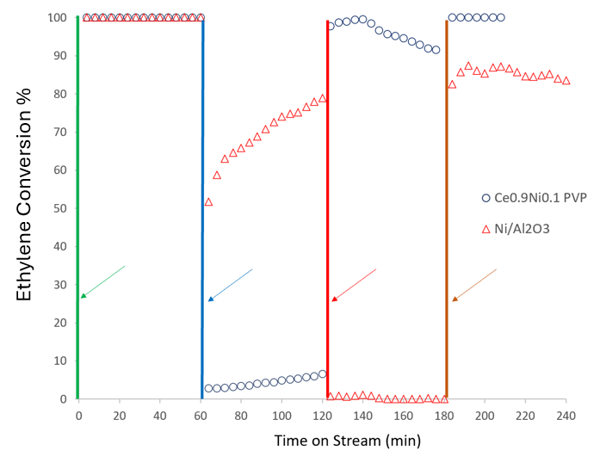
Figure S16a: Ethylene hydrogenation reactivity for the Ni SAC and a reference Ni/Al₂O₃ catalyst after four successive treatments shown in vertical lines. The green vertical line denotes an oxidation followed by reduction in 4% H₂ at 350°C which allows both catalysts to achieve 100% conversion of ethylene to ethane. After 60 minutes of reaction, the reactor was purged and cooled down and as indicated by the blue line, 30-minute run for acetylene hydrogenation was performed. After acetylene hydrogenation, it is seen that the Ni SAC deactivated and shows very low ethylene hydrogenation activity. In contrast, the metallic Ni catalyst recovers rapidly and achieves >80% conversion. After 60 minutes of reaction, as indicated by the vertical red line, the catalyst was given an oxidation treatment at 350°C. The catalysts were again tested for ethylene hydrogenation and it was found that the metallic Ni catalyst did not show any activity. This was because the metallic Ni had converted to NiO, which is not active for hydrogenation. In contrast, the activity of Ni SAC which was lost after performing acetylene hydrogenation in nearly fully restored, and the ionic Ni is active for hydrogenation even in its calcined state. The final treatment, shown with an orange line, denotes a reduction in 4% H₂ at 350°C, after which the reactivity of the metallic Ni catalyst is restored while the Ni SAC continues to be active. The experiment shows that performing acetylene hydrogenation (the vertical blue line) can shut off ethylene hydrogenation activity of the Ni SAC but not the metallic Ni catalyst.
Figure S16b: Acetylene hydrogenation reactivity for 3 wt% Ni/SiO₂ after calcination at 500 °C in air. The results show that the oxidized Ni is not active for this reaction and does not self-reduce under reaction conditions. In contrast, the Ni SAC can be used for this reaction without any pre-treatment or reduction (as shown in Figure S16a).

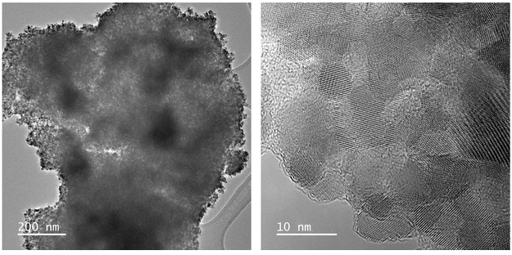
a
b
c
d
e
f

Figure S17: (a) CO₂ conversion for Ce_{0.9}Ni_{0.1}O_{2-x,} and Ni/SiO₂ during CO₂ hydrogenation shown in figure 5c. (b) The corresponding selectivity as shown in figure 5d. (c) Long term CO₂ conversion run at 350 °C for 24 hours, followed by oxidation, and then run for over 1000 minutes, demonstrating stable performance. (d) The corresponding CH₄ selectivity observed during the experiment shown in figure S17c.(e-f) HRTEM image of Ce_{0.9}Ni_{0.9}O_{2-x} after 40 h of CO₂ hydrogenation (see reactivity in Figure S17c). The high magnification image shows the individual CeO₂ crystallites, which contain Ni, but no Ni particles can be resolved. The dark line on the surface of the crystallites is due to graphitic carbon (approximately one monolayer) deposited on the surface of the catalyst due to the long term run.

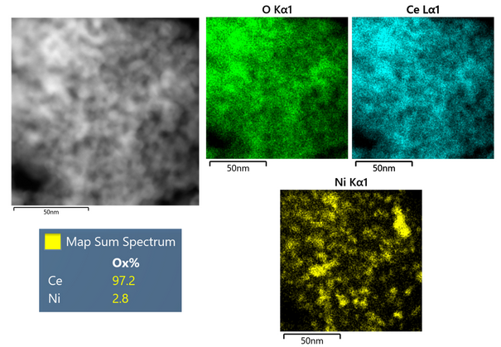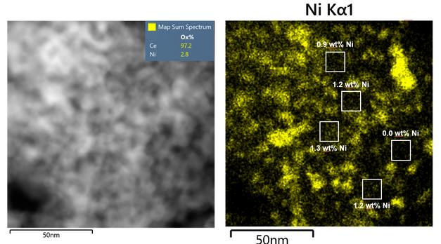
g
h
Figure s17g-h: (g) STEM image of Ce_{0.9}Ni_{0.9}O_{2-x} after 40 h of CO₂ hydrogenation (see reactivity in Figure S17c). The EDS map shows that Ni has aggregated to form nanoparticles, but they are not visible in the HRTEM image (figure S17e-f) because the crystalline CeO₂ dominates the contrast. (h) The same STEM image and Ni EDS map shown in Figure S17g is shown here, with EDS analysis of the boxed regions. The average composition of this region is 2.8 wt% while the average of the boxed regions is 1.15 wt% Ni. This implies that approximately 41% (100x1.15/2.8) of the Ni is still atomically dispersed after 40 hr of reaction at 350 °C in a reaction mixture containing 37.5 % H₂.
b
a
Figure S18: CO-oxidation reactivity of the fresh sample and after aging at 800°C in air and 10% steam for a set of (a) Ni SACs (3 wt% Ni SAC and 1.5 wt% NiZr@CeO₂) and (b) A Pt/CeO₂ having a similar Pt loading 3 wt% as the Ni sample after aging in air at 800 °C. The Ni SAC as-prepared (calcined 500 °C) shows excellent low temperature CO oxidation reactivity. After aging at 800°C in air/10% steam, the activity of the Ce_{0.9}Ni_{0.1}O_{2-x} drops but the inclusion of Zr as a co-dopant helps to improve the hydrothermal stability of the Ni doped ceria. The 800 °C aged Pt/CeO₂ is similar in reactivity to the aged Ni SAC, while the pure CeO₂ shows negligible activity at these temperatures.

a
Figure S19: (a) Arrhenius plot for CH₄ oxidation when activity ranged from 3-12 %. The obtained activation energies were 64 kJ/mol for the Ni SAC and 86 kJ/mol for Ni/SiO₂. (b) CH₄ conversion for the Ni SAC during CH₄ oxidation at 500°C. 50mg of catalyst was used with a GHSV of 69,000 ml/g_{cat} hr, feed composition was 2% CH_{4,} 8% O₂, balanced with N₂.

b
a
c
Figure S20: (a) CO₂ hydrogenation activity of Ce_{0.9}Ni_{0.1}O_{2-x} (red), IWI Ni/CeO₂ (prepared by incipient wetness impregnation, green), Ni/SiO₂ (blue), blank CeO₂ (black). (b) Selectivity during CO₂ hydrogenation of the Ce_{0.9}Ni_{0.1}O_{2-x} (red),the IWI Ni/CeO₂ (green), and Ni/SiO₂ (blue). (c) CH₄ oxidation on the Ce_{0.9}Ni_{0.1}O_{2-x} (black), the IWI Ni/CeO₂ (green), Ni/SiO₂ (blue), and pure CeO₂ (black).

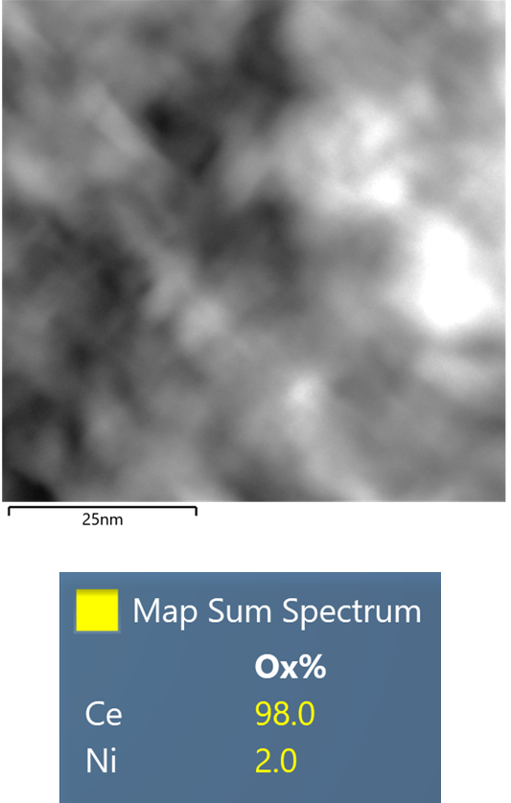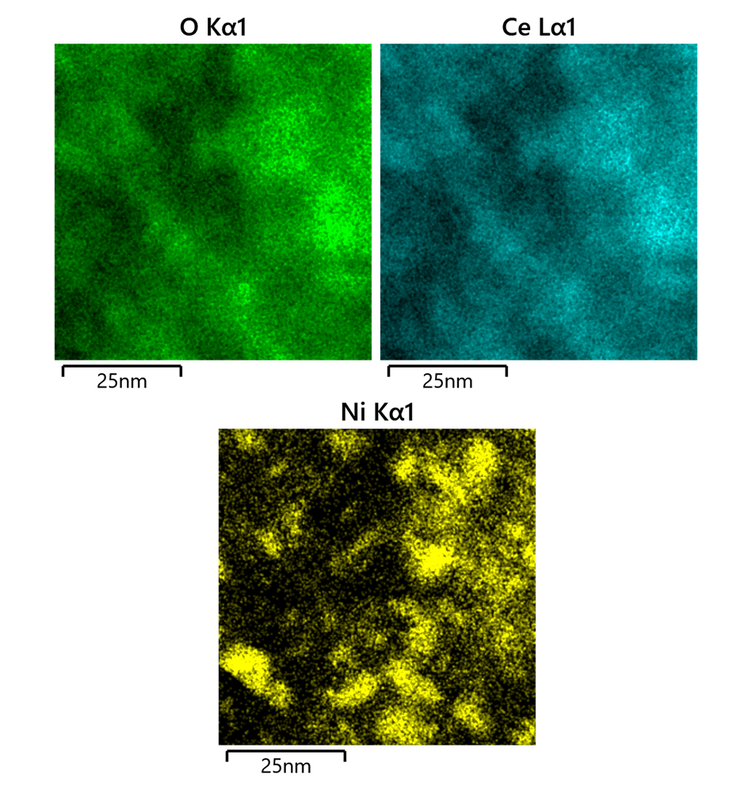
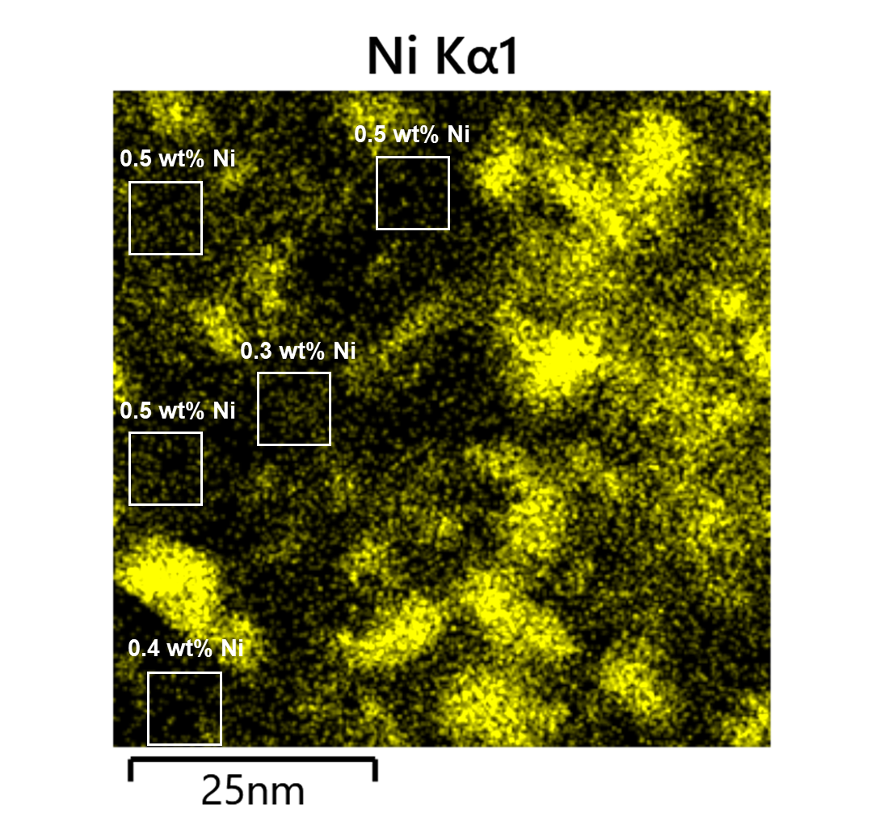

Figure S21:(a) TEM image of IWI Ni/CeO₂ after reduction at 500 °C and passivation in O₂, (b) EDS maps of showing the formation of Ni nanoparticles. Map sum spectrum shows wt% Ni and wt% CeO₂ (c) EDS map of areas without Ni nanoparticles suggesting atomically dispersed Ni is present.
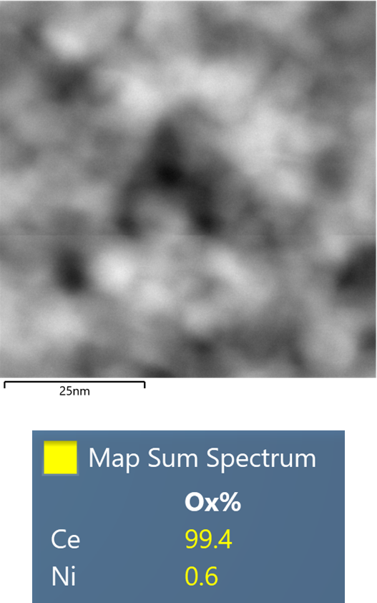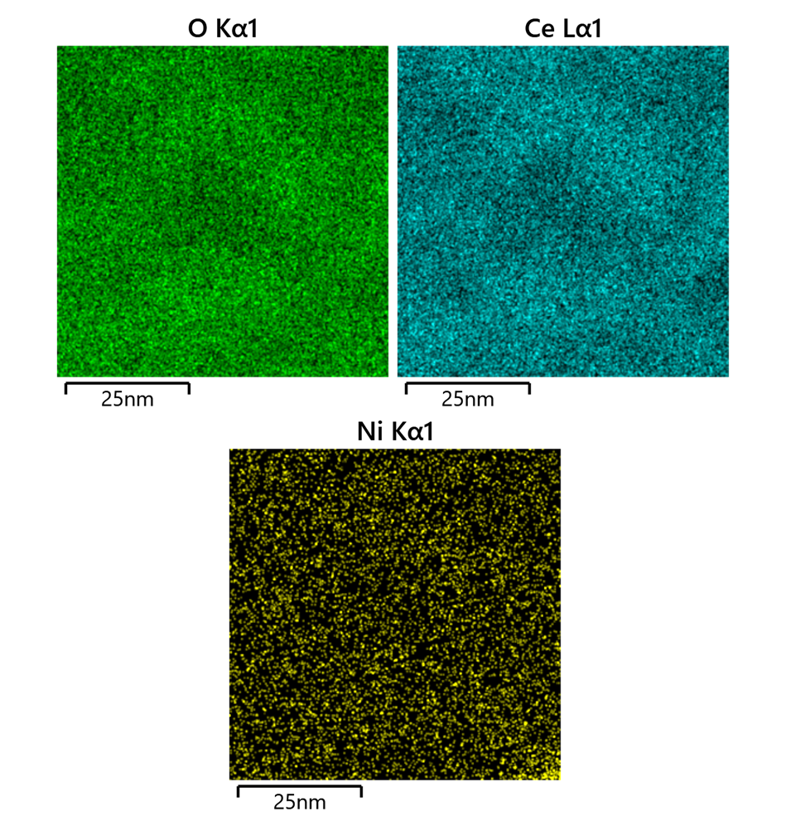
Figure S22: STEM image of IWI Ni/CeO₂ and EDS map showing a region that does not contain any Ni particles, but still shows significant concentration of Ni, suggesting the presence of atomically dispersed Ni. Map sum spectrum shows wt% Ni and wt% CeO₂

Table S1
XRD derived Lattice constants of the ceria and doped ceria samples
Sample | Lattice Constant(Ǻ)
CeO₂ | 5.410#
Ce_{0.9}Ni_{0.1}O_{2-x} (Ni doped Ce) | 5.408#
Ce_{0.9}Ni_{0.05}Zr_{0.05}O_{2-x} (co-doped Ce) | 5.424#
Ce_{0.9}Ni_{0.05}Zr_{0.05}O_{2-x} (co-doped Ce) | 5.424*
Ce_{0.9}Ni_{0.05}Zr_{0.05}O_{2-x} (co-doped Ce) - reduced 500 °C in 10% H₂ | 5.417*
The lattice constants were determined by fitting the laboratory XRD patterns (#) using Jade software and via synchrotron XRD (*).

Table S2
XAS analysis of Ce_{0.9}Ni_{0.1}O_{2-x} and reference samples*
Ni K-Edge XAS
Sample  Name | Treatment | XANES |  | Scattering | CN | R, Å | s² | Eo, (eV)
 |  | Pre-Edge Energy, keV | Edge Energy, keV |  |  |  |  | Eo, (eV)
Ni Foil* | - | - | 8.3332 | Ni-Ni | 12.0 | 2.49 | 0.006 | 5.7
NiO | - | 8.3334 | 8.3406 | Ni-O | 6.0 | 2.09 | 0.01 | -0.4
 |  |  |  | Ni-O-Ni | 12.0 | 2.96 | 0.01 | -1.8
Ce_{0.9}Ni_{0.1}O_{2-x} | As Prepared | 8.3330 | 8.3457 | Ni-O | 3.6(3) | 1.927(7) | 0.010 | -8.0
 |  |  |  | Ni-O-Ce | 2.4(3) | 3.08(1) | 0.005 | -8.0
Ce_{0.9}Ni_{0.1}O_{2-x} | 200C H₂ | 8.3327 | 8.3457 | Ni-O | 2.5(2) | 1.986(7) | 0.01 | 1.6
 |  |  |  | Ni-O-Ce | 2.1(2) | 2.693(9) | 0.009 | 1.6
Ce_{0.9}Ni_{0.1}O_{2-x} | 100C C₂H₄ + H₂ | 8.3330 | 8.3457 | Ni-O | 3.1(2) | 2.062(8) | 0.010 | 2.0
 |  |  |  | Ni-O-Ce | 1.7(2) | 2.70(1) | 0.005 | 2.0

*Analysis of data collected at NSLS-II BL-8 and presented in Figure 1c-d and in Figure S9.

Table S3
EXAFS analysis of Ce_{0.9}Zr_{0.05}Ni_{0.05}O_{2-x} along with some reference samples*
Sample | Edge | Bond | C.N. | R(Å) | σ²(Å²) | E0 shift (eV) | R-factor
CeZrNi | Ce L3 | Ce-O (Ce) | 6.2(4) | 2.312(7) | 0.012(1) | 6.5(5) | 0.0272
CeZrNi | Zr K | Zr-O | 7.8(3) | 2.195(4) | 0.0077(8) | -0.7(5) | 0.0108
CeZrNi | Ni K | Ni-O | 4.2(4) | 1.962(3) | 0.0067(6) | -8.0(3) | 0.0112
CeZrNi | Ni K | Ni-O-Ce | 0.8(3) | 2.97(1) | 0.015(4) | -8.0(3) | 0.0112
NiO | Ni K | Ni-O | 6.4(6) | 2.053(8) | 0.002(1) | -3.7(6) | 0.0277
NiO | Ni K | Ni-O-Ni | 12.5(9) | 2.983(9) | 0.010(1) | -3.7(6) | 0.0277
Ni foil | Ni K | Ni-Ni | 12.0(3) | 2.480(2) | 0.0056(8) | -6.5(3) | 0.0060
Zr foil | Zr K | Zr-Zr | 12.1(5) | 3.216(6) | 0.0060(4) | -3.3(7) | 0.0129
ZrO₂ | Zr K | Zr-O | 8.3(4) | 2.156(4) | 0.0052(8) | -1.9(6) | 0.0181
CeO₂ | Ce L₃ | Ce-O | 5.6(2) | 2.299(3) | 0.0097(6) | 4.0(3) | 0.0075

*Analysis of data collected at the Canadian Light Source HXMA beamline and presented in Figure S4.

Table S4
Comparison between bond distances obtained using PDF and EXAFS for Ce_{0.9}Zr_{0.05}Ni_{0.05}O_{2-x}
Bond | Bond Distances from EXAFS | Bond Distances from PDF | Coordination Number from EXAFS | Coordination Number from PDF
Ni-O | 1.962(1) Å | 1.930 Å | 4.2(3) | 4
Zr-O | 2.195(4) Å | 2.348 Å# | 7.8(3) | 8
Ce-O | 2.312(7) Å | 2.348 Å | 6.2(4)* | 8
Ni-O-Ce | 2.97(1) Å | 2.941 Å | 0.8(3) | -

#- the Zr-O distances are slightly different in PDF than the EXAFS as the positions of the Zr ions were fixed (same as Ce) during the PDF modeling and Zr atoms were not allowed to move. However, in reality, there is a lattice contraction around Zr because of its small size leading to a lower Zr-O bond distance.

* The low Ce-O coordination number in EXAFS (compared to the ideal 8 O atoms in the ceria lattice) can be associated with the small crystallite size of the CeO₂ and oxygen vacancies. However, for the PDF fitting, a bulk model was used with no vacancies.

Table S5
BET Surface Area after various treatments
Sample | Surface Area (m²/g)
CeO₂ calcined 500 °C in air | 150
Ce_{0.9}Ni_{0.1}O_{2-x} (Ni doped Ce) calcined 500 °C in air | 151
Ce_{0.9}Ni_{0.05}Zr_{0.05}O_{2-x} (co-doped Ce) calcined 500 °C in air | 140
Ce_{0.9}Ni_{0.1}O_{2-x} - reduced 500 °C in 10% H₂ | 105
SiO₂ calcined 500 °C in air | 194
Ni/SiO₂ calcined 500 °C in air | 186
Ce_{0.7}Ni_{0.1}Zr_{0.2}O_{2-x} calcined 500 °C in air | 156
Ce_{0.7}Ni_{0.1}Zr_{0.2}O_{2-x} aged 800 °C in air & steam | 24
Ce_{0.9}Ni_{0.1}O_{2-x} aged 800 °C in air & steam | 12

Table S6: Acetylene Hydrogenation on Ni based catalysts
Sample | Prep | Feed Mixture | GHSV  (ml/g*hr) | Temp (°C) | Conversion | Selectivity | Ref
Ce_{0.9}Ni_{0.1}O_{2-x} | Sol-gel | 0.5% C₂H₂  33.8% C₂H₄  2% H₂  83% He | 40000 | 230 | 100 | 100 | This work
Ni_{SAC}-Ni_{x}/C_{v} | Pyrolysis | 0.5 C₂H₂  20% C₂H₄  10% H₂  69.5% He | 30,000 | 240 | 95 | 93 | 5
Ni/AC-N-0.5 | Impregnation | 6% C₂H₂  17% H₂  77% He | 4,000 | 150 | 100 | 40 | 6
Ni₁MoS/Al₂O₃ | Precipitation | 0.15% C₂H₂  15% C₂H₄  3% H₂  81.8% He | 9,900 | 125 | 100 | 90 | 7
Na-Ni@CHA | Hydrothermal | 1% C₂H₂  16% H₂  83% He | 15,000 | 180 | 100 | 96 | 8
Ni_{n}/ND@G | Precipitation | 1% C₂H₂  20% C₂H₄  10% H₂  69% He | 20,000 | 150 | 100 | 90 | 9

Table S7: CO₂ Methanation on Ni based catalysts
Sample | Preparation | Feed Mixture | GHSV  (ml/g cat*hr) | Temp (°C) | CO₂  Conversion  At the temperature on the left | CH₄ Selectivity (%)  At the temperature on the left | r  (CO₂)  (μmol/sec*g cat) at the temperature on the right | Temp (°C) | Reference
Ce_{0.9}Ni_{0.1}O_{2-x}  (3.4 wt% Ni/CeO₂) | Sol-Gel | 12.5% CO₂ 37.5% H₂  50% N₂ | 72,000 | 350 | 46 | 99 | 26.3 | 260 | This work
Ni/SiO₂ 3wt% | Wet impregnation | 12.5% CO₂ 37.5% H₂  50% N₂ | 72,000 | 350 | 15 | 41 | 6.85 | 280 | This work
1.3wt%Ni@CeO₂ | Soft templating | 20% CO₂ 80%H₂ | 12,000 | 400 | 70 | 95 | 16 | 400 | 10
3.57wt%Ni/CeO₂ | Wet impregnation | 20% CO₂ 80% H₂ | 30,000 | 375 | 75 | 99 | 51 | 300 | 11
5wt% Ni/CeO₂ Nano Rods | Wet impregnation | 20% CO₂ 80% H₂ | 24,000 | 250 | 24 | 99 | 5.25 | 250 | 12
8.2wt% Ni/CeO₂ | Wet impregnation | 16% CO₂ 64% H₂  20% He | 12,000 | 300 | 62 | 99 | 28.3 | 300 | 13
8wt% Ni/CeO₂ | Wet impregnation | 20% CO₂ 80% H₂ | 30,000 | 300 | 92 | 99 | 52.6 | 300 | 14
8.9wt% Ni/CeO₂  rods | Wet impregnation | 20% CO₂ 80% H₂ | 20,000 | 225 | 84 | 98 | 33.1 | 250 | 15

Table S8: CO Oxidation on Ni based catalysts
Sample | Preparation | Feed Mixture | GHSV  (ml/g*hr) | T₅₀ | T₉₀ | Reference
Ce_{0.9}Ni_{0.1}O_{2-x} | Sol-gel | 2% CO  1% O₂  97% He | 225,000 | 130 | 165 | This work
Meso-Ni_{x}Ce | Precipitation | 1.6% CO  20.8% O₂  77.6% N₂ | 30,000 | 180 | 210 | 16
NiCo | Precipitation | 1.6% CO  20.8% O₂  77.6% N₂ | 30,000 | 100 | 120 | 17
PdNi | Precipitation | 0.5% CO  10% O₂  89.5% N₂ | 16,000 | 120 | 130 | 18
Ni-Pt/CB | Wet impregnation | 1% CO  20% O₂  79% He | 30,000 | 60 | 90 | 19

Table S9: Methane Oxidation on Ni based catalysts
Sample | Preparation | Feed Mixture | GHSV  (ml/g*hr) | T₅₀  (°C) | T₉₀ (°C) | r  (CH4)  (μmol/sec*g cat) at the temperature on the right | Temp (°C) | Ref
Ce_{0.9}Ni_{0.1}O_{2-x} | Sol-Gel | 4% CH₄  16% O₂  80% N₂ | 60,000 | 446 | 520 | 11.4 | 446 | This work
Ni/CeO₂-MgO | Sol-gel | 5% CH₄  23% O₂  72% N₂ | 40,000 | 413 | 478 | 8.85 | 413 | 20
Ni/YSZ | Co-precipitation | 1% CH₄  8% O₂  91% N₂ | 30,000 | 500 | 550 | 1.4 | 500 | 21
NiO-PVP | Sol-Gel | 1% CH₄  22% O₂  77% N₂ | 18,000 | 380 | 470 | 1.4 | 325 | 22
NiO | precipitation | 1% CH₄  20% O₂  79% N₂ | 30,000 | 365 | 440 | 0.8 | 300 | 23
NiO-ZrO₂ | Co-precipitation | 1% CH₄  10% O₂  89% N₂ | 30,000 | 400 | 460 | 1.4 | 350 | 21

References:
- Ravel, B.; Newville, M. It ATHENA, It ARTEMIS, It HEPHAESTUS: Data Analysis for X-Ray Absorption Spectroscopy Using It IFEFFIT. Journal of Synchrotron Radiation 2005, 12 (4), 537–541. https://doi.org/10.1107/S0909049505012719.
- Toby, B. H.; Von Dreele, R. B. It GSAS-II: The Genesis of a Modern Open-Source All Purpose Crystallography Software Package. Journal of Applied Crystallography 2013, 46 (2), 544–549. https://doi.org/10.1107/S0021889813003531.
- Juhás, P.; Davis, T.; Farrow, C. L.; Billinge, S. J. L. It PDFgetX3: A Rapid and Highly Automatable Program for Processing Powder Diffraction Data into Total Scattering Pair Distribution Functions. Journal of Applied Crystallography 2013, 46 (2), 560–566. https://doi.org/10.1107/S0021889813005190.
- Farrow, C. L.; Juhas, P.; Liu, J. W.; Bryndin, D.; Božin, E. S.; Bloch, J.; Proffen, T.; Billinge, S. J. L. PDFfit2 and PDFgui: Computer Programs for Studying Nanostructure in Crystals. Journal of Physics: Condensed Matter 2007, 19 (33), 335219. https://doi.org/10.1088/0953-8984/19/33/335219.
- Yao, H.; Qin, Y.; Qi, G.; Niu, Y.; Huang, D.; Li, W.; Pan, L.; Li, D. An Effective Strategy for Enhancing the Selective Hydrogenation of Acetylene by Defective Nickel Single-Atom Catalysts through Integration with Nickel Nanoclusters. Applied Surface Science 2025, 713, 164317. https://doi.org/10.1016/j.apsusc.2025.164317.
- Xu, Z.; Zhou, S.; Zhu, M. Ni Catalyst Supported on Nitrogen-Doped Activated Carbon for Selective Hydrogenation of Acetylene with High Concentration. Catalysis Communications 2021, 149, 106241. https://doi.org/10.1016/j.catcom.2020.106241.
- Fu, B.; McCue, A. J.; Liu, Y.; Weng, S.; Song, Y.; He, Y.; Feng, J.; Li, D. Highly Selective and Stable Isolated Non-Noble Metal Atom Catalysts for Selective Hydrogenation of Acetylene. ACS Catal. 2022, 12 (1), 607–615. https://doi.org/10.1021/acscatal.1c04758.
- Chai, Y.; Wu, G.; Liu, X.; Ren, Y.; Dai, W.; Wang, C.; Xie, Z.; Guan, N.; Li, L. Acetylene-Selective Hydrogenation Catalyzed by Cationic Nickel Confined in Zeolite. J. Am. Chem. Soc. 2019, 141 (25), 9920–9927. https://doi.org/10.1021/jacs.9b03361.
- Sui, C.; Ma, H.; Huang, F.; Wang, M.; Cai, X.; Diao, J.; Ren, P.; Wen, X.; Jin, L.; Wang, G.; Ma, D.; Liu, H. Fully Exposed Nickel Clusters for Semihydrogenation of Acetylene. ACS Catal. 2024, 14 (19), 14689–14695. https://doi.org/10.1021/acscatal.4c04462.
- Barreau, M.; Salusso, D.; Li, J.; Zhang, J.; Borfecchia, E.; Sobczak, K.; Braglia, L.; Gallet, J.-J.; Torelli, P.; Guo, H.; Lin, S.; Zafeiratos, S. Ionic Nickel Embedded in Ceria with High Specific CO2 Methanation Activity. Angewandte Chemie International Edition 2023, 62 (25), e202302087. https://doi.org/10.1002/anie.202302087.
- Varvoutis, G.; Lykaki, M.; Stefa, S.; Binas, V.; Marnellos, G. E.; Konsolakis, M. Deciphering the Role of Ni Particle Size and Nickel-Ceria Interfacial Perimeter in the Low-Temperature CO2 Methanation Reaction over Remarkably Active Ni/CeO2 Nanorods. Applied Catalysis B: Environmental 2021, 297, 120401. https://doi.org/10.1016/j.apcatb.2021.120401.
- Bian, Z.; Chan, Y. M.; Yu, Y.; Kawi, S. Morphology Dependence of Catalytic Properties of Ni/CeO2 for CO2 Methanation: A Kinetic and Mechanism Study. Catalysis Today 2020, 347, 31–38. https://doi.org/10.1016/j.cattod.2018.04.067.
- A. Cárdenas-Arenas, A. Quindimil, A. Davó-Quiñonero, E. Bailón-García, D. Lozano-Castelló, U. De-La-Torre, B. Pereda-Ayo, J. A. González-Marcos, J. R. González-Velasco, A. Bueno-López, Applied Catalysis B: Environmental 2020, 265, 118538
- Varvoutis, G.; Lykaki, M.; Stefa, S.; Papista, E.; Carabineiro, S. A. C.; Marnellos, G. E.; Konsolakis, M. Remarkable Efficiency of Ni Supported on Hydrothermally Synthesized CeO2 Nanorods for Low-Temperature CO2 Hydrogenation to Methane. Catalysis Communications 2020, 142, 106036. https://doi.org/10.1016/j.catcom.2020.106036.
- Xie, Y.; Chen, J.; Wu, X.; Wen, J.; Zhao, R.; Li, Z.; Tian, G.; Zhang, Q.; Ning, P.; Hao, J. Frustrated Lewis Pairs Boosting Low-Temperature CO₂ Methanation Performance over Ni/CeO₂ Nanocatalysts. ACS Catal. 2022, 12 (17), 10587–10602. https://doi.org/10.1021/acscatal.2c02535
- Tang, C.; Li, J.; Yao, X.; Sun, J.; Cao, Y.; Zhang, L.; Gao, F.; Deng, Y.; Dong, L. Mesoporous NiO–CeO2 Catalysts for CO Oxidation: Nickel Content Effect and Mechanism Aspect. Applied Catalysis A: General 2015, 494, 77–86. https://doi.org/10.1016/j.apcata.2015.01.037.
- Yi, Y.; Zhang, P.; Qin, Z.; Yu, C.; Li, W.; Qin, Q.; Li, B.; Fan, M.; Liang, X.; Dong, L. Low Temperature CO Oxidation Catalysed by Flower-like Ni–Co–O: How Physicochemical Properties Influence Catalytic Performance. RSC Adv. 2018, 8 (13), 7110–7122. https://doi.org/10.1039/C7RA12635B.
- Shan, S.; Petkov, V.; Yang, L.; Luo, J.; Joseph, P.; Mayzel, D.; Prasai, B.; Wang, L.; Engelhard, M.; Zhong, C.-J. Atomic-Structural Synergy for Catalytic CO Oxidation over Palladium–Nickel Nanoalloys. J. Am. Chem. Soc. 2014, 136 (19), 7140–7151. https://doi.org/10.1021/ja5026744.
- Mu, R.; Fu, Q.; Xu, H.; Zhang, H.; Huang, Y.; Jiang, Z.; Zhang, S.; Tan, D.; Bao, X. Synergetic Effect of Surface and Subsurface Ni Species at Pt−Ni Bimetallic Catalysts for CO Oxidation. J. Am. Chem. Soc. 2011, 133 (6), 1978–1986. https://doi.org/10.1021/ja109483a.
- Li, Y.; Guo, Y.; Xue, B. Catalytic Combustion of Methane over M (Ni, Co, Cu) Supported on Ceria–Magnesia. Fuel Processing Technology 2009, 90 (5), 652–656. https://doi.org/10.1016/j.fuproc.2008.12.002.
- Wang, Z.; Lin, J.; Xu, H.; Zheng, Y.; Xiao, Y.; Zheng, Y. Zr-Doped NiO Nanoparticles for Low-Temperature Methane Combustion. ACS Appl. Nano Mater. 2021, 4 (11), 11920–11930. https://doi.org/10.1021/acsanm.1c02487.
- Xu, X.; Li, L.; Yu, F.; Peng, H.; Fang, X.; Wang, X. Mesoporous High Surface Area NiO Synthesized with Soft Templates: Remarkable for Catalytic CH4 Deep Oxidation. Molecular Catalysis 2017, 441, 81–91. https://doi.org/10.1016/j.mcat.2017.08.005.
- Chen, K.; Li, W.; Li, X.; Ogunbiyi, A. T.; Yuan, L. Irregularly Shaped NiO Nanostructures for Catalytic Lean Methane Combustion. ACS Appl. Nano Mater. 2021, 4 (5), 5404–5412. https://doi.org/10.1021/acsanm.1c00732.
- Li, Z.; Werner, K.; Chen, L.; Jia, A.; Qian, K.; Zhong, J.-Q.; You, R.; Wu, L.; Zhang, L.; Pan, H.; Wu, X.-P.; Gong, X.-Q.; Shaikhutdinov, S.; Huang, W.; Freund, H.-J. Interaction of Hydrogen with Ceria: Hydroxylation, Reduction, and Hydride Formation on the Surface and in the Bulk. Chemistry – A European Journal 2021, 27 (16), 5268–5276. https://doi.org/10.1002/chem.202005374.
- Gill, L.; Beste, A.; Chen, B.; Li, M.; Mann, A. K. P.; Overbury, S. H.; Hagaman, E. W. Fast MAS 1H NMR Study of Water Adsorption and Dissociation on the (100) Surface of Ceria Nanocubes: A Fully Hydroxylated, Hydrophobic Ceria Surface. J. Phys. Chem. C 2017, 121 (13), 7450–7465. https://doi.org/10.1021/acs.jpcc.6b12375.

