Facet-Dependent Water Inhibition of Alkanol Dehydration on TiO₂ via Distinct Water–Alkanol Complexes

Supporting information
Table of contents
- Experimental section
- Notes
Note 1. Mass Transfer Calculation
Evaluation of internal and external diffusion limitations (Weisz–Prater and Mears criteria).
Note 2. Facet Analysis
Quantitative (001)/(101) surface fraction estimation by TEM image measurements.
Note 3. Extrapolation of Facet-Dependent Inhibition
Derivation and worked example of inhibition ratio as a function of (001) surface fraction.
Note 4. Activation Entropy Compensation Calculations
Entropy–enthalpy compensation analysis using transition-state theory (Eyring equation).
Note 5. Derivation of Turnover Rate Expression
Detailed kinetic model including IPA monomer, IPA-H₂O complex and site balance derivation.
- Figures
Figure S1. XRD patterns of fresh TiO₂(001) and (101) samples
Figure S2. TEM images of (A) (001) with nanosheet shapes and (B) (101) with bipyramidal shapes with facet ratio measurement analysis. (C) and (D) TEM images of (001) and (101) after reaction demonstrating no structural change and remained facet ratios.
Figure S3. (A) NH₃-TPD and (B) CO₂-TPD profiles of TiO₂(101) and (001).
Figure S4. Extrapolation of inhibition ratios vs. (001) fraction at different water pressures (2, 4, 8 kPa).
Figure S5. Kinetic dependence of IPA dehydration on TiO₂(001) (A) in the absence of water and (B) in the presence of water (0.2 kPa water). Operating conditions: 240-270 ºC,1 atm total pressure with 0.1-7 kPa IPA, 0.2 kPa co-fed H₂O, and balance He, and 47.6 cm³ g⁻¹ s⁻¹ GHSV.
Figure S6. Arrhenius plots of IPA dehydration on (A) TiO₂(001) and (B) (101) at 1 atm total pressure with 1 kPa IPA, 0-12 kPa co-fed H₂O and 47.6 cm³ g⁻¹ s⁻¹ GHSV.
Figure S7. High vacuum IR by introducing IPA and H₂O with increasing pressure from 0.1 mbar to 1.1 mbar on (101).
Figure S8. C-H vibration peak area integrated from DRIFTS spectra versus temperature with pure IPA adsorption and H₂O: IPA partial pressure ratio of 3:2 on (A) (101) and (B) (001)
Figure S9. DRIFTS spectra of -OH region with (bottom) pure IPA on (101) and (top) H₂O&IPA on (101).
Figure S10. (A) and (B) in situ DRIFTS-TPD spectra of adsorption and desorption of pure H₂O on (101) and (001)
Figure S11. Thermodynamic equilibria calculations of IPA dehydration at temperature range from 250-280 °C with or without co-fed water (water:IPA = 4:1 or 0:1, respectively)
Figure S12. In situ ¹³C direct polarization NMR of IPA and water adsorbed on (A) (001) and (B) (101); (C)¹³C NMR of different coverages IPA on (001) at 25 °C(DP) and 110 °C(CP)
Figure S13. (A) DFT-NMR simulated ¹³C NMR spectra of (B) isopropoxide, (C) isopropoxide + H₂O, (D) isopropanol, and (E) isopropanol + H₂O adsorbed on TiO₂.
Figure S14. Zoom in model structures illustrating bond angles and bond distances with (A) IPA on TiO₂ (001), (B) IPA+H₂O on TiO₂ (001), (C) IPA on TiO₂ (101) and (D) IPA+H₂O on TiO₂ (101).
Figure S15. Parity plots for the predicted (from eq. S33 and parameters in Table S7) and measured turnover frequencies on (A) TiO₂(101) and (B) (001) at 260 °C, 1 atm total pressure with 0.25-8 kPa IPA, 0-8 kPa H₂O, balance He, and 47.6 cm³ g⁻¹ s⁻¹ GHSV. The solid line represents a perfect prediction of turnover frequencies for propene formation
Figure S16. Sensitivity of sum of squares of residuals to variations in optimal kinetic and thermodynamic parameters of the rate expression (Table S3, eq. S33) on TiO₂ (001) at 260 ºC,1 atm total pressure with 0.25-8 kPa IPA, 0-8 kPa H₂O, and balance He, and 47.6 cm³ g⁻¹ s⁻¹ GHSV.
Figure S17. Sensitivity of sum of squares of residuals to variations in optimal kinetic and thermodynamic parameters of the rate expression (Table S3. eq. S33) on TiO₂ (101) at 260 ºC,1 atm total pressure with 0.25-8 kPa IPA, 0-8 kPa H₂O, and balance He, and 47.6 cm³ g⁻¹ s⁻¹ GHSV.

- Tables
Table S1. Length measurement and (001) percentage calculations
Table S2. Turnover frequencies and conversions of IPA dehydration on TiO₂(001) at 260 °C, 1 atm total pressure with 0.25-8 kPa IPA, 0-8 kPa H₂O, balance He, and 47.6 cm³ g⁻¹ s⁻¹ GHSV.
Table S3. Turnover frequencies and conversions of IPA dehydration on TiO₂(101) at 260 °C, 1 atm total pressure with 0.25-8 kPa IPA, 0-8 kPa H₂O, balance He, and 47.6 cm³ g⁻¹ s⁻¹ GHSV.
Table S4. Kinetic isotope effect of IPA dehydration using CD₃CH(OH)CD₃ or CH₃CH(OD)CH₃ with co-fed water on TiO₂(001) and (101) at 260 °C. 1 atm total pressure with 1 kPa reactant, 4 kPa H₂O, and balance He, and 47.6 cm³ g⁻¹ s⁻¹ gas hourly space velocity (GHSV).
Table S5. Elementary Steps of IPA dehydration on TiO₂(001)
Table S6. Elementary Steps of IPA dehydration on TiO₂(101)
Table S7. Kinetic and thermodynamic parameters obtained by the non-linear fitting of experimental data to rate expressions (eq. S33). Operating conditions: 260 °C, 1 atm total pressure with 0.25-8 kPa IPA, 0-8 kPa H₂O, balance He, and 47.6 cm³ g⁻¹ s⁻¹ GHSV.
Table S8A. The fractional coverage of surface species and turnover frequencies of monomeric and complex pathway on TiO₂(001) at 260 °C (calculated from eq. S33 and parameters in Table S7).
Table S8B. The fractional coverages of surface species and turnover frequencies of monomeric and complex pathway on TiO₂(101) at 260 °C (calculated from eq. S33 and parameters in Table S7).

- Experimental section
Catalysts preparation
TiO₂(101) and (001) nanocrystals with well-defined morphology and respective dominant (101) and (001) facet exposure were hydrothermally synthesized via a modified two-step approach.^{[62-64]} First, potassium titanate precursor was synthesized as follows: 22.4 g of KOH (Sigma-Aldrich, ≥ 85 wt %) was dissolved in 40 mL of deionized water, followed by adding 1 g of P25 (Aldrich, nanopowder, 21 nm in diameter, ≥ 99.5 wt %) while stirring. The obtained suspension was transferred into a Teflon-lined stainless-steel autoclave which was kept at 200 °C for 24 h. After synthesis, the white precipitate was treated by repeated washing-centrifugation five times and then dried at 80 °C overnight. TiO₂(101) was prepared by adding 0.2 g of the precursor to 250 mL of deionized water and sonicating for 45 min. The obtained solution was sealed in a Teflon-lined stainless-steel autoclave, and hydrothermal synthesis was conducted at 200 °C for 24 h. For the synthesis of TiO₂(001), after sonicating the same precursor/H₂O suspension for 45 min, 45 g of urea (Sigma-Aldrich, ACS reagent) was added as a capping agent. In this case, hydrothermal synthesis was carried out at 200 °C for 20 h. The as-synthesized catalysts were washed by 1.6 M HNO₃ followed by centrifugation separation two times to remove residual potassium, and then with repeated washing-centrifugation using deionized water for five times, dried in air at 80 °C overnight and calcined in the muffle furnace at 550 °C for 4 h.
Catalyst characterizations
The X-ray diffraction (XRD) analyses for the fresh TiO₂(001) and (101) catalysts were performed using a Rigaku Miniflex-II diffractometer (CuKα radiation) over a 2θ range of 10°-80°, with a scan speed of 2° min⁻¹, a voltage of 30 kV and a current of 15 mA.
Surface area measurements were conducted on a QuantaChrome Autosorb-6 using N₂ adsorption isotherms and BET analysis methods. Samples were degassed in vacuum at 150 °C for 4 h before adsorption measurements. TEM was carried out using a JEOL JEM 2010 system operated at 200 keV. The TEM specimens were prepared by dispersing calcined TiO₂ samples in ethanol and depositing the suspension onto a lacey carbon-coated copper grid.
Temperature-programmed desorption (TPD) of various probe molecules was performed using a chemisorption unit (AutoChem II 2920 Chemisorption Analyzer, Micromeritics) coupled with an online QMS (Quadra 220, Pfeiffer). Each sample was first pretreated at 450 °C under He flow (50 mL min⁻¹) for 1 h before cooling to 100 °C and exposing the sample to the probe molecule. Ammonia-TPD (NH₃-TPD) was conducted by exposing the sample to 1% NH₃/He (50 mL min⁻¹) until saturation. The sample was purged under He flow (50 mL min⁻¹) for 2 h to remove physically adsorbed ammonia. The temperature then increased to 700 °C at a ramping rate of 10 °C min⁻¹ under He flow (50 mL min⁻¹). The quadrupole mass spectrometer was used to measure the desorbed NH₃ (m/z = 16, 17) during TPD.
Transmission infrared (IR) spectra of TiO₂(101) and TiO₂(001) catalysts were recorded using a Nicolet iS50 FT-IR spectrometer (Thermo Fisher Scientific) at a resolution of 4 cm⁻¹. The catalyst powders were pressed into self-supporting wafers and placed in a custom-designed in situ IR cell, allowing the infrared beam to pass through the center of the wafer. FTIR spectra are presented in absorbance units (log(1/T), where T denotes transmittance). Identical catalyst mass, pellet preparation procedure, and optical conditions were used for all measurements. Spectra were baseline-corrected, and comparisons are therefore made under consistent experimental conditions. Scale bars were provided in the Figures. Prior to spectral acquisition, the samples were thermally activated under high vacuum (10⁻⁶ mbar) at 450 °C (10 °C/min of ramping rate) and held for 1 h. After cooling to 100 °C under high vacuum, baseline spectra were acquired against a blank background. Adsorption studies with water and IPA were performed using two distinct sequential protocols: for sequence (i) of water-to-IPA, the activated catalyst was exposed to 0.1 mbar of water vapor for 0.5 h at 100 °C, followed by vacuum outgassing (10⁻⁶ mbar) for 1 h, and subsequently exposed to 0.1 mbar IPA vapor for 0.5 h and outgassed again for 1 h; and for sequence (ii) of IPA-to-water, the activated catalyst was first exposed to 0.1 mbar IPA vapor for 0.5 h at 100 °C, followed by outgassing for 1 h, and then subjected to 0.1 mbar water vapor for 0.5 h, followed by another outgassing step. In both protocols, spectra were collected after vacuum outgassing to remove physisorbed species, ensuring the measurement of chemisorbed or strongly bound molecules. All transmission measurements were performed at 100 °C using the same blank background to ensure consistency across all experiments. These conditions allowed for detailed evaluation of the adsorption ability of IPA and water on TiO₂ surfaces.
In situ DRIFTS spectra of the IPA:H₂O mixtures were conducted using a Bruker Tensor 27 FTIR spectrometer equipped with an in situ cell (Harrick Scientific Products inc.). Approximately 20 mg of sample in the fine powder form was loaded into the sample holder and pretreated in 20 mL/min 10% O₂/He at 450 °C for 1 h to remove adsorbed water and other impurities. Sample was then progressively cooled to 100 °C at 10 °C min⁻¹ during which, background spectra were acquired at several designated temperatures by pausing the sample cooling. A complementary set of background scans were also acquired using KBr and TiO₂ catalysts. Solutions of IPA:H₂O were introduced by flowing 10 mL min⁻¹ He through a bubble generator until saturation (i.e., spectra become invariant with time). The cell was then purged with 50 mL min⁻¹ He to remove physiosorbed species from the surface. Sample temperature was then ramped to 450 °C at 10 °C min⁻¹, during which spectra were acquired at designated temperatures. Each spectrum was analyzed using the clean sample or KBr backgrounds.
In situ Magic Angle Spinning (MAS) ¹H and ¹³C NMR measurements were conducted on a Varian-Agilent Inova wide-bore 300 MHz NMR spectrometer using a commercial 7.5 mm Vespel pencil type MAS probe, operated at ¹H and ¹³C Larmor frequencies of 299.93 and 75.42 MHz, respectively.⁴⁶ A 7.5 mm home-made all zirconia in situ MAS NMR rotor^{[65-68]} was used to house mixtures of TiO₂ powder, IPA, and water. The faceted TiO₂ samples were calcined in 10% O₂/He (50 mL min⁻¹) at 450 °C for 1 h. The quartz tube containing the sample was sealed and transferred to a glovebox. Within the glovebox, about 100 mg of TiO₂ sample was packed into the zirconia rotor, and one or two monolayers of IPA and water were introduced using micro syringes. The monolayer capacity was defined as the number of surface-exposed Ti sites quantified by NH₃-TPD, assuming unimolecular binding. The required amount of IPA and H2O liquids were injected onto the samples inside NMR rotor in the glovebox via µL syringes. The rotor was sealed and then transferred to the NMR probe. NMR measurements were carried out at a sample spinning rate of 4 kHz to generate high resolution ¹H and ¹³C NMR spectra. Under these conditions, the adsorbates were evenly distributed across the catalyst surface within a few minutes. A direct pulse sequence was used for acquiring ¹H signals, consisting of a pulse width of 2.5 μs, an acquisition time of 100 ms and a recycle delay of 4 s. To generate ¹³C NMR signals, pulse width of 2.5 μs, an acquisition time of 100 ms and a recycle delay of 10 s were applied. ¹H-¹³C cross polarization NMR was employed to investigate the TiO₂ surface adsorbed species. A π/2 pulse width of 3.25 µs for ¹H with a 2 s recycle delay and a contact time of 1 ms were applied for the latter measurements. All spectra were externally referenced to TMS (0 ppm) using adamantane as a second reference at 1.82 ppm for ¹H and 38.48 ppm for ¹³C.^{[66]}
Catalysts evaluations
Steady-state kinetic measurements and temperature programmed surface reactions (TPSR) were conducted on a fixed-bed quartz reactor of 9 mm i.d. that contains a coarse quartz frit at half-length for sample supporting. About 35 mg of catalysts, mixed with 300 mg of SiC (200 mesh, Sigma Aldrich) were loaded on the quartz frit, and the reactor was placed in a tube furnace. Bed temperature was controlled using a custom-built temperature controller coupled with a K-type thermocouple with its tip inserted to the center of the catalyst bed. Prior to activity measurements, the catalysts were pretreated at 450 °C for 1h in a 10% O₂/He flow to remove water and other impurities. For steady-state kinetic measurements, IPA (Sigma Aldrich, >97 %) and deionized H₂O at varying partial pressures were introduced to the catalyst using a He carrier gas (100 mL/min). To generate steady flows and partial pressures, IPA and H₂O were introduced into vaporization zones located at the upstream of the reactor through gas tight syringes (Hamilton, Model 1002, 2.5 mL) mounted on syringe infusion pumps (KD Scientific, Model 100). The vaporization zones were heated to 90 °C for IPA and 120 °C for H₂O. IPA and H₂O partial pressures were adjusted by controlling the liquid injection rates of the syringe pumps. IPA and products were quantified using a gas chromatograph (Agilent, 7890A) equipped with a capillary column (Agilent HP-1, 19091Z-433, 30 m) connected to a flame ionization detector (FID). Prior to TPSR, the catalysts were first pretreated in a 10% O₂/He flow and then cooled down to 120 °C. Then, 4 kPa IPA, 4 kPa H₂O, or 10 kPa H₂O:IPA mixture (3:2 partial pressure ratio) was introduced in (25 mL/min) in He at 120 °C and 1 atm for 20 min, followed by He purging or mixed with constant pressure of H₂O. TPSR was conducted by heating the catalysts to 550 °C (10 °C min⁻¹) in flowing He (25 mL/min) with H₂O partial pressure varying from 0 to 8 kPa to study the impact of H₂O. The desorption products were recorded with an Agilent Technologies brand quadrupole mass spectrometer. Turnover frequency of IPA dehydration is defined by the measured dehydration rate (r_{propene}​) divided by the total moles of surface Ti sites per gram of catalyst (n_{surface Ti sites}) obtained from NH₃-TPD measurements with the assumption of a 1:1 stoichiometry between adsorbed NH₃ and Ti surface sites
$TOF (s^{-1})=\frac{{r_{propene}(mol}_{propene} s^{-1} {g_{catalyst}}^{-1})}{n_{surface Ti sites}(mol {g_{catalyst}}^{-1})}$ (S1)
Theoretical calculations
The CP2K code was used to perform first-principles periodic DFT calculations.^{[69]} The valence electron wave functions were expanded in a double-basis set with polarization functions and an auxiliary plane wave basis set with an energy cutoff of 350 Ry.^{[70]} Perdew, Burke, and Enzerhof's (PBE) generalized gradient approximation exchange-correlation functional was used.^{[71]} Excess electrons associated with Ti 3d orbitals were treated with the DFT+U method with a U value of 7 eV, as previously suggested.^{[72]} When the maximum force convergence criteria of 4.5*10-5 Hartree/bohr were used in the geometry optimization, the maximum coordinate change of 3.0*104 bohr was achieved. Anatase TiO₂(101) surfaces were used to model the TiO₂ substrate, constructed with cell dimensions of 20.926×15.211×24.432 Å with 15 Å vacuum space to minimize the interaction between slabs. Anatase TiO₂ (001) surface are represented here with cell dimensions of 19.361×19.365×23.633 Å. The Broyden-Fletcher-Goldfarb-Shanno (BGFS) algorithm was used to optimize each reaction state configuration,^{[73]} with self-consistent field (SCF) convergence criteria of 1.0*108 au. The DFT-D3 scheme with an empirical damped potential term was used to describe the van der Waals (vdW) dispersion interactions between adsorbates. The climbing image nudged elastic bands (CI-NEB) method with seven intermediate images along the reaction pathway between initial and final states was used to locate transition states of elementary steps^{[74]}. Computational modeling of the NMR chemical shifts (DFT-NMR) was carried out using the Amsterdam Density Functional (ADF-2022) package to validate the detailed molecular interaction by directly comparing with experimental NMR results. Geometries were optimized using the Hybrid Becke−Lee−Yang−Parr-D3 functional on a cluster model extracted from the above periodic DFT calculations via CP2K. Basis sets were carried out by using the all-electron TZ2P basis set (triple-ζ, 2-polarization function) with Slater-type orbitals. NMR chemical shielding calculations were performed based on geometry-optimized structures at the same level of theory and with the same basis set for each atom. A reference with 10 molecules of IPA was established based on experimental chemical shifts of pure IPA. Scalar relativistic effects were accounted for using the zero-order regular approximation (ZORA). The models provided two layers of depth, where the bottom layer was frozen to preserve the crystal structure.^{[75]}

- Notes

Note 1. Mass transfer calculation:
We have evaluated the possibility of both internal and external mass transfer limitations under our reaction conditions.
1.1 Internal diffusion (Weisz–Prater):
$N_{WP}=\frac{r_{vol}R_{P}^{2}}{C_{A}D_{eff}}$ (S2A)
r_{vol} = observed rate per catalyst particle volume (mol m_{cat}⁻³ s⁻¹)
R_{p} = particle radius (m)
C_{A} = reactant concentration at particle surface
D_{eff} = effective diffusivity inside pores (m² s⁻¹)
On TiO₂ (site density of 14 μmol g⁻¹), when TOF of IPA dehydration is 0.15 s⁻¹ at 533.15 K, 1 atm total pressure with 2 kPa IPA,
r_{vol} = 3.15 mol m⁻³ s⁻¹
C_{A} = 0.451 mol m⁻³
D_{eff} = 10⁻⁶ m² s⁻¹
Crushed powder (~50 µm): N_{WP} = 0.0044
200 mesh (~75 µm sieve cut): N_{WP} = 0.0098
Both values are far below the threshold of 0.3, confirming no internal diffusion limitation.

1.2 External diffusion:
$Mears=\frac{r_{vol}R_{P}}{C_{A}k_{g}}$ (S2B)
$k_{g}$ = external gas-film mass-transfer coefficient (m s⁻¹)
With typical gas properties at 533 K and ρ_{g} = 0.64 kg m⁻³, μ = 3.5 × 10⁻⁵ Pa s, D_{AB} = 1.0 × 10⁻⁵ m² s⁻¹, u = 0.10 m s⁻¹
Powder (~50 µm): Mears = 3.5 × 10⁻⁴
200 mesh (~75 µm): Mears = 7.6×10⁻⁴
Both are ≪0.15, confirming no external film resistance.
For both crushed powder and 200-mesh catalyst fractions, the Weisz–Prater and Mears criteria are well below their thresholds, demonstrating that the reported rates reflect intrinsic kinetics rather than transport artifacts.

Note 2. Facet analysis
The quantitative facet analysis follows the approach reported in Nat. Commun. 8, 581 (2017), where the lengths of the lateral dimension (A) and the apical height (B) of the bipyramidal/nanosheet structures are measured from TEM images and used to calculate the areal fraction of (001) and (101) surfaces, using the equation of $Percentage\left(001\right)=\frac{cos68.3°}{({\frac{A}{B})}^{2}+cos68.3°-1}$. Representative TEM images of (A) nanosheet-shaped (001) particles and (B) bipyramidal (101) particles, together with facet ratio analysis, are shown in Figure S1. The detailed measurements are summarized in Table S1. For (101) particles, the average surface distribution is 7% (001) and 93% (101), while for (001) nanosheets, the average is 60% (001) and 40% (101). The low standard deviations (±0.02–0.07) confirm reproducibility across multiple measurements. These data were obtained from several independently synthesized batches during the course of this study, further supporting the robustness of the synthesis and analysis methods.

Note 3. Extrapolation of Facet-Dependent Inhibition
3.1 Methodology
The inhibition ratio at 260 ºC is defined as:
$R=\frac{r_{dry}}{r_{PH_{2}O}}$ (S3)where the rates are selected at saturation IPA pressure, r_{dry} is the rate in the absence of water and $r_{PH_{2}O}$ is the rate at a given water partial pressure.
For a mixed-facet sample containing a fraction of (001) surface (denoted as x), the inhibition ratio is assumed to be a linear combination of pure-facet contributions R₍₁₀₁₎ and R₍₀₀₁₎:
$R\left(x\right)=xR_{(001)}+\left(1-x\right)R_{\left(101\right)}$ (S4)
From two measured samples with different (001) fractions, x = 0.6 and x = 0.07, we solve simultaneously:
$R\left(0.6\right)=0.6R_{(001)}+(1-0.6)R_{(101)}$ (S5)
$R\left(0.07\right)=0.07R_{(001)}+(1-0.07)R_{(101)}$ (S6)
Combining eqs. S5 and S6 yields:
$R_{(001)}=\frac{0.93R\left(0.6\right)-0.4R(0.07)}{0.6-0.07}$ and $R_{(101)}=\frac{0.6R\left(0.07\right)-0.07R(0.6)}{0.6-0.07}$ at each given water partial pressure.
3.2 Worked example (2 kPa H₂O)
For the (001)-enriched sample (R(0.6) = 3.5) and (101)-enriched sample (R(0.07) = 1.7):
$R_{\left(001\right)}=\frac{0.93×3.5-0.4×1.7}{0.6-0.07}=4.86≈4.9$ (S7)
$R_{(101)}=\frac{0.6×1.7-0.07×3.5}{0.6-0.07}=1.46≈1.5$ (S8)
3.3 Results
Figure S2 shows the extrapolation of inhibition ratios as a function of (001) fraction, with separate curves for 2, 4, and 8 kPa H₂O. The linear trends confirm that inhibition increases monotonically with (001) surface fraction, with maximum inhibition observed on pure (001) and minimum on pure (101).

Note 4. Calculations of Enthalpy-Entropy Compensation
The apparent discrepancy between the large increases in activation energies and the modest decreases in reaction rates can be rationalized by entropy–enthalpy compensation, as quantified below.
Transition-state theory (Eyring equation) is given as
$k_{i,j}=\frac{k_{B}T}{h}\exp\left(\frac{ΔS_{i,j}^{‡}}{R}\right)\exp\left(-\frac{ΔH_{i,j}^{‡}}{RT}\right)$ (S9)
where k_{i,j} denotes the rate constant of i (i = m or n, representing the monomeric or complex pathway, respectively) on the (j) facets (j = 001 or 101). $ΔH_{i,j}^{‡}$ and $ΔS_{i,j}^{‡}$ are the activation enthalpy and entropy, respectively. k_{B} and h are the Boltzmann and Planck constants, respectively.
The rate constant ratio of complex to monomeric pathway on the (j) facets is
$\frac{k_{d,j}}{k_{m,j}}=\exp\left(\frac{ΔS_{d,j}^{‡}-ΔS_{m,j}^{‡}}{R}\right)\exp\left(-\frac{ΔH_{d,j}^{‡}-ΔH_{m,j}^{‡}}{RT}\right)=\exp\left(\frac{Δ\left(ΔS_{j}^{‡}\right)}{R}\right)\exp\left(-\frac{Δ\left(ΔH_{j}^{‡}\right)}{RT}\right)$ (S10)
where $Δ\left(ΔS_{j}^{‡}\right)$ and $Δ\left(ΔH_{j}^{‡}\right)$ are the differences between activation entropies ($ΔS_{d,j}^{‡}-ΔS_{m,j}^{‡}$), and between activation enthalpies ($ΔH_{d,j}^{‡}-ΔH_{m,j}^{‡}$) of complex and monomeric pathways. Since the relationship between activation barrier and enthalpy of activation is
$E_{a,i,j}=ΔH_{i,j}^{‡}+RT$ (S11)
Substituting eq. S11 into S10 gives
$\frac{k_{d,j}}{k_{m,j}}=\exp\left(\frac{Δ\left(ΔS_{j}^{‡}\right)}{R}\right)\exp\left(-\frac{E_{a,d,j}-E_{a,m,j}}{RT}\right)=\exp\left(\frac{Δ\left(ΔS_{j}^{‡}\right)}{R}\right)\exp\left(-\frac{ΔE_{a,j}}{RT}\right)$ (S12)
where $ΔE_{a,j}$ is the differences between activation barriers of complex and monomeric pathways ($E_{a,d,j}-E_{a,m,j}$). Taking the natural logarithm of eq. S12 gives
$ln⁡\left(\frac{k_{d,j}}{k_{m,j}}\right)=\frac{Δ\left(ΔS_{j}^{‡}\right)}{R}-\frac{ΔE_{a,j}}{RT}$ (S13)
On TiO₂(001), the activation barrier of IPA dehydration at 1 atm total pressure with 1 kPa IPA and 0 kPa H₂O is 142 kJ mol⁻¹ (Figure 2E). Since the reaction in absence of water could only proceed via the monomeric pathway, $E_{a,m,001}$ equals to 142 kJ mol⁻¹. On the other hand, the activation barrier at 1 atm total pressure with 1 kPa IPA and 12 kPa H₂O is 182 ± 4 kJ mol⁻¹. According to the parameters in Table S3, the rate ratio of complex to monomeric pathway is 5.7 at 260 ºC, 1 atm total pressure with 1 kPa IPA and 12 kPa H₂O, indicating negligible contribution from monomeric pathway; and thus $E_{a,d,001}$ approximately equals 182 ± 5 kJ mol⁻¹. Therefore,
$ΔE_{a,001}=Δ\left(ΔH_{i,j}^{‡}\right)=40 kJ {mol}^{-1}$ (S14)
Besides, k_{d,001} and k_{m,001} are 2.49 (±0.15) × 10⁻³ and 1.56 (±0.17) × 10⁻² s⁻¹, respectively (260 ºC, Table S5). Substituting k_{d,001}, k_{m,001} and $ΔE_{a,001}$ into eq. 13 gives
$Δ\left(ΔS_{001}^{‡}\right)=R\left[\ln\left(\frac{k_{d,j}}{k_{m,j}}\right)+\frac{ΔE_{a,j}}{RT}\right]=60 J {mol}^{-1}K⁻¹$ (S15)
Likewise, $E_{a,m,101}$ and $E_{a,d,101}$ on TiO₂(101) are approximately 135 ± 1 and 160 ± 2 kJ mol⁻¹, respectively, as shown in Figure 2F, which give $ΔE_{a,101}$ of 25 kJ mol⁻¹. Since k_{d,101} and k_{m,101} are 7.10 (±0.90) × 10⁻³ s⁻¹ and 2.87 (±0.03) × 10⁻² s⁻¹ (260 ºC, Table S3), respectively, $Δ\left(ΔS_{101}^{‡}\right)$ equals to 35 J mol⁻¹ K⁻¹.

Note 5. Derivation of Turnover Rate Expression

Tables S1-S2 demonstrate the elementary steps of IPA dehydration on TiO₂(001) and (101), respectively. As described in the main manuscript, E2 eliminations of Ti(i-OC₃H₇)-O_{s}(H)-Ti(OH) (Step (001)-m5) and Ti(i-OC₃H₇···H₂O)-O_{s}(H)-Ti(OH) (Step (001)-d5) are the kinetically relevant steps for monomeric and complex pathways on TiO₂(001), respectively. Thus, the pseudo steady-state approximation of surface species leads to the following rate expression, in which r₀₀₁ is the sum of turnover rates of monomeric (r_{m,001}) and complex pathways (r_{d,001}),
$r_{001}=r_{m,001}+r_{d,001}$
$=k_{m,001}θ_{Ti\left(i-OC_{3}H_{7}\right)-O_{s}(H)-Ti(OH)}+k_{d,001}θ_{Ti\left(i-{OC_{3}H_{7}⋯H}_{2}O\right)-O_{s}(H)-Ti(OH)}$ (S16)
The fractional coverages of surface species, denoted as θ_{γ}, (γ = Ti(i-OC₃H₇)-O_{s}(H)-Ti(OH), Ti(H₂O)-O_{s}-Ti(OH), Ti(H₂O)₂-O_{s}-Ti(OH), and Ti(i-OC₃H₇···H₂O)-O_{s}(H)-Ti(OH), etc.) are given as
$θ_{Ti\left(i-OC_{3}H_{7}\right)-O_{s}(H)-Ti(OH)}=K_{I,001}[IPA]θ_{Ti-O_{s}-Ti(OH)}$ (S17)
$θ_{Ti\left(H_{2}O\right)-O_{s}-Ti(OH)}=K_{W1,001}[H_{2}O]θ_{Ti-O_{s}-Ti(OH)}$ (S18)
$θ_{Ti{{(H}_{2}O)}_{2}-O_{s}-Ti\left(OH\right)}=K_{W1-2,001}K_{W1,001}{\left[H_{2}O\right]}^{2}θ_{Ti-O_{s}-Ti\left(OH\right)}$
$=K_{W2,001}{[H_{2}O]}^{2}θ_{Ti-O_{s}-Ti(OH)}$ (S19)
where $K_{W2,001}$ is the overall equilibrium constant for Steps (001)-2 and (001)-4.
$θ_{Ti\left(i-{OC_{3}H_{7}⋯H}_{2}O\right)-O_{s}\left(H\right)-Ti\left(OH\right)}=K_{W∙D,001}\left[H_{2}O\right]θ_{Ti\left(i-OC_{3}H_{7}\right)-O_{s}\left(H\right)-Ti\left(OH\right)}$
$=K_{W∙D,001}K_{I,001}[IPA][H_{2}O]θ_{Ti-O_{s}-Ti(OH)}$ (S20)
The total fractional coverage of surface species and exposed active sites is
$θ_{Ti-O_{s}-Ti(OH)}+θ_{Ti\left(i-OC_{3}H_{7}\right)-O_{s}(H)-Ti(OH)}+θ_{Ti\left(H_{2}O\right)-O_{s}-Ti(OH)}+θ_{Ti{{(H}_{2}O)}_{2}-O_{s}-Ti(OH)}+θ_{Ti\left({i-OC_{3}H_{7}⋯H}_{2}O\right)-O_{s}(H)-Ti(OH)}=1$ (S21)
Substituting eqs. S17-S20 into eq. S21 gives
$θ_{Ti-O_{s}-Ti(OH)}=\frac{1}{1+K_{I,001}\left[IPA\right]+K_{W1,001}\left[H_{2}O\right]+K_{W2,001}{[H_{2}O]}^{2}+K_{W∙D,001}K_{I,001}[IPA][H_{2}O]}$ (S22)
The combination of eqs. S17, S20, S21 and S16 yields
$r_{001}=θ_{Ti-O_{s}-Ti(OH)}\left(k_{m,001}K_{I,001}[IPA]+k_{d,001}K_{W∙D,001}K_{I,001}[IPA][H_{2}O]\right)$
$=\frac{k_{m,001}K_{I,001}[IPA]+k_{d,001}K_{W∙D,001}K_{I,001}[IPA][H_{2}O]}{1+K_{I,001}\left[IPA\right]+K_{W1,001}\left[H_{2}O\right]+K_{W2,001}{[H_{2}O]}^{2}+K_{W∙D,001}K_{I,001}[IPA][H_{2}O]}$ (S23)

Likewise, since Steps (101)-m-5 and (101)-d-5 are the kinetically relevant steps for monomeric and complex pathways on TiO₂(101), respectively, the total turnover rate on TiO₂(101) is
$r_{101}=r_{m,101}+r_{d,101}=k_{m,101}θ_{Ti\left(IPA\right)-O_{s}}+k_{d,101}θ_{Ti\left(IPA{⋯H}_{2}O\right)-O_{s}}$ (S24)
The fractional coverages of surface species are
$θ_{Ti\left(IPA\right)-O_{s}}=K_{I,101}[IPA]θ_{Ti-O_{s}}$ (S25)
$θ_{Ti\left(H_{2}O\right)-O_{s}}=K_{W1,101}[H_{2}O]θ_{Ti-O_{s}}$ (S26)
$θ_{Ti{{(H}_{2}O)}_{2}-O_{s}}=K_{W1-2,101}K_{W1,101}{[H_{2}O]}^{2}θ_{Ti-O_{s}}=K_{W2,101}{[H_{2}O]}^{2}θ_{Ti-O_{s}}$ (S27)
where $K_{W2,101}$ is the overall equilibrium constant for Steps (101)-2 and (101)-4.
$θ_{Ti\left(IPA{⋯H}_{2}O\right)-O_{s}}=K_{W∙D,101}\left[H_{2}O\right]θ_{Ti\left(IPA\right)-O_{s}}$
$=K_{W∙D,101}K_{I,101}[IPA][H_{2}O]θ_{Ti-O_{s}}$ (S28)
The sum of total fractional coverages is given as
$θ_{Ti-O_{s}}+θ_{Ti\left(IPA\right)-O_{s}}+θ_{Ti\left(H_{2}O\right)-O_{s}}+θ_{Ti{{(H}_{2}O)}_{2}-O_{s}}+θ_{Ti\left(IPA{⋯H}_{2}O\right)-O_{s}}=1$ (S29)
Substituting eqs. S25-S28 into eq. S29 leads to
$θ_{Ti-O_{s}}\left(1+K_{I,101}\left[IPA\right]+K_{W1,101}\left[H_{2}O\right]+K_{W2,101}{[H_{2}O]}^{2}+K_{W∙D,101}K_{I,101}[IPA][H_{2}O]\right)=1$ (S30)
which can be rearranged into
$θ_{Ti-O_{s}}=\frac{1}{1+K_{I,101}\left[IPA\right]+K_{W1,101}\left[H_{2}O\right]+K_{W2,101}{[H_{2}O]}^{2}+K_{W∙D,101}K_{I,101}[IPA][H_{2}O]}$ (S31)
Thus, substituting eqs. S25, S28 and S30 into eq. S24 generates
$r_{101}=\frac{k_{m,101}K_{I,101}[IPA]+k_{d,101}K_{W∙D,101}K_{I,101}[IPA][H_{2}O]}{1+K_{I,101}\left[IPA\right]+K_{W1,101}\left[H_{2}O\right]+K_{W2,101}{[H_{2}O]}^{2}+K_{W∙D,101}K_{I,101}[IPA][H_{2}O]}$ (S32)
Thus, the general expression for IPA dehydration on TiO₂(001) (eq. S23) and TiO₂(101) (eq. S32) can be given as
$r_{j}=\frac{k_{m,j}K_{I,j}[IPA]+k_{d,j}K_{W∙D,j}K_{I,j}[IPA][H_{2}O]}{1+K_{I,j}\left[IPA\right]+K_{W1,j}\left[H_{2}O\right]+K_{W2,j}{[H_{2}O]}^{2}+K_{W∙D,j}K_{I,j}[IPA][H_{2}O]}$ (S33)
which is eq. 1 in the main manuscript.

- Figures
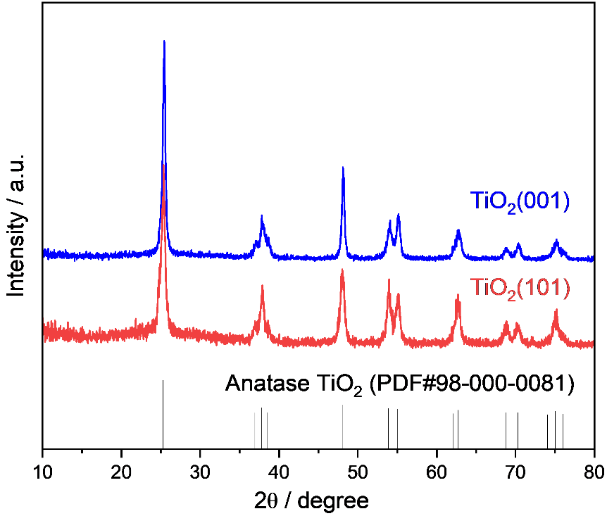
Figure S1. XRD patterns of fresh TiO₂(001) and (101) samples.
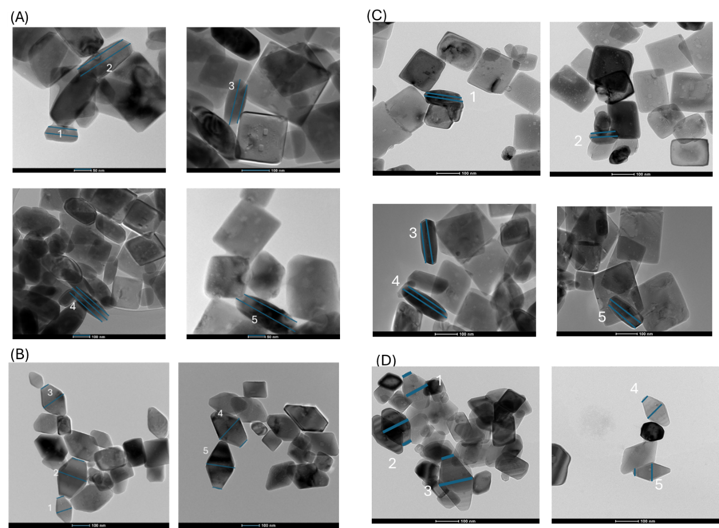
Figure S2. TEM images of (A) fresh TiO₂(001) with nanosheet shapes and (B) fresh TiO₂(101) with bipyramidal shapes. (C) and (D) TEM images of (001) and (101) after reaction with nanosheet shapes and bipyramidal shapes preserved respectively. Blue lines are dimensions of facets and are used to calculate the fraction of (001) and (101) surfaces.
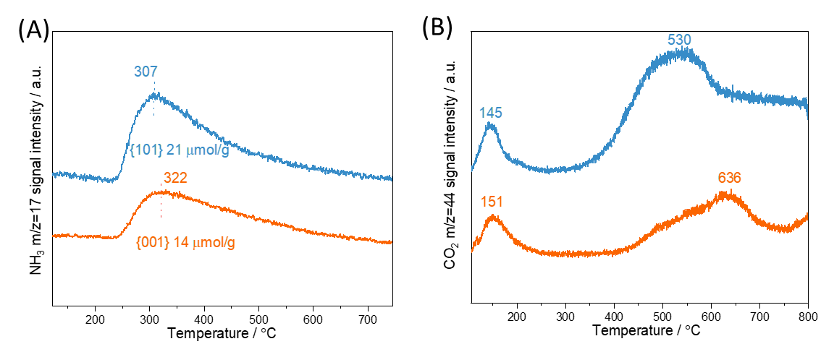
Figure S3 (A) NH₃-TPD and (B) CO₂-TPD profiles of TiO₂(101) and (001). Operating conditions: samples were pretreated at 450 °C for 1 h under He (50 mL min⁻¹), cooled to 100 °C, and then saturated with 1% NH₃/He or 10% CO₂/He (50 mL min⁻¹). Temperature was then ramped to 700 °C at 10 °C min⁻¹ under He (50 mL min⁻¹).

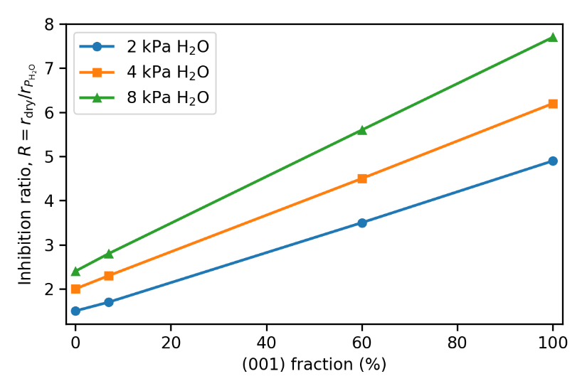
Figure S4. Extrapolation of inhibition ratios vs. (001) fraction at different water pressures (2, 4, 8 kPa).

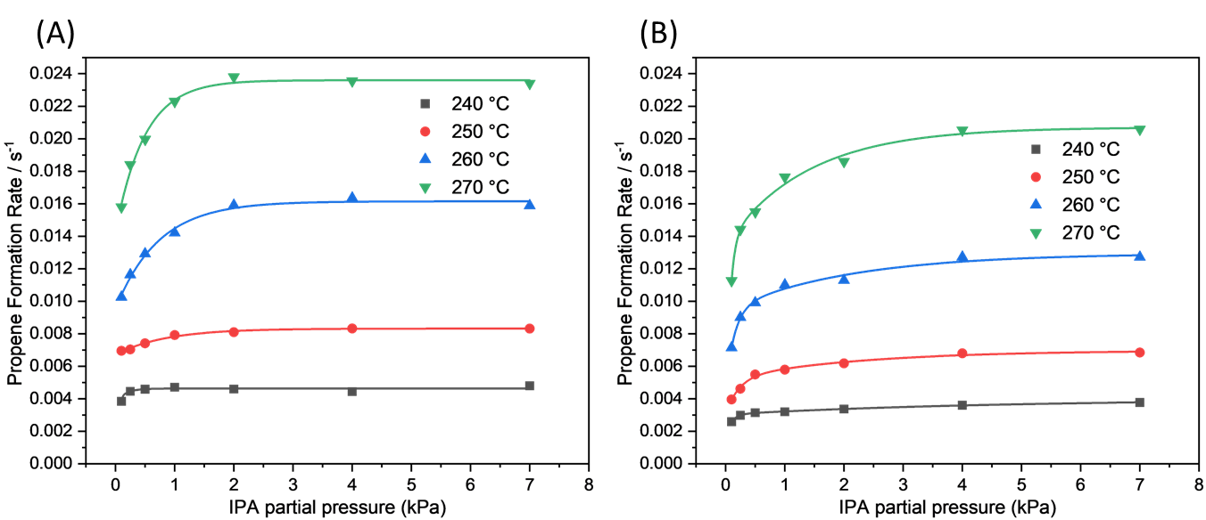
Figure S5. Kinetic dependence of IPA dehydration on TiO₂(001) (A) in the absence of water and (B) in the presence of water (0.2 kPa water). Operating conditions: 240-270 ºC,1 atm total pressure with 0.1-7 kPa IPA, 0.2 kPa co-fed H₂O, and balance He, and 47.6 cm³ g⁻¹ s⁻¹ GHSV.

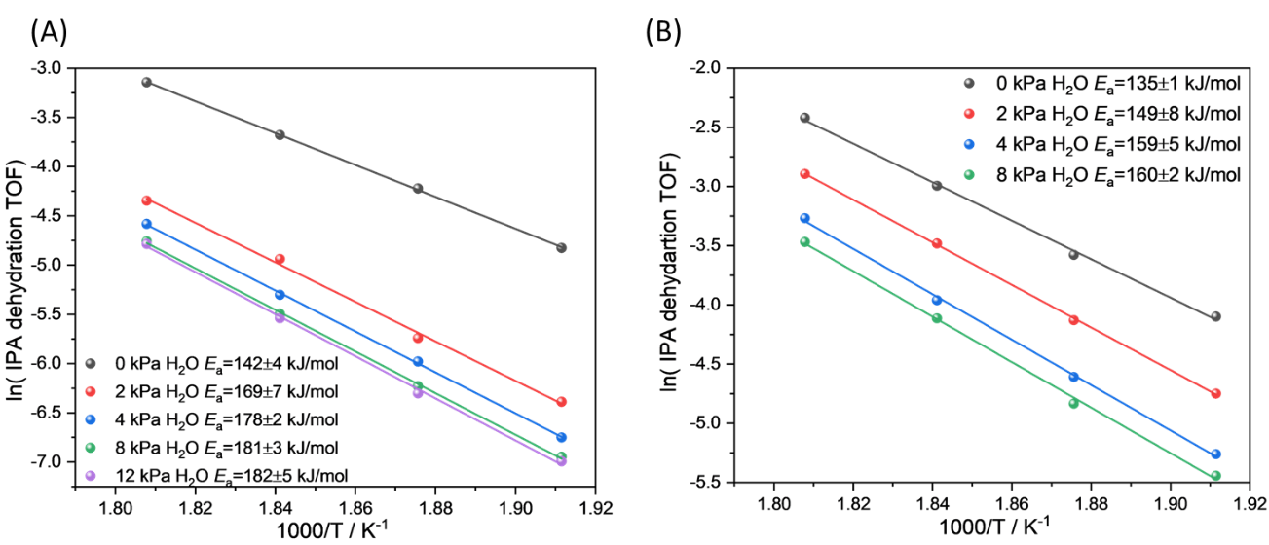
Figure S6. Arrhenius plots of IPA dehydration on (A) TiO₂(001) and (B) (101) at 1 atm total pressure with 1 kPa IPA, 0-12 kPa co-fed H₂O and 47.6 cm³ g⁻¹ s⁻¹ GHSV.

Figure S7. High vacuum IR by introducing IPA and H₂O with increasing pressure from 0.1 mbar to 1.1 mbar on (101) at 100 °C.

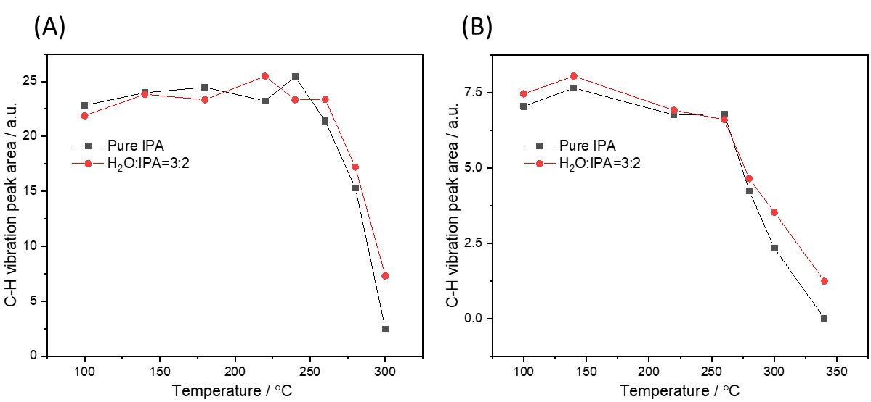
Figure S8. C-H vibration peak area integrated from DRIFTS spectra versus temperature with pure IPA adsorption and H₂O: IPA partial pressure ratio of 3:2 on (A) (101) and (B) (001)

Figure S9. DRIFTS spectra of -OH region with (bottom) pure IPA on (101) and (top) H₂O&IPA on (101).
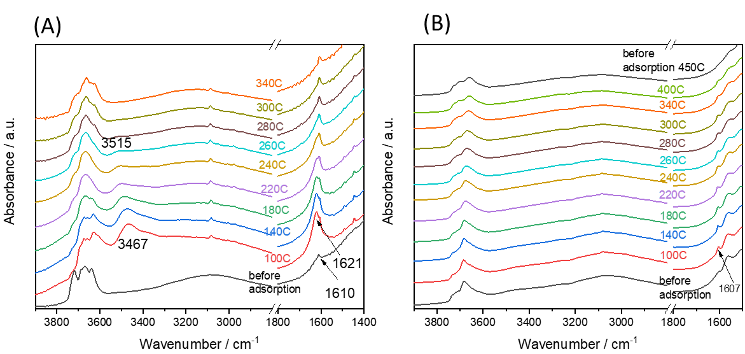
Figure S10. (A) and (B) in situ DRIFTS-TPD spectra of adsorption and desorption of pure H₂O on (101) and (001). Operating conditions: catalysts (20 mg) were pretreated in 10% O₂/He at 450 °C at ambient pressure for 1 h, and then treated with H₂O in flowing He at 100 °C until saturation, followed by ramping from 100 °C to 450 °C (10 °C min⁻¹) in flowing He (50 mL min⁻¹).

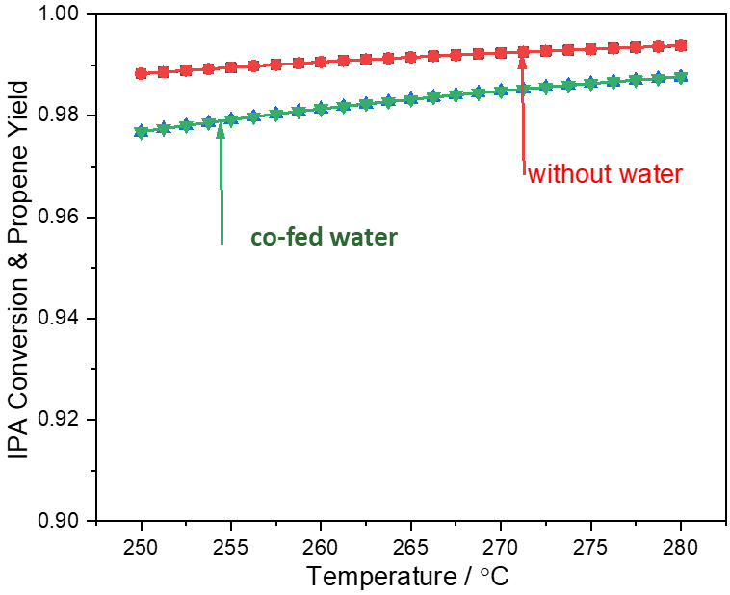
Figure S11. Thermodynamic equilibria calculations of IPA dehydration at temperature range from 250-280 °C with or without co-fed water (water:IPA = 4:1 or 0:1, respectively)
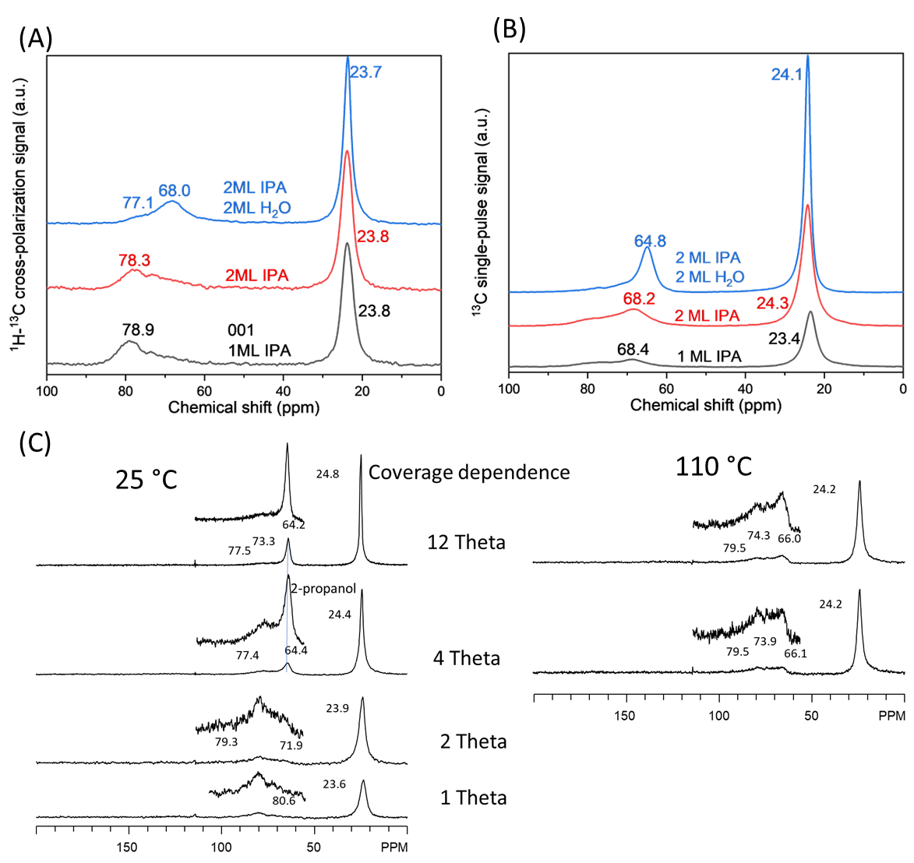
Figure S12. In situ ¹³C direct polarization NMR of IPA and water adsorbed on (A) (001) and (B) (101); (C)¹³C NMR of different coverages IPA on (001) at 25 °C(DP) and 110 °C(CP)

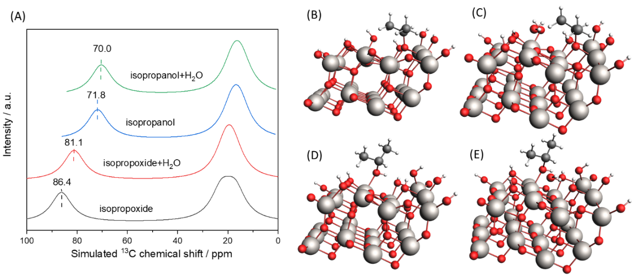
Figure S13. (A) DFT-NMR simulated ¹³C NMR spectra of (B) isopropoxide, (C) isopropoxide + H₂O, (D)isopropanol, and (E)isopropanol + H₂O adsorbed on TiO₂.

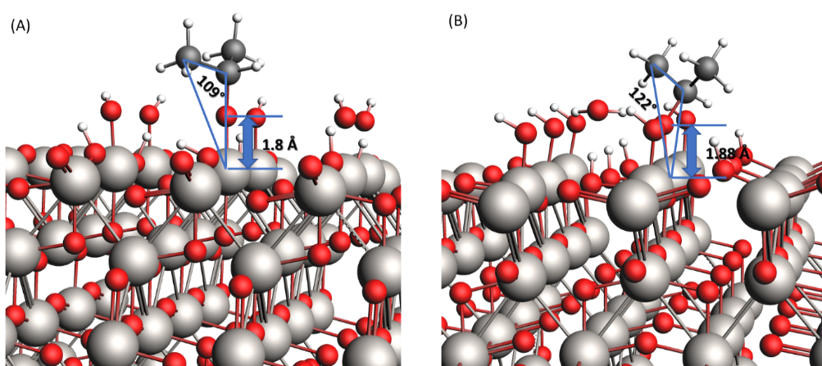
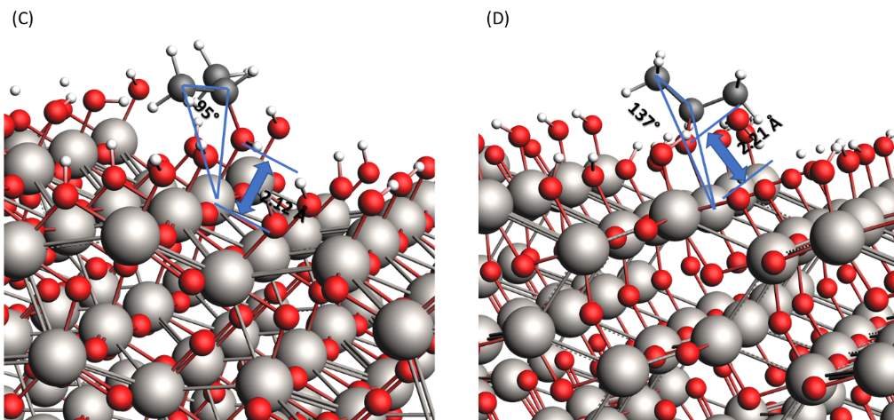
Figure S14. Zoom in model structures illustrating bond angles and bond distances with (A) IPA on TiO₂ (001), (B) IPA+H₂O on TiO₂ (001), (C) IPA on TiO₂ (101) and (D) IPA+H₂O on TiO₂ (101).
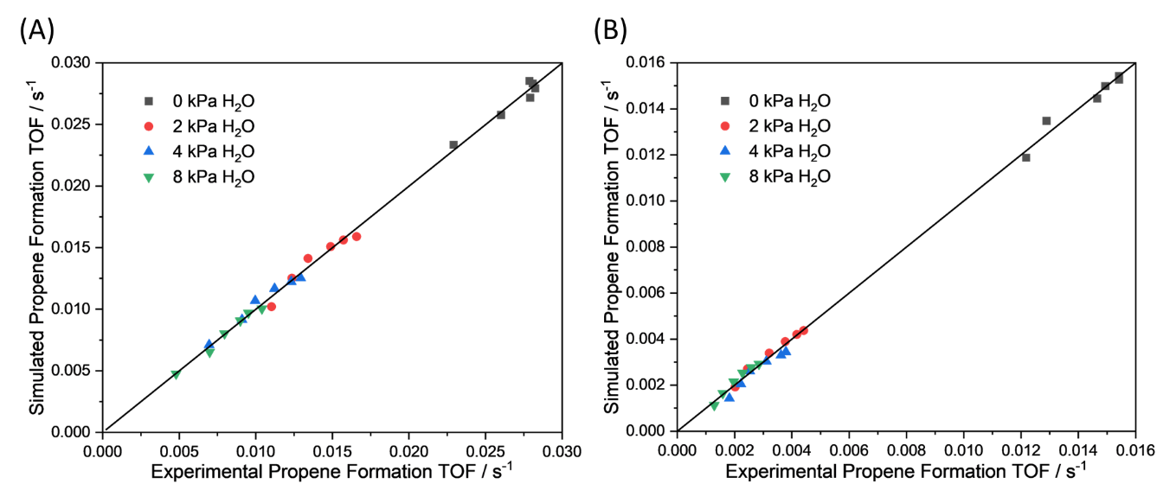
Figure S15. Parity plots for the predicted (from eq. S33 and parameters in Table S7) and measured turnover frequencies on (A) TiO₂(101) and (B) (001) at 260 °C, 1 atm total pressure with 0.25-8 kPa IPA, 0-8 kPa H₂O, balance He, and 47.6 cm³ g⁻¹ s⁻¹ GHSV. The solid line represents a perfect prediction of turnover frequencies for propene formation

Sensitivity analyses for the parameters in eq. 1 were performed by varying the optimal values by ±25% and then comparing the sum of squared residuals between the predicted and experimental data. As shown in Figures S16 and 17, the parameters are sensitive to the changes, confirming the reliability of the predicted values.

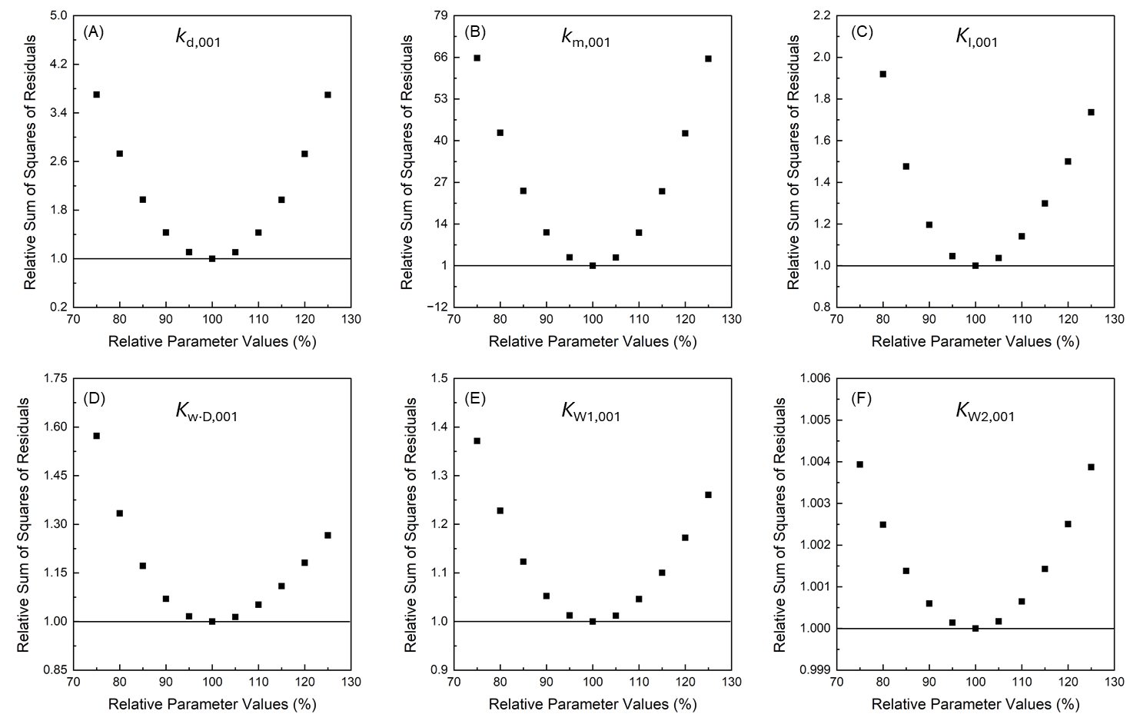
Figure S16. Sensitivity of sum of squares of residuals to variations in optimal kinetic and thermodynamic parameters of the rate expression (Table S3, eq. S33) on TiO₂ (001) at 260 ºC,1 atm total pressure with 0.25-8 kPa IPA, 0-8 kPa H₂O, and balance He, and 47.6 cm³ g⁻¹ s⁻¹ GHSV.

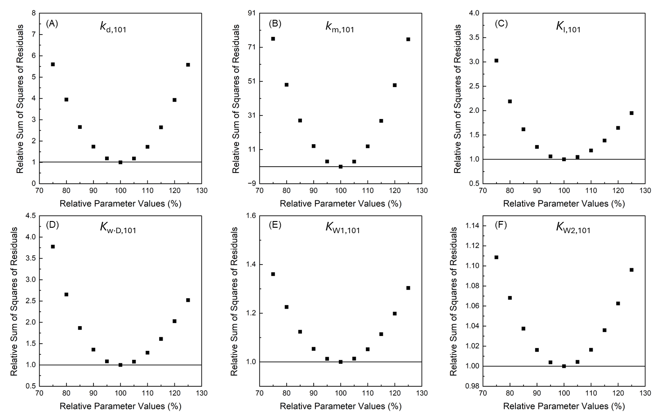
Figure S17. Sensitivity of sum of squares of residuals to variations in optimal kinetic and thermodynamic parameters of the rate expression (Table S3. eq. S33) on TiO₂ (101) at 260 ºC,1 atm total pressure with 0.25-8 kPa IPA, 0-8 kPa H₂O, and balance He, and 47.6 cm³ g⁻¹ s⁻¹ GHSV.

- Tables
Table S1. Length measurement and (001) percentage calculations
 | A length | B length | "%001" | "%101"
(101)
1 | 0.411096 | 0.199249 | 0.101952033 | 0.898048
2 | 0.746726 | 0.303645 | 0.068250829 | 0.9317492
3 | 0.62426 | 0.238537 | 0.059458157 | 0.9405418
4 | 0.738241 | 0.245153 | 0.043819416 | 0.9561806
5 | 0.742765 | 0.275862 | 0.055857893 | 0.9441421
 |  | Average | 0.07 | 0.93
 |  | Standard deviation | 0.02 | 0.02
(001)
1 | 0.977394 | 0.867006 | 0.577188653 | 0.4228113
2 | 1.828579 | 1.670479 | 0.650973145 | 0.3490269
3 | 1.402462 | 1.203038 | 0.507364167 | 0.4926358
4 | 1.343801 | 1.244829 | 0.691012433 | 0.3089876
5 | 1.905387 | 1.669641 | 0.550157117 | 0.4498429
 |  | Average | 0.60 | 0.40
 |  | Standard deviation | 0.07 | 0.07

Table S2. Turnover frequencies and conversions of IPA dehydration on TiO₂(001) at 260 ºC, 1 atm total pressure with 0.25-8 kPa IPA, 0-8 kPa H₂O, balance He, and 47.6 cm³ g⁻¹ s⁻¹ GHSV.
Partial Pressure, kPa |  | TOF, s⁻¹ | Conversion, % | Generated Waer, kPa
IPA, kPa | H₂O, kPa | TOF, s⁻¹ | Conversion, % | Generated Waer, kPa
0.25 | 0 | 0.01218 | 3.55 | 0.009
0.5 | 0 | 0.01289 | 1.88 | 0.009
1 | 0 | 0.01466 | 1.07 | 0.011
2 | 0 | 0.01494 | 0.54 | 0.011
4 | 0 | 0.01542 | 0.28 | 0.011
8 | 0 | 0.01542 | 0.14 | 0.011
0.25 | 2 | 0.00202 | 0.59 | 0.001
0.5 | 2 | 0.00245 | 0.36 | 0.002
1 | 2 | 0.00321 | 0.23 | 0.002
2 | 2 | 0.00377 | 0.14 | 0.003
4 | 2 | 0.00417 | 0.08 | 0.003
8 | 2 | 0.00441 | 0.04 | 0.003
0.25 | 4 | 0.00182 | 0.53 | 0.001
0.5 | 4 | 0.00222 | 0.32 | 0.002
1 | 4 | 0.00253 | 0.18 | 0.002
2 | 4 | 0.00311 | 0.11 | 0.002
4 | 4 | 0.00362 | 0.07 | 0.003
8 | 4 | 0.00379 | 0.03 | 0.003
0.25 | 8 | 0.00129 | 0.38 | 0.001
0.5 | 8 | 0.00159 | 0.23 | 0.001
1 | 8 | 0.00197 | 0.14 | 0.001
2 | 8 | 0.00228 | 0.08 | 0.002
4 | 8 | 0.00258 | 0.05 | 0.002
8 | 8 | 0.00285 | 0.03 | 0.002
Table S3. Turnover frequencies and conversions of IPA dehydration on TiO₂(101) at 260 ºC, 1 atm total pressure with 0.25-8 kPa IPA, 0-8 kPa H₂O, balance He, and 47.6 cm³ g⁻¹ s⁻¹ GHSV.
Partial Pressure, kPa |  | TOF, s⁻¹ | Conversion, % | Generated Waer, kPa
IPA | H₂O | TOF, s⁻¹ | Conversion, % | Generated Waer, kPa
0.25 | 0 | 0.02292 | 10.02 | 0.025
0.5 | 0 | 0.02602 | 5.69 | 0.028
1 | 0 | 0.02792 | 3.05 | 0.031
2 | 0 | 0.02825 | 1.54 | 0.031
4 | 0 | 0.02809 | 0.77 | 0.031
8 | 0 | 0.02787 | 0.38 | 0.03
0.25 | 2 | 0.01103 | 4.82 | 0.012
0.5 | 2 | 0.01236 | 2.7 | 0.014
1 | 2 | 0.01341 | 1.47 | 0.015
2 | 2 | 0.01489 | 0.81 | 0.016
4 | 2 | 0.01572 | 0.43 | 0.017
8 | 2 | 0.01658 | 0.23 | 0.018
0.25 | 4 | 0.00695 | 3.04 | 0.008
0.5 | 4 | 0.0091 | 1.99 | 0.01
1 | 4 | 0.00996 | 1.09 | 0.011
2 | 4 | 0.01122 | 0.61 | 0.012
4 | 4 | 0.01231 | 0.34 | 0.013
8 | 4 | 0.01294 | 0.18 | 0.014
0.25 | 8 | 0.00479 | 2.09 | 0.005
0.5 | 8 | 0.00698 | 1.53 | 0.008
1 | 8 | 0.00796 | 0.87 | 0.009
2 | 8 | 0.00899 | 0.49 | 0.01
4 | 8 | 0.00952 | 0.26 | 0.01
8 | 8 | 0.0104 | 0.14 | 0.011

Table S4. Kinetic isotope effect of IPA dehydration using CD₃CH(OH)CD₃ or CH₃CH(OD)CH₃ with co-fed water on TiO₂(001) and (101) at 260 ºC. 1 atm total pressure with 1 kPa reactant, 4 kPa H₂O, and balance He, and 47.6 cm³ g⁻¹ s⁻¹ gas hourly space velocity (GHSV).
KIE | CD₃CH(OH)CD₃ | CH₃CH(OD)CH₃
IPA on (001) | 1.6 | 1
H₂O+ IPA on (001) | 1.9 | 1
IPA on (101) | 1.7 | 1
H₂O+ IPA on (101) | 1.9 | 1

Table S5. Elementary Steps of IPA dehydration on TiO₂(001)
Elementary Stepsª |  | Parameters^{b}
(001)-1 | IPA (g) + Ti-O_{s}-Ti(OH)  Ti(iOC₃H₇)-O_{s}(H)-Ti(OH) | K_{I,001}
(001)-2 | Ti-O_{s}-Ti(OH) + H₂O (g) Ti(H₂O)-O_{s}-Ti(OH) | K_{W1,001}
(001)-3 | Ti(i-OC₃H₇)-O_{s}(H)-Ti(OH) + H₂O (g) Ti(i-OC₃H₇···H₂O)-O_{s}(H)-Ti(OH) | K_{W·D,001}
(001)-4 | Ti(H₂O)-O_{s}-Ti(OH) + H₂O (g) Ti(H₂O)₂-O_{s}-Ti(OH) | K_{W1-2,001}
(001)-m-5 | Ti(i-OC₃H₇)-O_{s}(H)-Ti(OH) Ti(O)-O_{s}(H)-Ti(H₂O) + CH₂CHCH₃ (g) | k_{m,001}
(001)-m-6 | Ti(O)-O_{s}(H)-Ti(H₂O) Ti-O_{s}-Ti(OH) + H₂O (g)
(001)-d-5 | Ti(i-OC₃H₇···H₂O)-O_{s}(H)-Ti(OH) Ti(O···H₂O)-O_{s}(H)-Ti(H₂O) +CH₂CHCH₃ (g) | k_{d,001}
(001)-d-6 | Ti(O···H₂O)-O_{s}(H)-Ti(H₂O) Ti-O_{s}-Ti(OH) + 2H₂O (g)
ªArrow “” represents a quasi-equilibrium reaction. “” represents an irreversible reaction. ^{b}K_{I,001,} K_{W1,001}, K_{W1-2,001}, K_{W·D,001} are the equilibrium constants corresponding to each elementary step, and k_{m,001} and k_{d,001} are the rate constants for Steps (001)-m-5 and (001)-d-5, respectively.

Table S6. Elementary Steps of IPA dehydration on TiO₂(101)
Elementary Stepsª |  | Parameters^{b}
(101)-1 | IPA + Ti-O_{s} Ti(IPA)-O_{s} | K_{I,101}
(101)-2 | Ti-O_{s} + H₂O (g) Ti(H₂O)-O_{s} | K_{W1,101}
(101)-3 | Ti(IPA)-O_{s} + H₂O (g) Ti(IPA···H₂O)-O_{s} | K_{W·D,101}
(101)-4 | Ti(H₂O)-O_{s} + H₂O (g) Ti(H₂O)₂-O_{s} | K_{W1-2,101}
(101)-m-5 | Ti(IPA)-O_{s} Ti(OH)-O_{s}(H) +CH₂CHCH₃ (g) | k_{m,101}
(101)-m-6 | Ti(OH)-O_{s}(H) Ti-O_{s} + H₂O (g)
(101)-d-5 | Ti(IPA···H₂O)-O_{s} Ti(OH···H₂O)-O_{s}(H) +CH₂CHCH₃ (g) | k_{d,101}
(101)-d-6 | Ti(OH···H₂O)-O_{s}(H) Ti-O_{s} + 2H₂O (g)
ªArrow “” represents a quasi-equilibrium reaction. “” represents an irreversible reaction. ^{b}K_{I,101,} K_{W1,101}, K_{W1-2,101}, K_{W·D,101} are the equilibrium constants corresponding to each elementary step, and k_{m,101} and k_{d,101} are the rate constants for Steps (101)-m-5 and (101)-d-5, respectively.

Table S7. Kinetic and thermodynamic parameters obtained by the non-linear fitting of experimental data to rate expressions (eq. S33). Operating conditions: 260 °C, 1 atm total pressure with 0.25-8 kPa IPA, 0-8 kPa H₂O, balance He, and 47.6 cm³ g⁻¹ s⁻¹ GHSV.
Parameters | (001) | (101)
k_{d,j} (s⁻¹) | 2.49 (±0.15) × 10⁻³ | 7.10 (±0.90) × 10⁻³
k_{m,j} (s⁻¹) | 1.56 (±0.17) × 10⁻² | 2.87 (±0.03) × 10⁻²
K_{I,j} (Pa⁻¹) | 1.29 (±0.10) × 10⁻² | 1.73 (±0.01) × 10⁻²
K_{w·D,j} (Pa⁻¹) | 2.67 (±0.23) × 10⁻³ | 6.91 (±0.48) × 10⁻⁴
K_{w1,j} (Pa⁻¹) | 1.28 (±0.16) × 10⁻² | 2.00 (±0.38) × 10⁻³
K_{w2,j} (Pa⁻²) | 3.28 (±2.67) × 10⁻⁷ | 2.60 (±0.88) × 10⁻⁷

Table S8A. The fractional coverage of surface species and turnover frequencies of monomeric and complex pathway on TiO₂(001) at 260 °C (calculated from eq. S33 and parameters in Table S7).
Partial Pressure, Pa |  | Fractional Coverages |  |  |  |  | r_{d,001}, s⁻¹ | r_{m,001}, s⁻¹ | r_{d,001}/r_{m,001}
IPA | H₂O | Ti-O_{s}-Ti(OH) | Ti(i-OC₃H₇···  H₂O)-O_{s}(H)-Ti(OH) | Ti(H₂O)-O_{s}-Ti(OH) | (Ti(H₂O)₂-O_{s}-Ti(OH) | Ti(i-OC₃H₇)-O_{s}(H)-Ti(OH) | r_{d,001}, s⁻¹ | r_{m,001}, s⁻¹ | r_{d,001}/r_{m,001}
250 | 0 | 24% | 0% | 0% | 0% | 76% | 0.000000 | 0.011880 | 0.00
500 | 0 | 13% | 0% | 0% | 0% | 87% | 0.000000 | 0.013476 | 0.00
1000 | 0 | 7% | 0% | 0% | 0% | 93% | 0.000000 | 0.014447 | 0.00
2000 | 0 | 4% | 0% | 0% | 0% | 96% | 0.000000 | 0.014987 | 0.00
4000 | 0 | 2% | 0% | 0% | 0% | 98% | 0.000000 | 0.015273 | 0.00
8000 | 0 | 1% | 0% | 0% | 0% | 99% | 0.000000 | 0.015419 | 0.00
250 | 2000 | 2% | 36% | 53% | 3% | 7% | 0.000886 | 0.001036 | 0.86
500 | 2000 | 1% | 50% | 37% | 2% | 9% | 0.001246 | 0.001457 | 0.86
1000 | 2000 | 1% | 63% | 23% | 1% | 12% | 0.001564 | 0.001829 | 0.86
2000 | 2000 | 1% | 72% | 13% | 1% | 13% | 0.001793 | 0.002096 | 0.86
4000 | 2000 | 0% | 78% | 7% | 0% | 15% | 0.001934 | 0.002262 | 0.86
8000 | 2000 | 0% | 81% | 4% | 0% | 15% | 0.002014 | 0.002355 | 0.86
250 | 4000 | 1% | 36% | 54% | 6% | 3% | 0.000901 | 0.000527 | 1.71
500 | 4000 | 1% | 52% | 39% | 4% | 5% | 0.001292 | 0.000755 | 1.71
1000 | 4000 | 0% | 66% | 25% | 3% | 6% | 0.001649 | 0.000964 | 1.71
2000 | 4000 | 0% | 77% | 14% | 1% | 7% | 0.001914 | 0.001119 | 1.71
4000 | 4000 | 0% | 83% | 8% | 1% | 8% | 0.002081 | 0.001216 | 1.71
8000 | 4000 | 0% | 87% | 4% | 0% | 8% | 0.002176 | 0.001272 | 1.71
250 | 8000 | 1% | 35% | 52% | 11% | 2% | 0.000872 | 0.000255 | 3.42
500 | 8000 | 0% | 51% | 38% | 8% | 2% | 0.001277 | 0.000373 | 3.42
1000 | 8000 | 0% | 67% | 25% | 5% | 3% | 0.001662 | 0.000486 | 3.42
2000 | 8000 | 0% | 79% | 15% | 3% | 4% | 0.001958 | 0.000572 | 3.42
4000 | 8000 | 0% | 86% | 8% | 2% | 4% | 0.002149 | 0.000628 | 3.42
8000 | 8000 | 0% | 91% | 4% | 1% | 4% | 0.002260 | 0.000660 | 3.42

Table S8B. The fractional coverages of surface species and turnover frequencies of monomeric and complex pathway on TiO₂(101) at 260 °C (calculated from eq. S33 and parameters in Table S7).
Partial Pressure, Pa |  | Fractional Coverages |  |  |  |  | r_{d,101}, s⁻¹ | r_{m,101}, s⁻¹ | r_{d,101}/  r_{m,101}
IPA | H₂O | Ti-O_{s} | Ti(IPA···H₂O)-O_{s} | Ti(H₂O)-O_{s} | Ti(H₂O)₂-O_{s} | Ti(IPA)-O_{s} | r_{d,101}, s⁻¹ | r_{m,101}, s⁻¹ | r_{d,101}/  r_{m,101}
250 | 0 | 19% | 0% | 0% | 0% | 81% | 0.000000 | 0.023343 | 0.00
500 | 0 | 10% | 0% | 0% | 0% | 90% | 0.000000 | 0.025761 | 0.00
1000 | 0 | 5% | 0% | 0% | 0% | 95% | 0.000000 | 0.027168 | 0.00
2000 | 0 | 3% | 0% | 0% | 0% | 97% | 0.000000 | 0.027930 | 0.00
4000 | 0 | 1% | 0% | 0% | 0% | 99% | 0.000000 | 0.028328 | 0.00
8000 | 0 | 1% | 0% | 0% | 0% | 99% | 0.000000 | 0.028531 | 0.00
8000 | 0 | 1% | 0% | 0% | 0% | 99% | 0.000000 | 0.028531 | 0.00
250 | 2000 | 6% | 37% | 24% | 6% | 26% | 0.002597 | 0.007609 | 0.34
500 | 2000 | 4% | 45% | 15% | 4% | 32% | 0.003186 | 0.009334 | 0.34
1000 | 2000 | 2% | 51% | 8% | 2% | 37% | 0.003593 | 0.010526 | 0.34
2000 | 2000 | 1% | 54% | 5% | 1% | 39% | 0.003838 | 0.011245 | 0.34
4000 | 2000 | 1% | 56% | 2% | 1% | 41% | 0.003974 | 0.011642 | 0.34
8000 | 2000 | 0% | 57% | 1% | 0% | 41% | 0.004046 | 0.011852 | 0.34
250 | 4000 | 3% | 41% | 27% | 14% | 15% | 0.002884 | 0.004224 | 0.68
500 | 4000 | 2% | 52% | 17% | 9% | 19% | 0.003714 | 0.005440 | 0.68
1000 | 4000 | 1% | 61% | 10% | 5% | 22% | 0.004338 | 0.006354 | 0.68
2000 | 4000 | 1% | 67% | 6% | 3% | 24% | 0.004736 | 0.006938 | 0.68
4000 | 4000 | 0% | 70% | 3% | 2% | 25% | 0.004964 | 0.007271 | 0.68
8000 | 4000 | 0% | 72% | 1% | 1% | 26% | 0.005086 | 0.007450 | 0.68
250 | 8000 | 2% | 39% | 26% | 27% | 7% | 0.002744 | 0.002010 | 1.37
500 | 8000 | 1% | 53% | 18% | 18% | 10% | 0.003769 | 0.002760 | 1.37
1000 | 8000 | 1% | 65% | 11% | 11% | 12% | 0.004634 | 0.003394 | 1.37
2000 | 8000 | 0% | 74% | 6% | 6% | 13% | 0.005234 | 0.003834 | 1.37
4000 | 8000 | 0% | 79% | 3% | 3% | 14% | 0.005597 | 0.004099 | 1.37
8000 | 8000 | 0% | 82% | 2% | 2% | 15% | 0.005798 | 0.004247 | 1.37

References:
[62] Y. Wu, F. Gao, H. Wang, L. Kovarik, B. Sudduth, Y. Wang, The Journal of Physical Chemistry C 125, (2021): 3988.
[63] X. Han, X. Wang, S. Xie, Q. Kuang, J. Ouyang, Z. Xie, L. Zheng, RSC Advances 2, (2012).
[64] F. Lin, Y. Chen, L. Zhang, D. Mei, L. Kovarik, B. Sudduth, H. Wang, F. Gao, Y. Wang, ACS Catalysis 10, (2020): 4268.
[65] N. R. Jaegers, W. Hu, Y. Wang, J. Z. Hu, J. Vis. Exp., (2020).
[66] N. R. Jaegers, W. Hu, T. J. Weber, J. Z. Hu, Scientific Reports 11, (2021): 7800.
[67] N. R. Jaegers, K. T. Mueller, Y. Wang, J. Z. Hu, Acc Chem Res 53, (2020): 611.
[68] J. Z. Hu, M. Y. Hu, Z. Zhao, S. Xu, A. Vjunov, H. Shi, D. M. Camaioni, C. H. F. Peden, J. A. Lercher, Chemical Communications 51, (2015): 13458.
[69] J. VandeVondele, M. Krack, F. Mohamed, M. Parrinello, T. Chassaing, J. Hutter, Computer Physics Communications 167, (2005): 103.
[70] S. Goedecker, M. Teter, J. Hutter, Physical Review B 54, (1996): 1703.
[71] J. P. Perdew, K. Burke, M. Ernzerhof, Physical Review Letters 77, (1996): 3865.
[72] Z. Zhang, Y. Yoon, X. Lin, D. Acharya, B. D. Kay, R. Rousseau, Z. Dohnálek, The Journal of Physical Chemistry Letters 3, (2012): 3257.
[73] S. Grimme, J. Antony, S. Ehrlich, H. Krieg, The Journal of Chemical Physics 132, (2010): 154104.
[74] G. Henkelman, B. P. Uberuaga, H. Jónsson, The Journal of Chemical Physics 113, (2000): 9901.
[75] N. R. Jaegers, J. K. Lai, Y. He, E. Walter, D. A. Dixon, M. Vasiliu, Y. Chen, C. Wang, M. Y. Hu, K. T. Mueller, I. E. Wachs, Y. Wang, J. Z. Hu, Angew Chem Int Ed Engl 58, (2019): 12609.

